<https://stackblitz.com/edit/stackblitz-starters-azd5vjg7?file=index.js>

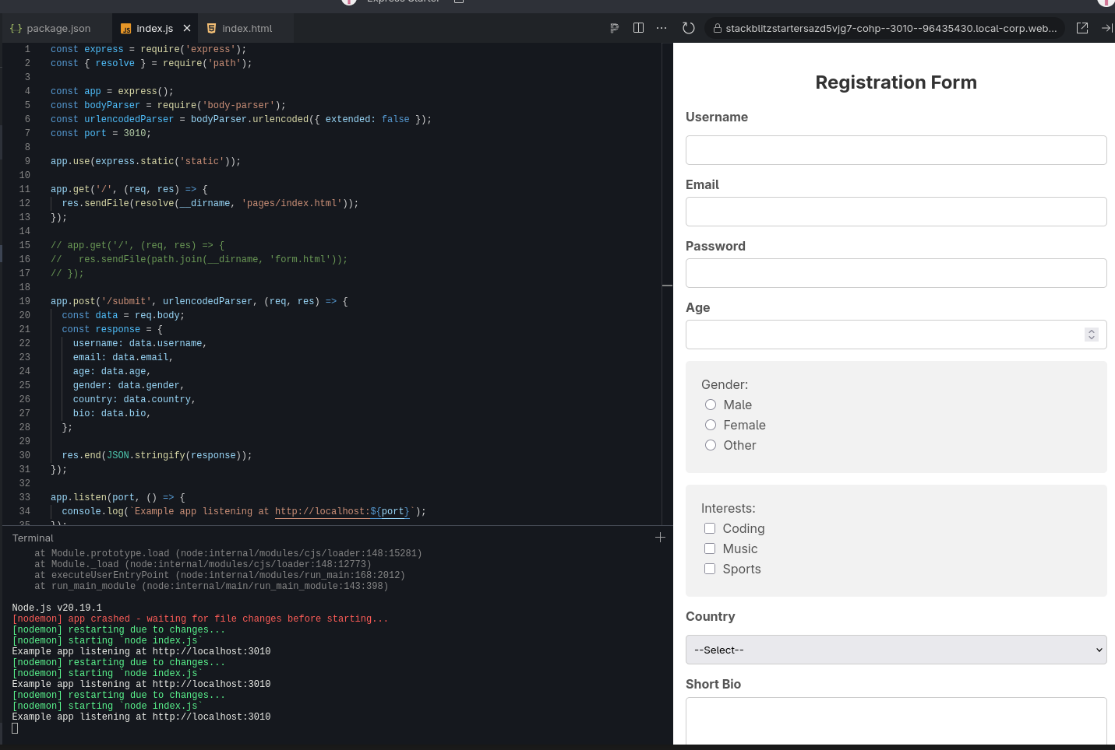INDEX.JS

I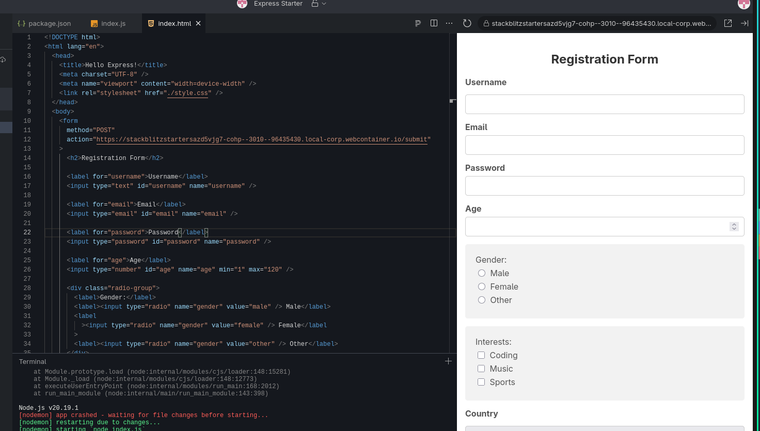NDEX.HTML

STYLE.CSS

