Only LSPs are available in the current editor I use (Neovim). I have setup the needed tools in order to have a smooth experience in writing Vue. It uses conform and prettier for formatting, vue_ls and vtsls for the lsp, and treesitter for highlighting and textobjects.

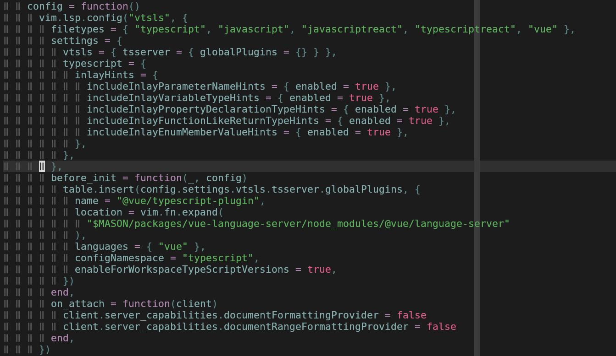

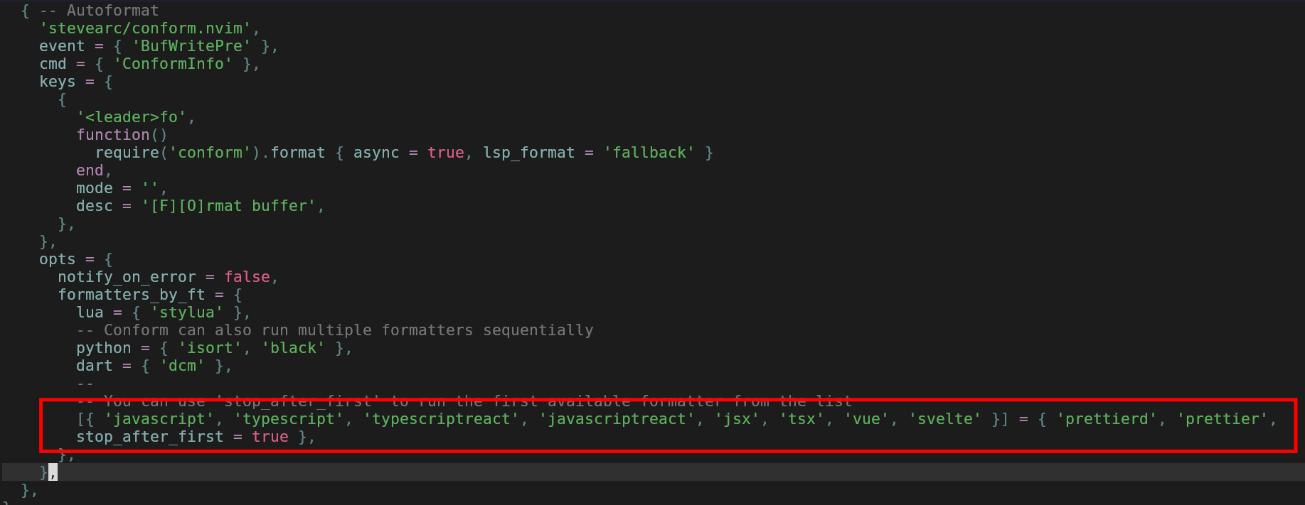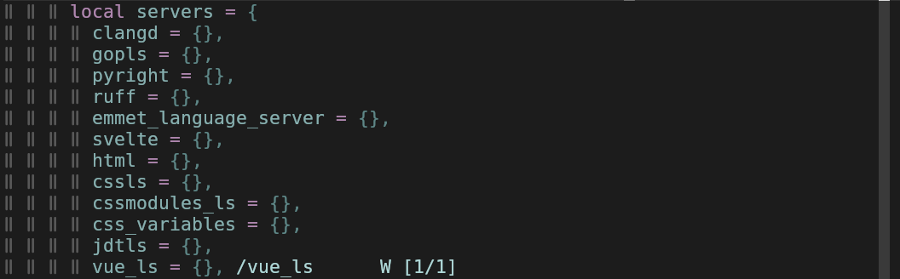

Using latest vue version, it doesn’t support using a cdn link in the script tag anymore.

## FIGURE 7

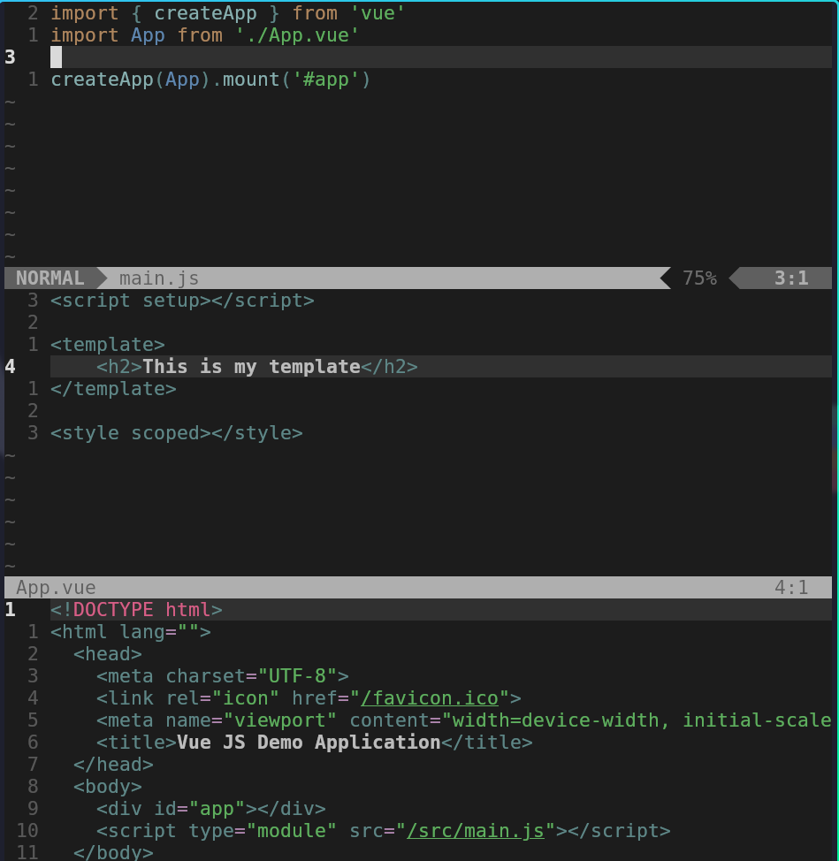

## FIGURE 8 and 9

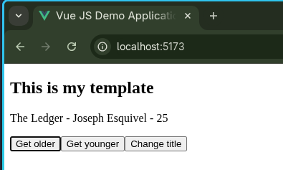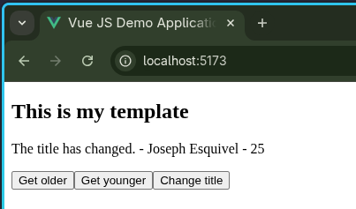

## FIGURE 10-12

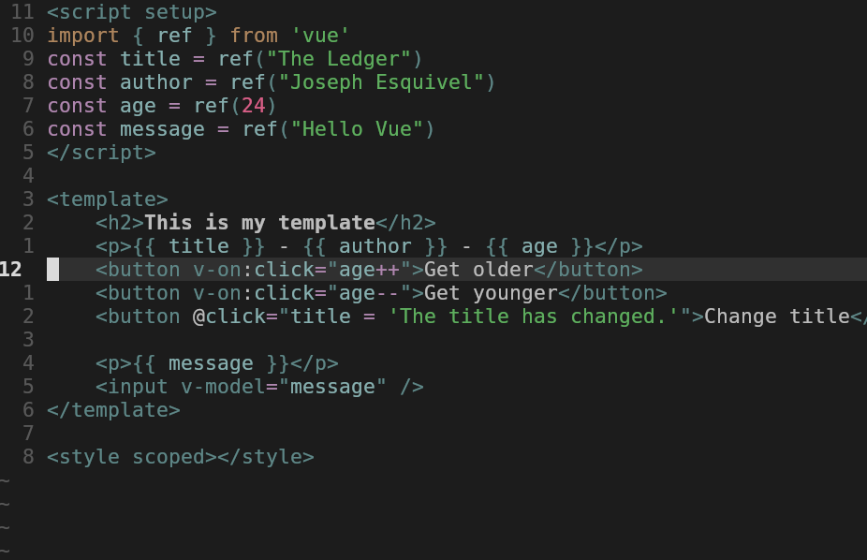

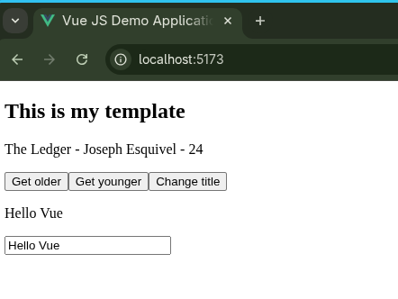

## FIGURE 13

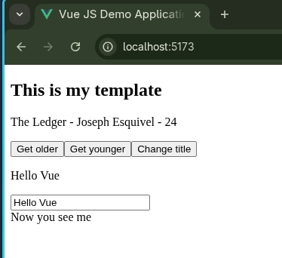

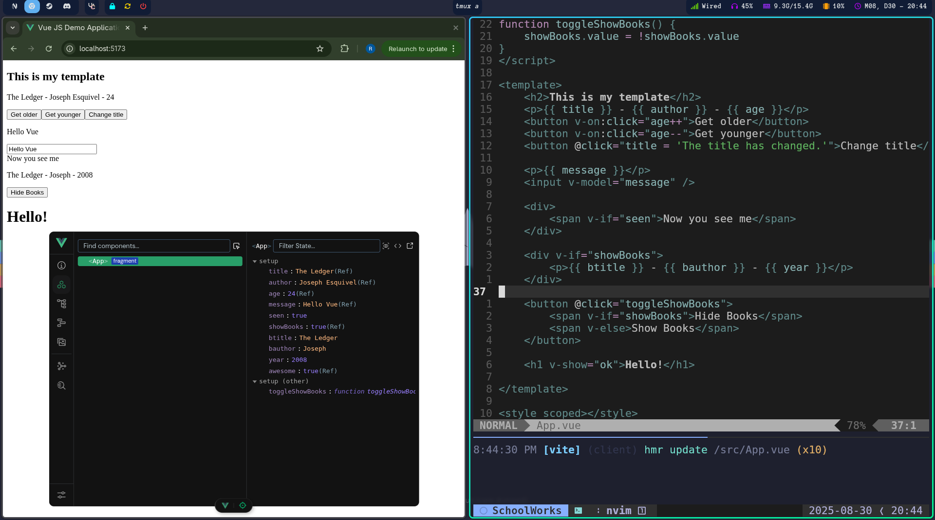

## FIGURE 14-17

## FIGURE 18-19

