
Faculity of Engineering and Technology
Department of Electrical and Computer Engineering

Linux Labortary
ENCS3130
Project # 2
—--- Test Cases —--
ــــــــــــــــــــــــــــــــــــــــــــــــــــــــــــــــــــــــــــــــــــــــــــــــــــــــــــــــــــــــــــــــــ
Prepared By:Mohammed Injass 1231814
Instructor : Khader Mohammed
Teaching Assistant : Hamza Awashra
Section: 2
Partner : Julnar Naal Assi 1221669
Instructor:Dr. Rida Defallah
Teaching Assistant: Eng. Loor Sawalhi
Section:4
Date:18/1/2026

Input files:
- Schedules

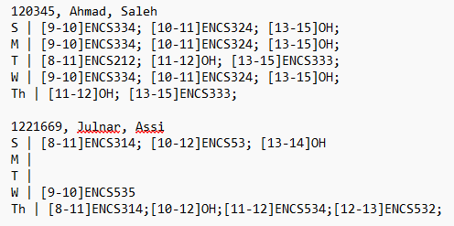

- Valid corse codes

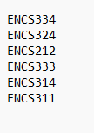

- Instructors preferences

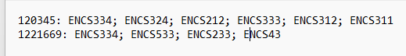

Output result:

