**A Progressive Web App Information System and Accessibility Mapping for Persons with Disabilities (PWD) utilizing Geographical Information System and Data Analytics**

A Capstone Project presented to the Faculty, College of Computer Studies

Laguna State Polytechnic University Los Baños Campus

Los Baños, Laguna

In partial fulfillment of the requirements for the degree

Bachelor of Science in Information Technology Specialized in Web and

Mobile Application Development

Ros, Jenn Julian

Pascual, Ivan Louie

Crisanto F. Gulay

2024

**CHAPTER 1**

**PROJECT CONTEXT**

Persons with disabilities often experience exclusion from daily life activities and not being provided equal access to health care, education, and employment, as well as necessary disability-related services preventing them from fully participating in the society, which leads them to be trapped in poverty (Nation Council on Disability Affairs, 2024). As indicated by the World Health Organization (2023), an estimated 1.3 billion, or 16% of the global population, are living with some form of disability. In the Philippines, according to Pedron (2024), there are about 1.44 million Filipinos living with a disability, and the highest count of those living with a disability comes from Region IV-A.

Persons with disabilities, especially those with physical/motor disability, often face difficulties in accessing public environments due to inadequate infrastructure and barriers such as inaccessible entrances, inaccessible parking spaces, transportation, and inaccessible restrooms that not only restrict their mobility but also trigger their feelings of exclusion and isolation from society. Imagine being a person with disability, making plans to go somewhere, and upon arriving, getting stuck outside without accessible parking, cannot enter the place because of inaccessible entrance, have no access to a restroom, and are prevented from sitting with family; it is a highly frustrating situation that people with disability or wheelchair users are all too familiar with Chiluba & Njapawu (2019).

Moreover, Smith, J., & Jones, K. (2020) highlights that PWDs' social exclusion is further aggravated due to their limited access to inclusive information and resources. It is revealed in their findings that Persons with Disabilities often encounter difficultie in getting information about PWD support services, events, and opportunities in their communities, which also contributes to their feelings of exclusion and isolation from society.

In response to the discussed challenges and problems faced by persons with disabilities, this capstone project aims to develop a user-friendly Progressive Web App Information System and Accessibility Mapping utilizing Geographic Information System and Data Analytics specifically designed for Persons with Disabilities (PWDs). By leveraging emerging technologies, we seek to provide Persons with Disabilities access to a platform through which they can get inclusive information/resources while also equipping them with the tools they need utilizing Geographical Information System (GIS) and Data Analytics in developing a mapping system that they can use to map places/establishments accessibility so that they can navigate and plan daily activities and destinations with confidence and ease and for them to have a chance to participate more fully without feeling excluded and isolated from society.

**PROJECT OBJECTIVES**

This project’s main objective is to develop a Progressive Web App Information System and Accessibility Mapping Utilizing Geographic Information System and Data Analytics for Persons with Disabilities (PWDs). In particular, this project specifically aims to:

1. Design and develop a system that allows persons with disabilities in Los Baños, Laguna, to view inclusive information/resources within their locality (e.g., PWD assistance, events, programs).
2. Provide a mapping system for Persons with Disabilities to map places/establishments accessibility features such as Persons with disability accessible entrances, parking spaces, and restrooms, seating based on point of interest categories of places such as Healthcare, Educational Institutions, Restaurants, etc.
3. Test and evaluate the system following the ISO 25010 software standard criteria and conducting a user acceptance evaluation based on Technology Acceptance Model (TAM).

**PROJECT PURPOSE**

This project’s focus is to develop a system in response to the challenges and problems faced by persons with disabilities. The researchers’ aim is to develop a system that will serve as a platform for persons with disabilities to get inclusive information/resources e.g.(Events, Programs, PWD assistance, etc..) and also providing a mapping platform they can use map the accessibility features of places/establishments(PWD Accessible entrance, parking, restroom, seating) so that they can navigate and plan daily activities and destinations with confidence and ease, and to improve persons with disability inclusivity and accessibility so that they can participate more fully in community and reduce their feelings of exclusion and isolation from the community. The following are the main beneficiaries of the project:

1. **Persons with Disabilities (PWDs):** The primary beneficiaries of this project are persons with disabilities. They will have a platform they can use to get resources/information in their locality as well as a mapping system that can determine and map locations' accessibility, enabling them to navigate their surroundings more independently and to plan and have information on the places they can go and know the if the place is accessible for them before going which can help them participate more fully in the community without feelings of exclusion.
2. **Local Businesses:** Local businesses and service providers in Los Baños can benefit from increased support from PWDs. By being listed on the accessibility mapping platform and demonstrating their commitment to inclusivity, these businesses can attract a broader customer base and foster a more inclusive community.
3. **Local Government Units (LGUs):** This project can map the accessibility needs of people with disabilities in the area, which might be advantageous for LGUs in Los Baños.  They will also have a platform to provide Information/Resources for PWDs, and with the data from our software’s mapping, which places/establishments are accessible or not; they can take initiatives for infrastructure development, urban planning, and policymaking to improve persons with disabilities accessibility and inclusivity in the community.
4. **Community Organizations:** Community organizations that assist and provide help for individuals with disabilities (PWDs) can use the platform to promote inclusive practices, providing PWDs a system that will serve as a platform of information/resources as well as a platform that can help them find locations that are inclusive/accessible for persons with disability in the community. They can also collaborate with the researchers to ensure that the platform meets the needs of PWDs in Los Baños effectively.
5. **Caregivers and Family Members**: Caregivers and family members of PWDs will also benefit from the platform by accessing essential information/resources and mapping accessible places within Los Baños, Laguna. This project can assist them in getting information/resources like PWD assistance and programs for their loved ones with a disability, as well as accessing the mapping which they can use to determine accessibility of essential places like healthcare facilities and schools, and plan first before going.

**SCOPE AND LIMITATION OF THE STUDY**

The study's Geographical Coverage will focus specifically on Los Baños, Laguna, Philippines; it will cover the mapping and information gathering within this geographical area. The primary target of this study is persons with disabilities (PWDs) so that they can get inclusive information/resources like PWD assistance, events, etc. The researchers will also develop an accessibility mapping so that persons with disabilities can navigate and plan their daily activities and destinations with confidence and ease and for them to participate more fully in the without feeling excluded and isolated from society. The mapping module, which maps accessibility features of places and filter them based on user-selected point-of-interest category such as healthcare, educational institutions, restaurants, etc. is one of its key features. The system will also implement user reviews/ratings, further increasing the reliability of the mapping information and facilitating informed decision-making for other PWDs. The main limitation of the system is that the mapping module can currently determine 4 accessibility features of places which are (Persons with Disability accessible entrance, parking, restrooms, seatings) which are mainly beneficial for those with physical disability or wheelchair users, but those with other types of disability can still benefit with the use the system because those place accessibility features are generalized for all persons with disabilities, and they can still also use the system to get/view inclusive information/resources.

**CHAPTER II**

**THEORETICAL FRAMEWORK OF THE PROJECT**

**REVIEW OF RELATED LITERATURE, STUDIES, AND SYSTEMS**

**Accessibility Challenges and Barriers faced by Persons with Disabilities**

According to Ahmad M. Alzouby, (2019). The percentage of people living with disabilities worldwide is at 15%. The fundamental right to live freely and on an equal footing with others belongs to this group of people. They are guaranteed equal opportunity to select their place of residence as well as access to public services and amenities thanks to this right. The key public services necessary for a person with disability were highlighted as transportation, education, healthcare, recreation, shopping, and sport, as well as access to public institutions, religious places, and disability associations.

Persons with disabilities (PWDs) face significant challenges in navigating their communities due to a lack of comprehensive information on the accessibility of public spaces. According to World Health Organization (2020). inadequate information about the accessibility features of public spaces, such as wheelchair ramps on entrances and accessible restrooms, poses significant hurdles for PWDs in planning their activities and fully participating in community life.

Chiluba & Njapawu, (2019), Emphasized that Physical barriers faced by people with disabilities include the lack of accessible entrance with ramps, restroom, parking, seating, as well as inadequate signage and inaccessible public transportation. Such restrictions not only limit mobility but also lead to emotions of exclusion frustration, isolation among people with disabilities. Furthermore, studies underline the necessity of tackling attitudinal barriers, which indicate widespread social beliefs and biases that prevent PWD from fully integrating into metropolitan environments. Negative public attitudes, along with a lack of information, enhance the difficulties that people with disabilities have in accessing public amenities, services, and employment prospects.

According to Ahmad M. Alzouby, (2019). The percentage of people living with disabilities worldwide is at 15%. The fundamental right to live freely and on an equal footing with others belongs to this group of people. They are guaranteed equal opportunity to select their place of residence as well as access to public services and amenities thanks to this right. The key public services necessary for a person with disability were highlighted as transportation, education, healthcare, recreation, shopping, and sports, as well as access to public institutions, disability associations, and religious buildings.

According to Munthali et al.(2019) People with disabilities in Malawi face numerous barriers while trying to access healthcare services because of institutional hurdles that prevent them from receiving the essential medical care Long commutes to medical facilities are one of these barriers, which is especially troublesome for people who live far from cities. Unbearably long river crossings during the rainy season and hilly terrain further compound the problem, making healthcare inaccessible for a big number of people. Not only that, but the absence of support leads to the problem because people with disabilities frequently depend on others for transportation, struggle to find willing caregivers, and experience resistance or incapacity from family members to offer essential assistance.

According to Pedron, (2024) The majority of the 1.44 million Filipinos who live with disabilities in the country are living in poverty. the critical problem of unemployment among people with disabilities in the Philippines is covered in the Policy Brief. Employment and poverty are related, with unemployment serving as the center of the poverty cycle. Equal opportunity, as well as access to jobs, healthcare, political participation, and education, are denied to those with disabilities. Furthermore, because of exclusion, their sociodemographic background and disability, discrimination was also rampant. PWDs face daily challenges that make it difficult for them to carry out their activities in their every day life. Centers for Disease Control and Prevention (2020), articulates that barriers makes it challenging for a person with a disability to function or participate in society, to break down the stigma barrier among people with disabilities, community integration is the way forward. Access to the community's jobs, healthcare, education, and other resources is ensured by integration chances. One area of integration that requires attention is employment, The International Labour Organization (2023) states that PWD employment is both low in the public and private sectors as a result of certain hiring-related barriers. The kind of disability, inadequate education or training, workplace adjustments for accessibility, and one of the barriers mentioned was the lack of transportation that is accessible to people with disabilities

Kaisa Ligaya, Sol Cruz, (2021), regardless of policies in place, persons with disabilities continue to face challenges accessing their rights. Persons with disabilities are restricted in mobility due to lack of accessible school infrastructure, accessible healthcare structures, policies for work employment, Information and communication, as well as transportation. Persons with disabilities also lack of social protection and inconsistency among existing programs, and have more chances of experiencing advancement and development programs for social protection support most likely within metro manila, and highly improbable in provincial districts without capabilities for service providers and limited financial resources.  persons with disabilities continue to experience financial insecurity, a lack of employment opportunities, and challenges in asserting their rights to participate in politics.

Economists, planners, and geographers frequently use the phrase "accessibility." Taking certain criteria into consideration, it often indicates simple access to primary public services in metropolitan regions. Walking and other forms of private or public transportation are useful considerations when assessing the accessibility and distribution of services including health, education, and recreation, especially for persons with disabilities. (Ahmad M. Alzouby, 2019)

Salvio, (2020). Emphasized that the majority of government sites providing web services are inaccessible from the standpoint of a person with a disability. Additionally, every e-Government web There are error(s) in Philippine services in regard to their in terms of accessibility. But with the Web Content Accessibility Guidelines (WCAG)  memorandum Circular in place which is The DICT's No. 004 Series of 2017 suggests that developers and designers of government websites need to use online accessibility guidelines to get rid of the barrier preventing social and professional connections between those with disabilities.

According to, Susmerano & Yamada, (2022), in their research study, using multiple case studies design examined how selected LGUs in the Philippines Implement the policy on supplementary social services for people with disabilities (PWDs) and examine how it is influenced by elements such as local policy guidelines, financial resources, and local institutional individuals. Local policies were discovered to play an important role in providing knowledge and guidance to local governments on the social services that must be given, and they can serve as the foundation for budget allocation. Financial resources can also have an impact on the operation of the unit/office in charge of providing services, the sorts of services that the local government can provide, the number of people with disabilities who can get services, and capacity building initiatives for local government staff. Similarly, local institutional players can influence the functionality of accountable offices.

**Exclusion of Persons with Disabilities**

According to Westlund & Mats, (2022). Social exclusion is related with limited access to core opportunities, as well as social and political participation, and it has a direct impact on poverty levels for persons with disabilities and their families. Social exclusion is also linked to social justice, as minority groups do not have equal opportunities and face discrimination while accessing services, impacting their well-being and quality of life.

Gender and disability can increase the likelihood of being excluded from social security programs at every stage of the process. Information systems that specifically focus on lowering and eliminating these obstacles, however, can present important chances to advance inclusion and allow for a more customized response to the requirements of women and girls as well as people with disabilities. (Barca, et al., 2021)

Dianito, et al., (2021). In their study emphasizes that majority of students with disabilities faced difficulties due to the constraints of assistive devices and internet connectivity. PWD students stayed strong because they had a strong network of support behind them. The PWD students believed that they lived in an inaccessible physical environment in addition to experiencing social exclusions. The participants were reminded that they were unique due to a particular circumstance in public settings, schools, society, and even their own homes.

According to Sarkar & Parween, (2021). students with disabilities often experience exclusion from education, society, and mainstream development programs. Historically, children with impairments were excluded from normal education and enrolled in special schools. In other situations, children are separated from their families and placed in long-term residential facilities. They are schooled in seclusion from the community, if not at all.

**Utilizing Emerging Technologies in Disability studies**

A systematic approach to leveraging geospatial technologies to enhance the rights and well-being of individuals with disabilities necessitates structuring the problem by identifying fundamental needs. It involves designing the system proactively and iteratively to accommodate updates with emerging technologies and user input data (Kocaman & Ozdemir, 2020).

As geospatial technologies have become more prevalent, the analysis of social needs has become increasingly achievable. New applications of GIS now extend to examining the interactions between geographic phenomena and social structures, impacting both individuals and society (Kocaman & Ozdemir, 2020). This includes assessing how the environment influences specific social groups and individuals. GIS serves as a valuable tool for evaluating community needs and resources, shaping policy decisions, planning interventions, and assessing and redirecting initiatives.

Comai, De Bernardi, Matteucci, & Salice, (2019). Developed a system called Maps for Easy Paths (MEP) to improve geographic maps and urban pedestrian routes' accessibility for those with mobility issues. The outcomes of their experimentation revealed the viability and suitability of the strategy.

GIS tools have been swiftly adopted in health services, facilitating the monitoring of disease incidence and spread. Notably, historical mapping, exemplified during the 19th-century cholera outbreak in London, illustrated the utility of maps in pinpointing the source of contamination from a specific water pump, as demonstrated by Dr. John Snow. Moreover, GIS applications extend to transportation, particularly benefiting individuals with disabilities.

Geospatial tools and methods are instrumental in identifying structural injustices experienced uniquely by individuals with disabilities. Depending on the type of disability, various factors may impede access to the environment, yet these tools can also aid in devising solutions (Kocaman & Ozdemir, 2020).

Efficient and effective navigation is crucial for daily travel, impacting personal activities and contributing to the smooth operation of cities and successful search and rescue missions. In contemporary times, navigation systems have become more prevalent and sophisticated, largely due to the widespread availability of smartphones and small assistive computers. As of 2019, 81% of adults aged 18 and older in the United States own GPS-enabled smartphones, marking a substantial increase from 2011 when only 35% of U.S. adults had smartphones (Pew Research, 2019).

Cui, Y., et al. (2020). Exploring new ways of measuring and illustrating accessibility both in macro and microscale, could be characterized as a necessity for urban areas, both at the present and in the future. In this context, this research aims to develop accessibility metrics that integrate micro and macroscale features for assessing districts and neighborhoods by considering public perception. More specifically, the proposed framework uses an infrastructure-based and distance-based approach to model accessibility by considering four types of users: pedestrians, people with disabilities, cyclists, and public transport users. Two accessibility indices are developed: the infrastructure accessibility index, which assesses existing infrastructure, and the opportunity accessibility index, which integrates a spatial interaction model with the propensity to travel to different destinations. The accessibility indices may be aggregated or used individually, thus provide the flexibility to interested stakeholders to use either one based on data availability to provide a holistic accessibility assessment of an urban area.

Edinger, et al. (2019) introduced WheelShare, an application intended to collect data and provide routing suggestions based on accessible pathways. The utilization of Artificial Intelligence (AI) enables the analysis of sensors integrated into smartphones. This user-friendly application actively records data as wheelchair users navigate their surroundings.

**SYNTHESIS AND RELEVANCE OF THE STUDY**

The synthesis of this study’s focus is the findings and insights from diverse literatures, methods, and significant findings that will address the study's Objectives. The significance of this study is improving the inclusivity and accessibility of persons with disabilities (PWDs) with the use of our mapping platform, which they can map the accessibility features of places/establishments, as well as to provide a platform where they can access relevant information/resources.

Related literature and study emphasize that although people living with disabilities have the fundamental right to live on equal footing with other people, most of them are having a hard time living life due to social exclusions from getting information/resources, accessing public places and other disability related services. For persons with disabilities, the lack of ramps or accessible entrance, restrooms, and parking on establishments as well as their limited access on information/resources prevents them from participating fully in the community and also aggravates their feelings of exclusion, isolation. With the challenges and barriers, they face, it is necessary to develop technology that can contribute on improving their accessibility to public places and provide a platform where they can get inclusive information/resources.

**LITERATURE MATRIX**

**Table 1.** Literature Matrix of Related Literature

|  |  |  |
| --- | --- | --- |
| **Author/s & Year** | **Title** | **Key Findings** |
| Ahmad M. Alzouby, et al.,  (2019) | GIS based Multi Criteria Decision Analysis for analyzing accessibility of the disabled | In their findings, combining MCDA and GIS approaches results in a suggested software for monitoring disabled accessibility as well as a dependable methodology. This can be used by urban planners to consider a range of aspects. These criteria can help with decision-making for the location of necessary services and facilities, policy development, and future planning to ensure inclusive and sustainable urban growth. |
| Aini, Q., Marlina, H., & Nikmatullah  (2020) | Evaluation of Accessibility for People with Disability in Public Open Space | Evaluation of suitability and comfort of access to public spaces is largely impartial for access for persons with disabilities (PwDs). Standard conformity is seen only on pedestrian lines but connecting to nearby public facilities is not easily accessible to PwDs (not accessible). The facilities and accessibility in the public spaces in Banda Aceh are not comprehensive to provide comfort to PwDs. |
| Kaisa Ligaya, Sol Cruz  (2019) | An Initial Analysis of Access to Social and Public Services, Education, Work and Employment, and Civic Participation and Governance | There are still gaps in implementing the Accessibility Law since most physical infrastructures, buildings, transportation, and information and communication are not compliant with the minimum standards set by its IRR. |
| Zimmermann-Janschitz, S.  (2019) | Geographic Information Systems in the Context of Disabilities | The study’s findings demonstrate the significant impact that GIS has on the field of disability concerns, particularly in the areas of agency and disaster management as well as accessibility navigation and orientation. |
| Koc aman,S. & Ozdemir, N.  (2020) | Improvement of Disability Rights via Geographic Information Science | The findings revealed that upon implementation of the methodological framework, It would be feasible to pinpoint the geographic factors that contribute to and hinder motor disability and to create appropriate and creative procedures. Additionally, by gathering the necessary data, more useful apps can aid in the formulation of policies. |
| Edinger, J., et al.,  (2019) | WheelShare: Crowd-sensed Surface Classification for Accessible Routing | The findings have put forth the WheelShare system concept, which employs a totally objective and data-centric approach to distinguish clearly accessible spaces. |

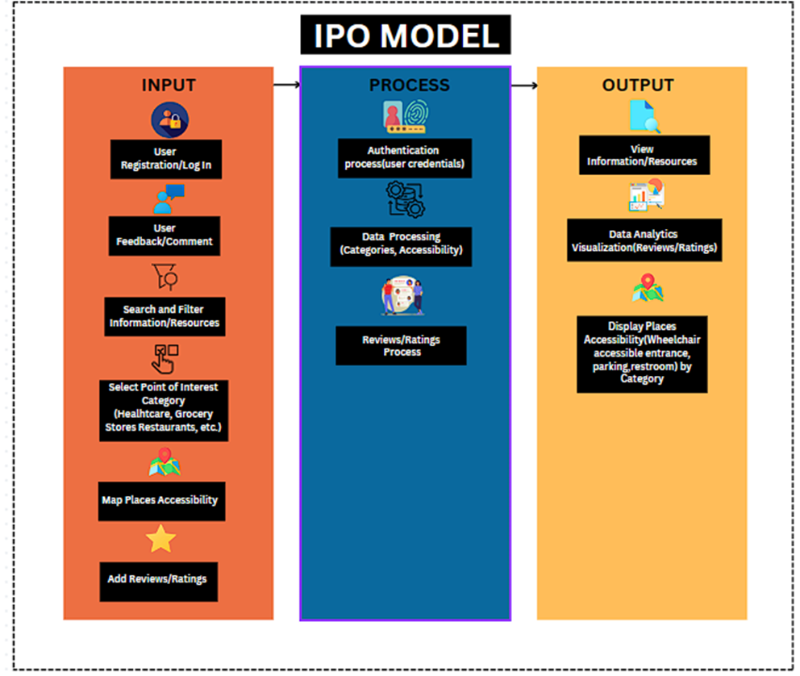**Conceptual Framework**

**Figure 1.** Conceptual Framework

Figure 1 above is the conceptual framework, which uses the IPO (Input, Process, Output) Model. Within the Input is the user registration/login, user feedback/comment, search and filter information/resources where the user can search resources and filter them by category (events, pwd assistance, etc.), next is the select point of interest category, map places accessibility, and add reviews/ratings.

Within the process is the authentication process, where the system will validate user login credentials and will grant access to authenticated users; data processing, where the system will process the selected category and the accessibility of places, integrating data from Google Maps javascript API to display the map and google places API to get the desired place details. The last process is the reviews/ratings process, in which the system processes the submitted reviews/ratings.

Within the output are View Information/Resources, Data Analytics Visualization of (Ratings), where the system will analyze and display the most accessible places based on user ratings. Lastly, is the Display Places Accessibility, where the system will output the accessibility of the place, whether it has (PWD accessible entrance, restroom, or parking) based on the selected point of interest category by the user, like Healthcare, Educational institutions, etc.

**CHAPTER III**

**METHODOLOGY**

This chapter discusses the required Software, Hardware, Project Locale, Project Design, Project Development, Evaluation Matrix as well as the Statistical Analysis of Data and Ethical Considerations to Progressive Web App Information System and Accessibility Mapping for Persons with Disabilities (PWD) utilizing Geographical Information System and Data Analytics.

**Project Design**

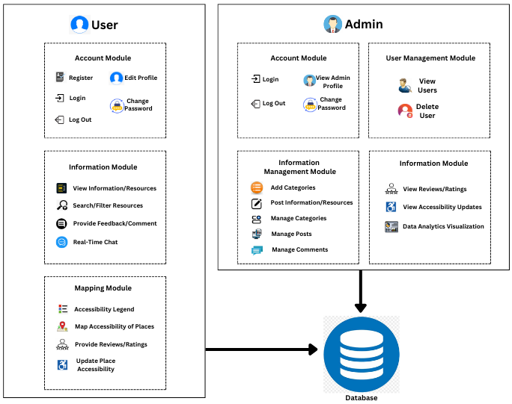

**Figure 2.** System Architecture

Figure 2 above illustrates the architecture of the system, The system has a total of five (5) modules which are the Account Module, Information Module, User Management Module, Information Management Module, and Mapping Module. To access the system, the user should register an account in the account module, and then when authenticated by the system, the user can now log in and access the different modules of the system.

The account module(user) has 5 components which are the register, login, edit profile, change password and logout.

The account module(admin) has four components and its contents are identical with the user account module but the register account is removed because the admin has an exclusive account.

The Information module(user) has four components which are theView Information/resources where users can access valuable information/resources for PWD in the community, the Search & Filter Information where the user can filter or search resources/information by category e.g., events, programs, information, etc., Another component is the feedback/comment, where users can provide feedback or comments in the posted information/resources. Lastly, is the Real-Time chat, where users can communicate in real-time and can have private messages as well as an all-chat-like forum where all users can communicate with each other.

The mapping module has four components and the first is the Accessibility Legend, where the marked places will be green markers for fully accessible, blue for partially accessible, and red for not accessible, it will be determined based on the level of accessibility features each place/establishment has. Where users can map places for Persons with disability accessibility. Second component is Map accessibility, where users can mark places and determine their accessibility features (PWD accessible entrance, parking, restroom, seating), the researchers also implemented a button search by point of interest categories of places/establishments for PWDs (Healthcare, Educational Institutions, Restaurants, etc.). The third component is the reviews/ratings component, the researchers chose to provide a reviews/ratings functionality to improve the reliability further and facilitate informed decision-making for persons with disabilities. Lastly, the Update Place Accessibility where the mapping module applies crowdsourcing on users where users can update the Accessibility features of places if it has PWD accessible entrances, parking, restrooms, seating, or not.

 The Information Module (Admin) has three components which are View reviews/ratings, where the admin can see the reviews/ratings on the places submitted by the users. The second component is view accessibility updates, where the admin can see user accessibility updates on places/establishments. Last is Data Analytics Visualization, which will displaytop-rated places based on the crowdsourced ratings of places/establishments by the users as well as the count of Accessibility of Places via charts or graphs.

The User Management module has two (2) components which are View users, where the admin can view all the registered users within the system. The second component is deleting users, where the admin has the power to delete users in case to maintain security, manage user access, and ensure compliance with policies.

The Information Management Module has 5 components, which are Add Categories where the admin can add categories to what they post e.g. events, programs, information, etc. The second component is Post Information/resources, where the admin can post inclusive information/resources for persons with disability by the added categories. The third component is Manage Categories where the admin can view categories posted, edit or delete them, Manage Posts, where the admin can view posted information/resources, edit or delete them, and Manage Comments in which the admin can view and delete user comments.

**Materials**

To develop and finalize the Web-based Inclusivity Information System and Accessibility Mapping for Persons with Disabilities (PWD) utilizing Geographical Information System and Data Analytics, the researchers will use the following materials and equipment

**Software**

Below is a list of software required to develop the Web-based Inclusivity Information System and Accessibility Mapping for Persons with Disabilities (PWD) utilizing Geographical Information System and Data Analytics.

**HTML**

HTML or Hypertext Markup Language is used in the Front-end Development of the system, HTML is a common markup language for documents intended for web browser display. It is used for the organization of components and web content of the system.

**CSS**

The researchers used the traditional CSS in combination with Bootstrap, to further improve the responsiveness and Design of the system. CSS, also called Cascading Style Sheets, is a language used to define the visual presentation of websites. It separates content from design, allowing developers to specify elements like colors, fonts, spacing, and layout for HTML elements.

**Bootstrap**

On the front-end of the system, `bootstrap` was utilized by researchers. The researchers aim was to make it easier for any developer to come up with mobile first responsive sites as well as web applications fast and effectively through its use. To help facilitate fast and effective development of mobile first responsive websites and web applications, bootstrap is famous for allowing designers create a menu system that is more fluid using its grid layout than other frameworks present today. Myriads pre-built user interface elements together with layouts within library make web development process less complicated.

**PHP**

In terms of the Backend, PHP script language was used by researchers; PHP was created for web development and is largely used as a web server-side scripting language. This language enables creation of interactive web pages with dynamic content, easily incorporated into HTML code. So, while executing PHP scripts happens on server side, only final HTML is transferred to user’s web browser.

**MySQL**

The development of the system will require the use of MySQL, a freely available Relational Database Management System (RDBMS) utilized for information storage, organization and retrieval by the researchers mentioned. It is highly esteemed for its dependability, uprightness speediness as well as user-friendliness hence becoming a leading database system among various software’s including web applications.

**Google Maps JavaScript API**

In the mapping Module, the researchers used Google Maps JavaScript API, which is a web service that allows developers to embed and customize Google Maps on their web pages using JavaScript. This API provides a range of tools and features for integrating interactive maps into websites, including options to add markers, directions, routes, and more. With the API, developers can create rich, dynamic, and engaging map.

**Google Maps Places API**

The researchers used Google Maps Places API in the mapping module to determine place details that will be displayed in the mapping, as well as the PWD Accessibility Options of places used on the system which determines if the place has PWD accessible entrance, parking, restroom, seating. Google Maps Places API is a web service that allows developers to access comprehensive information about various places, such as establishments, points of interest, and geographic locations, from the Google Places database. The API provides a way to integrate location-based search and data into web or mobile applications. This is the most convenient to determine the researchers’ goals because Google Maps Places API Data Covers a very wide range of places real-time Data and a proven reliable and accurate information based on the Crowdsourced Data from More than 1.2 billion users Worldwide.

**Google Cloud Platform**

The researchers will utilize the google cloud platform, which offers a wide range of cloud computing services under the Google Cloud Platform brand. the researchers will primarily use this as a platform to activate the APIs that will be used in developing the project like the Google Places api, and Google Maps javascript api.

**Hardware**

To complete the project, the researcher utilized their personal laptops with enough specification. These are the following computer specifications utilized to develop the system:

**Table 2.** Computer Specification

|  |  |
| --- | --- |
| PERSONAL COMPUTER SPECIFICATION | |
| Processor (CPU)  Memory (RAM)  Storage  OS  Graphics Card | AMD Ryzen 5 7520U with Radeon Graphics  8.00 GB  240 GB SSD  Windows 11  AMD Radeon Graphics | |

This table shows the specifications that will be used in this project. The Processor (CPU) is AMD Ryzen 5 7th Generation with Integrated Radeon graphics, 8GB of Memory (RAM) to execute the system smoothly, 240GB Solid State Drive Storage for faster loading of application, Windows 11 Operating System.

**Project Development**

To effectively design and develop the system, the researchers utilized the Agile Software Development Life Cycle Methodology (SDLC).

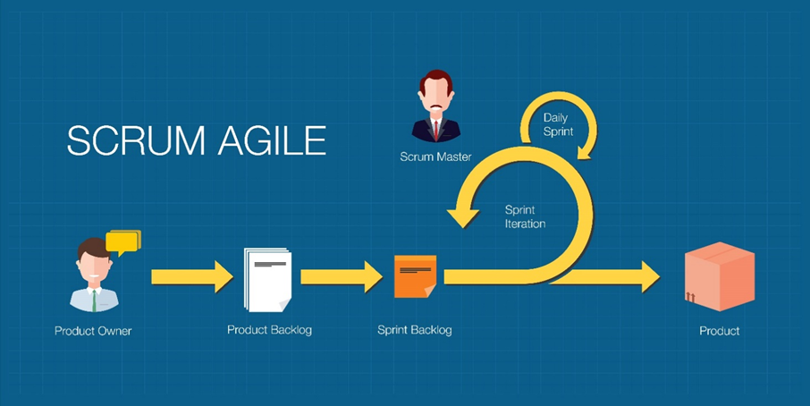

**Figure 3.** Agile Scrum Methodology

The researchers utilized Agile Scrum Methodology, which is a project management methodology that encourages gradual advancement. To create the most crucial features first and create a deliverable product, each cycle is broken between two two-to-four-week sprints. To ensure the project's success and relevance, the Progressive Web App Information System and Accessibility Mapping for Persons with Disabilities (PWD) utilizing Geographic Information System and Data Analytics are being developed using the Agile Scrum methodology.

**Product Backlog**

With the product backlog, the researchers will determine the requirements and features of the system, which contains item lists of what needs to be developed in the system as well as the estimated time of completion of the development of the items.

|  |  |  |
| --- | --- | --- |
| PRIORITY | ITEMS | EST HR/DAY |
| 1 | As an Administrator, I want to have a secured login. | 4 Hours |
| 2 | As an Administrator, I want to have an admin dashboard. | 2 Hours |
| 3 | As an Administrator, I want to manage users. | 4 Hours |
| 4 | As an Administrator, I want to view reviews/ratings. | 4 Hours |
| 5 | As an Administrator, I want to Manage Information/Resources. | 4 Hours |
| 6 | As an Administrator, I want to manage categories/comments. | 2 Hours |
| 7 | As an Administrator, I want to have Visualization of Data Analytics | 3 Hours |

**Table 3.** Product Backlog (Administrator)

Table 3 shows the product backlog for the Administrator, the use of product backlog arranges different tasks and features for the admin, giving precedence to their significance and estimated completion duration.

|  |  |  |
| --- | --- | --- |
| PRIORITY | ITEMS | EST HR/DAY |
| 1 | As a User, I want to login account & register. | 3 Hours |
| 2 | As a User, I want to Edit Profile and Change password. | 2 Hours |
| 3 | As a User, I want to view Resources/Information. | 2 Hours |
| 4 | As a User, I want to have a search and filter of Resources/Information. | 3 Hours |
| 5 | As a user, I want to provide feedback or comment on the information & Resources. | 2 Hours |
| 6 | As a User, I want to map accessibility of places or establishments. | 4 Hours |
| 7 | As a User, I want to provide reviews/rating on places/establishments. | 3 Hours |

**Table 4**. Product Backlog (User)

Table 4 shows the product backlog for the user, with the use of product backlog for the user, it provides a structured overview of the tasks and features to be addressed in the project, prioritized based on their importance and estimated time for completion. Each item in the backlog represents a specific task or feature that contributes to the overall.

**Sprint Planning**

**Table 5.** Sprint Backlog (Administrator)

|  |  |  |  |
| --- | --- | --- | --- |
| PRIORITY | ITEMS | TASKS | EST HR/DAY |
| 1 | As an Administrator, I want to have a secured login. | Develop and design secured login form. | 4 Hours |
| 2 | As an Administrator, I want to have an admin dashboard. | Develop and design Admin Dashboard. | 3 Hours |
| 3 | As an Administrator, I want to have a user verification page. | Develop and design Verify User Page. | 2 Hours |
| 4 | As an Administrator, I want to manage users. | Develop and design user management page. | 4 Hours |
| 5 | As an Administrator, I want to view reviews/ratings. | Develop and Design Data Analytics Page. | 5 Hours |
| 6 | As an Administrator, I want to manage Information & Resources | Develop and Design Information & resources Management Page. | 4 Hours |
| 7 | As an Administrator, I want to manage categories & comments | Develop and Design categories & comments page. | 2 Hours |

Table 5 shows the sprint backlog for the administrator, the development team's prioritized tasks for the Administrator job during the sprint are listed in this table. Every task has a corresponding user story that describes the intended functionality from the administrator's point of view. Each user story's precise tasks are outlined in the "Tasks" column.

**Table 6.** Sprint Backlog (User)

|  |  |  |  |
| --- | --- | --- | --- |
| PRIORITY | ITEMS | TASKS | EST HR/DAY |
| 1 | As a User, I want to login account & register. | Develop and design the registration and login page. | 4 Hours |
|  |  |  |  |
| 2 | As a User, I want to Edit Profile and Change password. | Develop and design Edit profile and Change password page. | 3 Hours |
| 3 | As a User, I want to view Resources/Information. | Develop and design Resources/Information Page | 4 Hours |
| 4 | As a User, I want to have a search and filter of Resources/Information. | Develop and implement a search and filter functionality. | 3 Hours |
| 5 | As a user, I want to provide feedback or comment on the information & Resources. | Develop and provide a feedback/comment functionality. | 5 Hours |
| 6 | As a User, I want to map accessibility of places or establishments. | Develop and Design mapping module. | 5 Hours |
| 7 | As a User, I want to provide reviews/rating on places/establishments. | Develop and implement a reviews/rating functionality. | 3 Hours |

Table 6 shows the sprint backlog for the user in order of priority, with an emphasis on the features that users of the system desire. Every task has an associated user story that details the intended features or actions from the viewpoint of the user. The "Est Hr/Day" column provides an estimate of the time needed for completion, while the "Tasks" column lists the tasks required to implement each user narrative.

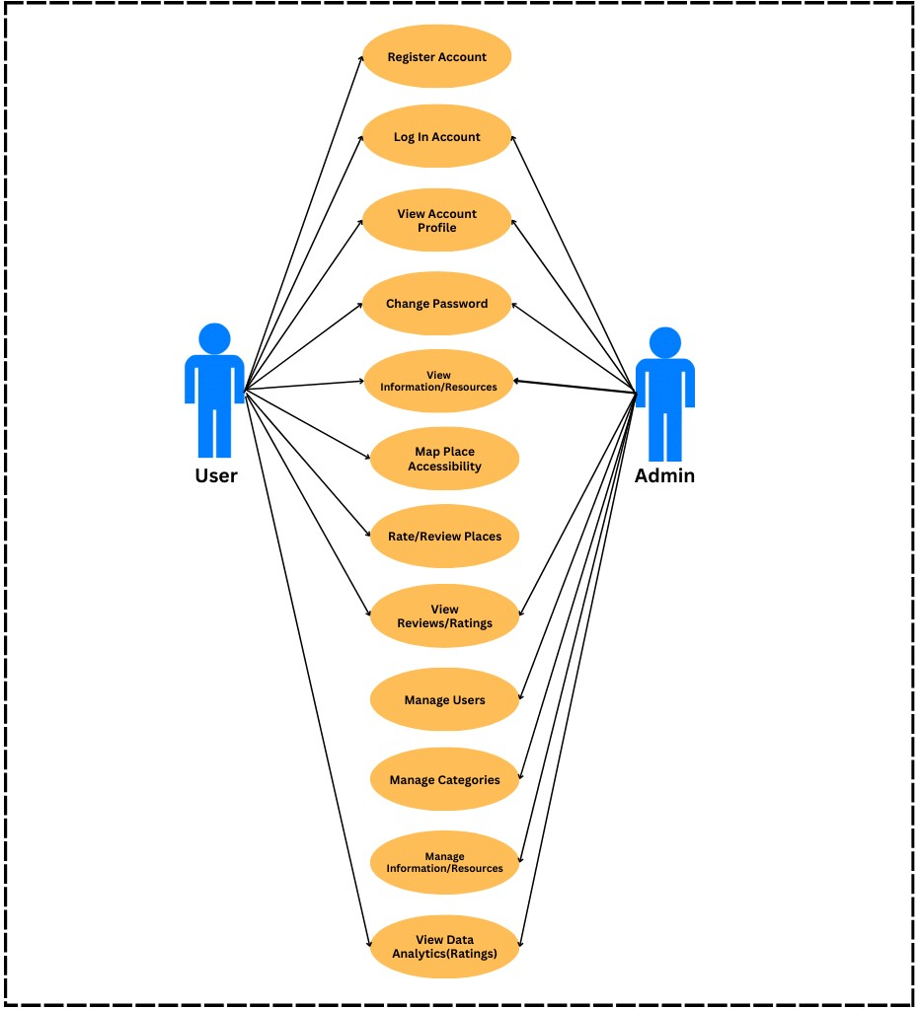**Use Case Diagram**

**Figure 4.** Use Case Diagram

Figure 4 shows the Use Case Diagram, it demonstrates the components of the system that the user and admin can use. The user needs to first register, and then they can now log in to the system as well as view their account profile and information as well as change their password. The user can also view resources/information on the homepage and can also map the accessibility features of places such as (PWD accessible entrance, parking, restroom, seating). Users can also filter places/locations based on the Point of interest categories (e.g. healthcare, educational institutions, restaurants, etc.) as well as provide reviews and ratings, update place accessibility features, reviews/ratings, view data analytics (ratings/accessibility features). On the admin side, the admin can log in, view profile, change password, and view information/resources, manage users such as edit, delete, manage categories, manage information/resources such as post, edit, deletion of information/resources that will be displayed on the user page. The admin can also view Data Analytics graphs based on the user ratings of the places with the highest ratings/accessibility.

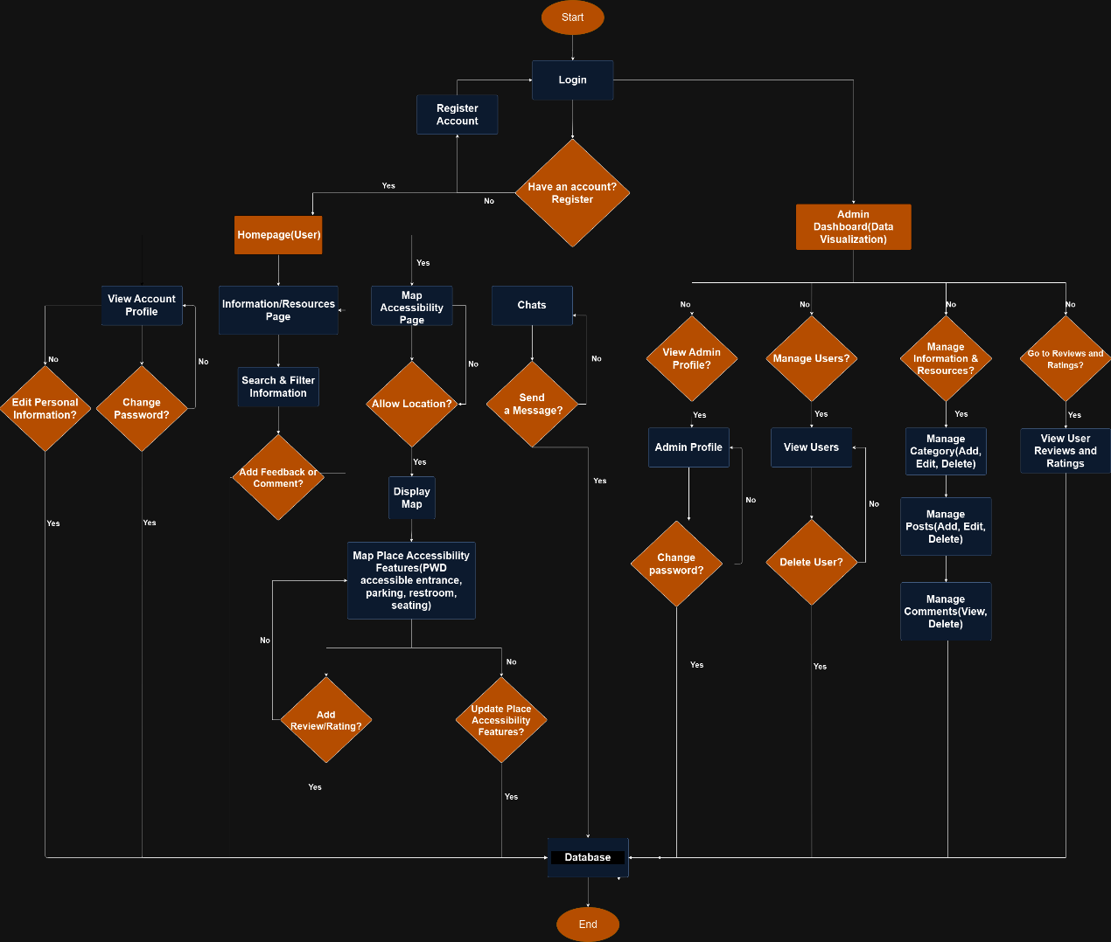**System Flowchart**

**Figure 5.** System Flowchart

Figure 5 above shows the system flowchart, which displays all the functionalities of the system for both the user and the admin. The user starts with a login, where if the user is not registered, there will be a register page they can sign up and then when registered within the system, the user can now log in and will be redirected to the homepage. Within the homepage, the user can manage their account by viewing their account profile, change their account password and log out, the user can also view information/resources and filter/search them by category and also provide feedback/comment on information/resources. The user also have the a platform where they can have private messages and an all chat forum with other users via real time chat. On the mapping page, the user will need to allow location to display the map and the user can navigate and click locations and view the place details as well as their accessibility features, users can also provide data on places by updating their accessibility features and providing a review/rating on places/establisments to improve the reliability of the information and facilitate informed decision-making for other users. On the popular places page, the user can view top-rated places based on their submitted reviews/ratings.

 On the admin side, the admin needs to log in and will be redirected to the dashboard, where Data analytics Visualization are displayed. The admin can view the profile, change the password, and log out. The admin can also manage content, which can add, edit, and delete posts and categories. The admin also has the power to the view all users and delete. Lastly, the admin can also view the reviews/ratings of places as well as view accessibility features update of users and has the authority to update the accessibility features of places.

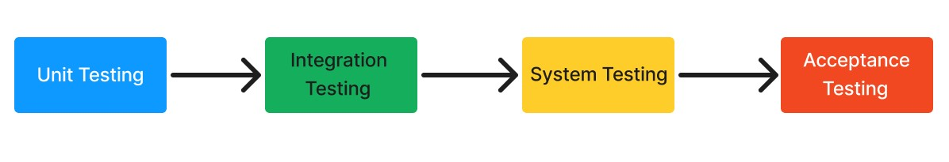**Project Testing**

**Figure 6.** Project Testing

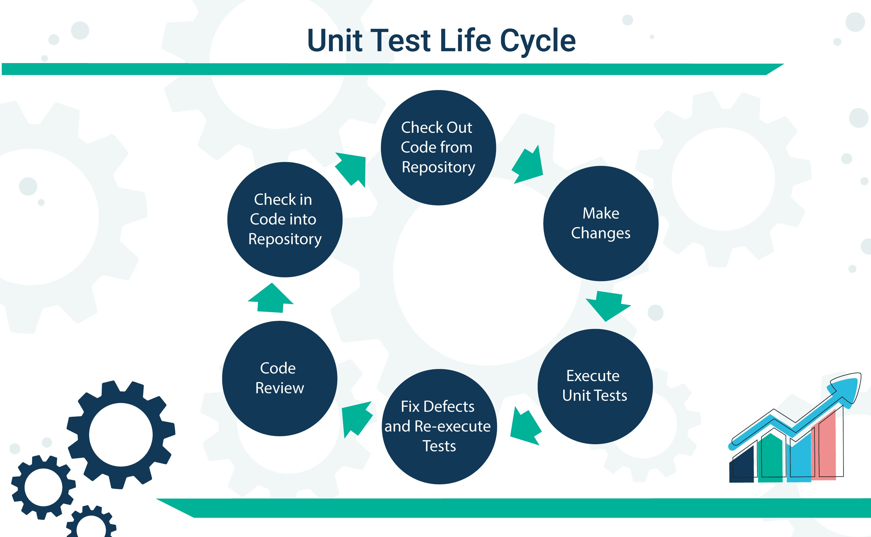 This figure displays the software test plan for the project. Unit testing will be the first test to be conducted as the researchers will test each module and components source code individually to make sure there are no bugs/errors. Next is Integration testing, where the researchers will test the individual module and components when they are integrated, to verify if they work as intended without errors when combined. Next is system testing, where testing is carried out on a fully integrated system to see if it complies with the system’s requirements. Finally, acceptance testing will be performed, during which the ISO 25010 will be used to evaluate the system.

**Figure 7.** Unit Testing

The researchers will utilize unit testing and test each module and components source code individually to make sure they function as intended without bugs/errors. Unit testing is where each module and components source code are being tested. wherein each software program parts or components are tested to make sure they function as intended.

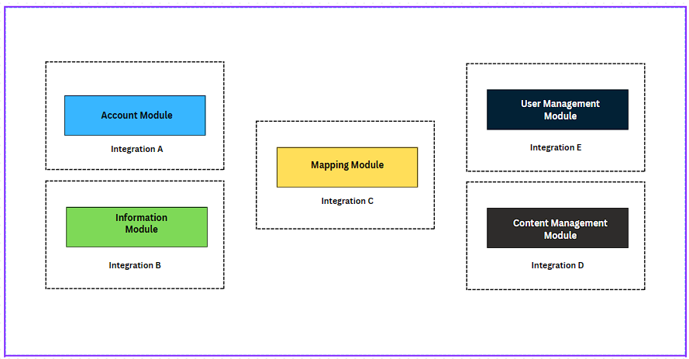

**Figure 8.** Integration Testing

The researchers will test individual software modules or components where they are combined and tested as a group. Testing the integration of modules and components is crucial to verify that the integrated components work together as expected, making sure there are no bugs/errors and that they interact correctly according to the specified requirements.

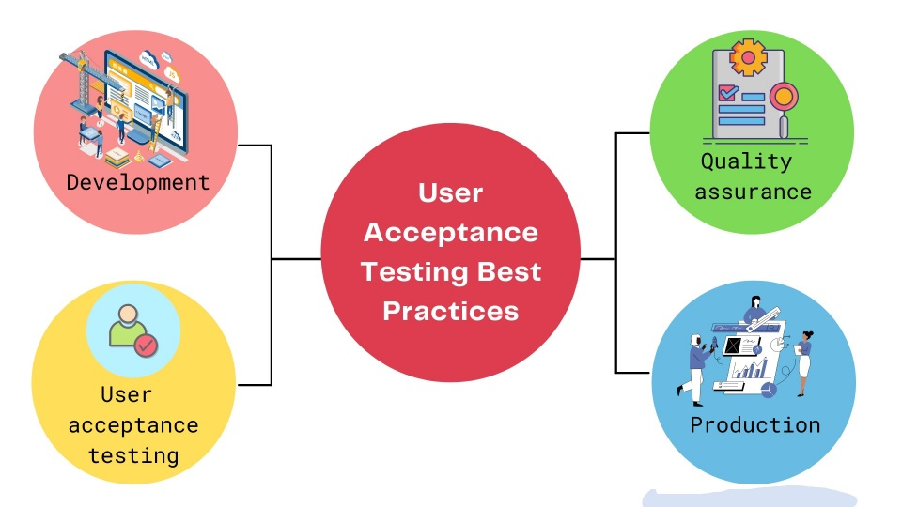

**Figure 9.** Acceptance Testing

The researchers will implement an acceptance testing before the program is deployed, acceptance testing is a crucial stage the development of this project because acceptance testing makes sure it satisfies stakeholders' needs and expectations. It acts as the last checkpoint, confirming that the program is prepared for end users to download. During this testing phase, the business objectives and non-functional requirements are verified in addition to the functional aspects.

**Evaluation Procedure**

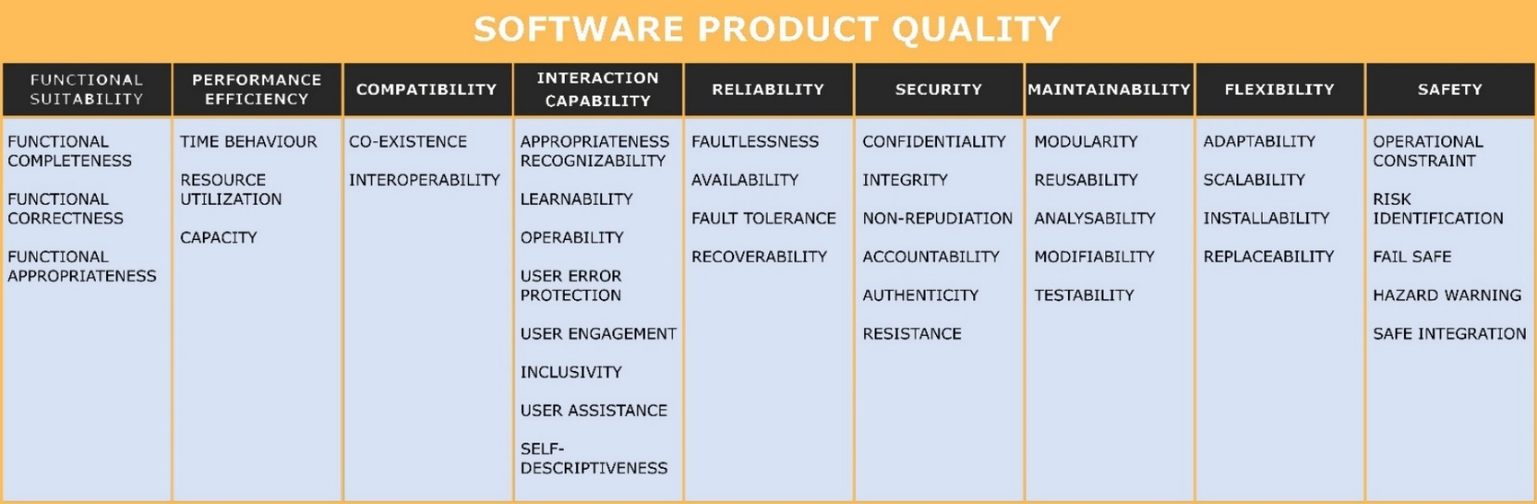 The researchers chose to conduct two primary methods for the evaluation of the system, the two primary methods are the ISO 25010 standard for software quality procedure and the Technology Acceptance Model (TAM) for the evaluation of user acceptance of the software.

**Figure 10.** ISO 25010 Software Product Quality

The researchers will utilize ISO 25010 Software Product Quality to ensure quality evaluation of the system. The quality model determines which quality characteristics will be taken into account when evaluating the properties of a software product. The quality of a system is the degree to which the system satisfies the stated and implied needs of its various stakeholders and thus provides value. Those stakeholders' needs (functionality, performance, security, maintainability, etc.) are precisely what is represented in the quality model, which categorizes the product quality into characteristics and sub-characteristics.

1. **Functional Suitability:** The researchers will assess the functional suitability of the system, which checks the software’s ability to satisfy specified functional requirements for a particular use. It considers whether the software provides the necessary functions to address user needs accurately and comprehensively.
2. **Performance Efficiency:** Performance efficiency will assess how well the software utilizes resources to carry out its functions. Including aspects such as response time, throughput, and resource utilization under various conditions, ensuring that the software performs efficiently without wasting resources.
3. **Compatibility:** The researchers will test the system’s compatibility with different devices and browsers making sure that the software application is compatible and can run smoothly on other platforms.
4. **Usability:** Assessment of usability is a vital for the project because it is based on user experience and how easily users can interact with and navigate through the software and doing their tasks, ensuring that the software is intuitive and user-friendly.
5. **Reliability:** The researchers will assess the reliability of the software's ability to maintain level of performance under different conditions, ensuring that the software operates consistently and predictably without unexpected failures.
6. **Security:** The researchers will assess the security of the system, which has the software's ability to protect data and resources from unauthorized access, alteration, or destruction, ensuring that sensitive information of the system is safeguarded against security threats and vulnerabilities.
7. **Maintainability:** Assessment of maintainability of the software is important because it is the ease with which the software can be modified, including fixing errors, improving performance, or adapting to changes in requirements or environments. ensuring that the software can be efficiently maintained throughout its lifecycle.
8. **Flexibility:** The researchers will assess the system’s flexibility, which is the software's ability to adapt to different contexts or changes in requirements without requiring significant modifications. enabling the software to accommodate evolving needs persons with disabilities and the community effectively.
9. **Safety:** The assessment of safety for the system ensures that the software does not pose risks of harm, injury, or damage to users, the community, or property. It involves identifying potential hazards, assessing risks, implementing mitigation measures, and complying with safety regulations and standards, ensuring that the software operates safely and reliably in its intended context.

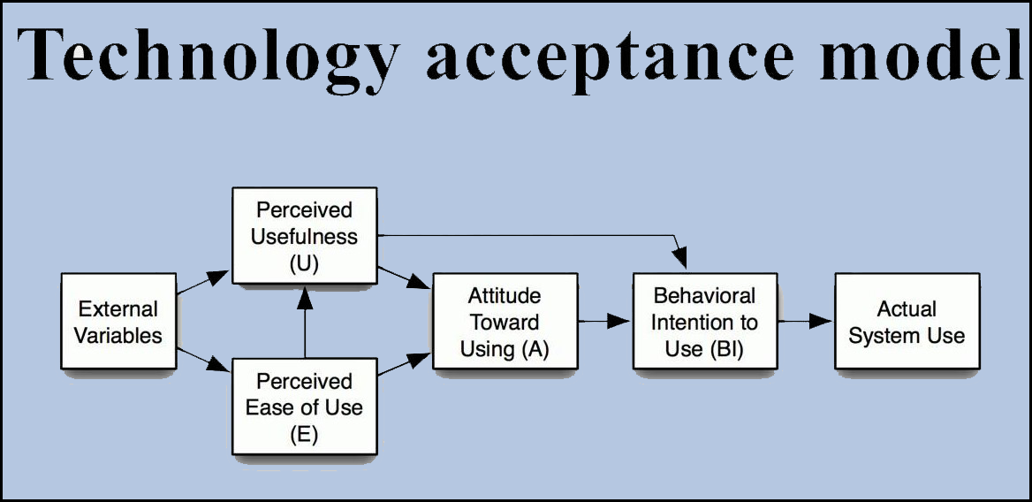

**Figure 11.** Technology Acceptance Model (TAM)

The researchers will use the Technology Acceptance Model (TAM) to evaluate user acceptance for this project. This model is essential for assessing the Progressive Web App Information System and Accessibility Mapping for Persons with Disabilities because it focuses on the users' perceptions and attitudes, which are critical for the success of any technology that includes accessibility. The core concept of TAM is the idea that perceived usefulness and ease of use are primary factors influencing users' acceptance and intention to use technology. By applying TAM, the researchers can gain valuable insights into how PWD participants perceive the system's benefits and ease of use, essential for ensuring that the system meets their needs and preferences. Furthermore, utilizing TAM's structured approach systematically evaluates users' attitudes and behavioral intentions, providing critical feedback that can guide further enhancements to the system.

**Perceived Usefulness:** The researchers will assess the perceived usefulness of the system; it is a vital part of the assessment because perceived usefulness is when users feel that utilizing a specific system would improve their performance or simplify their tasks. In the context of this study, evaluating perceived usefulness helps determine if persons with disabilities (PWDs) find the Progressive Web App Information System valuable in accessing information and resources. Understanding this aspect is crucial because if the system is perceived as valuable, it is more likely to be adopted and used regularly by PWDs. Assessing perceived usefulness provides insights into how well the system meets the practical needs of its users and highlights areas where the system can be improved to provide more significant benefits.

**Perceived Ease of Use**: The researchers will assess participants perceived ease of use, which is referred as the extent to which the user thinks utilizing a specific technology would be easy or requires minimal effort is known as perceived ease of use. This component is essential for evaluating the system because it directly impacts the users' willingness to adopt and use the technology. For PWDs, ease of use is particularly important as it ensures that the system does not add additional complexity or barriers to their daily activities. By assessing perceived ease of use, the study can identify any usability issues that must be addressed to make the system more accessible and user-friendly. This evaluation helps ensure the system is intuitive and easy to navigate, critical for achieving high user satisfaction and acceptance.

**Attitude Towards Use:** The researchers will assess the participants attitude towards use, which commonly refers to the user's overall affective reaction to using a system, including feelings of favorability or unfavourability. This measure helps PWDs understand the emotional responses and overall acceptance of the system. Evaluating users' attitudes towards the system can reveal their overall opinions and readiness to integrate the technology into their daily lives. A positive attitude towards the system indicates that users will likely use the technology, which is important for its long-term success and sustainability. The study can address negative perceptions and enhance features that contribute to a more positive user experience by assessing this attitude.

**Behavioral Intention to Use:** The need for the researcher’s assessment of users’ behavioral intention to use is important because it is the degree of which a user plans to use the system. This component is a strong predictor of actual system usage and is critical for evaluating the system's potential success and adoption rate among PWDs. By assessing the behavioral intention to use, this can help for the estimation of the likelihood of the target population using the system regularly. This measure helps identify factors influencing users' intentions and can guide improvements that increase the system's attractiveness and utility. Understanding behavioral intention provides vital data on ensuring the system can be integrated to the user’s everyday lives.

**Population of the Study**

The researchers will conduct a survey on twenty (20) persons with disability residing the geographic area of Los Baños, Laguna. This demographic is chosen by the researchers according to their significant challenges in accessing inclusive resources/information as well as the accessibility of various establishments within the community, making sure that the respondents will provide reliable data and information by their knowledge, experience. The researchers will also conduct a survey on two (2) IT experts to ensure the quality standard of the software.

**Sampling Design**

A purposive sampling method was used to select participants for the evaluation of the system. Purposive sampling is a non-probability sample in which researchers deliberately select individuals based on their knowledge, expertise, or relevance to the research questionnaires. By utilizing purposive sampling, the researchers can gather in-depth insights and detailed feedback from those who directly benefit from the proposed Progressive Web App Information System and Accessibility Mapping. Using this approach will maximize the reliability and relevance of the study's findings ensuring the developed system effectively meets the needs of the PWD community in Los Baños, Laguna.

**Data Collection Instrument**

To help with the success of the study, it is essential to gather information from the target users which are persons with disabilities as well as some IT experts. The researchers will use both online and offline methods to collect data from selected participants. In conducting online survey, the researchers will utilize google forms in order to have efficient collection of information, the researchers will also provide hardcopy questionnaires that will be prepared and will conduct face to face survey for those who do not have internet access. Additionally, in order to assess participants’ experience in using the system, the researchers will use Likert Scale Method survey questionnaire. With the use of Likert scale, the respondents will be able to express their experience in the usability or functionality of the system. On the Likert Scale basis; 4 = Strongly Agree; 3 = Agree; 2 = Disagree; 1 = Strongly Disagree. The data collected will then entered into an MS Excel spreadsheet for processing.

**Statistical Treatment**

The frequency of each response will be determined based on how many respondents answered specific items. The Likert Scalar method will be utilized to reflect the respondents' insights. Once collected, the data will be organized and then will be processed in Microsoft Excel which will then be used to calculate the Mean and Standard deviation, and will be utilized for further interpretation of data.  The set of questions on the assessment can be answered with one of four impressions or replies, which are ranked from highest to lowest as follows:

Four (4) - Strongly Agree, three (3) - Agree, two (2) - Disagree, and One (1) - Strongly Disagree. is important for evaluating the questionnaire responses provided by the respondents. The responses will be summarized using mean and standard deviation. The composite mean will then be computed for the respondents' overall perception.

|  |  |  |
| --- | --- | --- |
| RATING | INTERPRETATION | RANGE |
| 4 | Strongly Agree | 3.25 – 4.00 |
| 3 | Agree | 2.50 – 3.24 |
| 2 | Disagree | 1.75 – 2.49 |
| 1 | Strongly Disagree | 1.0 – 1.74 |

**Table 7**. Likert Scale Method

Table 7 shows the Likert Scale Method that was used as a survey method to assess how satisfied users were with the application. The respondents' evaluations are measured using a percentage technique. The formula is as follows:

Where:

Highest Score – Lowest Score 4 – 1 = 3

Highest Score 3/4 = 0.75

**REFERENCES**

Alzouby, A. M., Nusair, A. A., & Taha, L. M. (2019). GIS based multi criteria decision analysis for analyzing accessibility of the disabled in the Greater Irbid Municipality Area, Irbid, Jordan. *Alexandria Engineering Journal*, *58*(2), 689-698.

Pedron, B. J. N. Breaking The Barrier: Persons With Disabilities (PWDs) As A Workforce in The Philippines.

Aini, Q., Marlina, H., & Nikmatullah, A. (2019, April). Evaluation of accessibility for people with disability in public open space. In IOP Conference Series: Materials Science and Engineering (Vol. 506, No. 1, p. 012018). IOP Publishing.

Chiluba, B. C. (2019). Barriers of Persons with Physical Disability over Accessibility and Mobility to Public Buildings in Zambia. Indonesian Journal of Disability Studies, 6(1), 53-63.

Comai, S., De Bernardi, E., Matteucci, M., & Salice, F. (2019). Maps for Easy Paths (MEP): A Mobile Application for City Accessibility. *EAI Endorsed Transactions on Internet of Things*.

Munthali, A. C., Swartz, L., Mannan, H., MacLachlan, M., Chilimampunga, C., & Makupe, C. (2019). “This one will delay us”: barriers to accessing health care services among persons with disabilities in Malawi. *Disability and rehabilitation*, *41*(6), 683-690.

Affairs, N. C. (2024, April 12). *National Council on Disability Affairs*. Retrieved from ncda.gov.ph: https://ncda.gov.ph

Smith, J., & Jones, K. (2020). Information Barriers and Social Exclusion: A Study of Persons with Disabilities in Urban Areas. Journal of Disability & Society, 35(7), 1083-1100. doi:10.1080/09687599.2019.1700782

Susmerano, E. B., & Yamada, K. (2022). Revisiting auxiliary social services for persons with disability: The Philippines case. *International Journal of Social Welfare*, *31*(2), 187-202.

Salvio, K. B. V. (2020, July). Extending the Evaluation on Philippine E-Government Services on its Accessibility for Disabled Person. In *2020 Fourth World Conference on Smart Trends in Systems, Security and Sustainability (WorldS4)* (pp. 428-434). IEEE.

Westlund, K., & Mats, J. (2022). Quality of Life of People with Mobility-Related Disabilities in Sweden: A Comparative Cross-Sectional Study. *International Journal of Environmental Research and Public Health*, 17.

Barca, V., Hebbar, M., Cote, A., & Wylde, E. (2021). Inclusive Information Systems for Social Protection: Intentionally Integrating Gender and Disability. *SPACE series, March*.

Lollar, D. J., & Chamie, M. (2021). International Public Health and Global Disability. In *Public Health Perspectives on Disability* (pp. 149-171). Springer, New York, NY.

Zimmermann-Janschitz S. (2019). Geographic Information Systems in the Context of Disabilities. Journal of Accessibility and Design for All, vol. 8, no. 2, pp. 1130

Kocaman S., Ozdemir N. (2020). Improvement of Disability Rights via Geographic Information Science. Sustainability, no. 12, pp. 117.

Kaisa Ligaya Sol Cruz, R. E. (2021). An Initial Analysis of Access to Social and Public Services, Education,Work and Employment, and Civic Participation and Governance . *Philippine Disability Sector Research*.

Cognitive map formation through tactile map navigation in visually impaired and sighted persons Research Center, P. (2019). Mobile fact sheet [Data file and code book 15 January 2020]. Retrieved from https://www.pewresearch.org/internet/fact-sheet/mobile/Haber Ugalde, B., Alcause Vinluan, A., & Torres

Carpio, J. (2021, June). Wheelchair Navigation System using Node Combination Technique for People with Motor Disabilities. In Proceedings of the 13th International Conference on Computer Modeling and Simulation (pp. 203-209).

Dianito, A. J., Espinosa, J., Duran, J., & Tus, J. (2021). A glimpse into the lived experiences and challenges faced of PWD students towards online learning in the Philippines amidst COVID-19 pandemic. International Journal Of Advance Research And Innovative Ideas In Education, 7(1), 1206-1230.

Cui et al., 2020

Organization, W. H. (2023, March 7). Retrieved from World Health Organization: https://www.who.int/news-room/fact-sheets/detail/disability-and-health#:~:text=Health%20inequities%20arise%20from%20unfair%20conditions%20faced%20by,and%20barriers%20faced%20in%20the%20health%20system%20itself.

B. Cui, C. Boisjoly, L. Miranda-Moreno, A. El-Geneidy Accessibility matters: exploring the determinants of public transport mode share across income groups in Canadian cities Transp. Res. D Environ., 80 (2020), Article 102276, 10.1016/j.trd.2020.102276

Edinger, J., Hofmann, A., Wachner, A., Becker, C., Raychoudhury, V., & Krupitzer, C. (2019, March). Wheelshare: Crowd-sensed surface classification for accessible routing. In *2019 IEEE International Conference on Pervasive Computing and Communications Workshops (PerCom Workshops)* (pp. 584-589). IEEE.