Artificial Intellingece

Introduction and basics

Start date: (6/4/2022 6:34:53 PM)

Table of Contents

[Methodology 1](#_Toc107937844)

[What is the project about? 1](#_Toc107937845)

[Which are the objectives of doing so? 1](#_Toc107937846)

[What is Artificial Intelligence? 1](#_Toc107937847)

[Which Python libraries are recommended to work with AI? 3](#_Toc107937848)

[Visualization: 3](#_Toc107937849)

[Numeric calculations, data analysis: 3](#_Toc107937850)

[Machine learning: 3](#_Toc107937851)

[Deep learning: 3](#_Toc107937852)

[Explainable AI. 4](#_Toc107937853)

[Natural language processing. 4](#_Toc107937854)

[Works Cited 4](#_Toc107937855)

[STARTING POINT 4](#_Toc107937856)

[Installation and Basic Operations 6](#_Toc107937857)

[Colab 6](#_Toc107937858)

[Databricks 7](#_Toc107937859)

## Methodology

Just look for it on the internet/bookss

## What is the project about?

In reality it’s not supposed to be a big deal or a deep research, basically the purpose is to learn the basics about artificial intelligence, what kind of tools are required, the logic behind and if possible, implement examples with increasing difficulty, as well as to know the notions of how and when to implement these tools.

## Which are the objectives of doing so?

The objectives are blurred because there´s no something concrete to do or to achieve, just to get involve with the topic, and if possible, to come up with ideas that may be used later on in existing projects or new ones. In simple words it’s just by curiosity.

## What is Artificial Intelligence?

From what we know and what we commonly hear on a regular basis, to me artificial intelligence involves a logic process or task performed by a bunch of codes which in a macroscopic view, try to simulate the ability of people reasoning and decisions making. And these bunch of code lines are assumed to be part of software that may control a physical or virtual object/system under certain restrictions or criteriums given a stimuli and producing a response.

That’s why these kind of technologies are pretty common now, and they are used in several fields such as entertainment (social network and streaming platforms), industry (machine and production control), digital commerce, information sharing etc. But even before we start to deal with these tools, the first thing to do is to get a formal definition of the concept; but some restrictions are taken because when trying to discuss about the terms “artificial” and “intelligence”, there’s no problem with “artificial” which describes to an object or concept whose origin comes from a person, or to something that doesn’t occur under natural conditions and therefore requires a forced action from humans to happen.

On the other hand, it’s difficult to define what “intelligence” is; because even though there plenty of definitions, the fact there are different definitions which depend on a context to settle down, means there’s not a consensus. Also, the necessity of involving philosophy makes it even harder to describe. That’s why and according to (Casali) a technological criterium is assumed to overcome this issue.

In this way artificial intelligence refers to “*part of the computing sciences whose main purpose is to design smart computing systems, this is, systems that exhibit characteristics associated with the intelligence in the human behavior*”[[1]](#footnote-1). Another definition is “*the study of how to make computers to do things that are currently better done by humans*”[[2]](#footnote-2). The AI implies an effort to understand the complexity of the human experience in terms of information.

Besides the AI inherits ideas and techniques from different disciplines, such as mathematics, probability, mathematical modeling, engineering, computing, as well as some others that may differ from these fields but count with their own logic behind such as linguistics and human speech

One of the very first pioneers whose attributions led the AI to born is known as Alan Touring between years 1943 and 1956. He published an article call “*Computing Machinery and Intelligence*” in which he states the question “*May machines think?*” and beyond that he proposed a very interesting *test* known as the “*Touring’s Test*”; it led to the user identify whether a machine *thinks* or at least the grade of “*intelligence*” it shows. An example of how this test works is by putting a person to use a virtual chat in two computers/Devices, one of them is being attended by another person far away from the room the first person is at, and the second device is being operated by an AI. If the probe subject can’t detect which one is the IA and which the real person, then it’s concluded the IA has nailed the test.

## Which Python libraries are recommended to work with AI?

According to (Heras, 2020) some of the recommended python libraries are for several purposes such as visualization, numeric calculations, data analysis, machine learning, deep learning, and natural language processing.

The previous purposes demand specific libraries which based on the web page, which are described to each field:

### Visualization:

Briefly it refers to represent information through graphics, these graphics collect data or sets of related data and allow us to interpret easier and quicker what it´s implied in the behavior of the graphic. The libraries are:

* Matplotlib (creates diverse kind of graphics and functions related to them)
* Seaborn (It’s based on matplotlib and focuses on the statistics data representation)
* Bokeh (It allows the interactive data visualization in a web browser)

### Numeric calculations, data analysis:

Of course, as we expect to deal with sets of data (usually numbers or similar representations independent from the topic faced) in which case the libraries suitable for it are:

* NumPy (universal data structure that allows data analysis and exchange of data between algorithms)
* SciPy (Offers efficient numeric routines and easy to use which also operates with the NumPy structures.)
* Pandas (Very useful for data scientists, for one-dimensional datasets series are used and data-frames for bidimensional datasets)
* Numba (translates python-written-functions to machine code, this optimizes the time it takes doing mathematical operations)

### Machine learning:

It seems there are steps for the machine learning process and the don’t take much time because of the efficiency behind, there are relatively used a lot, so the procedures were optimized to be done quickly. The libraries are:

* Scikit-learn (It’s based on matplotlib, NumPy and Scilab, it’s easy to use and counts with a huge amount of learning techniques, supervised and non-supervised learning. Problems of classification and regression).

### Deep learning:

Even though this field is covered by machine learning, deep learning has gained popularity, so libraries were made specifically for this reason:

* TensorFlow (Developed by Google, performs calculations through flow diagrams, makes it easier to program a deep neuronal network)
* Keras (It’s an interface to work with neuronal networks, it’s easier to use rather than TensorFlow)
* CNTK
* Theano
* PyTorch (Developed by Facebook, allows the calculations efficiently in CPUs and GPUs, offers the capabilities of NumPy in a GPU)

### Explainable AI.

* SHAP (performs AI explainable, uses calculations from game field theory, guesses which variables influence the most in predictions, helps to find out how decisions are taken in black box models)

### Natural language processing.

Some of the mentioned libraries are by themselves useful in this field as it can be scikit-learn, bus as each field, there are libraries dedicated specifically for them such as:

* NLTK (It’s one of the oldest libraries, still, is very useful to study and teach about language processing)
* Genism (Created by Radim Rehurek, identifies effectively and automatically the topic of a set of documents, also the similarity between documents and vector representations)
* spaCy (It’s the fastest natural processing library, it was built to extract relevant information; it allows the building of linguistic-statistic sophisticated models, and finally can pre-process data to be used with TensorFlow, PyTorch, scikit.learn, Gensim etc.)

# Works Cited

Casali, A. (n.d.). *¿Qué es la inteligencia Aritifial?* Retrieved junio 4, 2022, from www.academia.edu: https://www.academia.edu/23769799/\_Qu%C3%A9\_es\_la\_Inteligencia\_Artificial#:~:text=Otra%20definici%C3%B3n%20es%20%E2%80%9CLa%20Inteligencia,cambios%20de%20foco%20y%20alcance.

Heras, J. M. (2020, octubre 10). *15 Librerías de Python para Machine Learning.* Retrieved junio 4, 2022, from www.iartificial.net: https://www.iartificial.net/librerias-de-python-para-machine-learning/

# STARTING POINT

## TensorFlow

So, the first step is to use TensorFlow, the date for that to happen is: 25/06/2022 10:56:42 p. m. As you may infer there´s lot to do, so the first thing done is to create a virtual environment for python libraries and whose procedure link is given below: <https://www.youtube.com/watch?v=N9PdRkXOQ4w&ab_channel=OMES>. Not only to create but **activate**[[3]](#footnote-3), after that now we can move on the installation as normal.

After that the next step is to install the required dependencies, so you must know how to navigate through the CMD and for that there´s a specific site: <https://www.abrirllave.com/cmd/cambiar-de-unidad.php>

Also, the library´s documentation counts with a web page: <https://www.tensorflow.org/>

Installation occurring at: 6/29/2022 6:18 PM

At this point the installation has been successful.

Of course, this was able in a local machine, but there´s a web option through “***Colab***” that allows the same functions with an already equipped setup. <https://colab.research.google.com/> there are more links related to how to use this tool which seems to be oriented to data analysis or data exploration and just to get engaged here there´s another link; <https://www.youtube.com/watch?v=RLYoEyIHL6A&ab_channel=CodewithDogaOzgon>

## Installation and Basic Operations

### Colab

The first thing to say about Colab is the fact it works pretty much like a Jupiter notebook in the sense you can introduce commands which may executed directly or by selecting the set of commands/lines to execute:

Besides it allows to make savings into a GitHub repository:

Going back to Colab this is how python library´s installation and importing works:

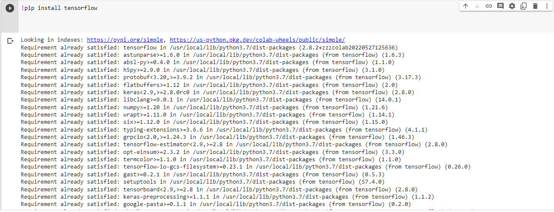

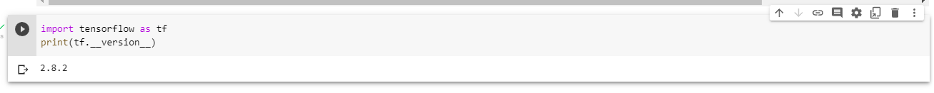

Another characteristic of Colab is that it allows users to have access to more “computing power” by a certain amount of time, depending on the needs of the program. So, each time a command is executed, there’s a connection involved with those equipment.

### Databricks

This tools it’s similar to Colab in the sense it allows to use notebooks with additional functions or tools, for example it not only allows to use python but some other languages as well like SQL, R, for mentioning some of them. To use it, we need a subscription, a free trial, or the community edition account. As said, the fact it incorporates python, means, TensorFlow is used as well like in Colab. Microsoft has info about it: <https://docs.microsoft.com/en-us/azure/databricks/notebooks/>

As usually the web page itself contains documentation like this: <https://docs.gcp.databricks.com/>

So, it seems the first step is to create a “cluster”:

Machine Learning

7/5/2022 6:29

The previous tools (Colab and databricks) are the ones recommended in the book “*Learn TensorFlow 2.0 Implement Machine Learning And Deep Learning Models With Python (Pramod Singh, Avinash Manure) (z-lib.org)*”[[4]](#footnote-4). But after searching on Internet, I came across with an interesting virtual-educational organization “Udacity” which contains several types of courses, amongst them “artificial intelligence”. By reading a bit about requisites needed to ride these topics, these are the main ones to start properly:

By now some discoveries or approaches to understand how machine learning works are written here [Udacity\_Notes.docx](Knowledge%20Creation.docx)[[5]](#footnote-5)

There´s also a summarized document about probability and statistics here <Prob_and_Stat_Doc.docx>[[6]](#footnote-6)

In the GitHub’s repositories you can create .md files which may include headers and other document formats helpful to present or explain the functioning of the written program/files, more documentation about how to add such formats is found [here](https://docs.github.com/es/get-started/writing-on-github/getting-started-with-writing-and-formatting-on-github/basic-writing-and-formatting-syntax). Those formats include text aspect such as headers, font, create code blocks, diagrams as well as mathematical equations using [LaTeX](https://en.wikibooks.org/wiki/LaTeX/Mathematics).

1. This citation is taken from what the author of the document, but also the citation is being cited from another author whose work will be also cited here. [↑](#footnote-ref-1)
2. The same thing occurs here, as the last citation, the original author will be cited here. [↑](#footnote-ref-2)
3. In order to activate the virtual environment, first you must be in the folder containing the environment, then use the following command (this on CMD): .\MyAI\Scripts\activate [↑](#footnote-ref-3)
4. Add citations\* [↑](#footnote-ref-4)
5. This is a different document, but the idea is to develop learnings from Udacity, document them and if possible, add them here once completed. [↑](#footnote-ref-5)
6. In the author’s personal background of such topic, the fundamentals are too poor, that’s why if needed to refresh concepts this summary helps as reference of future analysis or procedures [↑](#footnote-ref-6)