AI ASSISTED CODING
Experiment 9 : Documentation Generation -Automatic documentation and code comments

NAME : J.CHARAN
ROLL NO : 2503A52697
BATCH : 24

Problem 1: Consider the following Python function:
def find_max(numbers):
return max(numbers)
Task:
- Write documentation for the function in all three formats:
(a) Docstring
(b) Inline comments
(c) Google-style documentation
- Critically compare the three approaches. Discuss the advantages, disadvantages, and suitable use cases of each style.
Recommend which documentation style is most effective for a mathematical utilities library and justify your answer.
(a) Docstring :-

def find_max(numbers):
"""Return the maximum value from a list of numbers."""
return max(numbers)

b) Inline Comments:-

def find_max(numbers):
# Find and return the largest value in the list
return max(numbers)

(c) Google-Style Documentation
def find_max(numbers):
"""Find the maximum value in a collection of numbers.

Args:
numbers (list): A list of numeric values.

Returns:
int or float: The largest value in the collection.

Raises:
ValueError: If the collection is empty.
"""
return max(numbers)
comparison:
- Docstring :- A docstring is a string written inside a function to describe what the function does. It can be accessed using help(find_max) or find_max.__doc__.
- Inline comments:- An inline comment explains a particular line or operation in the code.
- Google-style documentation:- Google-style documentation provides structured information about the purpose, arguments, return value, and possible errors.

Recommendation:-
For a mathematical utilities library, Google-style documentation is the most effective.

Problem 2: Consider the following Python function:
def login(user, password, credentials):
return credentials.get(user) == password
Task:
- Write documentation in all three formats.
- Critically compare the approaches.
- Recommend which style would be most helpful for new developers onboarding a project, and justify your choice.

(a) Docstring:-
def login(user, password, credentials):
"""
Check whether the provided username and password are valid.
"""
return credentials.get(user) == password
(b) Inline Comments:-
def login(user, password, credentials):
# Retrieve the stored password for the given user
# Compare it with the entered password
return credentials.get(user) == password

(c) Google-Style Documentation:-
def login(user, password, credentials):
"""Validate a user's login credentials.

Args:
user (str): Username entered by the user.
password (str): Password entered by the user.
credentials (dict): Dictionary containing usernames
as keys and passwords as values.

Returns:
bool: True if the username and password match,
otherwise False.

Notes:
This example compares plain-text passwords and is
intended only for educational purposes. Real systems
should use secure password hashing.
"""
return credentials.get(user) == password

Recommendation for New Developers Onboarding a Project:-
For new developers joining a project, Google-style documentation is the most helpful.

Problem 3: Calculator (Automatic Documentation Generation)
Task: Design a Python module named calculator.py and demonstrate automatic documentation generation.
Instructions:
- Create a Python module calculator.py that includes the following functions, each written with appropriate docstrings:
  - add(a, b) – returns the sum of two numbers
  - subtract(a, b) – returns the difference of two numbers
  - multiply(a, b) – returns the product of two numbers
  - divide(a, b) – returns the quotient of two numbers
- Display the module documentation in the terminal using Python’s documentation tools.
- Generate and export the module documentation in HTML format using the pydoc utility, and open the generated HTML file in a web browser to verify the output.

Python code :
File name :- calculator.py
CODE:
def add(a, b):
"""Return the sum of two numbers."""
return a + b

def subtract(a, b):
"""Return the difference of two numbers."""
return a - b

def multiply(a, b):
"""Return the product of two numbers."""
return a * b

def divide(a, b):
"""Return the quotient of two numbers."""
return a / b

steps:
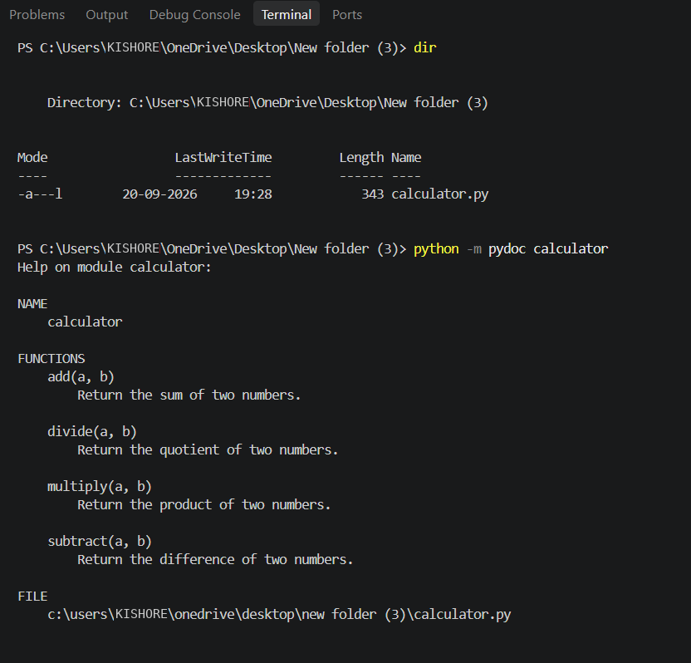
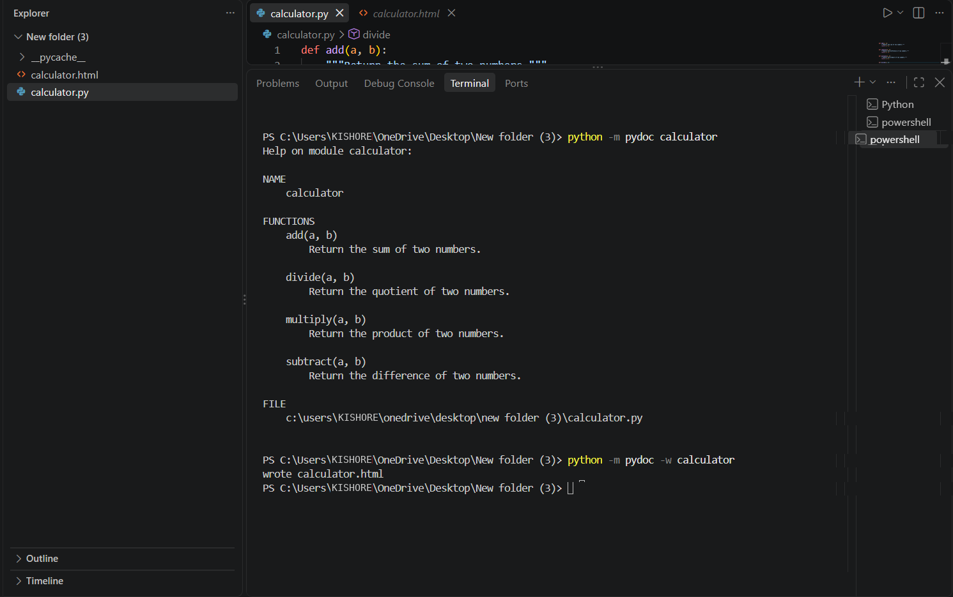

Then an new folder will be created as calculator.html
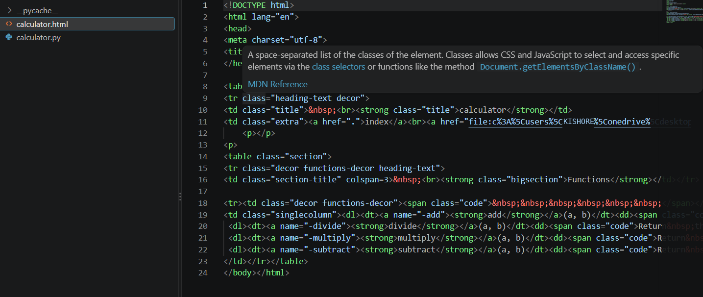

Problem 4: Conversion Utilities Module:-
Task:
- Write a module named conversion.py with functions:
  - decimal_to_binary(n)
  - binary_to_decimal(b)
  - decimal_to_hexadecimal(n)
- Use Copilot for auto-generating docstrings.
- Generate documentation in the terminal.
- Export the documentation in HTML format and open it in a browser.

Create an file named conversion.py
Python code:
def decimal_to_binary(n):
"""Convert a decimal number to binary.

Args:
n (int): Decimal number.

Returns:
str: Binary representation of the number.
"""
return bin(n)[2:]

def binary_to_decimal(b):
"""Convert a binary number to decimal.

Args:
b (str): Binary number as a string.

Returns:
int: Decimal representation of the binary number.
"""
return int(b, 2)

def decimal_to_hexadecimal(n):
"""Convert a decimal number to hexadecimal.

Args:
n (int): Decimal number.

Returns:
str: Hexadecimal representation of the number.
"""
return hex(n)[2:]
documentation in termanil:-
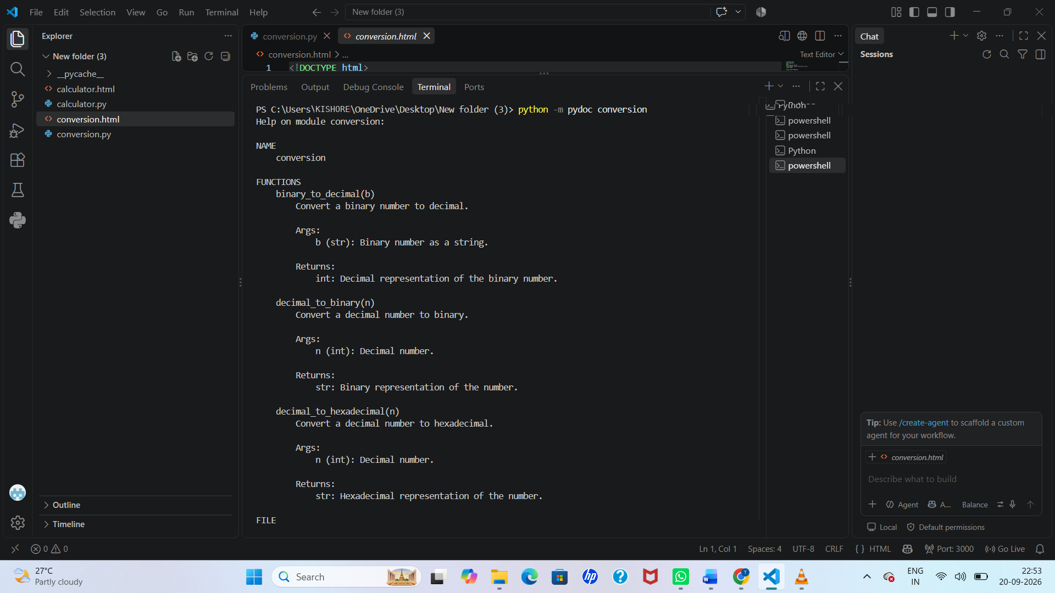

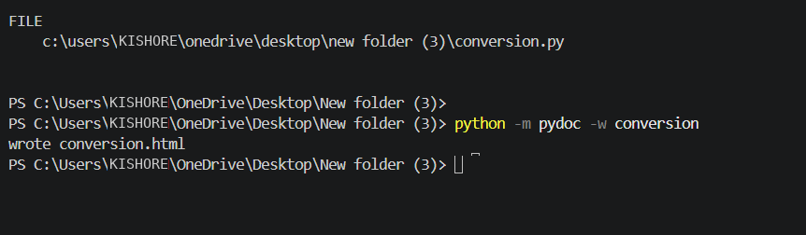

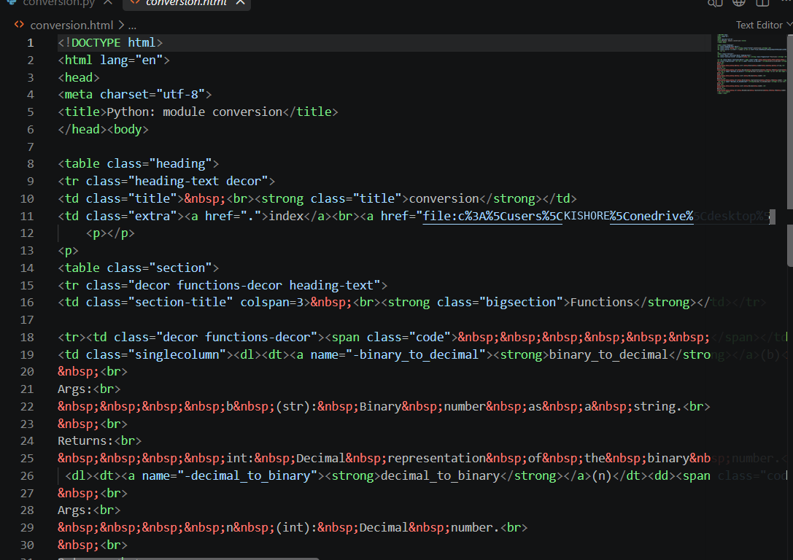

Problem 5 – Course Management Module
Task:
- Create a module course.py with functions:
  - add_course(course_id, name, credits)
  - remove_course(course_id)
  - get_course(course_id)
- Add docstrings with Copilot.
- Generate documentation in the terminal.
Export the documentation in HTML format and open it in a browser.
STEPS:-
Create an folder in vs code named as course.py
CODE:-
courses = {}
def add_course(course_id, name, credits):
"""Add a new course to the course list.

Args:
course_id (str): Unique ID of the course.
name (str): Name of the course.
credits (int): Number of credits for the course.

Returns:
str: Confirmation message.
"""
courses[course_id] = {
"name": name,
"credits": credits
}

return "Course added successfully."

def remove_course(course_id):
"""Remove a course using its course ID.

Args:
course_id (str): ID of the course to remove.

Returns:
str: Confirmation message.
"""
if course_id in courses:
del courses[course_id]
return "Course removed successfully."

return "Course not found."

def get_course(course_id):
"""Retrieve course information using its course ID.

Args:
course_id (str): ID of the course.

Returns:
dict or None: Course information if found,
otherwise None.
"""
return courses.get(course_id)

