LAB ASSIGNMENT 12

Name: J.CHARAN
Roll no. : 2503A52697
Batch: 24

Task Description #1: Linear Search
Implementation with AI Assistance
Task: Use an AI tool to generate a Python program that implements the Linear Search algorithm.
Instructions:
Prompt AI to create a function linear_search(arr, target) that searches for a target element in a list.
Return the index of the target element if found; otherwise, return -1.
Ask AI to include a docstring explaining the best-case, average-case, and worst-case time complexities.
Test the function with different inputs, including an empty list and a target that is not present.
Expected Output:
A working Python program implementing Linear Search.
Test cases with outputs.
A brief explanation of time complexity.
Prompt:
Write linear_search(arr, target) in Python. Return the index or -1, add a docstring with best/average/worst time complexity, and test normal, empty, and missing-target cases.
Code:
def linear_search(arr, target):
"""Best: O(1); Average: O(n); Worst: O(n)."""
for i, value in enumerate(arr):
if value == target:
return i
return -1
numbers = [10, 25, 30, 45, 50]
print("Target 30:", linear_search(numbers, 30))
print("Target 10:", linear_search(numbers, 10))
print("Target 99:", linear_search(numbers, 99))
print("Empty list:", linear_search([], 10))

Output:
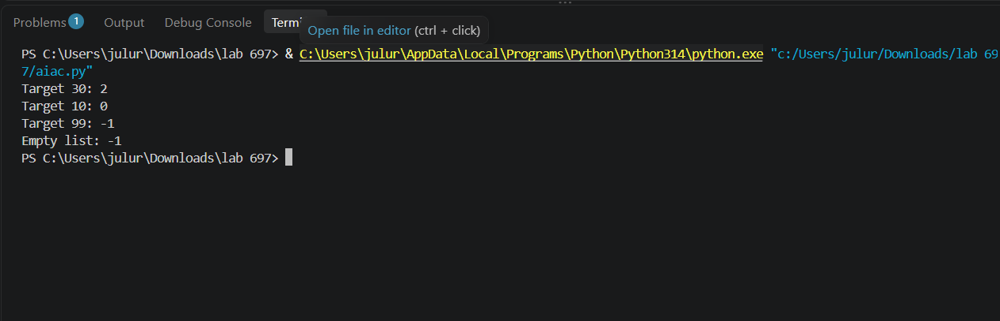

Task 2:
Task Description #2: Binary Search
Implementation with AI Optimization
Task: Use AI to generate an efficient Python program that implements Binary Search on a sorted list.
Instructions:
Prompt AI to create a function binary_search(arr, target).
Use the iterative approach to find the target element.
Return the index if the element is found; otherwise, return -1.
Ask AI to explain why the input list must be sorted.
Include best-case, average-case, and worst-case time complexities.
Test the program with the first element, last element, middle element, and a missing element.
Expected Output:
A working Binary Search program.
Test results for different target values.
An explanation of why Binary Search is more efficient than Linear Search for
Prompt :
Write iterative binary_search(arr, target) for a sorted list. Return the index or -1, document time complexity, and test first, middle, last, and missing targets.
Code :
def binary_search(arr, target):
"""Best: O(1); Average: O(log n); Worst: O(log n).
The list must be sorted in ascending order.
"""
low, high = 0, len(arr) - 1
while low <= high:
mid = (low + high) // 2
if arr[mid] == target:
return mid
if arr[mid] < target:
low = mid + 1
else:
high = mid - 1
return -1
numbers = [10, 20, 30, 40, 50, 60, 70]
for target in [10, 40, 70, 45]:
print(target, "->", binary_search(numbers, target))

Output:

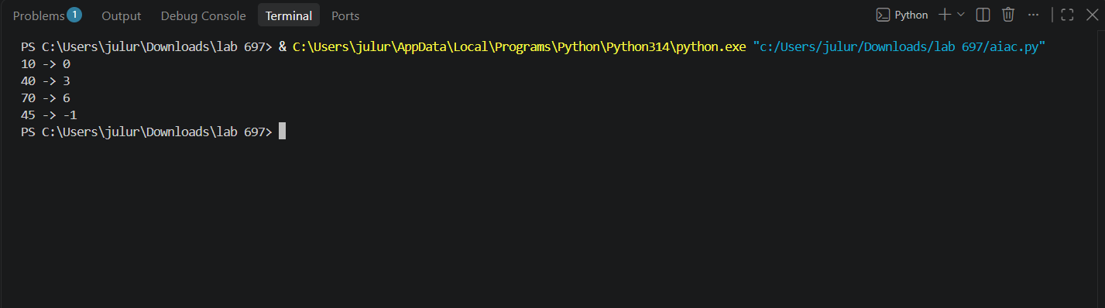

Task 3:
Task Description #3: Student Record Search System
Scenario: A university maintains student records containing roll numbers, names, and marks. Faculty members need to search for student records using roll numbers.
Student Task:
Use AI to recommend either Linear Search or Binary Search for searching student roll numbers.
Implement both algorithms in Python.
Test the algorithms using a list of student roll numbers.
Compare the results when the roll numbers are stored in unsorted and sorted order.
Explain the time complexity of both algorithms.
Expected Output:
Python functions for Linear Search and Binary Search.
Sample student records and test results.
A comparison table showing algorithm, input requirements, and time complexity.
Justification for selecting the appropriate search algorithm.

Prompt :
Create student records with roll number, name, and marks. Implement Linear and Binary Search by roll number, test unsorted and sorted records, and explain their time complexity.

Code :

def linear_search(records, roll_no):

for i, student in enumerate(records):

if student["roll_no"] == roll_no:

return i

return -1

def binary_search(records, roll_no):

low, high = 0, len(records) - 1

while low <= high:

mid = (low + high) // 2

value = records[mid]["roll_no"]

if value == roll_no:

return mid

if value < roll_no:

low = mid + 1

else:

high = mid - 1

return -1

students = [

{"roll_no": 103, "name": "Kiran", "marks": 82},

{"roll_no": 101, "name": "Anu", "marks": 91},

{"roll_no": 105, "name": "Ravi", "marks": 76},

{"roll_no": 102, "name": "Meena", "marks": 88},

]

print("Unsorted Linear Search:", linear_search(students, 102))

sorted_students = sorted(students, key=lambda s: s["roll_no"])

print("Sorted Binary Search:", binary_search(sorted_students, 102))

print("Record:", sorted_students[binary_search(sorted_students, 102)])

Output:
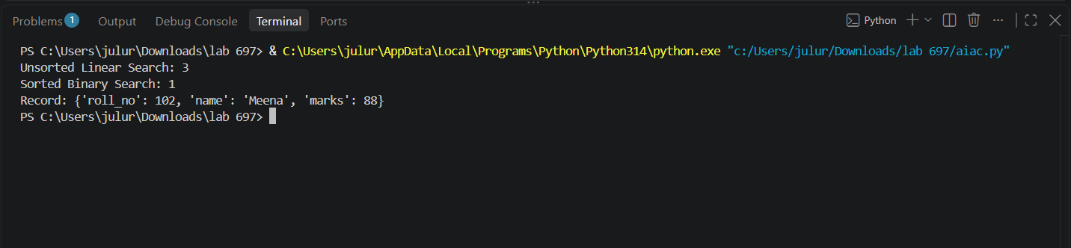

Task 4:
Question 4: Bubble Sort – Student Marks Sorting
A university maintains student records containing Roll Number,
Student Name, and Marks.
• Write a program to implement Bubble Sort to arrange
students in ascending order of marks.
• Display the array after each pass.
• Explain the swapping process.

Prompt
Write Linear and Binary Search functions that return the index and comparison count. Test an existing and missing book ID, sorting the list for Binary Search.
Code :

def linear_search_count(arr, target):

comparisons = 0

for i, value in enumerate(arr):

comparisons += 1

if value == target:

return i, comparisons

return -1, comparisons

def binary_search_count(arr, target):

low, high = 0, len(arr) - 1

comparisons = 0

while low <= high:

mid = (low + high) // 2

comparisons += 1

if arr[mid] == target:

return mid, comparisons

if arr[mid] < target:

low = mid + 1

else:

high = mid - 1

return -1, comparisons

books = [410, 125, 305, 220, 515, 180, 460]

sorted_books = sorted(books)

for target in [305, 999]:

print("Book ID:", target)

print("Linear:", linear_search_count(books, target))

print("Binary:", binary_search_count(sorted_books, target))

Output

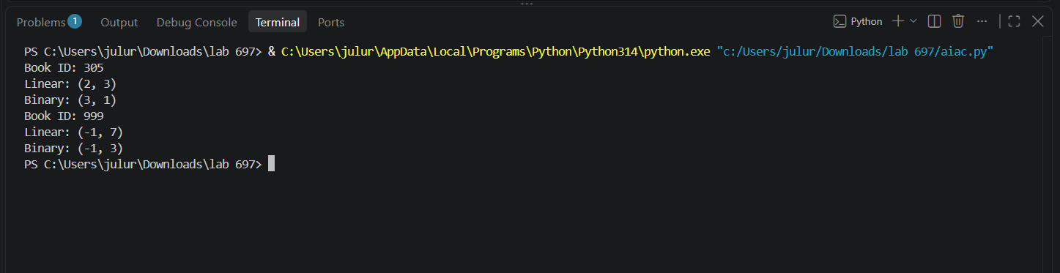

Task 5:
Question 5: Quick Sort – Examination Result Processing
A university maintains examination results containing Roll Number,
Student Name, and Total Marks.
• Write a program to implement Quick Sort to arrange students
in descending order of marks.
• Select the last element as the pivot.
• Explain the partitioning process and recursive calls.
• Analyze the best, average, and worst-case time complexities.

Prompt
Write Linear and Binary Search functions that count comparisons. Test sorted product ID lists of sizes 100, 1000, and 10000 for first, middle, last, and missing targets. Measure execution time and print a comparison table.

Code :
from time import perf_counter
def linear_search(arr, target):
count = 0
for i, value in enumerate(arr):
count += 1
if value == target:
return i, count
return -1, count
def binary_search(arr, target):
low, high, count = 0, len(arr) - 1, 0
while low <= high:
mid = (low + high) // 2
count += 1
if arr[mid] == target:
return mid, count
if arr[mid] < target:
low = mid + 1
else:
high = mid - 1
return -1, count
print("N Case Algorithm Index Comparisons Time(ms)")
for n in [100, 1000, 10000]:
products = list(range(n))
tests = [("first", products[0]), ("middle", products[n//2]),
("last", products[-1]), ("missing", -1)]
for case, target in tests:
for name, func in [("Linear", linear_search), ("Binary", binary_search)]:
start = perf_counter()
index, count = func(products, target)
elapsed = (perf_counter() - start) * 1000
print(n, case, name, index, count, f"{elapsed:.6f}")

Output:
