LAB ASSIGNMENT-2

COURSE:- AI ASSISTED CODING
NAME:- Juluri Charan
ENTROLL NO:- 2503A52697
BATCH.NO:- 24

TASK :-CHECKING WHICH AI TOOLS IS BEST TO FIND FACTORS AND ADD NUMBERS

TASK-1:-VS CODE
PROMPT: generate a python code to find the factorial of a number.
CODE:
num = int(input("Enter a number: "))
factors = []
for i in range(1, num + 1):
if num % i == 0:
factors.append(i)
print("Factors of", num, "are:", factors)
OUTPUT:
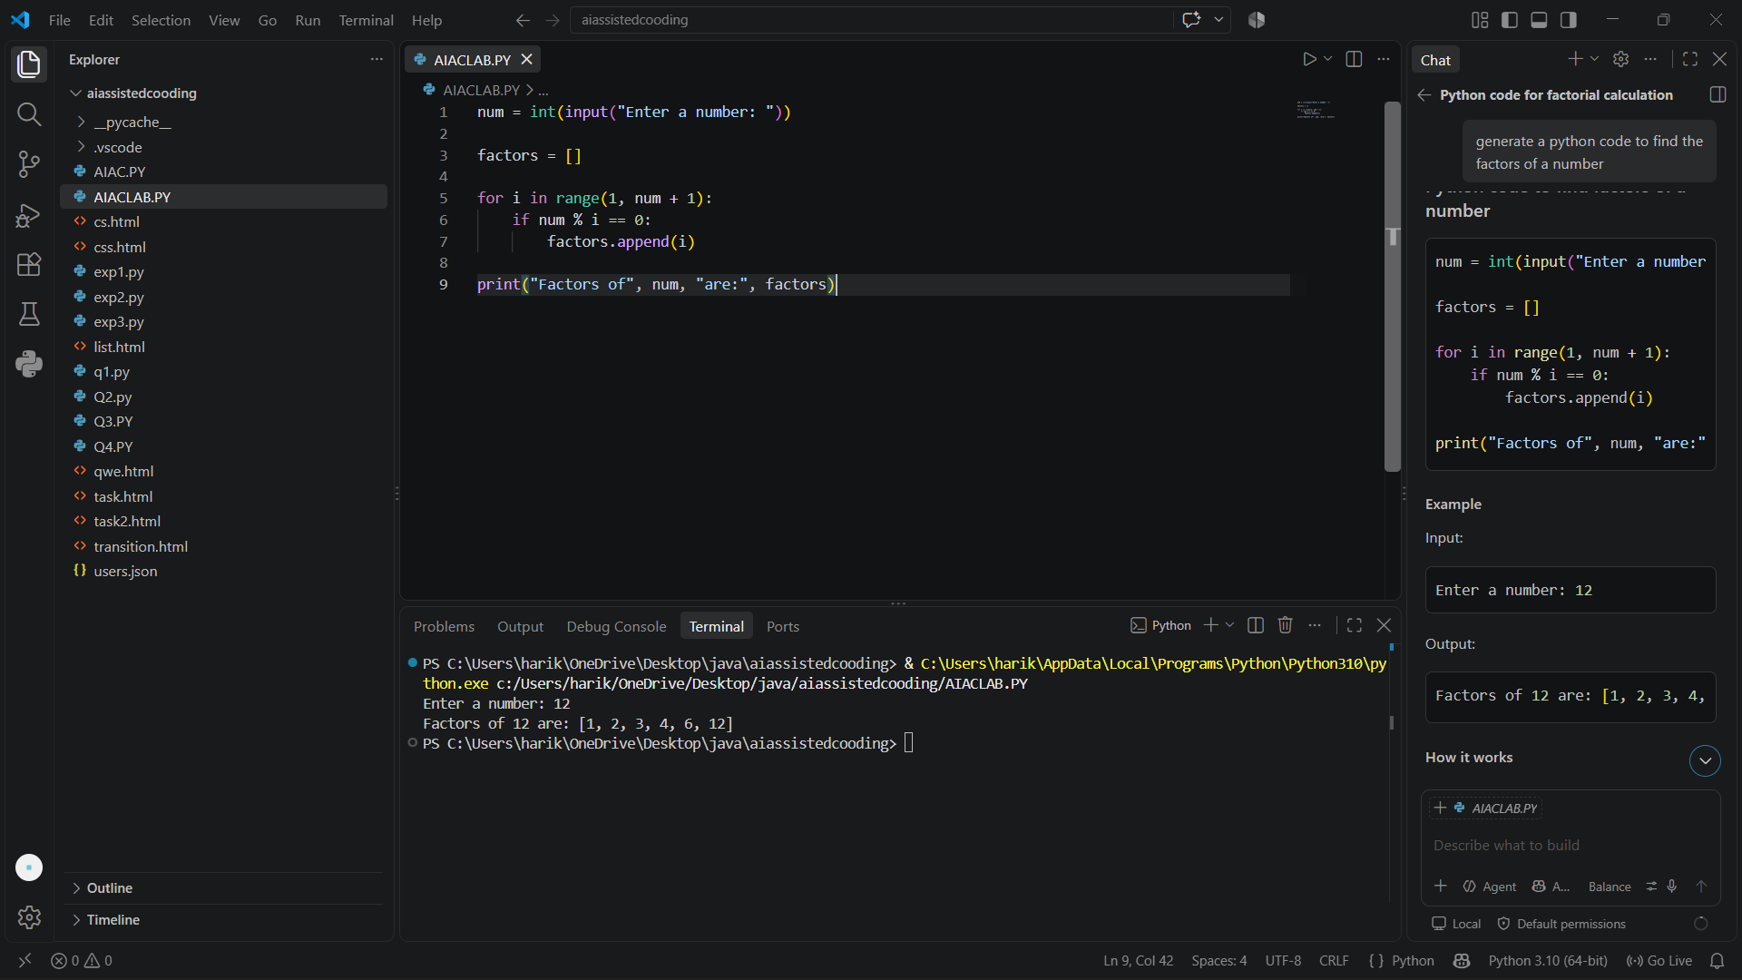
TASK-2: GOOGLE COLAB

PROMPT: generate a python code to find the factors of a number.

CODE:
def find_factors(number):
factors = []
for i in range(1, number + 1):
if number % i == 0:
factors.append(i)
return factors
num = 28
print(f"The factors of {num} are: {find_factors(num)}")
num = 12
print(f"The factors of {num} are: {find_factors(num)}")

OUTPUT:
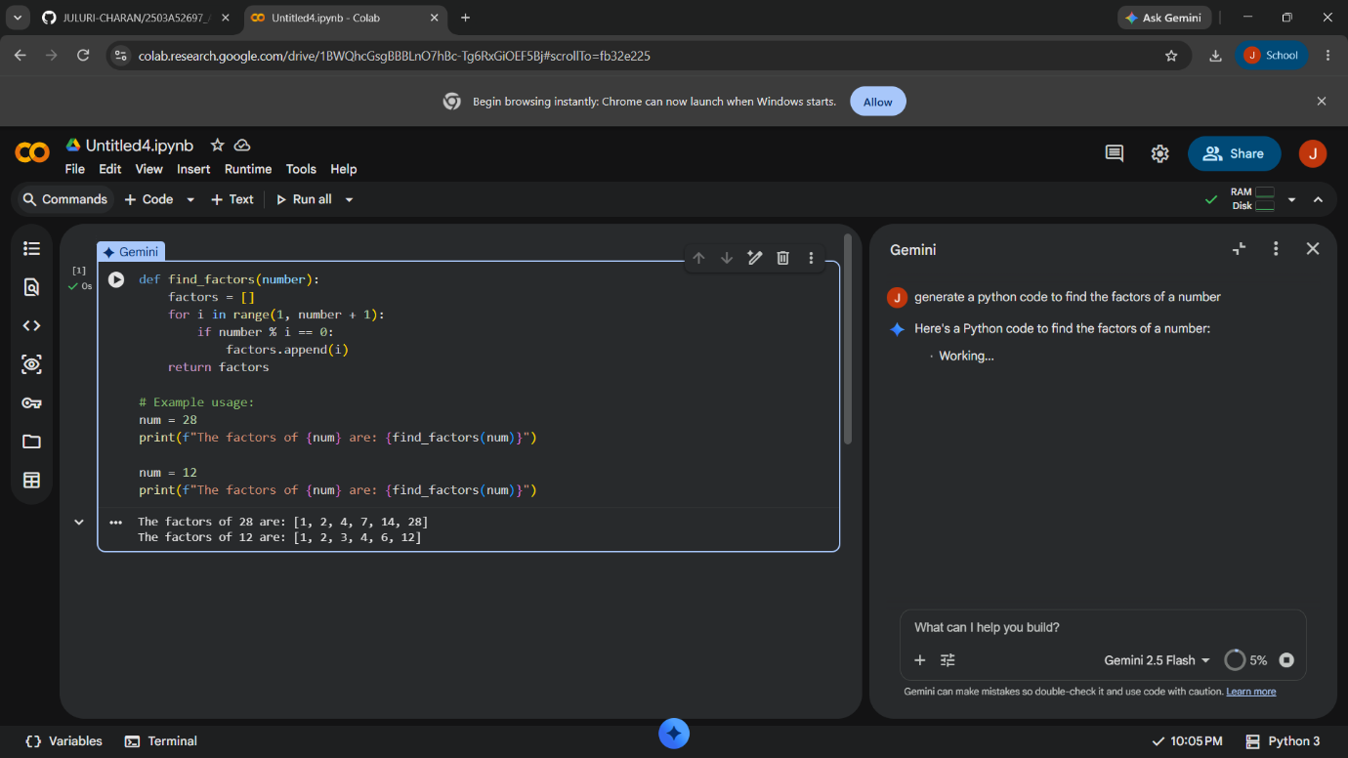

TASK-2 : CLAUDE AI

PROMPT: generate a python code to find the factors of a number.

CODE:
def find_factors(n):
if n <= 0:
raise ValueError("Please enter a positive integer")
factors = set()
for i in range(1, int(n**0.5) + 1):
if n % i == 0:
factors.add(i)
factors.add(n // i)
return sorted(factors)
num = int(input("Enter a number: "))
print(f"Factors of {num}: {find_factors(num)}")

OUTPUT:
