LAB ASSIGNMENT-02

Name: J.CHARAN
Enroll No.: 2503A52697
Batch: 24

Task 1: Statistical Summary for Survey Data
- Scenario:
You are a data analyst intern working with survey responses stored as numerical lists.
- Task:
Use Google Gemini in Colab to generate a Python function that reads a list of numbers and calculates the mean, minimum, and maximum values.
- Expected Output:
  - Correct Python function
  - Output shown in Colab
  - Screenshot of Gemini prompt and result

PROMPT: Generate a Python function that takes a list of numerical survey responses as input and calculates the mean, minimum, and maximum values. Return the results clearly.

CODE:
def summarize_survey_responses(responses):
if not responses:
return {
"mean": None,
"minimum": None,
"maximum": None,
"message": "No responses provided."
}
mean_value = sum(responses) / len(responses)
min_value = min(responses)
max_value = max(responses)
return {
"mean": mean_value,
"minimum": min_value,
"maximum": max_value
}

# Sample input
survey_responses = [18, 22, 25, 29, 31, 27, 24]

result = summarize_survey_responses(survey_responses)

print("Mean:", result["mean"])
print("Minimum:", result["minimum"])
print("Maximum:", result["maximum"])

OUTPUT:
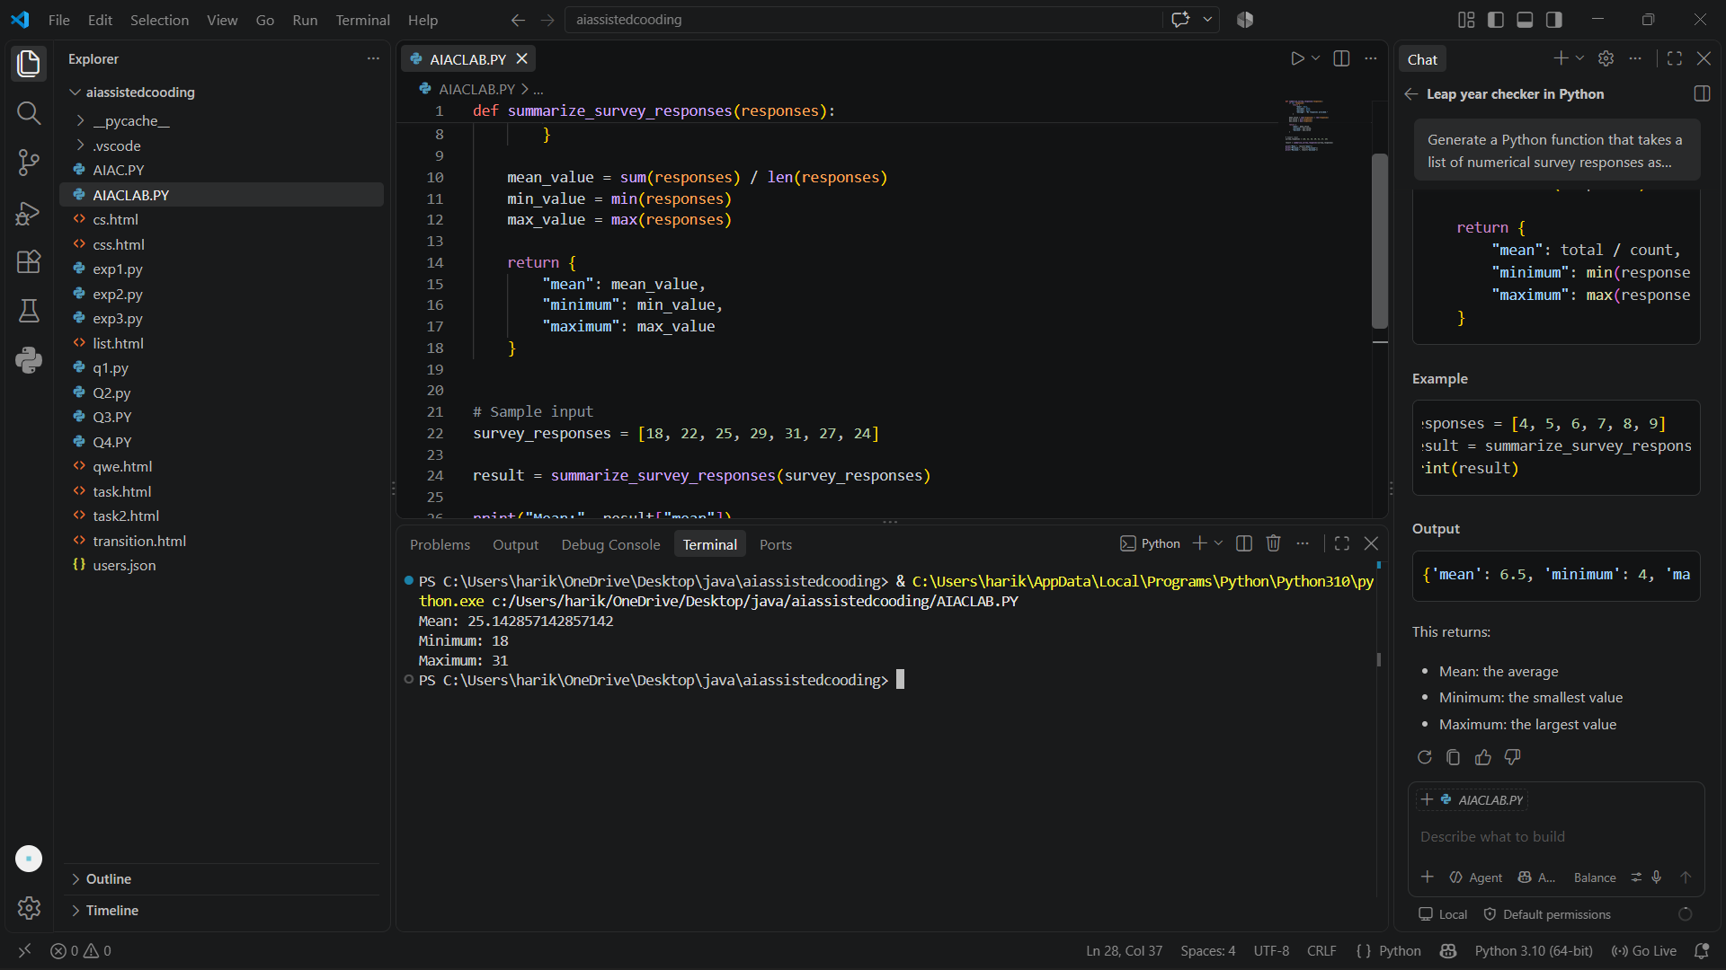

Task 2: Armstrong Number – AI Comparison
- Scenario:
You are evaluating AI tools for numeric validation logic.
- Task:
Generate an Armstrong number checker using Gemini and GitHub Copilot.
Compare their outputs, logic style, and clarity.
- Expected Output:
  - Side-by-side comparison table
  - Screenshots of prompts and generated code

PROMPT: Generate a Python program to check whether a given number is an Armstrong number or not.

CODE:
num = int(input("Enter a number: "))
if num < 0:
print(f"{num} is not an Armstrong number.")
else:
original = num
digits = len(str(num))
total = 0
while num > 0:
digit = num % 10
total += digit ** digits
num //= 10
if total == original:
print(f"{original} is an Armstrong number.")
else:
print(f"{original} is not an Armstrong number.")

OUTPUT:
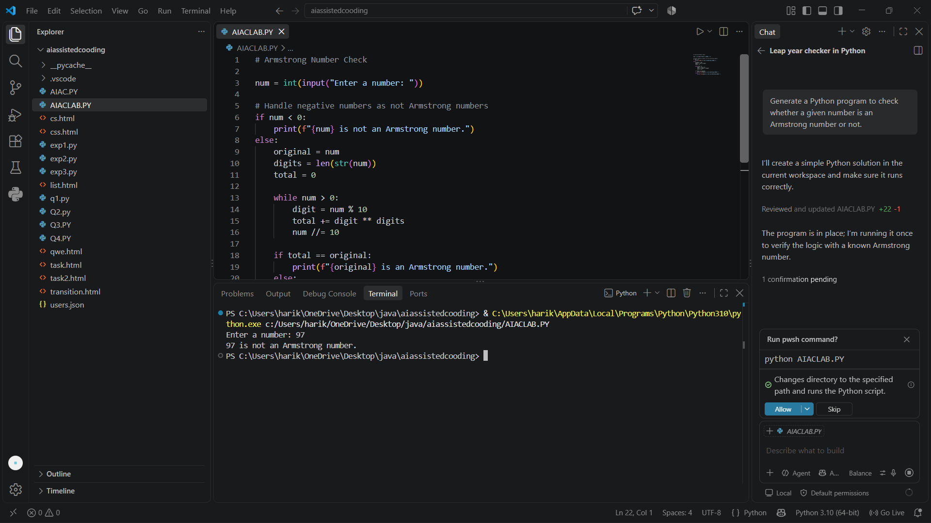

Task 3: Leap Year Validation Using Cursor AI
- Scenario:
You are validating a calendar module for a backend system.
- Task:
Use Cursor AI to generate a Python program that checks whether a given year is a leap year.
Use at least two different prompts and observe changes in code.
- Expected Output:
  - Two versions of code
  - Sample inputs/outputs
  - Brief comparison

PROMPT: Generate a simple Python program that checks whether a given year is a leap year or not. Use a function is_leap_year(year) and return True for a leap year and False otherwise. Include sample inputs and outputs.
CODE:
def is_leap_year(year):
if (year % 400 == 0) or (year % 4 == 0 and year % 100 != 0):
return True
return False
# Example usage
year = int(input("Enter a year: "))
print(is_leap_year(year))

OUTPUT:
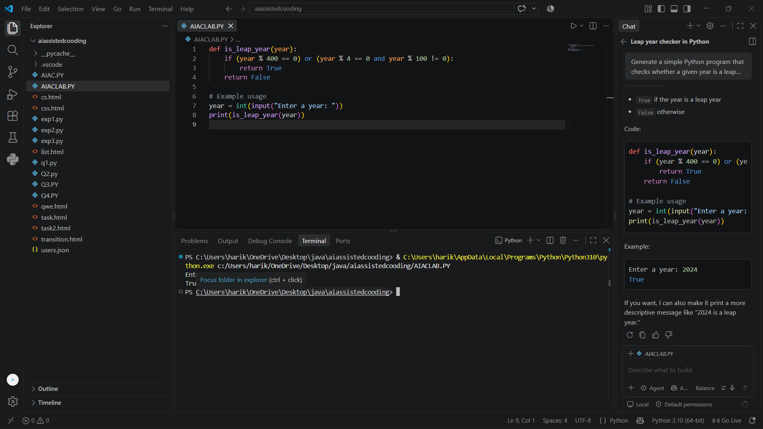

Task 4: Student Logic + AI Refactoring (Odd/Even Sum)
- Scenario:
Company policy requires developers to write logic before using AI.
- Task:
Write a Python program that calculates the sum of odd and even numbers in a tuple, then refactor it using any AI tool.
- Expected Output:
  - Original code
  - Refactored code
  - Explanation of improvements
PROMPT: Refactor this Python program that calculates the sum of odd and even numbers in a tuple

CODE:
def calculate_odd_even_sums(numbers):
"""Return the sum of odd and even numbers in a tuple."""
odd_sum = sum(number for number in numbers if number % 2 != 0)
even_sum = sum(number for number in numbers if number % 2 == 0)
return odd_sum, even_sum
def main():
numbers = tuple(int(value) for value in input("Enter numbers separated by spaces: ").split())
odd_sum, even_sum = calculate_odd_even_sums(numbers)
print(f"Tuple: {numbers}")
print(f"Sum of odd numbers: {odd_sum}")
print(f"Sum of even numbers: {even_sum}")
if __name__ == "__main__":
main()

OUTPUT: 