AI ASSISTED CODING LAB-03
- ENROLNO : 2503A52704
- NAME: J.CHARAN
- BATCH-24

TASK : 1
Question 1: Zero-Shot Prompting (Palindrome Number Program)
Write a zero-shot prompt (without providing any examples) to generate a Python function that checks whether a given number is a palindrome.
Task:
- Record the AI-generated code.
- Test the code with multiple inputs.
- Identify any logical errors or missing edge-case handling.

PROMPT : give a python code to check wheather the number is palindrom are not .

CODE:
num = int(input("Enter a number: "))

original = num
reverse = 0

while num > 0:
digit = num % 10
reverse = reverse * 10 + digit
num = num // 10

if original == reverse:
print(original, "is a palindrome number")
else:
print(original, "is not a palindrome number")
OUTPUT:

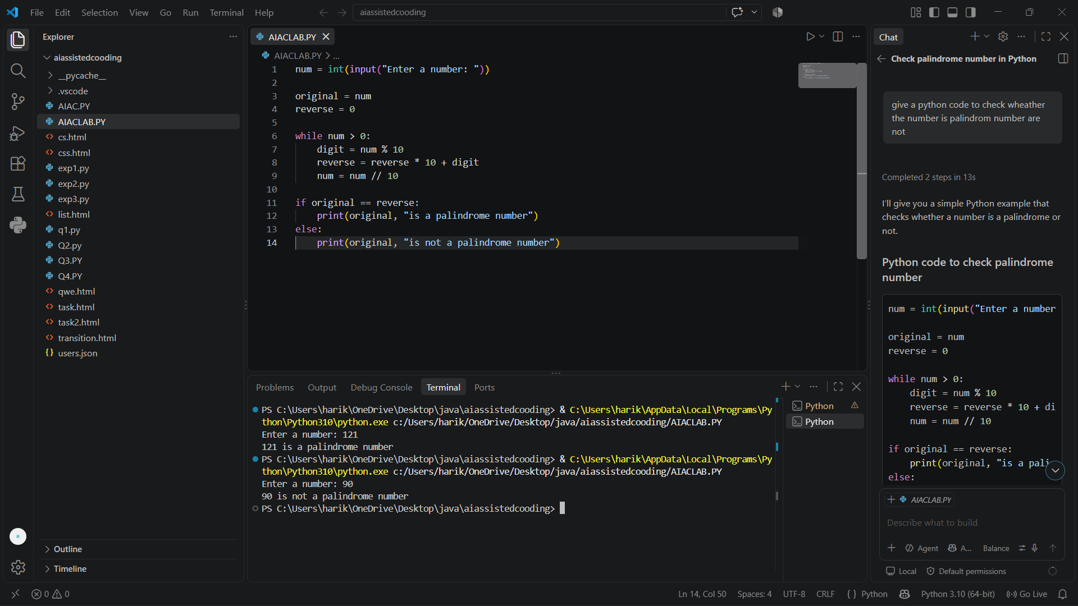

TASK:-2

Question 2: One-Shot Prompting (Factorial Calculation)
Write a one-shot prompt by providing one input-output example and ask the AI to generate a Python function to compute the factorial of a given number.
Example:
Input: 5 → Output: 120
Task:
- Compare the generated code with a zero-shot solution.
- Examine improvements in clarity and correctness.
PROMPT: Give a python code to calculate factorial of a number

CODE:
n = int(input("Enter a number: "))
factorial = 1
if n < 0:
print("Factorial is not defined for negative numbers.")
elif n == 0:
print("Factorial of 0 is 1")
else:
for i in range(1, n + 1):
factorial *= i
print(f"Factorial of {n} is {factorial}")

OUTPUT:
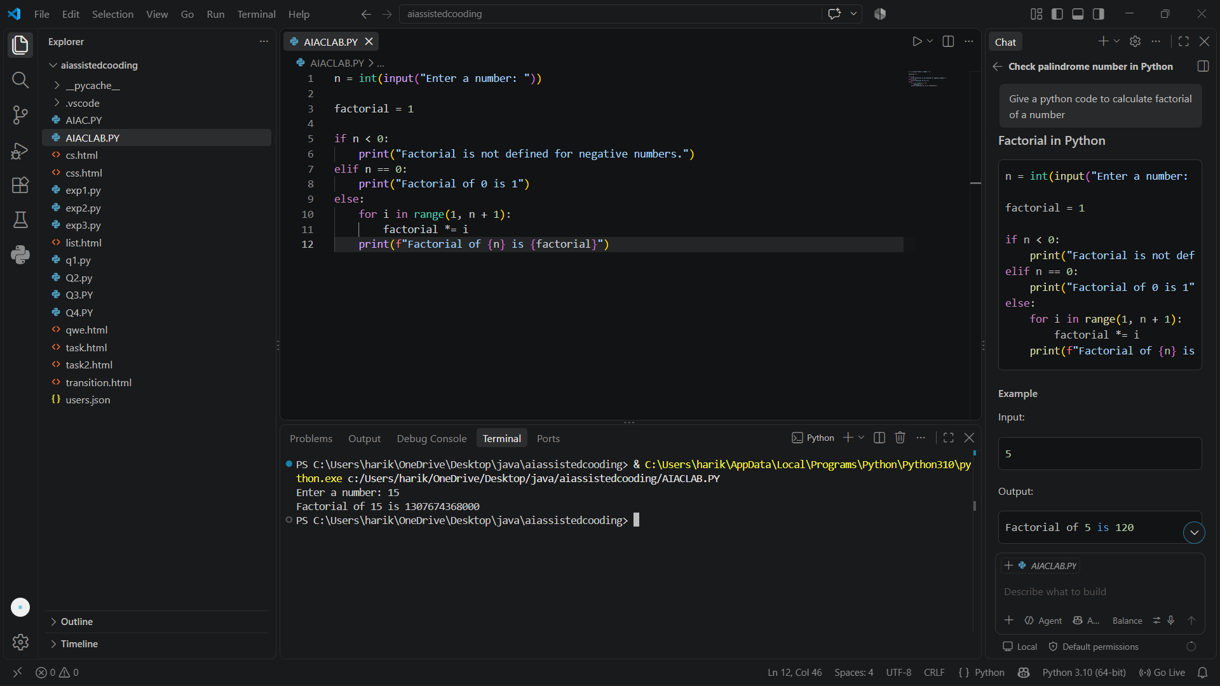

TASK:-3
Few-Shot Prompting (Armstrong Number Check)
Write a few-shot prompt by providing multiple input-output examples to guide the AI in generating a Python function to check whether a given number is an Armstrong number.
Examples:
- Input: 153 → Output: Armstrong Number
- Input: 370 → Output: Armstrong Number
- Input: 123 → Output: Not an Armstrong Number
Task:
- Analyze how multiple examples influence code structure and accuracy.
- Test the function with boundary values and invalid inputs.

PROMPT: give a python code to check wheather armstrong number.
CODE:
num = int(input("Enter a number: "))
original = num
digits = len(str(num))
sum_of_powers = 0
while num > 0:
digit = num % 10
sum_of_powers += digit ** digits
num //= 10
if sum_of_powers == original:
print(original, "is an Armstrong number")
else:
print(original, "is not an Armstrong number")

OUTPUT:
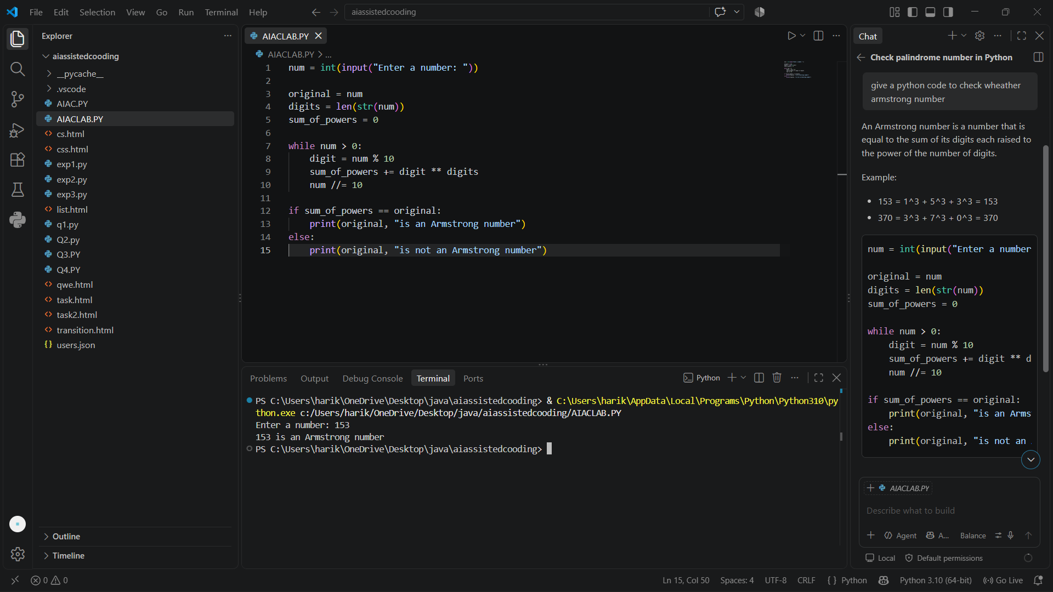

TASK:-4 Question 4: Context-Managed Prompting (Optimized Number Classification)
Design a context-managed prompt with clear instructions and constraints to generate an optimized Python program that classifies a number as prime, composite, or neither.
Task:
- Ensure proper input validation.
- Optimize the logic for efficiency.
- Compare the output with earlier prompting strategies.

PROMPT: give a python code to classification of optimized number

CODE:
def classify_number(n):
if n <= 0:
return "Invalid input: enter a positive integer."
total = 1 # 1 is always a proper divisor for n > 1
# Optimized divisor search: only check up to sqrt(n)
limit = int(n ** 0.5)
for i in range(2, limit + 1):
if n % i == 0:
total += i
# If i and n/i are different, add both divisors
other = n // i
if other != i:
total += other
if total == n:
return "Perfect number"
elif total > n:
return "Abundant number"
else:
return "Deficient number"
# Example usage
for num in [6, 12, 28, 15, 1, 10]:
print(f"{num} -> {classify_number(num)}")

OUTPUT:
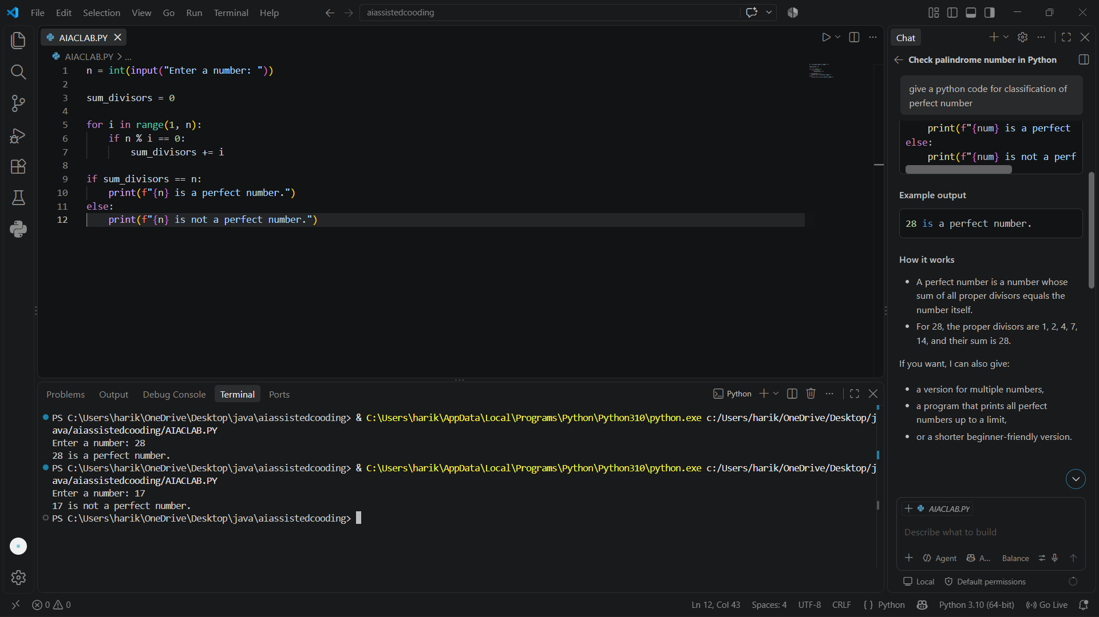

Question 6: Few-Shot Prompting (Even or Odd Classification with Validation)
Write a few-shot prompt by providing multiple input-output examples to guide the AI in generating a Python program that determines whether a given number is even or odd, including proper input validation.
Examples:
Input: 8 → Output: Even
Input: 15 → Output: Odd
Input: 0 → Output: Even
Task:
Analyze how examples improve input handling and output clarity.
Test the program with negative numbers and non-integer inputs.

PROMPT: generate a python code whether a given number is even or odd

CODE:
num = int(input("Enter a number: "))
if num % 2 == 0:
print(num, "is even")
else:
print(num, "is odd")

OUTPUT:
