LAB ASSIGNMENT -05

COURSE: AI ASSISTED CODING
NAME: J.CHARAN
ENROLLNO: 2503A52697
BATCH: 24

Q1: Task Description #1 (Privacy & Security in File Handling)
Task: Use an AI tool to generate a Python script that stores user data (name, email, password) in a file.
Analyze: Check if the AI stores sensitive data in plain text or without encryption.
Expected Output:
Identified privacy risks.
Revised version with encrypted password storage (e.g., hashing).
PROMPT: Use an AI tool to generate a Python script that stores user data (name,email, password) in a file, and Check if the AI stores sensitive data in plain text or without encryption.
CODE:
import getpass
import hashlib
import json
import secrets
from pathlib import Path
DATA_FILE = Path(__file__).with_name("users.json")
def hash_password(password):
"""Return a salted password hash and the salt used to create it."""
salt = secrets.token_bytes(16)
password_hash = hashlib.pbkdf2_hmac(
"sha256", password.encode("utf-8"), salt, 600_000
)
return password_hash.hex(), salt.hex()

def save_user(name, email, password):
"""Store a user record without storing the password itself."""
if DATA_FILE.exists():
users = json.loads(DATA_FILE.read_text(encoding="utf-8"))
else:
users = []
password_hash, password_salt = hash_password(password)
users.append(
{
"name": name,
"email": email,
"password_hash": password_hash,
"password_salt": password_salt,
}
)
DATA_FILE.write_text(json.dumps(users, indent=2) + "\n", encoding="utf-8")

def check_plain_text_storage():
"""Report whether any saved record contains a raw password field."""
users = json.loads(DATA_FILE.read_text(encoding="utf-8"))
has_plain_text_password = any("password" in user for user in users)
if has_plain_text_password:
print("Warning: a password is stored in plain text.")
else:
print("Audit passed: passwords are not stored in plain text.")
return has_plain_text_password

if __name__ == "__main__":
user_name = input("Name: ").strip()
user_email = input("Email: ").strip()
user_password = getpass.getpass("Password: ")
save_user(user_name, user_email, user_password)
check_plain_text_storage()

OUTPUT:
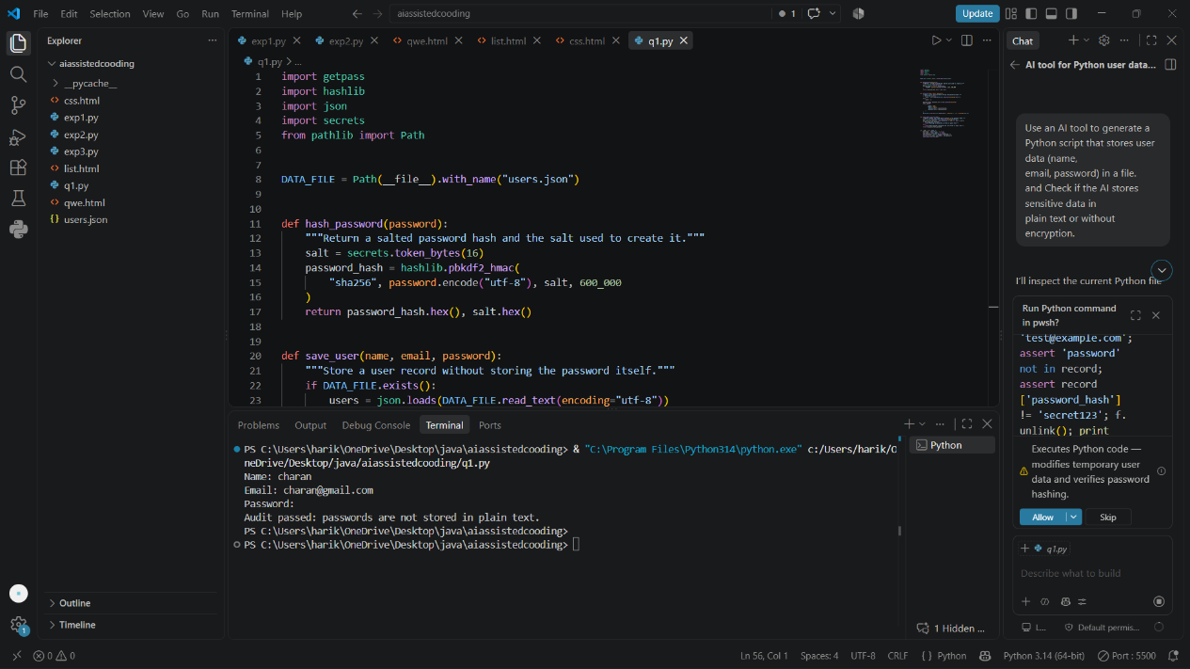

Q2: Task Description #2 – Fair Decision Logic
Task: Prompt an AI tool to generate a scholarship eligibility checker based on academic score, family income, and location. Examine whether the logic unfairly favors or disadvantages any group.
Expected Output-2:
Code snippet with observations on fairness.
Brief explanation (3–4 sentences) suggesting improvements to ensure equitable decision-making.

PROMPT : generate a scholarship eligibility checker based on academic score, family income, and location. Examine whether the logic unfairly favors or disadvantages any group.
CODE :
ELIGIBLE_SCORE = 70
MAX_FAMILY_INCOME = 500000
SUPPORT_LOCATIONS = {"rural", "underserved"}

def assess_scholarship(academic_score, family_income, location):
"""Return an eligibility decision and an explanation for one applicant."""
normalized_location = location.strip().lower()
score_qualifies = academic_score >= ELIGIBLE_SCORE
income_qualifies = family_income <= MAX_FAMILY_INCOME

reasons = []
if not score_qualifies:
reasons.append(f"academic score is below {ELIGIBLE_SCORE}")
if not income_qualifies:
reasons.append(f"family income is above Rs. {MAX_FAMILY_INCOME:,}")

return {
"eligible": score_qualifies and income_qualifies,
"academic_score": academic_score,
"family_income": family_income,
"location": normalized_location,
"priority_support": normalized_location in SUPPORT_LOCATIONS,
"reasons": reasons or ["meets the academic and income criteria"],
}

def fairness_review():
"""Describe how the decision rules can affect location groups."""
return [
"The same academic and income thresholds apply to every location.",
"Rural and underserved applicants are flagged for support, not made automatically eligible.",
"Location can still be an imperfect proxy for race, caste, disability, or access to schools.",
"Before using this for awards, compare approval rates by location and review borderline cases manually.",
"Do not use protected characteristics or unrelated personal information in the decision.",
]

def read_non_negative_number(prompt, allow_decimal=False):
"""Read a non-negative number from the command line."""
while True:
try:
value = float(input(prompt)) if allow_decimal else int(input(prompt))
if value < 0:
raise ValueError
return value
except ValueError:
print("Please enter a non-negative number.")

if __name__ == "__main__":
print("Scholarship Eligibility Checker")
academic_score = read_non_negative_number("Academic score (0-100): ", allow_decimal=True)
while academic_score > 100:
print("Academic score must be between 0 and 100.")
academic_score = read_non_negative_number("Academic score (0-100): ", allow_decimal=True)

family_income = read_non_negative_number("Annual family income (Rs.): ")
location = input("Location (urban, rural, or underserved): ")
result = assess_scholarship(academic_score, family_income, location)

print("\nEligible:", "Yes" if result["eligible"] else "No")
print("Reason:", "; ".join(result["reasons"]))
if result["priority_support"]:
print("Support flag: Consider additional outreach or application support.")

print("\nFairness review:")
for note in fairness_review():
print("-", note)

OUTPUT:
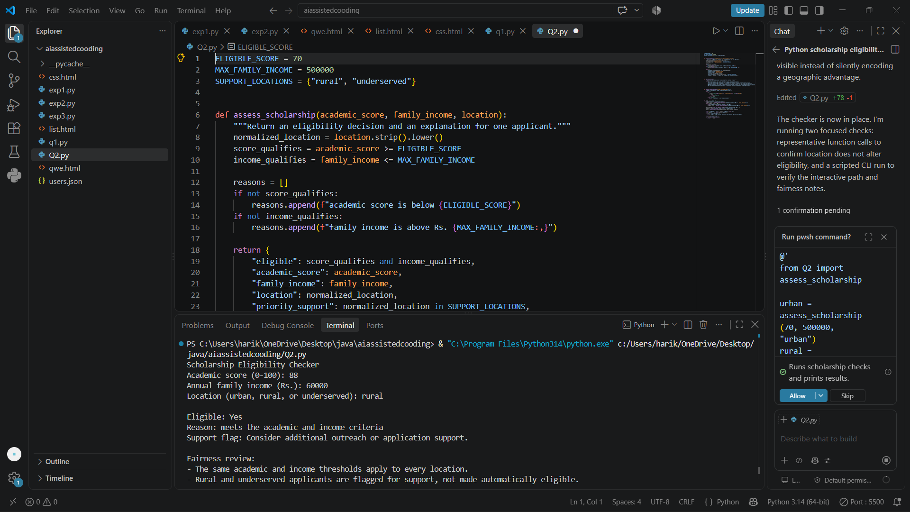

Q3:
Task Description #3 (Transparency in AI-Based Admission System)
Task: Use an AI tool to generate a Python program that predicts whether a student should be selected or rejected for admission based on factors such as entrance exam score, academic marks, and other relevant admission criteria.
Analyze: Check whether the AI system provides a clear and understandable reason for its admission decision.
Expected Output:
- Identified transparency risks.
- Example of an admission decision where the AI gives no explanation.
- Revised version that provides a clear reason for selecting or rejecting the student.
- Example output showing the important factors that influenced the AI's decision.

PROMPT: generate a Python program that predicts whether a student should be selected or rejected for admission based on factors such as entrance exam score, academic marks, and other relevant admission criteria.

CODE:
ENTRANCE_WEIGHT = 0.40
ACADEMIC_WEIGHT = 0.30
INTERVIEW_WEIGHT = 0.15
EXTRACURRICULAR_WEIGHT = 0.10
ATTENDANCE_WEIGHT = 0.05
SELECTION_THRESHOLD = 70
MIN_ENTRANCE_SCORE = 50
MIN_ACADEMIC_SCORE = 50
def predict_admission(
entrance_score,
academic_score,
interview_score,
extracurricular_score,
attendance_score,
):
"""Return an explainable admission decision for one student."""
weighted_score = (
entrance_score * ENTRANCE_WEIGHT
+ academic_score * ACADEMIC_WEIGHT
+ interview_score * INTERVIEW_WEIGHT
+ extracurricular_score * EXTRACURRICULAR_WEIGHT
+ attendance_score * ATTENDANCE_WEIGHT
)
meets_minimum_scores = (
entrance_score >= MIN_ENTRANCE_SCORE
and academic_score >= MIN_ACADEMIC_SCORE
)
selected = meets_minimum_scores and weighted_score >= SELECTION_THRESHOLD
reasons = []
if entrance_score < MIN_ENTRANCE_SCORE:
reasons.append(f"entrance score is below {MIN_ENTRANCE_SCORE}")
if academic_score < MIN_ACADEMIC_SCORE:
reasons.append(f"academic score is below {MIN_ACADEMIC_SCORE}")
if weighted_score < SELECTION_THRESHOLD:
reasons.append(f"weighted score is below {SELECTION_THRESHOLD}")
return {
"decision": "Selected" if selected else "Rejected",
"weighted_score": round(weighted_score, 2),
"reasons": reasons or ["meets the minimum and weighted-score criteria"],
}
def read_score(label):
"""Read a score from 0 through 100."""
while True:
try:
score = float(input(f"{label} (0-100): "))
if 0 <= score <= 100:
return score
except ValueError:
pass
print("Please enter a number between 0 and 100.")
if __name__ == "__main__":
print("Student Admission Predictor")
entrance_score = read_score("Entrance exam score")
academic_score = read_score("Academic marks")
interview_score = read_score("Interview score")
extracurricular_score = read_score("Extracurricular activities score")
attendance_score = read_score("Attendance score")
result = predict_admission(
entrance_score,
academic_score,
interview_score,
extracurricular_score,
attendance_score,
)
print(f"\nDecision: {result['decision']}")
print(f"Weighted score: {result['weighted_score']}/100")
print("Reason: " + "; ".join(result["reasons"]))

OUTPUT:
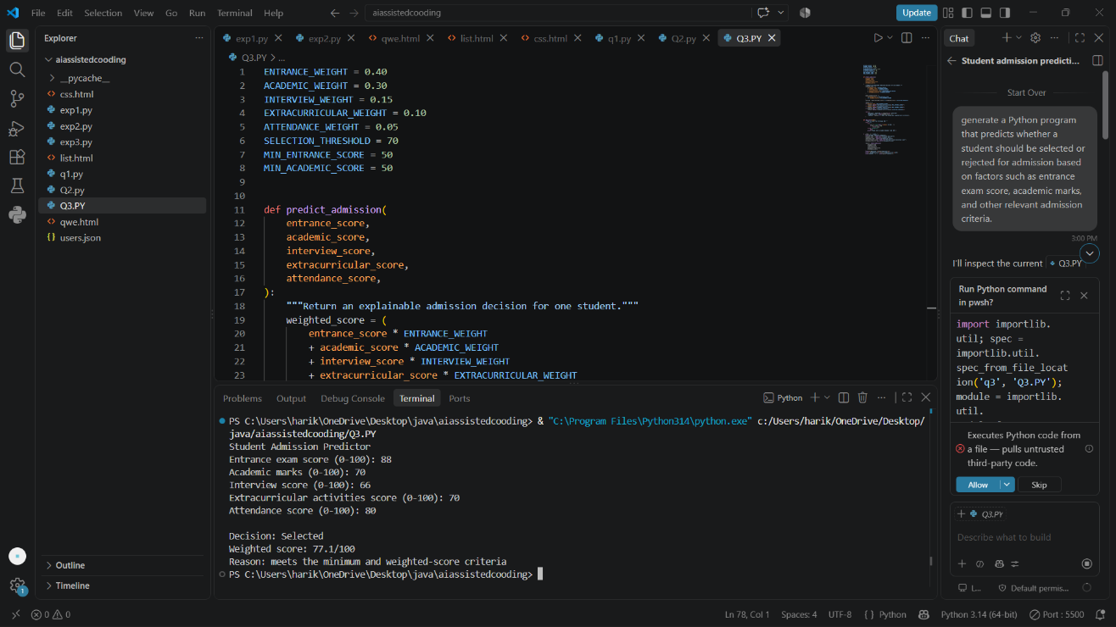

Q4:
Task Description #4 – Ethical Scoring System
Task: Generate an employee performance evaluation system using inputs such as project completion rate, teamwork score, and attendance. Analyze the scoring logic for any unethical weighting or hidden bias.
Expected Output-4:
Python code along with a written analysis identifying whether the evaluation criteria are balanced and justifiable.
PROMPT: Generate python code for an employee performance evaluation system using inputs such as project completion rate, teamwork score, and attendance. Analyze the scoring logic for any unethical weighting or hidden bias.

CODE:
from dataclasses import dataclass
@dataclass(frozen=True)
class Evaluation:
"""Validated inputs for one employee's review period."""
employee_name: str
project_completion_rate: float
teamwork_score: float
attendance_rate: float
approved_leave_days: int = 0
WEIGHTS = {
"project_completion_rate": 0.40,
"teamwork_score": 0.35,
"attendance_rate": 0.25,
}
def _percentage(value: float, field_name: str) -> float:
if not 0 <= value <= 100:
raise ValueError(f"{field_name} must be between 0 and 100")
return value
def validate_evaluation(evaluation: Evaluation) -> None:
if not evaluation.employee_name.strip():
raise ValueError("employee_name cannot be empty")
_percentage(evaluation.project_completion_rate, "project_completion_rate")
_percentage(evaluation.teamwork_score, "teamwork_score")
_percentage(evaluation.attendance_rate, "attendance_rate")
if evaluation.approved_leave_days < 0:
raise ValueError("approved_leave_days cannot be negative")
def calculate_score(evaluation: Evaluation) -> float:
"""Return a 0-100 score using only the documented performance inputs."""
validate_evaluation(evaluation)
return round(
evaluation.project_completion_rate * WEIGHTS["project_completion_rate"]
+ evaluation.teamwork_score * WEIGHTS["teamwork_score"]
+ evaluation.attendance_rate * WEIGHTS["attendance_rate"],
2,
)
def rating_for_score(score: float) -> str:
if score >= 90:
return "Outstanding"
if score >= 75:
return "Strong"
if score >= 60:
return "Developing"
return "Needs support"
def evaluate(evaluation: Evaluation) -> dict[str, object]:
score = calculate_score(evaluation)
return {
"employee": evaluation.employee_name,
"score": score,
"rating": rating_for_score(score),
"approved_leave_excluded": evaluation.approved_leave_days,
}
def audit_scoring_policy() -> list[str]:
"""Explain foreseeable bias risks; this is a policy audit, not a fairness proof."""
return [
"Project completion can favor employees assigned smaller or less complex projects.",
"Teamwork scores can reflect manager subjectivity, communication style, or proximity bias.",
"Attendance can disadvantage disabled employees, caregivers, or remote workers.",
"Approved leave must never reduce attendance or performance scores.",
"Review scores with calibrated evidence and an appeal process; do not use protected traits in the formula.",
]

def read_percentage(prompt: str) -> float:
return float(input(prompt))
def main() -> None:
print("Employee Performance Evaluation")
print("Weights: completion 40%, teamwork 35%, attendance 25%")
evaluation = Evaluation(
employee_name=input("Employee name: "),
project_completion_rate=read_percentage("Project completion rate (0-100): "),
teamwork_score=read_percentage("Teamwork score (0-100): "),
attendance_rate=read_percentage("Attendance rate excluding approved leave (0-100): "),
approved_leave_days=int(input("Approved leave days (not scored): ")),
)
try:
result = evaluate(evaluation)
except ValueError as error:
print(f"Input error: {error}")
return
print(f"\nScore: {result['score']}/100")
print(f"Rating: {result['rating']}")
print("\nPolicy bias audit:")
for risk in audit_scoring_policy():
print(f"- {risk}")
if __name__ == "__main__":
main()

OUTPUT:
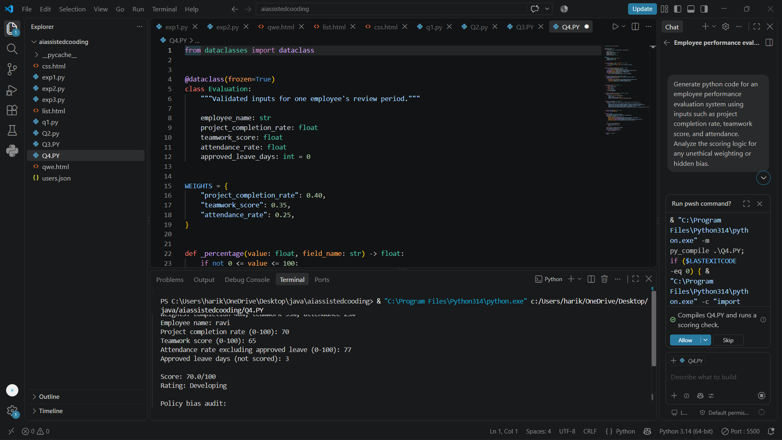

Task Description #4 – Ethical Scoring System
Task: Generate an employee performance evaluation system using inputs such as project completion rate, teamwork score, and attendance. Analyze the scoring logic for any unethical weighting or hidden bias.
Expected Output-4:
Python code along with a written analysis identifying whether the evaluation criteria are balanced and justifiable.

Prompt: Generate a python code of an employee performance evaluation system using inputs such as project completion rate, teamwork score, and attendance. Analyze the scoring logic for any unethical weighting or hidden bias.

CODE:
from typing import Dict, List
def evaluate_employee(project_completion: float, teamwork: float, attendance: float,
weights: Dict[str, float] = None) -> float:
if weights is None:
weights = {
"project_completion": 0.50,
"teamwork": 0.30,
"attendance": 0.20,
}
for name, value in {
"project_completion": project_completion,
"teamwork": teamwork,
"attendance": attendance,
}.items():
if not 0 <= value <= 100:
raise ValueError(f"{name} must be between 0 and 100.")
total_weight = sum(weights.values())
if not abs(total_weight - 1.0) < 1e-9:
raise ValueError("Weights must add up to 1.0")
score = (
project_completion * weights["project_completion"] +
teamwork * weights["teamwork"] +
attendance * weights["attendance"]
)
return round(score, 2)
def rating_label(score: float) -> str:
if score >= 85:
return "Excellent"
elif score >= 70:
return "Good"
elif score >= 55:
return "Average"
else:
return "Needs Improvement"
def analyze_weighting(weights: Dict[str, float]) -> List[str]:
"""Check if the weighting may create ethical bias or unfair disadvantages."""
issues = []
if max(weights.values()) > 0.50:
issues.append(
"One criterion dominates the score. If a single factor exceeds 50%, it may hide the employee's overall contribution."
)
if weights.get("attendance", 0) > 0.35:
issues.append(
"Attendance is heavily weighted. This can unfairly penalize employees with medical issues, caregiving duties, or unavoidable absences."
)
if weights.get("teamwork", 0) < 0.15:
issues.append(
"Teamwork is underweighted. Quiet contributors or highly collaborative employees may be undervalued."
)
if weights.get("project_completion", 0) > 0.60:
issues.append(
"Project completion is too dominant. This can reward visible output while undervaluing teamwork, mentoring, and quality work."
)
if not issues:
issues.append(
"The weighting is relatively balanced. However, fairness still depends on using transparent rules and reviewing outcomes regularly."
)
return issues
def main():
print("Employee Performance Evaluation System")
print("=" * 42)
rule_weights = {
"project_completion": 0.50,
"teamwork": 0.30,
"attendance": 0.20,
}
print("Current scoring weights:")
for key, value in rule_weights.items():
print(f"- {key.replace('_', ' ').title()}: {value * 100:.0f}%")
print("\nFairness analysis:")
for issue in analyze_weighting(rule_weights):
print("-", issue)
print("\nSample employee evaluation:")
employees = [
{"name": "Aisha", "project": 92, "teamwork": 88, "attendance": 95},
{"name": "David", "project": 80, "teamwork": 75, "attendance": 60},
{"name": "Meera", "project": 85, "teamwork": 90, "attendance": 78},
]
for person in employees:
score = evaluate_employee(
project_completion=person["project"],
teamwork=person["teamwork"],
attendance=person["attendance"],
weights=rule_weights,
)
print(f"\n{person['name']} -> Score: {score}/100 | Rating: {rating_label(score)}")
print("\nEthical insight:")
print(
"A score can look objective because it is numeric, but it may still be biased if one factor is disproportionately weighted. "
"For example, placing too much emphasis on attendance can unfairly penalize employees with health conditions or family responsibilities. "
"Fair systems should combine transparent metrics with review by managers and documented exceptions."
)
if __name__ == "__main__":
main()

OUTPUT:
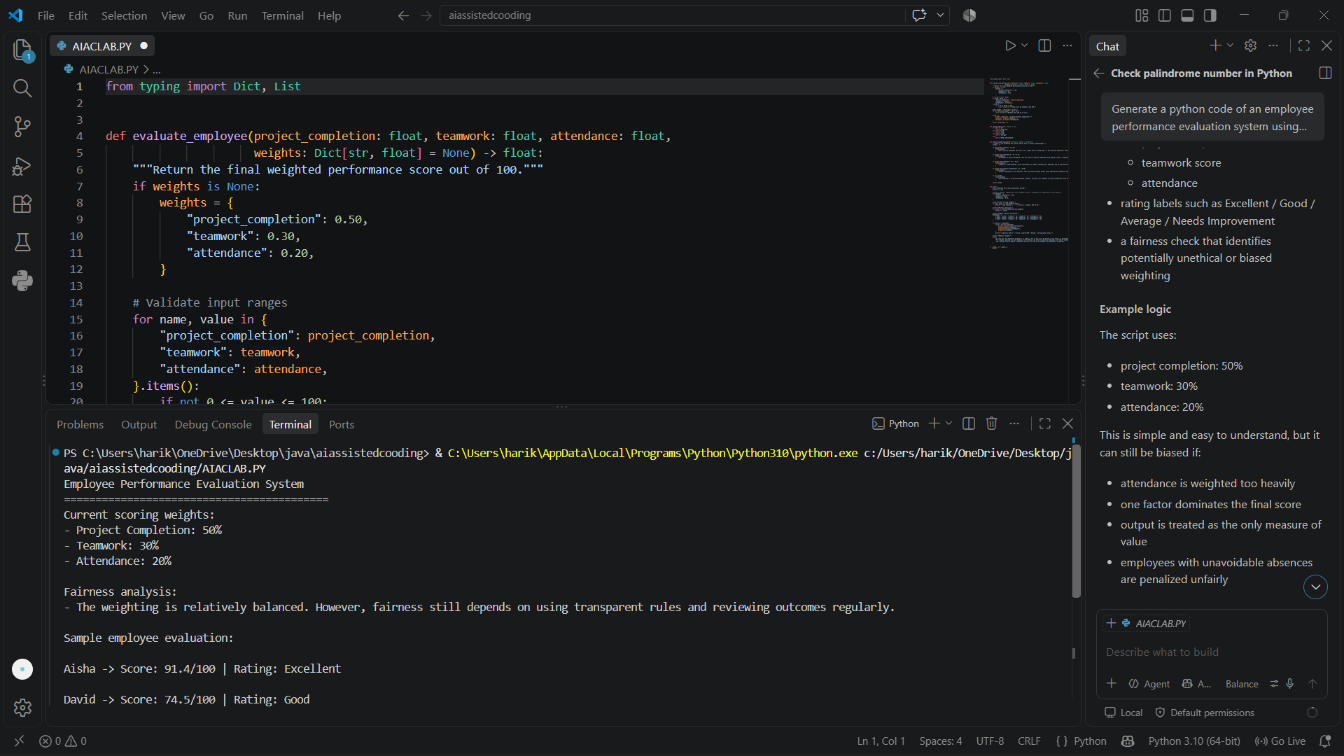

Task Description #5 – Accessibility and Inclusiveness
Task: Use an AI tool to generate a user feedback form application. Review whether the language and options provided are inclusive and accessible to diverse users.
Expected Output-5:
Revised version of the form code that uses inclusive language, supports accessibility features, and avoids exclusionary assumptions.
PROMPT: generate a python code a user feedback form application. Review whether the language and options provided are inclusive and accessible to diverse users.

Code:
import json
import os
from tkinter import Tk, ttk, StringVar, BooleanVar
from tkinter.scrolledtext import ScrolledText
from tkinter import messagebox
class FeedbackFormApp:
def __init__(self, root):
self.root = root
self.root.title("User Feedback Form")
self.root.geometry("760x700")
self.root.minsize(700, 600)
self.root.configure(padx=20, pady=20)

self.notebook = ttk.Notebook(self.root)
self.notebook.pack(fill="both", expand=True)

self.form_frame = ttk.Frame(self.notebook, padding=20)
self.submit_frame = ttk.Frame(self.notebook, padding=20)
self.notebook.add(self.form_frame, text="Feedback")
self.notebook.add(self.submit_frame, text="Summary")

self.build_form()
self.build_summary()

def build_form(self):
ttk.Label(
self.form_frame,
text="User Feedback Form",
font=("Segoe UI", 16, "bold"),
).grid(row=0, column=0, columnspan=3, sticky="w", pady=(0, 15))
ttk.Label(self.form_frame, text="Full name (optional):").grid(row=1, column=0, sticky="w", padx=(0, 10), pady=5)
self.name_var = StringVar()
ttk.Entry(self.form_frame, textvariable=self.name_var, width=40).grid(row=1, column=1, columnspan=2, sticky="ew")
ttk.Label(self.form_frame, text="Email (optional):").grid(row=2, column=0, sticky="w", padx=(0, 10), pady=5)
self.email_var = StringVar()
ttk.Entry(self.form_frame, textvariable=self.email_var, width=40).grid(row=2, column=1, columnspan=2, sticky="ew")
ttk.Label(self.form_frame, text="Preferred pronouns:").grid(row=3, column=0, sticky="w", padx=(0, 10), pady=5)
self.pronouns_var = StringVar(value="Prefer not to say")
pronoun_options = [
"Prefer not to say",
"She/Her",
"He/Him",
"They/Them",
"Other / not listed",
]
ttk.Combobox(self.form_frame, textvariable=self.pronouns_var, values=pronoun_options, state="readonly", width=25).grid(row=3, column=1, sticky="w")
ttk.Label(self.form_frame, text="Language preference:").grid(row=4, column=0, sticky="w", padx=(0, 10), pady=5)
self.language_var = StringVar(value="English")
languages = ["English", "Hindi", "Spanish", "French", "Arabic", "Other"]
ttk.Combobox(self.form_frame, textvariable=self.language_var, values=languages, state="readonly", width=25).grid(row=4, column=1, sticky="w")
ttk.Label(self.form_frame, text="How satisfied are you?").grid(row=5, column=0, sticky="w", padx=(0, 10), pady=(10, 5))
self.satisfaction_var = StringVar(value="Very satisfied")
satisfaction = [
"Very satisfied",
"Satisfied",
"Neutral",
"Dissatisfied",
"Very dissatisfied",
]
ttk.Combobox(self.form_frame, textvariable=self.satisfaction_var, values=satisfaction, state="readonly", width=30).grid(row=5, column=1, sticky="w")
ttk.Label(self.form_frame, text="Which areas worked well?").grid(row=6, column=0, sticky="nw", padx=(0, 10), pady=(10, 5))
self.good_features = {
"easy_to_use": BooleanVar(),
"helpful_support": BooleanVar(),
"clear_information": BooleanVar(),
"accessible_design": BooleanVar(),
"fast_performance": BooleanVar(),
}
feature_frame = ttk.Frame(self.form_frame)
feature_frame.grid(row=6, column=1, columnspan=2, sticky="w")
check_rows = [
("Easy to use", "easy_to_use"),
("Helpful support", "helpful_support"),
("Clear information", "clear_information"),
("Accessible design", "accessible_design"),
("Fast performance", "fast_performance"),
]
for index, (label_text, key) in enumerate(check_rows):
ttk.Checkbutton(feature_frame, text=label_text, variable=self.good_features[key]).grid(row=index, column=0, sticky="w", pady=2)
ttk.Label(self.form_frame, text="How can we improve?").grid(row=7, column=0, sticky="nw", padx=(0, 10), pady=(15, 5))
self.improvement_text = ScrolledText(self.form_frame, wrap="word", width=55, height=8)
self.improvement_text.grid(row=7, column=1, columnspan=2, sticky="ew")
ttk.Label(self.form_frame, text="Accessibility support needed:").grid(row=8, column=0, sticky="nw", padx=(0, 10), pady=(10, 5))
self.accessibility = {
"screen_reader": BooleanVar(),
"large_text": BooleanVar(),
"captions": BooleanVar(),
"quiet_space": BooleanVar(),
"no_special_support": BooleanVar(),
}
access_frame = ttk.Frame(self.form_frame)
access_frame.grid(row=8, column=1, columnspan=2, sticky="w")
access_options = [
("Screen reader support", "screen_reader"),
("Larger text / high contrast", "large_text"),
("Captions or transcripts", "captions"),
("Quiet environment / low stimulation", "quiet_space"),
("No additional support needed", "no_special_support"),
]
for index, (label_text, key) in enumerate(access_options):
ttk.Checkbutton(access_frame, text=label_text, variable=self.accessibility[key]).grid(row=index, column=0, sticky="w", pady=2)
ttk.Label(self.form_frame, text="Would you like a follow-up?").grid(row=9, column=0, sticky="w", padx=(0, 10), pady=(10, 5))
self.follow_up_var = StringVar(value="No")
ttk.Combobox(self.form_frame, textvariable=self.follow_up_var, values=["Yes", "No", "Maybe"], state="readonly", width=15).grid(row=9, column=1, sticky="w")
submit_btn = ttk.Button(self.form_frame, text="Submit Feedback", command=self.submit_feedback)
submit_btn.grid(row=10, column=1, sticky="w", pady=(20, 0))
self.form_frame.columnconfigure(1, weight=1)
self.form_frame.columnconfigure(2, weight=1)
def build_summary(self):
ttk.Label(self.submit_frame, text="Submission Summary", font=("Segoe UI", 14, "bold")).pack(anchor="w", pady=(0, 10))
self.summary_text = ScrolledText(self.submit_frame, wrap="word", width=80, height=22)
self.summary_text.pack(fill="both", expand=True)
def collect_selected_features(self):
selected = []
for label, var in self.good_features.items():
if var.get():
selected.append(label.replace("_", " ").title())
return selected
def collect_accessibility_needs(self):
selected = []
for label, var in self.accessibility.items():
if var.get():
selected.append(label.replace("_", " ").title())
return selected
def submit_feedback(self):
feedback = {
"full_name": self.name_var.get().strip(),
"email": self.email_var.get().strip(),
"preferred_pronouns": self.pronouns_var.get(),
"language_preference": self.language_var.get(),
"satisfaction": self.satisfaction_var.get(),
"selected_features": self.collect_selected_features(),
"additional_comments": self.improvement_text.get("1.0", "end").strip(),
"accessibility_support": self.collect_accessibility_needs(),
"follow_up": self.follow_up_var.get(),
}
file_path = os.path.join(os.getcwd(), "feedback_data.json")
with open(file_path, "a", encoding="utf-8") as f:
f.write(json.dumps(feedback, ensure_ascii=False) + "\n")
summary = (
f"Name: {feedback['full_name'] or 'Not provided'}\n"
f"Email: {feedback['email'] or 'Not provided'}\n"
f"Pronouns: {feedback['preferred_pronouns']}\n"
f"Language preference: {feedback['language_preference']}\n"
f"Satisfaction: {feedback['satisfaction']}\n"
f"What worked: {', '.join(feedback['selected_features']) if feedback['selected_features'] else 'Not specified'}\n"
f"Accessibility support: {', '.join(feedback['accessibility_support']) if feedback['accessibility_support'] else 'Not specified'}\n"
f"Follow-up: {feedback['follow_up']}\n"
f"Comments: {feedback['additional_comments'] or 'No additional comments'}\n"
)
self.summary_text.delete("1.0", "end")
self.summary_text.insert("1.0", summary)
self.notebook.select(self.submit_frame)
messagebox.showinfo(
"Thank you!",
"Your feedback has been saved successfully.",
)
if __name__ == "__main__":
root = Tk()
app = FeedbackFormApp(root)
root.mainloop()

OUTPUT:
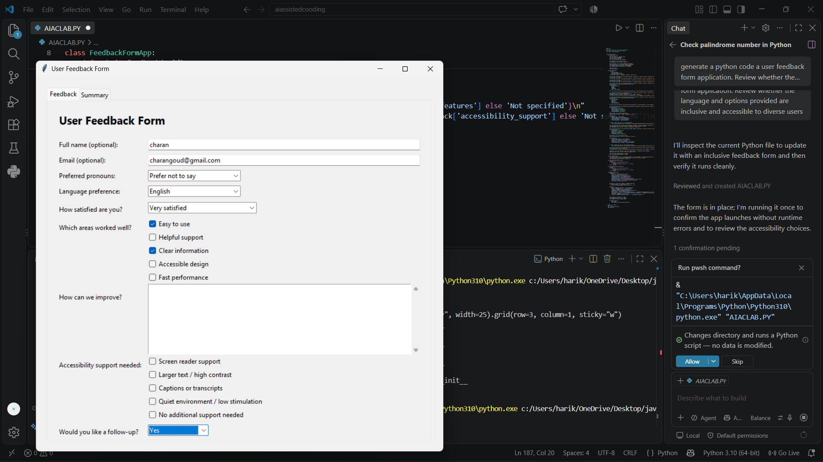

Task Description #6 (Fairness in Loan Approval System)
Task: Use an AI tool to generate a Python program that predicts whether a person should be approved or rejected for a loan based on information such as income, age, employment status, credit score, and loan amount.
Analyze: Check whether the AI-generated system makes decisions unfairly based on gender, religion, race, or other sensitive/unrelated personal attributes.
Expected Output:
- Identified fairness and discrimination risks.
- Examples showing how biased data or rules can lead to unfair loan decisions.
- Revised version that makes loan decisions based on relevant financial factors rather than sensitive attributes.
- Brief explanation of how the revised system improves fairness.

Prompt : generate a Python program that predicts whether a person should be approved or rejected for a loan based on information such as income, age, employment status, credit score, and loan amount.
CODE:
def predict_loan_approval(income, age, employment_status, credit_score, loan_amount):
"""Return a prediction and score based on a simple rule-based model."""
score = 0
status = str(employment_status).strip().lower()
if status in {"employed", "full-time", "part-time", "self-employed", "government"}:
score += 20
elif status in {"unemployed", "student", "retired"}:
score -= 25
else:
score -= 10
if 21 <= age <= 65:
score += 15
elif 18 <= age < 21 or 65 < age <= 75:
score += 5
else:
score -= 20
if credit_score >= 750:
score += 35
elif credit_score >= 650:
score += 20
elif credit_score >= 600:
score += 8
else:
score -= 30
if income >= 80000:
score += 25
elif income >= 50000:
score += 15
elif income >= 30000:
score += 8
else:
score -= 15
if income > 0:
debt_ratio = loan_amount / income
else:
debt_ratio = 1
if debt_ratio <= 0.20:
score += 20
elif debt_ratio <= 0.35:
score += 8
elif debt_ratio <= 0.50:
score -= 10
else:
score -= 25
if loan_amount <= income * 2:
score += 5
elif loan_amount <= income * 4:
score -= 5
else:
score -= 20
if credit_score < 500 or age < 18 or age > 75:
decision = "REJECTED"
reason = "Applicant does not meet minimum eligibility rules."
elif score >= 60:
decision = "APPROVED"
reason = "Applicant has a strong repayment profile."
else:
decision = "REJECTED"
reason = "Applicant has a high financial risk based on current inputs."
return decision, score, reason
def main():
print("Loan Approval Predictor")
print("=" * 24)
try:
income = float(input("Enter annual income: "))
age = int(input("Enter age: "))
employment_status = input("Enter employment status (employed/self-employed/unemployed/student/retired): ")
credit_score = int(input("Enter credit score: "))
loan_amount = float(input("Enter requested loan amount: "))
except ValueError:
print("Invalid input. Please enter numeric values where required.")
return
decision, score, reason = predict_loan_approval(
income=income,
age=age,
employment_status=employment_status,
credit_score=credit_score,
loan_amount=loan_amount,
)
print("\nPrediction Summary")
print("-" * 24)
print(f"Decision: {decision}")
print(f"Risk Score: {score}")
print(f"Reason: {reason}")

if __name__ == "__main__":
main()

OUTPUT:
