# Insert data:

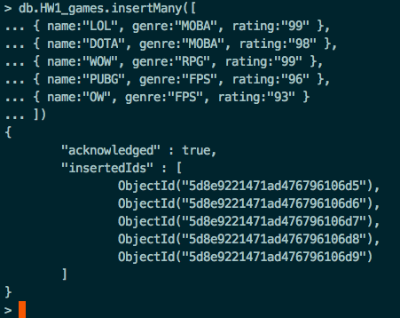

# FIND ALL:

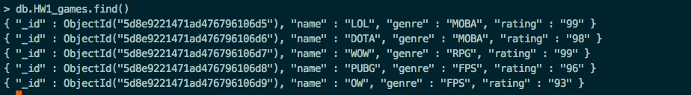

# FIND ONE:

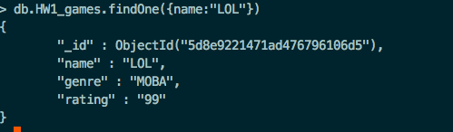

# FIND TOP 3 RATINGS:

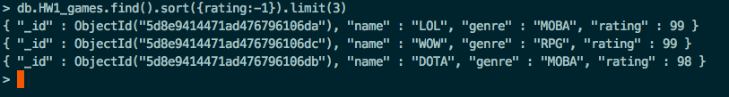

# UPDATE WITH “UPDATE” FUNCTION:

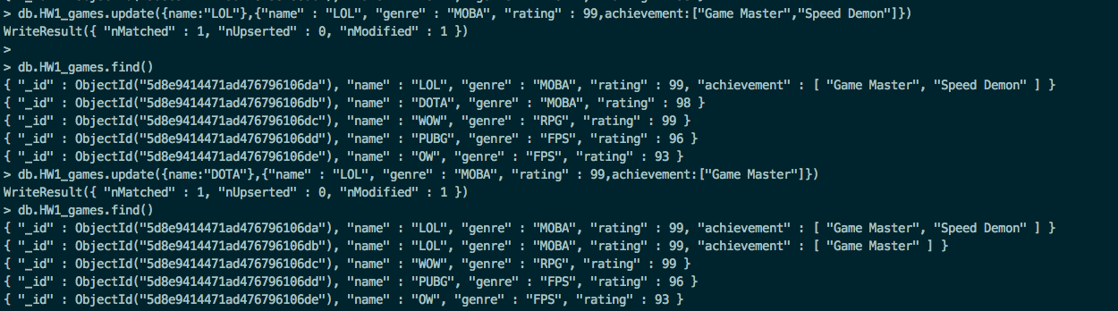

# UPDATE WITH “SAVE” FUNCTION:

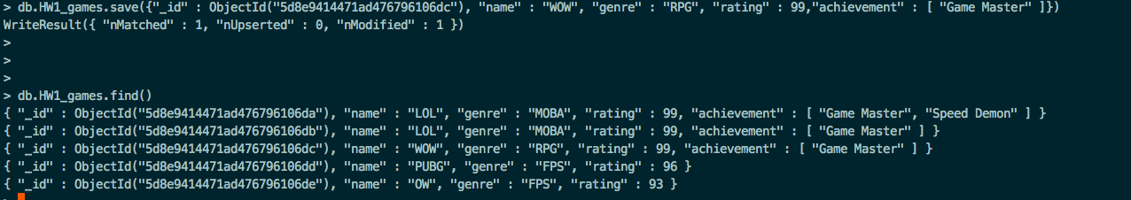

QUERY GAME WITH BOTH TWO ACHIEVEMENTS:



QUERY GAMES CONTAINING ACHIEVEMENTS:

