>db.MR_for_generes.help()

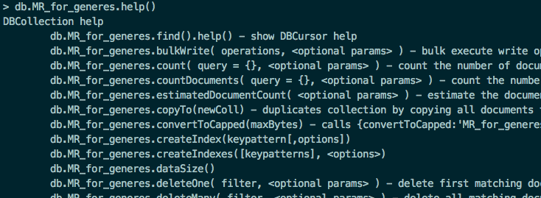

>db.MR_for_generes.dataSize()



> db.MR_for_generes.count()



**> db.MR_for_generes.totalSize()**



**> db.MR_for_generes.drop()**

