目 录

1. 园区网建设的需求分析 1
2. 园区网安全建设目标 2
3. 园区网拓扑结构设计 3
4. 网络设备选型 8
5. 网络设备配置 10
5.1 VLAN与Trunk配置 10
5.2 DHCP自动分配配置 11
5.3 OSPF动态路由配置 12
5.4 NAT地址转换配置 12
5.5 防火墙双机热备配置 14
5.6 GRE配置 15
6. 网络连通性测试 15
6.1 教一楼ping教二楼 16
6.2 行政楼ping信息中心PC1 16
6.3 行政楼DHCP获取ip地址 17
6.4 行政楼ping联通服务器 17
6.5 行政楼ping北校区 18
6.6 行政楼ping北校区教学楼 18
6.7 行政楼财政服务器 19
6.8 服务器80端口访问 21
6.9 2号学院楼ping外网 22
7. 园区网安全性分析 23
7.1 网络整体现状概述 23
7.2 网络现存主要安全风险 23
7.3 校园网面临的主要安全威胁类型 24
7.4 现有安全防护体系短板分析 25
7.5 网络安全综合评估 25
7.6 网络安全优化改进建议 26
8. 网络管理 27
8.1 设备远程管理 27
8.2 设备监控 28
8.3 应急响应 29
参考文献 34
附录 35
附录A 35
附录B 37

一. 园区网建设的需求分析

1.1 业务需求
1. VLAN与Trunk建设
将内网划分为多个VLAN，减小广播域。
交换机端口配置Access，允许VLAN通过。
交换机端口配置Trunk，允许多VLAN通过。
2. 网关与VLAN间路由
核心交换机配置各VLAN的网关，实现VLAN间路由。
3. DHCP自动分配
核心层为用户终端自动分配IP地址、网关、DNS。
4. 动态路由（OSPF）
所有校区之间运行动态路由协议，实现路由自动学习与链路冗余。
5. 出口多链路选路
至少两条出口链路，配置主备或负载均衡，单链路故障时自动切换。
6. NAT地址转换
内网用户访问互联网时，源地址转换为公网IP。
7. Web服务器映射
将内网Web服务器的80端口映射到公网，允许外网访问。
8. 设备远程管理
所有网络设备支持远程登录管理，使用统一认证账号。
9. 部分VLAN禁止上网
企业财务服务器，只允许（行政楼）的职工访问。其他职工禁止访问。
禁止二号学院楼的职工访问外网且关键设备做好实时监控
10.设备监控
设置管理口令和协议版本，以便网管软件能监控或配置设备。

园区网安全建设目标

2.1 安全需求
1.防止外部网络非法访问内部服务器。
2.防止内部用户进行扫描、攻击或越权访问。
3.实现端口安全，限制每个接入端口最大 MAC 地址数。
4.记录关键流量日志，支持攻击检测与溯源。

2.2 性能与可靠性
1.核心链路采用链路聚合与冗余设计。
2.核心交换机双机热备（VRRP/HSRP）。

三. 园区网拓扑结构设计

3.1 组网说明
本园区网络整体采用核心层、汇聚层、接入层经典三层网络架构，搭配独立服务器区域与出口安全区域，同时通过 GRE 隧道实现多校区跨网互联、防火墙双机热备保障出口可靠性，整体组网兼顾功能性、安全性、冗余性与可扩展性，具体组网规划如下：
层级划分与设备部署：全网划分为接入层、汇聚层、核心层三大转发层级，另设置服务器区、出口安全区、外网运营商区域。接入层部署多台接入交换机，分别对应教学楼、科研楼、一号学院楼、行政楼、图书馆、实验楼、二号学院楼等楼宇终端接入，负责终端设备入网、VLAN 划分与端口安全控制；汇聚层交换机对接各楼宇接入设备，汇聚区域流量，执行 ACL 访问控制、流量监管等策略；核心层部署两台高性能核心交换机 LSW1、LSW2，采用链路聚合、VRRP 冗余备份，承担全网高速数据转发、VLAN 间路由、DHCP 服务、OSPF 动态路由等核心功能，是整个园区网的数据转发中枢。
VLAN与二层组网：按照不同楼宇、业务区域划分独立VLAN，将广播域进行分割，抑制广播风暴。接入交换机下联终端端口配置为 Access模式，划入对应业务VLAN；接入交换机上联汇聚交换机、汇聚交换机上联核心交换机的互联端口统一配置为Trunk模式，允许所有业务VLAN数据透传，保障二层跨设备同VLAN终端正常通信。同时全网部署MSTP多生成树协议，解决二层环路问题，实现链路冗余与流量负载分担。
三层路由与跨校区互联：全网内部统一运行OSPF 动态路由协议，骨干区域为 Area 0，各分支区域划分对应OSPF非骨干区域，核心设备、汇聚设备、校区互联路由器均加入OSPF进程，实现内网路由自动学习、收敛，简化路由配置。主校区、北校区、南校区之间搭建GRE隧道，实现不同校区私有网络跨公网互通。
出口安全与链路冗余：网络出口部署两台防火墙FW1、FW2，组成双机热备架构，实现设备级冗余，单台防火墙故障时流量可自动切换至另一台，保障外网访问不中断。防火墙作为内网边界安全网关，部署安全区域划分、安全策略、NAT 地址转换、服务器端口映射功能：内网私有地址通过源 NAT 转换为公网地址访问互联网；内网 Web 服务器通过目的 NAT 端口映射，对外提供公网访问服务。园区设置联通、移动两条运营商出口链路，配置主备路由，实现链路级冗余，单运营商线路故障可自动切换链路。
业务与安全策略组网：财务服务器部署在独立服务器区域，通过防火墙与交换机 ACL 策略做访问限制，仅允许行政楼网段访问，拒绝其他区域越权访问；针对二号学院楼网段配置上网限制策略，禁止该区域终端访问外网。全网交换机开启端口安全功能，限制接入端口最大 MAC 地址数量，防范非法设备接入。所有网络设备配置 AAA 认证、远程登录服务与SNMP网管协议，支持统一远程管理，满足运维与安全溯源需求。
地址分配规则：内网终端以DHCP 自动获取 IP为主，由核心交换机统一搭建全局地址池，为不同 VLAN 分配对应网段 IP、网关及 DNS 地址；服务器、核心网关、互联接口、网络设备管理地址采用静态 IP配置，保证关键设备地址固定。设备之间点对点互联链路统一使用 / 30 掩码子网，合理节约 IP 地址资源。

3.2 拓扑说明
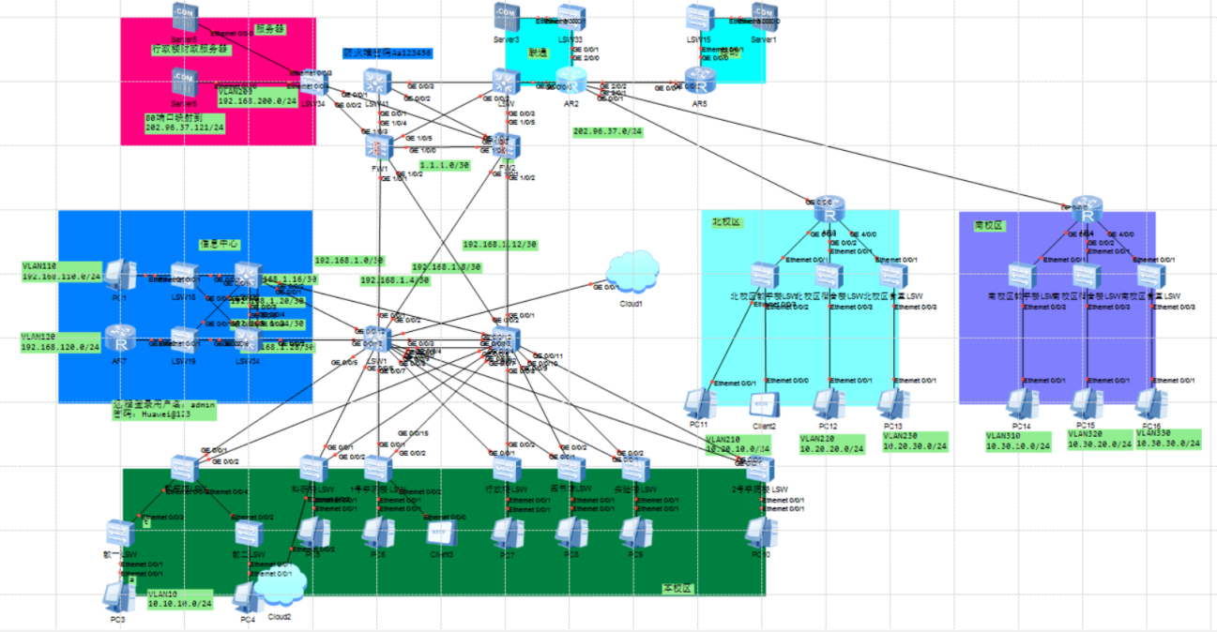
层级 | 设备 | 功能
核心层 | LSW1 / LSW2 | 高速转发、VLAN 间路由、冗余
汇聚层 | 教学楼LSW | 区域流量汇聚、执行 ACL 策略
接入层 | 科研楼LSW，1号学院楼LSW，行政楼LSW,图书馆LSW,实验楼LSW,2号学院楼LSW | 用户接入、端口安全、VLAN 划分
边界安全 | FW-1 / FW-2（主备） | NAT、访问控制、VPN、攻击防护
服务器集群 | 行政楼财政服务器，web服务器，联通服务器，移动服务器 | 业务服务与数据存储

3.3 IP 地址规划
全网采用私有IP地址与公网IP地址混合规划方案。校园网内部用户采用私有IP地址，通过防火墙NAT地址转换访问互联网。各功能区域按照VLAN进行地址划分，具体规划如下：
VLAN ID | 网段 | 网关 | 用途 | 所属区域
VLAN 10 | 10.10.10.0/24 | 10.10.10.254 | 教学楼用户终端 | 主校区
VLAN 210 | 10.20.10.0/24 | 10.20.10.254 | 北校区教学楼 | 北校区
VLAN 220 | 10.20.20.0/24 | 10.20.20.254 | 北校区宿舍楼 | 北校区
VLAN 230 | 10.20.30.0/24 | 10.20.30.254 | 北校区食堂 | 北校区
VLAN 310 | 10.30.10.0/24 | 10.30.10.254 | 南校区教学楼 | 南校区
VLAN 320 | 10.30.20.0/24 | 10.30.20.254 | 南校区宿舍楼 | 南校区
VLAN 330 | 10.30.30.0/24 | 10.30.30.254 | 南校区食堂 | 南校区
VLAN 110 | 192.168.110.0/24 | 192.168.110.254 | 信息中心管理网段 | 主校区
VLAN 200 | 192.168.200.0/24 | 192.168.200.254 | 内部服务器网段 | 主校区

网络互联地址采用/30子网掩码，每条点对点链路分配一个独立网段。互联地址规划如下：
互联链路 | IP网段 | 互联设备
防火墙 FW1至FW2 | 1.1.1.0/30 | FW1 ↔ FW2
核心 LSW1至防火墙FW1 | 192.168.1.0/30 | LSW1 ↔ FW1
核心 LSW1至FW2 | 192.168.1.4/30 | LSW1 ↔ FW2
核心LSW2至FW1 | 192.168.1.8/30 | LSW2 ↔ FW1
核心LSW2至FW1 | 192.168.1.12/30 | LSW2 ↔ FW2
信息中心至LSW1 | 192.168.1.16/30 | LSW32 ↔ FW1
信息中心至LSW1 | 192.168.1.20/30 | LSW32 ↔ FW2
信息中心至LSW2 | 192.168.1.24/30 | LSW34 ↔ FW1
信息中心至LSW2 | 192.168.1.28/30 | LSW34 ↔ FW2

公网出口地址规划：联通出口网段116.116.116.0/24，移动出口网段117.117.117.0/24。出口路由器与运营商之间运行OSPF实现路由可达。
DHCP地址分配策略：终端用户PC默认通过DHCP自动获取IP地址；服务器及关键管理设备（PC1等）采用静态IP地址配置。
DHCP服务器部署在核心层，为各VLAN提供地址分配服务，同时下发默认网关及DNS服务器地址。

四. 网络设备选型
设备类型 | 型号 | 关键特性
核心交换机 | S5700 | 高吞吐、冗余电源、支持 VRRP/IRF2
汇聚交换机 | S3700 | 三层功能、ACL、QoS、VLAN 间路由
接入交换机 | H3C S5120V2-28P | 千兆接入、端口安全、802.1X 认证
防火墙 | H3C SecPath F1070 | 应用识别、入侵防御、VPN、双机热备
IDS | Snort + 日志服务器 | 开源入侵检测，规则定期更新
服务器 | 华为 FusionServer | 部署 Web、DB、文件、备份服务

五、网络设备配置
此处仅展示部分关键命令，完整配置命令详见附录B。

5.1 VLAN与Trunk配置
在核心交换机（LSW1/LSW2）及各接入交换机上创建业务VLAN，实现二层网络隔离。接入交换机与核心交换机之间配置Trunk链路，允许所有业务VLAN通过。以主校区教学楼区域为例：
【核心交换机LSW1关键配置】
vlan batch 10 20 21 22 30 31 32 110 120 200
interface GigabitEthernet0/0/1 # 上联FW1
port link-type access
port default vlan 110
interface GigabitEthernet0/0/2 # 上联FW2
port link-type access
port default vlan 110
interface GigabitEthernet0/0/3 # 互联LSW2
port link-type trunk
port trunk allow-pass vlan all
interface GigabitEthernet0/0/4 # 下联教学楼LSW
port link-type trunk
port trunk allow-pass vlan 120
# 配置VLANIF接口作为各VLAN网关
interface Vlanif10
ip address 10.10.10.254 255.255.255.0
interface Vlanif110
ip address 192.168.110.254 255.255.255.0
interface Vlanif120
ip address 192.168.120.254 255.255.255.0

5.2 DHCP自动分配配置
在核心交换机上启用DHCP服务，为各VLAN终端自动分配IP地址。配置全局DHCP地址池及接口DHCP模式：
dhcp enable
ip pool vlan10
network 10.10.10.0 mask 255.255.255.0
gateway-list 10.10.10.254
dns-list 115.115.115.115
interface Vlanif10
dhcp select global
ip pool vlan120
network 192.168.120.0 mask 255.255.255.0
gateway-list 192.168.120.254
dns-list 115.115.115.115
interface Vlanif120
dhcp select global

5.3 OSPF动态路由配置
启用OSPF动态路由协议，区域0为骨干区域，实现路由自动学习与快速收敛。核心交换机、汇聚交换机、路由器均参与OSPF路由域：
ospf 1 router-id 1.1.1.1
area 0.0.0.0
network 192.168.110.0 0.0.0.255
network 10.10.10.0 0.0.0.255
network 192.168.1.0 0.0.0.3
network 192.168.1.4 0.0.0.3
# 出口路由器引入默认路由
ospf 1
default-route-advertise always

5.4 NAT地址转换配置
本次园区网采用源 NAT（PAT 多对多转换） 实现内网用户访问互联网，搭配目的 NAT（服务器端口映射） 实现内网 Web 服务器对外发布，同时结合多出口链路、安全策略完成 NAT 部署，以下基于 FW1 设备配置说明，FW2 配置逻辑一致。
1. 配置 NAT 地址组
定义公网地址池，工作模式为 PAT，支持多终端共用公网 IP 访问外网。
plaintext
nat address-group 0 2
mode pat
section 0 202.96.37.20 202.96.37.30
nat address-group 1 1
mode pat
section 0 202.96.37.88 202.96.37.88
2. 配置源 NAT 策略
匹配内网信任区域访问外网非信任区域的流量，对指定内网网段进行源地址转换，同时排除南北校区跨校区流量，避免误转换。
plaintext
nat-policy
rule name nat
source-zone trust
destination-zone untrust
source-address 10.10.0.0 mask 255.255.192.0
source-address 192.168.110.0 mask 255.255.255.0
source-address 192.168.120.0 mask 255.255.255.0
destination-address-exclude 10.20.0.0 mask 255.255.0.0
destination-address-exclude 10.30.0.0 mask 255.255.0.0
action source-nat address-group 0
3. 配置服务器端口映射（目的 NAT）
将 DMZ 区域内网 Web 服务器的 80 端口映射至公网地址，实现外网用户访问内网业务服务。
plaintext
nat server server6_all protocol tcp global 202.96.37.121 www inside 192.168.200.2 www

5.5 防火墙双机热备配置
采用HRP+VRRP实现两台防火墙主备冗余，设备故障时流量自动切换。
1. 主防火墙 FW1 配置
plaintext
hrp enable
hrp interface GigabitEthernet1/0/0 remote 1.1.1.2
hrp mirror session enable

interface GigabitEthernet1/0/3
vrrp vrid 2 virtual-ip 192.168.200.254 active
interface GigabitEthernet1/0/4
vrrp vrid 1 virtual-ip 100.1.1.1 active
interface GigabitEthernet1/0/5
vrrp vrid 2 virtual-ip 2.2.2.1 active
2. 简要说明
全局启用 HRP 建立双机备份、同步会话表；各接口配置 VRRP 虚拟网关，FW1 作为主设备。FW2 对应接口 VRRP 状态为standby，为主设备故障时的备用网关，实现设备与链路双重热备。

5.6 GRE配置
通过 GRE 隧道实现主校区与南北校区跨公网三层互通，防火墙两端分别配置隧道接口。
FW1 隧道配置
plaintext
interface Tunnel1
ip address 192.168.1.17 255.255.255.252
tunnel-protocol gre
source 100.1.1.2
destination 116.116.116.2
interface Tunnel2
ip address 192.168.1.21 255.255.255.252
tunnel-protocol gre
source 2.2.2.2
destination 117.117.117.2

六、网络连通性测试

6.1 教一楼ping教二楼
测试目的：验证同一VLAN内终端之间的二层通信正常，在VLAN10上ping同VLAN10内其他终端，验证二层可达性。预期结果：同VLAN内PC之间可以相互ping通，且ARP表项正常学习。
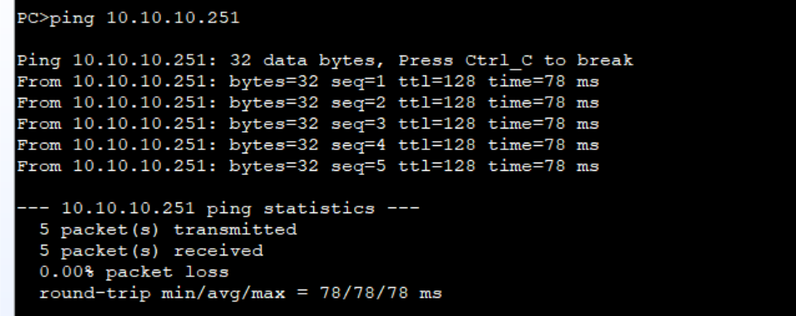

6.2 行政楼ping信息中心PC1
测试目的：验证不同VLAN之间通过核心交换机VLANIF三层接口实现互通。从VLAN40（行政楼）的PC ping VLAN110（信息中心）的终端，验证跨VLAN三层通信。预期结果：核心交换机上VLANIF接口状态UP，跨VLAN Ping成功。
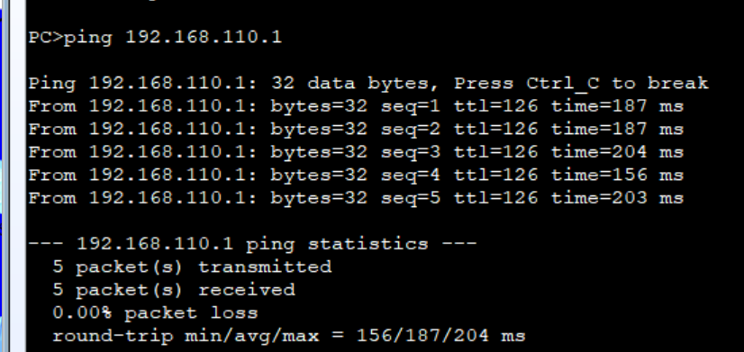

6.3 行政楼DHCP获取ip地址
测试目的：验证终端PC能够通过DHCP自动获取IP地址、子网掩码、默认网关及DNS服务器信息。将PC设置为DHCP模式，执行ipconfig 命令。预期结果：终端成功获取对应VLAN网段的IP地址及网络参数。
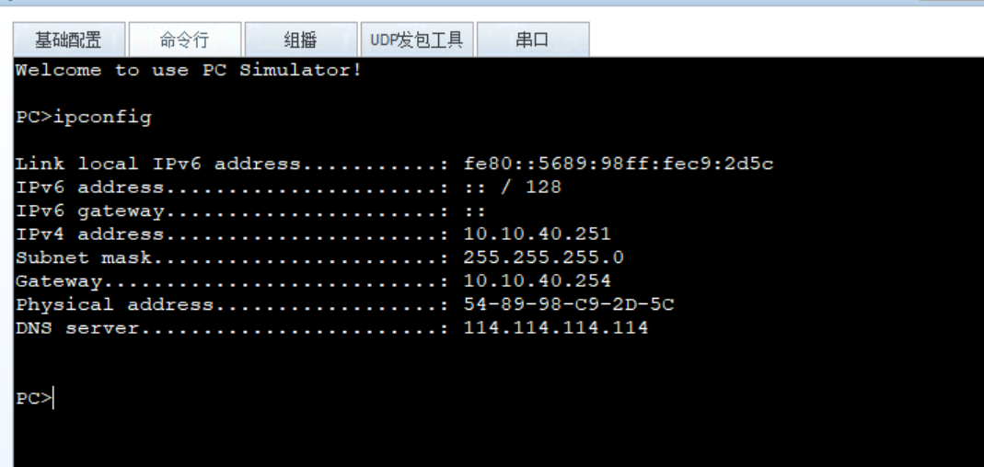

6.4 行政楼ping联通服务器
测试目的：验证内网能否ping通外网

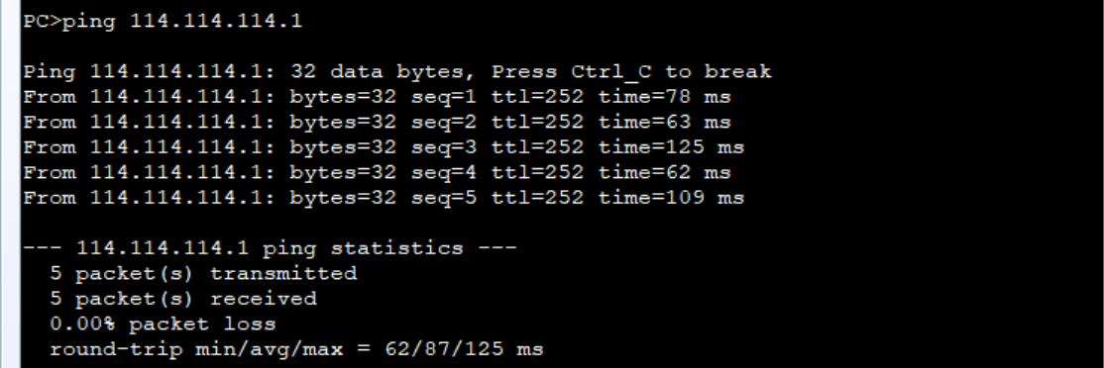

6.5 行政楼ping北校区
测试目的：验证主校区与北校区之间通过GRE隧道实现跨Internet互通。
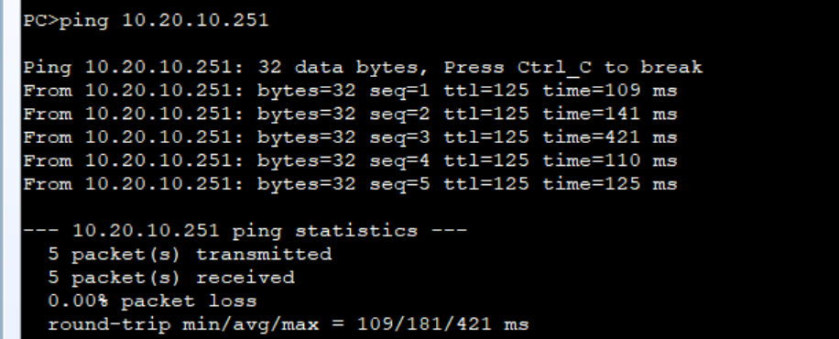

6.6 行政楼ping北校区教学楼
测试目的：验证FW1与FW2之间的双机热备切换功能。手动断开FW1的上行链路，观察FW2是否自动接管流量，业务中断时间是否在秒级范围内。预期结果：FW2自动切换为主设备，业务中断时间<3秒，切换后内网用户上网不受影响。
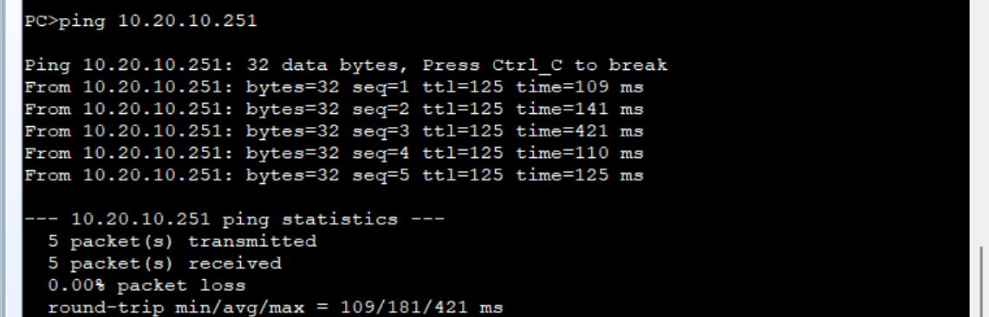

6.7 行政楼财政服务器
行政楼ping财政服务器。
测试目的：验证行政楼能否访问行政楼服务器。
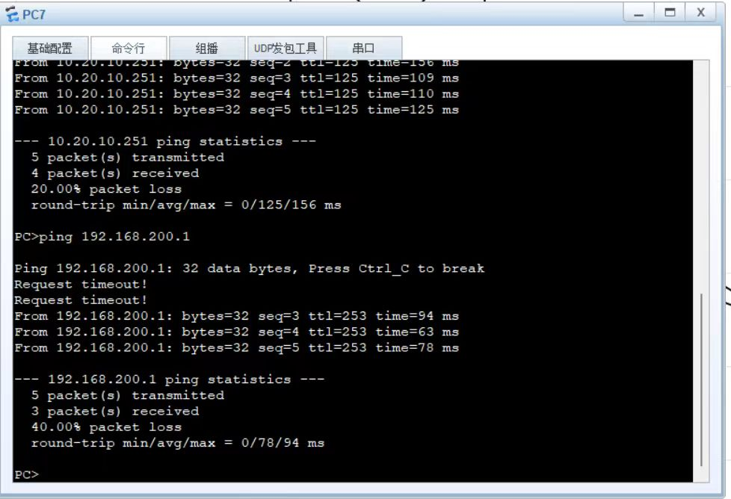
内网其余ping财政服务器。
测试目的：验证其余能否访问财政服务器。
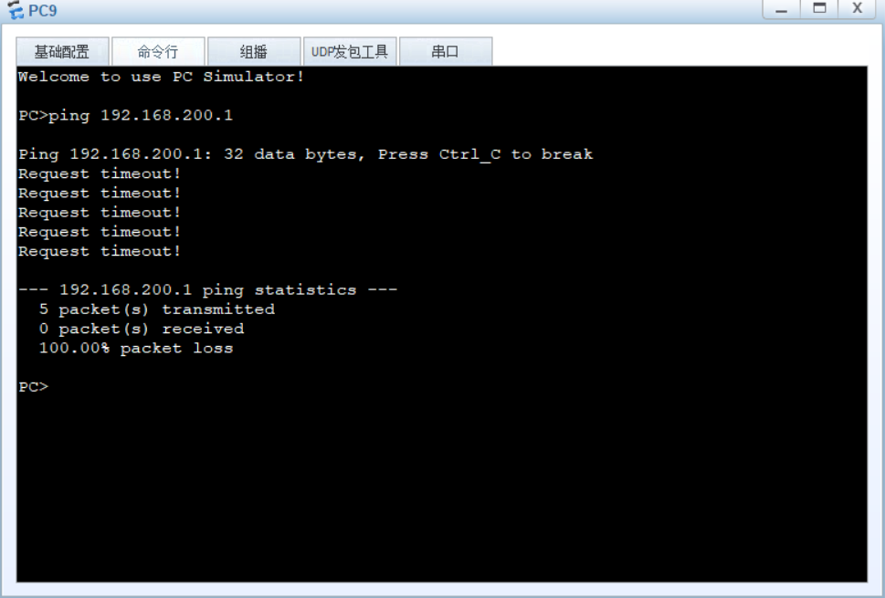
外网ping财政服务器。
测试目的：验证外网能否访问财政服务器。
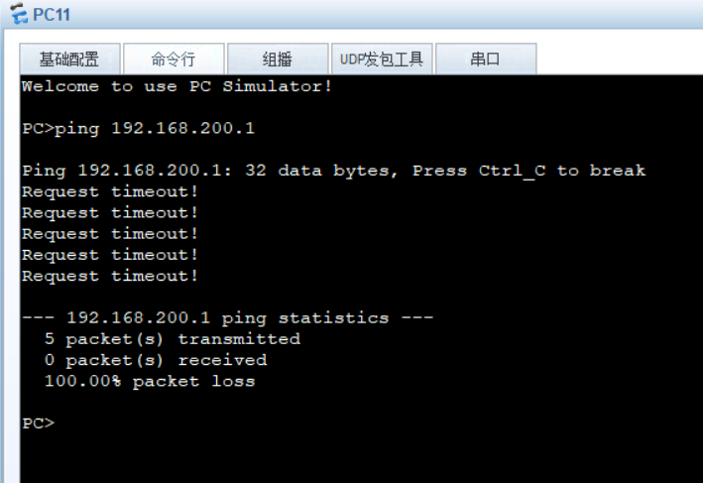

6.8 服务器80端口访问
外网访问80端口。
测试目的：外网可以正常访问80端口。
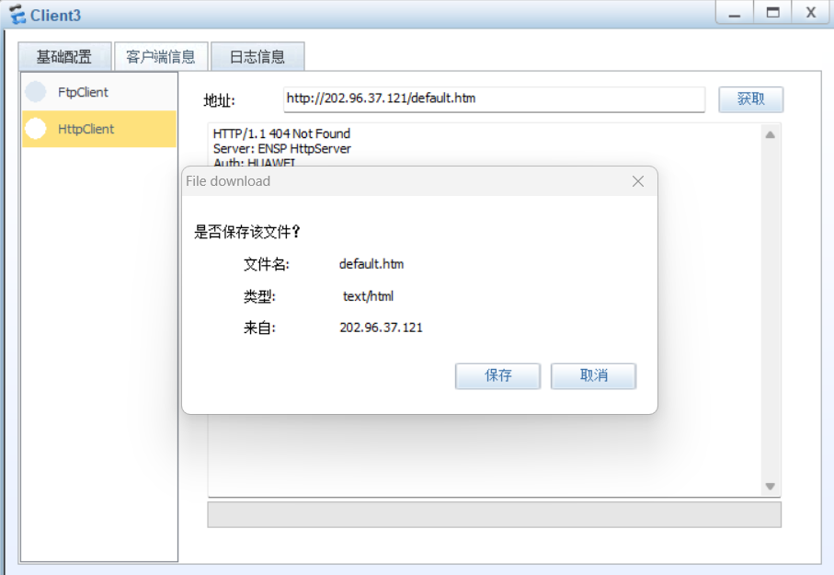
内网访问80端口。
测试目的：内网可以正常访问80端口。

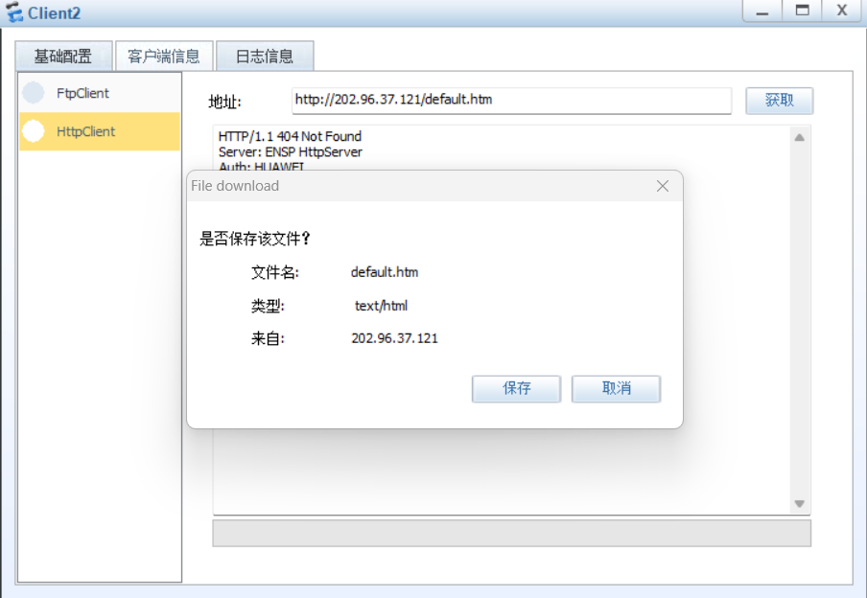
PC机ping服务器。
测试目的：只能访问80端口，其他端口应不能访问。
预测结果：ping超时。

6.9 2号学院楼ping外网
测试目的：测试2号学院楼能否访问外网。
预测结果：ping超时。
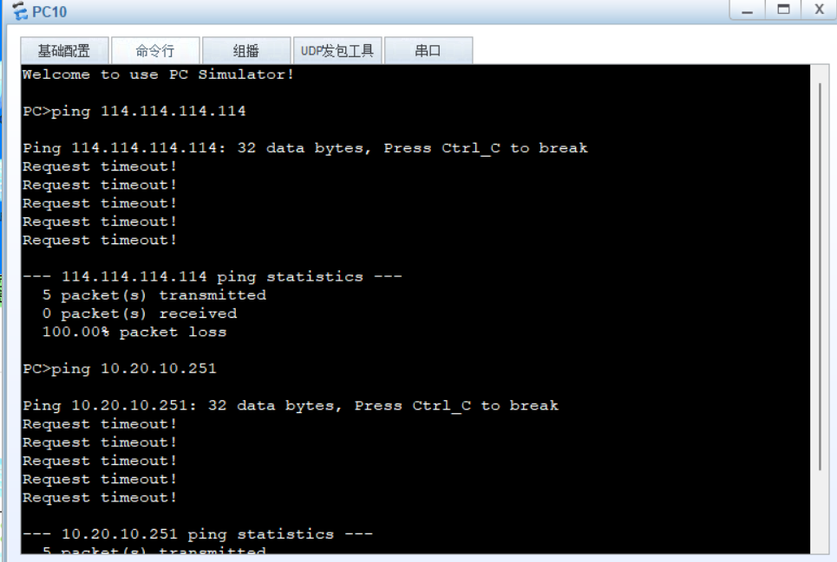

七、网络网安全性分析

7.1 网络整体现状概述
本次园区网采用三层架构搭建，划分多 VLAN 实现二层隔离，搭配防火墙、接入安全策略、动态路由、GRE 隧道等技术，完成主校区、北校区、南校区多区域互联。网络部署了 VLAN 隔离、端口安全、防火墙访问控制、NAT 转换、双机热备、远程管理认证等基础安全机制，同时通过 OSPF、VRRP、链路聚合实现网络冗余，保障业务连续运行。整体网络可满足日常办公、上网、内网服务发布、跨校区通信等基础业务需求，基础安全防护体系已初步建成，能够抵御常规的非法接入、跨网段越权访问等简单威胁。

7.2 网络现存主要安全风险
接入层安全风险：虽然配置端口安全限制接入终端数量，但未开启 802.1X 认证、MAC 地址绑定，存在私自更换终端、盗用合法端口接入非法设备的风险。
设备管理风险：全网设备统一使用固定管理账号与密码，口令复杂度虽达标，但未定期轮换，存在账号泄露、远程登录被暴力破解的隐患。
日志与审计缺失：设备仅开启基础 SNMP 监控，未部署独立日志服务器与行为审计系统，流量异常、违规操作无法完整记录，安全事件难以溯源。
边界防护短板：防火墙仅配置基础包过滤策略，未深度开启入侵防御、病毒查杀、URL 过滤功能，无法抵御木马、恶意脚本、网页攻击等应用层威胁。
GRE 隧道安全风险：校区间 GRE 隧道为明文传输，数据在公网转发过程中存在被窃听、篡改的风险。
广播域与环路隐患：虽部署 VLAN 与生成树协议，但未对广播风暴、异常组播流量做限流策略，大流量广播报文易造成网络卡顿。

7.3 校园网面临的主要安全威胁类型
结合园区使用场景与网络架构，梳理出日常运行中易遭遇的安全威胁：
非法接入威胁：用户私自加装路由器、随身 WiFi、外来终端接入内网，挤占带宽同时引入外部病毒与恶意程序。
越权访问威胁：内网用户尝试访问财务服务器、管理网段等涉密区域，非法窃取内部数据。
网络攻击威胁：包括 ARP 欺骗、端口扫描、泛洪攻击，易造成网关欺骗、网络断网、带宽拥塞。
外网恶意威胁：外网木马、钓鱼网站、恶意攻击通过互联网渗透至内网，入侵终端与服务器。
数据传输威胁：跨校区 GRE 明文隧道传输业务数据，存在数据窃听、篡改风险。
人为操作威胁：员工误配置设备、违规使用下载软件、传播病毒文件，引发内网大面积故障。

7.4 现有安全防护体系短板分析
防护层次单一：当前防护集中在二层隔离 + 三层包过滤，仅实现基础访问控制，缺乏应用层安全防护，对高级攻击防御能力不足。
安全设备功能未充分利用：防火墙仅启用 NAT、VRRP、基础安全策略，入侵防御、防病毒、内容过滤等安全模块处于闲置状态。
终端安全管控薄弱：安全策略仅部署在网络设备上，未对接终端安全软件，无法对终端行为、病毒、木马进行统一管控。
安全监控与预警能力不足：仅依靠 SNMP 查看设备运行状态，无实时流量监控、异常告警功能，安全问题出现后无法提前预警。
隧道与传输安全缺失：GRE 隧道未加密，公网传输数据无保护机制，跨校区数据安全性无法保障。
应急响应机制不完善：未制定安全事件应急处置流程，遭遇攻击、网络瘫痪时，故障排查与恢复效率较低。

7.5 网络安全综合评估
综合网络架构、安全配置、测试结果与风险分析，对本园区网安全等级综合评估如下：
基础访问安全：合格。通过 VLAN、ACL、端口安全、网段权限划分，实现内网区域隔离与访问管控，可杜绝基础越权访问、非法接入问题。
设备与链路可靠性：良好。防火墙双机热备、核心设备 VRRP 冗余、多出口链路备份，有效解决单点故障，网络稳定性较强。
边界外网防护：基本合格。仅依靠基础包过滤策略，应用层攻击防御能力弱，外网入侵风险较高。
跨校区传输安全：不合格。GRE 明文传输，数据保密性差，存在数据泄露风险。
安全审计与溯源：不合格。无独立日志审计系统，异常行为无法记录、追溯。
整体安全等级：基础可用，防护偏弱。网络可满足正常业务运行与基础安全需求，但面对复杂网络攻击、高级威胁时抵御能力不足，距离标准化校园安全网络还有较大优化空间。

7.6 网络安全优化改进建议
强化接入层安全 在接入交换机配置静态 MAC + 端口绑定，结合 802.1X 身份认证，杜绝非法终端入网；配置广播风暴抑制策略，限制异常广播流量。
加固设备管理安全 定期更换设备管理密码，划分不同权限管理账号，细化运维权限；关闭不必要的远程登录服务，仅开放指定地址段访问设备。
提升边界防火墙防护能力 启用防火墙入侵防御、防病毒、URL 过滤、应用识别功能，拦截木马、钓鱼网站与网络攻击；细化安全策略，严格管控内外网双向流量。
加固跨校区隧道安全 在现有 GRE 隧道基础上叠加 IPSec 加密，实现跨校区数据加密传输，防止数据窃听与篡改。
搭建日志与审计系统 部署独立日志服务器，收集全网设备流量、登录、策略命中日志，实现安全事件可查询、可溯源；开启设备异常告警功能。
完善终端与整体防护体系 全网统一部署终端安全软件，实现终端病毒查杀、行为管控；划分安全区域，形成 “接入 - 汇聚 - 核心 - 边界” 多层防护架构。
制定安全管理制度与应急方案 建立网络设备运维、口令管理、终端入网等规章制度；编写网络攻击、断网、病毒爆发等场景的应急处置流程，提升故障处理效率。

网络管理

8.1 设备远程管理
本次网络设备开启远程登录功能，支持Telnet协议，结合设备配置与实际测试，对协议的安全性进行分析。
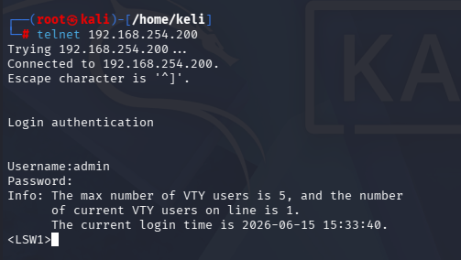
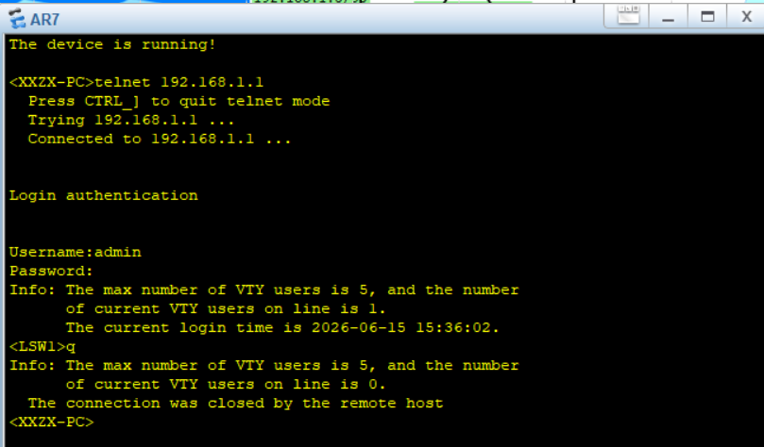
Telnet 属于明文传输协议，设备登录账号、密码、配置指令等所有数据均以明文形式在网络中转发。在ARP中间人欺骗测试环境下，攻击者可轻松截获Telnet登录凭证，直接获取设备管理员权限，篡改网络配置、关闭安全策略，对整网造成严重破坏。

8.1 设备监控
应用snmp实现设备监控，使用软件snmpb监控设备。
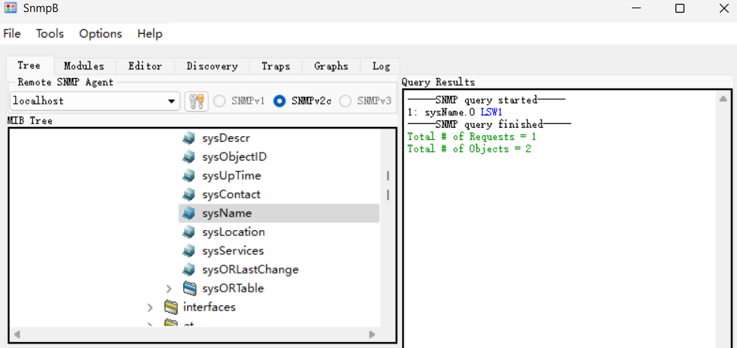

8.3 应急响应
结合本次连通性与功能测试过程，模拟并观测到几类典型网络异常与安全事件：
1.DHCP 耗尽攻击测试
攻击操作：在 Kali 主机执行dhcpstarv -i eth5 -v 10.10.20.1-254，工具持续向网段 DHCP 服务器大批量发送伪造 DHCP 请求报文，疯狂抢占地址池内可用 IP。
攻击现象：日志持续输出分配记录，大量虚拟 MAC 地址从 DHCP 服务器 10.10.20.254 获取 10.10.20 网段 IP 地址；服务器仅下发 IP、缺失子网掩码配置项。短时间内地址池可用地址被虚假终端大量占用，合法后续接入设备无法获取 IP，出现内网断网、入网失败故障。
风险危害：属于拒绝服务攻击，直接瘫痪网段 DHCP 分配服务，阻止正常办公终端、业务设备接入网络，大面积影响内网基础连通。
防范：立即在核心交换机上开启 DHCP Snooping 功能，将上联口（连接合法DHCP服务器）设为信任接口，非信任端口丢弃来自非信任端口的DHCP请求报文，阻止伪造DHCP报文。在接入交换机上配置 接口限速，限制每秒DHCP报文数量，减缓攻击流量冲击。若攻击持续，通过日志获取攻击源MAC地址，在接入交换机上手动添加MAC黑洞或ACL屏蔽该MAC。长远部署IP Source Guard，结合DHCP Snooping绑定表，防止非法终端获取IP。
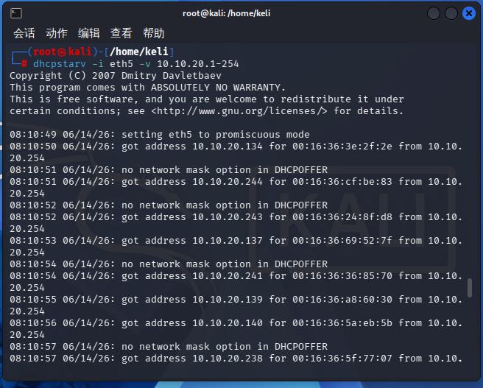
2.ARP 双向欺骗中间人攻击测试
攻击操作：向终端 10.10.20.251 发送伪造 ARP 报文，谎称网关 10.10.20.254 的 MAC 为攻击机网卡 MAC；同步向网关发送伪造 ARP，谎称终端 IP 对应攻击机 MAC，实现流量劫持。
攻击现象：前期欺骗包持续发送，短暂无流量拦截；之后成功劫持双向流量，监控捕获终端与网关之间的传输数据包。攻击机作为中间人，可以窃听、篡改内网明文传输数据（账号、文件、网页内容等）。
防范：在核心交换机上启用 DAI（动态ARP检测），结合DHCP Snooping绑定表，校验ARP报文的IP-MAC对应关系，丢弃非法ARP报文，从根本上阻断欺骗。在接入交换机端口启用 端口安全，限制每个端口学习到的MAC数量，并配置静态MAC绑定（如将网关MAC与上行口绑定），防止伪造网关。紧急情况下，在核心交换机上手工配置静态ARP条目（如 arp static 10.10.20.254 xxxx-xxxx-xxxx），同时在受影响终端上临时使用 arp -s 绑定网关MAC。长远部署防ARP欺骗的终端安全软件，并划分更细的VLAN减少广播域。
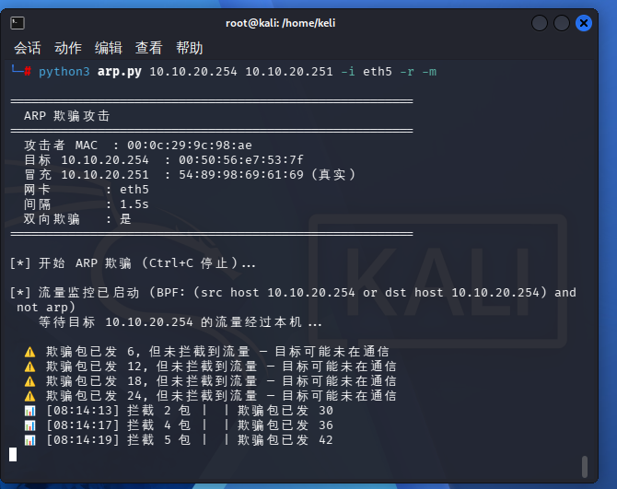
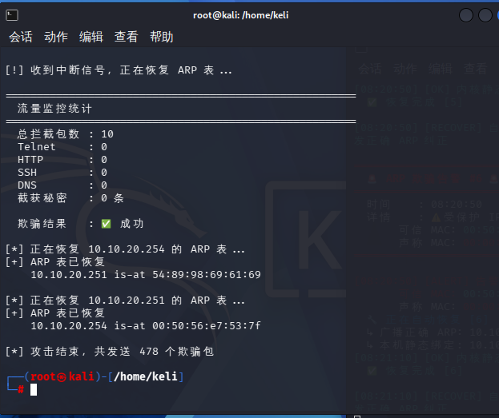
被攻击后ping网关不通。
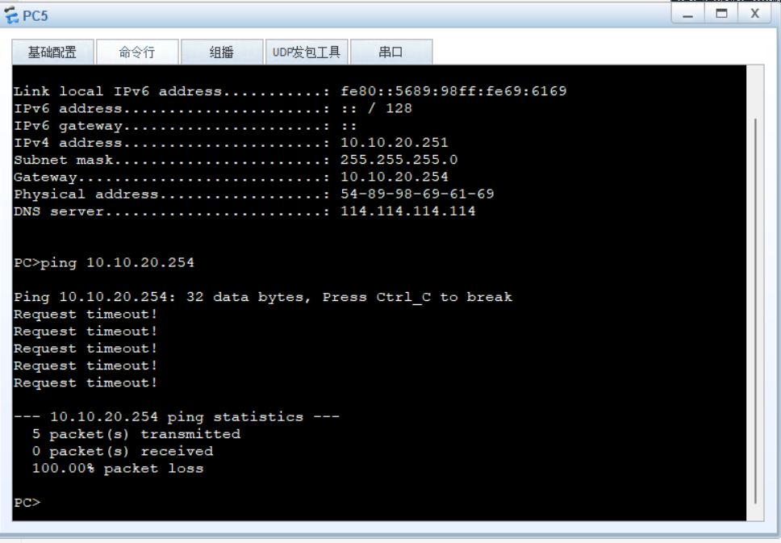
3.主机存活探测
攻击操作：扫描网段存活主机，通过 ICMP、ARP 扫描快速嗅探在线设备。
探测现象：扫描快速输出网段内所有开机终端、网关、服务器 IP 与对应 MAC 地址，攻击者可快速绘制内网资产拓扑，定位可攻击目标。
安全风险：为后续端口爆破、漏洞渗透、定向欺骗攻击提供精准目标情报，是内网渗透的前置侦察步骤。
防范：在边界防火墙上配置策略，限制外部对内部IP的ICMP探测（非必要不响应），同时在内网核心交换机上通过ACL限制跨网段的ICMP请求。部署入侵检测系统（IDS），配置规则检测异常扫描流量（如短时间内大量ICMP或ARP请求），并触发告警。在接入交换机上启用 端口隔离，使同一VLAN内终端之间二层隔离，减少内部扫描面。运维人员发现扫描告警后，及时定位扫描源IP并临时阻断，同时排查该主机是否已被入侵。
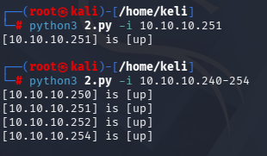
- 端口探测
攻击操作：针对存活主机开展全端口扫描，识别开放服务端口。
探测现象：扫描结果列出目标开放端口、对应服务版本（如 80 Web、22 SSH、3389 远程桌面等）；攻击者依据开放端口匹配对应系统漏洞、弱口令爆破点。
安全风险：暴露设备对外业务端口与服务版本，极易引发漏洞利用、暴力破解、恶意入侵，威胁终端与服务器数据安全。
防范：在防火墙上配置 入侵防御（IPS） 规则，识别并丢弃端口扫描流量，同时启用扫描攻击防护，自动封禁扫描源IP一段时间。对内部服务器，仅开放必要端口（如仅开放80/443），并在防火墙上做严格的目的NAT映射，限制访问来源。定期对内部系统进行漏洞扫描，及时关闭非必要服务，更新服务版本，减少攻击面。发现端口探测告警后，立即对目标主机进行安全加固，检查是否存在已利用漏洞，并修改默认服务端口（如将SSH改为非标准端口）。
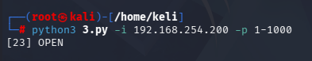

参考文献
[1] 华为技术有限公司. Huawei S5700系列交换机产品文档[Z]. 2024.
[2] 华为技术有限公司. Huawei USG6000V系列防火墙管理员指南[Z]. 2023.
[3] 华为技术有限公司. eNSP网络仿真平台用户手册[Z]. 2024.
[4] 谢希仁. 计算机网络（第8版）[M]. 北京: 电子工业出版社, 2021.
[5] 石志国, 薛为民. 网络安全技术与应用实践[M]. 北京: 清华大学出版社, 2022.
[6] RFC 2328: OSPF Version 2[S]. IETF, 1998.
[7] RFC 2784: Generic Routing Encapsulation (GRE)[S]. IETF, 2000.

附录

附录A 拓扑设备清单（部分）
序号 | 设备名称 | 设备型号 | 所属区域
1 | FW1 | USG6000V | 出口区域
2 | FW2 | USG6000V | 出口区域
3 | LSW1 | S5700 | 核心层
4 | LSW2 | S5700 | 核心层
5 | LSW32 | S5700 | 汇聚层
6 | LSW34 | S5700 | 汇聚层
7 | LSW41 | S5700 | 汇聚层
8 | LSW33 | S3700 | 汇聚层
9 | LSW15 | S3700 | 汇聚层
10 | LSW18 | S3700 | 汇聚层
11 | LSW19 | S3700 | 汇聚层
12 | 教学楼LSW | S3700 | 主校区汇聚层
13 | 办公楼LSW | S3700 | 主校区汇聚层
14 | 1号学院楼LSW | S3700 | 主校区汇聚层
15 | 2号学院楼LSW | S3700 | 主校区汇聚层
16 | 图书馆LSW | S3700 | 主校区汇聚层
17 | 实验楼LSW | S3700 | 主校区汇聚层
18 | 教一LSW | S3700 | 主校区接入层
19 | 教二LSW | S3700 | 主校区接入层
20 | 北校区教学楼LSW | S3700 | 北校区汇聚层
21 | 北校区食堂LSW | S3700 | 北校区汇聚层
22 | 北校区宿舍楼LSW | S3700 | 北校区汇聚层
23 | 南校区教学楼LSW | S3700 | 南校区汇聚层
24 | 南校区食堂LSW | S3700 | 南校区汇聚层
25 | 北校区宿舍楼LSW | S3700 | 南校区汇聚层
26 | AR2 | AR1220 | 出口区域
27 | AR3 | AR2240 | 北校区核心
28 | AR4 | AR2240 | 南校区核心
29 | AR5 | AR2220 | 出口区域
30 | AR7 | AR2220 | 出口区域
31 | Server1 | Server | 服务器区
32 | Server3 | Server | 服务器区
33 | Server5 | Server | 服务器区
34 | Server6 | Server | 服务器区
35 | Client2 | Client | 北校区
36 | PC1 | PC | 信息中心

附录B 配置命令汇总

教一LSW
sysname J1
vlan batch 10 20 30 40 50 60 70 100
stp region-configuration
region-name huawei
revision-level 1
instance 1 vlan 10 20 30 100 to 102
instance 2 vlan 40 50 60 70 103 to 104
instance 3 vlan 105 to 108 110 120
active region-configuration
aaa
authentication-scheme default
authorization-scheme default
accounting-scheme default
domain default
domain default_admin
local-user admin password cipher <K.R)YFE!!(I\I9%HS7.!Q!!
local-user admin privilege level 15
local-user admin service-type telnet
interface Ethernet0/0/1
port link-type access
port default vlan 10
interface Ethernet0/0/2
port link-type trunk
port trunk pvid vlan 100
port trunk allow-pass vlan 2 to 4094
interface Ethernet0/0/3
port link-type trunk
port trunk allow-pass vlan 2 to 4094
snmp-agent
snmp-agent local-engineid 800007DB034C1FCCEC3794
snmp-agent community read one@123
snmp-agent sys-info version v2c v3
snmp-agent trap enable
user-interface con 0
user-interface vty 0 4
authentication-mode aaa
protocol inbound all
return

教二LSW
sysname J2
vlan batch 10 20 30 40 50 60 70 100
stp region-configuration
region-name huawei
revision-level 1
instance 1 vlan 10 20 30 100 to 102
instance 2 vlan 40 50 60 70 103 to 104
instance 3 vlan 105 to 108 110 120
active region-configuration
aaa
authentication-scheme default
authorization-scheme default
accounting-scheme default
domain default
domain default_admin
local-user admin password cipher <K.R)YFE!!(I\I9%HS7.!Q!!
local-user admin privilege level 15
local-user admin service-type telnet
interface Ethernet0/0/1
port link-type access
port default vlan 10
interface Ethernet0/0/2
port link-type trunk
port trunk allow-pass vlan 2 to 4094
interface Ethernet0/0/3
port link-type trunk
port trunk pvid vlan 100
port trunk allow-pass vlan 2 to 4094
snmp-agent
snmp-agent local-engineid 800007DB034C1FCCE30444
snmp-agent community read one@123
snmp-agent sys-info version v2c v3
snmp-agent trap enable
user-interface con 0
user-interface vty 0 4
authentication-mode aaa
protocol inbound all
return

教学楼LSW
sysname JX
vlan batch 10 20 30 40 50 60 70 100
stp region-configuration
region-name huawei
revision-level 1
instance 1 vlan 10 20 30 100 to 102
instance 2 vlan 40 50 60 70 103 to 104
instance 3 vlan 105 to 108 110 120
active region-configuration
aaa
authentication-scheme default
authorization-scheme default
accounting-scheme default
domain default
domain default_admin
local-user admin password cipher <K.R)YFE!!(I\I9%HS7.!Q!!
local-user admin privilege level 15
local-user admin service-type telnet
interface Ethernet0/0/3
port link-type trunk
port trunk allow-pass vlan 2 to 4094
interface Ethernet0/0/4
port link-type trunk
port trunk allow-pass vlan 2 to 4094
interface GigabitEthernet0/0/1
port link-type trunk
port trunk allow-pass vlan 2 to 4094
snmp-agent
snmp-agent local-engineid 800007DB034C1FCCAC4BE6
snmp-agent community read one@123
snmp-agent sys-info version v2c v3
snmp-agent trap enable
user-interface con 0
user-interface vty 0 4
authentication-mode aaa
protocol inbound all
return

科研楼LSW
sysname KY
vlan batch 10 20 30 40 50 60 70 100
stp region-configuration
region-name huawei
revision-level 1
instance 1 vlan 10 20 30 100 to 102
instance 2 vlan 40 50 60 70 103 to 104
instance 3 vlan 105 to 108 110 120
active region-configuration
aaa
authentication-scheme default
authorization-scheme default
accounting-scheme default
domain default
domain default_admin
local-user admin password cipher <K.R)YFE!!(I\I9%HS7.!Q!!
local-user admin privilege level 15
local-user admin service-type telnet
interface Ethernet0/0/1
port link-type access
port default vlan 20
interface GigabitEthernet0/0/1
port link-type trunk
port trunk pvid vlan 100
port trunk allow-pass vlan 2 to 4094
interface GigabitEthernet0/0/2
port link-type trunk
port trunk allow-pass vlan 2 to 4094
snmp-agent
snmp-agent local-engineid 800007DB034C1FCCA12D91
snmp-agent community read one@123
snmp-agent sys-info version v2c v3
snmp-agent trap enable
user-interface con 0
user-interface vty 0 4
authentication-mode aaa
protocol inbound all
return

1号学院楼
sysname X1
vlan batch 10 20 30 40 50 60 70 100
stp region-configuration
region-name huawei
revision-level 1
instance 1 vlan 10 20 30 100 to 102
instance 2 vlan 40 50 60 70 103 to 104
instance 3 vlan 105 to 108 110 120
active region-configuration
aaa
authentication-scheme default
authorization-scheme default
accounting-scheme default
domain default
domain default_admin
local-user admin password cipher <K.R)YFE!!(I\I9%HS7.!Q!!
local-user admin privilege level 15
local-user admin service-type telnet
interface Ethernet0/0/1
port link-type access
port default vlan 30
interface GigabitEthernet0/0/1
port link-type trunk
port trunk pvid vlan 100
port trunk allow-pass vlan 2 to 4094
interface GigabitEthernet0/0/2
port link-type trunk
port trunk allow-pass vlan 2 to 4094
snmp-agent
snmp-agent local-engineid 800007DB034C1FCC036E4A
snmp-agent community read one@123
snmp-agent sys-info version v2c v3
snmp-agent trap enable
user-interface con 0
user-interface vty 0 4
authentication-mode aaa
protocol inbound all
return

行政楼
sysname XZ
vlan batch 10 20 30 40 50 60 70 100
stp region-configuration
region-name huawei
revision-level 1
instance 1 vlan 10 20 30 100 to 102
instance 2 vlan 40 50 60 70 103 to 104
instance 3 vlan 105 to 108 110 120
active region-configuration
aaa
authentication-scheme default
authorization-scheme default
accounting-scheme default
domain default
domain default_admin
local-user admin password cipher <K.R)YFE!!(I\I9%HS7.!Q!!
local-user admin privilege level 15
local-user admin service-type telnet
interface Ethernet0/0/1
port link-type access
port default vlan 40
interface GigabitEthernet0/0/1
port link-type trunk
port trunk pvid vlan 100
port trunk allow-pass vlan 2 to 4094
interface GigabitEthernet0/0/2
port link-type trunk
port trunk allow-pass vlan 2 to 4094
snmp-agent
snmp-agent local-engineid 800007DB034C1FCCC74F7A
snmp-agent community read one@123
snmp-agent sys-info version v2c v3
snmp-agent trap enable
user-interface con 0
user-interface vty 0 4
authentication-mode aaa
protocol inbound all
return

图书馆
sysname TS
vlan batch 10 20 30 40 50 60 70 100
stp region-configuration
region-name huawei
revision-level 1
instance 1 vlan 10 20 30 100 to 102
instance 2 vlan 40 50 60 70 103 to 104
instance 3 vlan 105 to 108 110 120
active region-configuration
aaa
authentication-scheme default
authorization-scheme default
accounting-scheme default
domain default
domain default_admin
local-user admin password cipher <K.R)YFE!!(I\I9%HS7.!Q!!
local-user admin privilege level 15
local-user admin service-type telnet
interface Ethernet0/0/1
port link-type access
port default vlan 50
interface GigabitEthernet0/0/1
port link-type trunk
port trunk pvid vlan 100
port trunk allow-pass vlan 2 to 4094
interface GigabitEthernet0/0/2
port link-type trunk
port trunk allow-pass vlan 2 to 4094
snmp-agent
snmp-agent local-engineid 800007DB034C1FCCFD1786
snmp-agent community read one@123
snmp-agent sys-info version v2c v3
snmp-agent trap enable
user-interface con 0
user-interface vty 0 4
authentication-mode aaa
protocol inbound all
return

实验楼
sysname SY
vlan batch 10 20 30 40 50 60 70 100
stp region-configuration
region-name huawei
revision-level 1
instance 1 vlan 10 20 30 100 to 102
instance 2 vlan 40 50 60 70 103 to 104
instance 3 vlan 105 to 108 110 120
active region-configuration
aaa
authentication-scheme default
authorization-scheme default
accounting-scheme default
domain default
domain default_admin
local-user admin password cipher <K.R)YFE!!(I\I9%HS7.!Q!!
local-user admin privilege level 15
local-user admin service-type telnet
interface Ethernet0/0/1
port link-type access
port default vlan 60
interface GigabitEthernet0/0/1
port link-type trunk
port trunk pvid vlan 100
port trunk allow-pass vlan 2 to 4094
interface GigabitEthernet0/0/2
port link-type trunk
port trunk allow-pass vlan 2 to 4094
snmp-agent
snmp-agent local-engineid 800007DB034C1FCCE30657
snmp-agent community read one@123
snmp-agent sys-info version v2c v3
snmp-agent trap enable
user-interface con 0
user-interface vty 0 4
authentication-mode aaa
protocol inbound all
return

2号学院楼
sysname X2
vlan batch 10 20 30 40 50 60 70 100
stp region-configuration
region-name huawei
revision-level 1
instance 1 vlan 10 20 30 100 to 102
instance 2 vlan 40 50 60 70 103 to 104
instance 3 vlan 105 to 108 110 120
active region-configuration
aaa
authentication-scheme default
authorization-scheme default
accounting-scheme default
domain default
domain default_admin
local-user admin password cipher <K.R)YFE!!(I\I9%HS7.!Q!!
local-user admin privilege level 15
local-user admin service-type telnet
interface Ethernet0/0/1
port link-type access
port default vlan 70
interface GigabitEthernet0/0/1
port link-type trunk
port trunk pvid vlan 100
port trunk allow-pass vlan 2 to 4094
interface GigabitEthernet0/0/2
port link-type trunk
port trunk allow-pass vlan 2 to 4094
snmp-agent
snmp-agent local-engineid 800007DB034C1FCC35019D
snmp-agent community read one@123
snmp-agent sys-info version v2c v3
snmp-agent trap enable
user-interface con 0
user-interface vty 0 4
authentication-mode aaa
protocol inbound all
return

AR7
[V200R003C00]
sysname XXZX-PC
snmp-agent local-engineid 800007DB03000000000000
snmp-agent
clock timezone China-Standard-Time minus 08:00:00
portal local-server load portalpage.zip
drop illegal-mac alarm
set cpu-usage threshold 80 restore 75
aaa
authentication-scheme default
authorization-scheme default
accounting-scheme default
domain default
domain default_admin
local-user admin password cipher %$%$K8m.Nt84DZ}e#<0`8bmE3Uw}%$%$
local-user admin service-type http
firewall zone Local
priority 15
interface GigabitEthernet0/0/0
ip address 192.168.120.1 255.255.255.0
ip route-static 0.0.0.0 0.0.0.0 192.168.120.254
user-interface con 0
authentication-mode password
user-interface vty 0 4
user-interface vty 16 20
wlan ac
return

LSW18
sysname LSW18
vlan batch 110 120
aaa
authentication-scheme default
authorization-scheme default
accounting-scheme default
domain default
domain default_admin
local-user admin password cipher <K.R)YFE!!(I\I9%HS7.!Q!!
local-user admin privilege level 15
local-user admin service-type telnet
interface Ethernet0/0/1
port link-type access
port default vlan 110
interface GigabitEthernet0/0/1
port link-type trunk
port trunk allow-pass vlan 2 to 4094
interface GigabitEthernet0/0/2
port link-type trunk
port trunk allow-pass vlan 2 to 4094
snmp-agent
snmp-agent local-engineid 800007DB034C1FCC8879DE
snmp-agent community read one@123
snmp-agent sys-info version v2c v3
snmp-agent trap enable
user-interface con 0
user-interface vty 0 4
authentication-mode aaa
protocol inbound all
return

LSW19
sysname LSW19
vlan batch 110 120
aaa
authentication-scheme default
authorization-scheme default
accounting-scheme default
domain default
domain default_admin
local-user admin password cipher <K.R)YFE!!(I\I9%HS7.!Q!!
local-user admin privilege level 15
local-user admin service-type telnet
interface Ethernet0/0/1
port link-type access
port default vlan 120
interface GigabitEthernet0/0/1
port link-type trunk
port trunk allow-pass vlan 2 to 4094
interface GigabitEthernet0/0/2
port link-type trunk
port trunk allow-pass vlan 2 to 4094
snmp-agent
snmp-agent local-engineid 800007DB034C1FCC183B8C
snmp-agent community read one@123
snmp-agent sys-info version v2c v3
snmp-agent trap enable
user-interface con 0
user-interface vty 0 4
authentication-mode aaa
protocol inbound all
return

LSW32
sysname LSW32
undo info-center enable
vlan batch 105 to 108 110 120
stp instance 3 root primary
stp region-configuration
region-name huawei
revision-level 1
instance 1 vlan 10 20 30 100 to 102
instance 2 vlan 40 50 60 70 103 to 104
instance 3 vlan 105 to 108 110 120
active region-configuration
aaa
authentication-scheme default
authorization-scheme default
accounting-scheme default
domain default
domain default_admin
local-user admin password cipher <K.R)YFE!!(I\I9%HS7.!Q!!
local-user admin privilege level 15
local-user admin service-type telnet
interface Vlanif105
ip address 192.168.1.18 255.255.255.252
interface Vlanif106
ip address 192.168.1.22 255.255.255.252
interface Vlanif107
ip address 192.168.1.26 255.255.255.252
interface Vlanif108
ip address 192.168.1.30 255.255.255.252
interface Vlanif110
ip address 192.168.110.252 255.255.255.0
vrrp vrid 110 virtual-ip 192.168.110.254
vrrp vrid 110 priority 120
interface Vlanif120
ip address 192.168.120.252 255.255.255.0
vrrp vrid 120 virtual-ip 192.168.120.254
vrrp vrid 120 priority 120
interface Eth-Trunk2
port link-type trunk
port trunk allow-pass vlan 2 to 4094
interface GigabitEthernet0/0/1
port link-type access
port default vlan 106
stp disable
interface GigabitEthernet0/0/2
port link-type access
port default vlan 105
stp disable
interface GigabitEthernet0/0/3
eth-trunk 2
interface GigabitEthernet0/0/4
eth-trunk 2
interface GigabitEthernet0/0/5
port link-type trunk
port trunk allow-pass vlan 2 to 4094
interface GigabitEthernet0/0/6
port link-type trunk
port trunk allow-pass vlan 2 to 4094
ospf 1
area 0.0.0.2
network 192.168.110.0 0.0.0.255
network 192.168.1.16 0.0.0.3
network 192.168.1.20 0.0.0.3
network 192.168.120.0 0.0.0.255
snmp-agent
snmp-agent local-engineid 800007DB034C1FCC900A19
snmp-agent community read one@123
snmp-agent sys-info version v2c v3
snmp-agent trap enable
user-interface con 0
user-interface vty 0 4
authentication-mode aaa
protocol inbound all
return

LSW34
sysname LSW34
undo info-center enable
vlan batch 105 to 108 110 120
stp instance 3 root secondary
stp region-configuration
region-name huawei
revision-level 1
instance 1 vlan 10 20 30 100 to 102
instance 2 vlan 40 50 60 70 103 to 104
instance 3 vlan 105 to 108 110 120
active region-configuration
aaa
authentication-scheme default
authorization-scheme default
accounting-scheme default
domain default
domain default_admin
local-user admin password cipher <K.R)YFE!!(I\I9%HS7.!Q!!
local-user admin privilege level 15
local-user admin service-type telnet
interface Vlanif105
ip address 192.168.1.18 255.255.255.252
interface Vlanif106
ip address 192.168.1.22 255.255.255.252
interface Vlanif107
ip address 192.168.1.26 255.255.255.252
interface Vlanif108
ip address 192.168.1.30 255.255.255.252
interface Vlanif110
ip address 192.168.110.253 255.255.255.0
vrrp vrid 110 virtual-ip 192.168.110.254
vrrp vrid 110 priority 110
interface Vlanif120
ip address 192.168.120.253 255.255.255.0
vrrp vrid 120 virtual-ip 192.168.120.254
vrrp vrid 120 priority 110
interface Eth-Trunk2
port link-type trunk
port trunk allow-pass vlan 2 to 4094
interface GigabitEthernet0/0/1
port link-type access
port default vlan 107
stp disable
interface GigabitEthernet0/0/2
port link-type access
port default vlan 108
stp disable
interface GigabitEthernet0/0/3
eth-trunk 2
interface GigabitEthernet0/0/4
eth-trunk 2
interface GigabitEthernet0/0/5
port link-type trunk
port trunk allow-pass vlan 2 to 4094
interface GigabitEthernet0/0/6
port link-type trunk
port trunk allow-pass vlan 2 to 4094
ospf 1
default-route-advertise
area 0.0.0.2
network 192.168.120.0 0.0.0.255
network 192.168.1.24 0.0.0.3
network 192.168.1.28 0.0.0.3
network 192.168.110.0 0.0.0.255
snmp-agent
snmp-agent local-engineid 800007DB034C1FCCBC3689
snmp-agent community read one@123
snmp-agent sys-info version v2c v3
snmp-agent trap enable
user-interface con 0
user-interface vty 0 4
authentication-mode aaa
protocol inbound all
return

LSW1
sysname LSW1
undo info-center enable
vlan batch 10 20 30 40 50 60 70 100 to 108
stp instance 1 root primary
stp instance 2 root secondary
dhcp enable
stp region-configuration
region-name huawei
revision-level 1
instance 1 vlan 10 20 30 100 to 102
instance 2 vlan 40 50 60 70 103 to 104
instance 3 vlan 105 to 108 110 120
active region-configuration
ip pool vlan10
gateway-list 10.10.10.254
network 10.10.10.0 mask 255.255.255.0
excluded-ip-address 10.10.10.252 10.10.10.253
dns-list 114.114.114.114
ip pool vlan20
gateway-list 10.10.20.254
network 10.10.20.0 mask 255.255.255.0
excluded-ip-address 10.10.20.252 10.10.20.253
dns-list 114.114.114.114
ip pool vlan30
gateway-list 10.10.30.254
network 10.10.30.0 mask 255.255.255.0
excluded-ip-address 10.10.30.252 10.10.30.253
dns-list 114.114.114.114
ip pool vlan40
gateway-list 10.10.40.254
network 10.10.40.0 mask 255.255.255.0
excluded-ip-address 10.10.40.252 10.10.40.253
dns-list 114.114.114.114
ip pool vlan50
gateway-list 10.10.50.254
network 10.10.50.0 mask 255.255.255.0
excluded-ip-address 10.10.50.252 10.10.50.253
dns-list 114.114.114.114
ip pool vlan60
gateway-list 10.10.60.254
network 10.10.60.0 mask 255.255.255.0
excluded-ip-address 10.10.60.252 10.10.60.253
dns-list 114.114.114.114
ip pool vlan70
gateway-list 10.10.70.254
network 10.10.70.0 mask 255.255.255.0
excluded-ip-address 10.10.70.252 10.10.70.253
dns-list 114.114.114.114
ip pool vlan100
gateway-list 192.168.100.254
network 192.168.100.0 mask 255.255.255.0
excluded-ip-address 192.168.100.252 192.168.100.253
dns-list 114.114.114.114
aaa
authentication-scheme default
authorization-scheme default
accounting-scheme default
domain default
domain default_admin
local-user admin password cipher <K.R)YFE!!(I\I9%HS7.!Q!!
local-user admin privilege level 15
local-user admin service-type telnet
interface Vlanif10
ip address 10.10.10.252 255.255.255.0
vrrp vrid 10 virtual-ip 10.10.10.254
vrrp vrid 10 priority 120
dhcp select global
interface Vlanif20
ip address 10.10.20.252 255.255.255.0
vrrp vrid 20 virtual-ip 10.10.20.254
vrrp vrid 20 priority 120
dhcp select global
interface Vlanif30
ip address 10.10.30.252 255.255.255.0
vrrp vrid 30 virtual-ip 10.10.30.254
vrrp vrid 30 priority 120
dhcp select global
interface Vlanif40
ip address 10.10.40.252 255.255.255.0
vrrp vrid 40 virtual-ip 10.10.40.254
vrrp vrid 40 priority 110
dhcp select global
interface Vlanif50
ip address 10.10.50.252 255.255.255.0
vrrp vrid 50 virtual-ip 10.10.50.254
vrrp vrid 50 priority 110
dhcp select global
interface Vlanif60
ip address 10.10.60.252 255.255.255.0
vrrp vrid 60 virtual-ip 10.10.60.254
vrrp vrid 60 priority 110
dhcp select global
interface Vlanif70
ip address 10.10.70.252 255.255.255.0
vrrp vrid 70 virtual-ip 10.10.70.254
vrrp vrid 70 priority 110
dhcp select global
interface Vlanif100
ip address 192.168.100.252 255.255.255.0
vrrp vrid 100 virtual-ip 192.168.100.254
vrrp vrid 100 priority 120
dhcp select global
interface Vlanif101
ip address 192.168.1.1 255.255.255.252
interface Vlanif102
ip address 192.168.1.5 255.255.255.252
interface Vlanif106
ip address 192.168.1.21 255.255.255.252
interface Vlanif107
ip address 192.168.1.25 255.255.255.252
interface Eth-Trunk1
port link-type trunk
port trunk allow-pass vlan 2 to 4094
interface GigabitEthernet0/0/1
port link-type access
port default vlan 101
stp disable
interface GigabitEthernet0/0/2
port link-type access
port default vlan 102
stp disable
interface GigabitEthernet0/0/3
eth-trunk 1
interface GigabitEthernet0/0/4
eth-trunk 1
interface GigabitEthernet0/0/5
port link-type trunk
port trunk allow-pass vlan 2 to 4094
interface GigabitEthernet0/0/6
port link-type trunk
port trunk allow-pass vlan 2 to 4094
interface GigabitEthernet0/0/7
port link-type trunk
port trunk allow-pass vlan 2 to 4094
interface GigabitEthernet0/0/8
port link-type trunk
port trunk allow-pass vlan 2 to 4094
interface GigabitEthernet0/0/9
port link-type trunk
port trunk allow-pass vlan 2 to 4094
interface GigabitEthernet0/0/10
port link-type trunk
port trunk allow-pass vlan 2 to 4094
interface GigabitEthernet0/0/11
port link-type trunk
port trunk allow-pass vlan 2 to 4094
interface GigabitEthernet0/0/12
port link-type access
port default vlan 106
stp disable
interface GigabitEthernet0/0/13
port link-type access
port default vlan 107
stp disable
ospf 1
area 0.0.0.0
network 192.168.1.0 0.0.0.3
network 192.168.1.4 0.0.0.3
network 0.0.0.0 255.255.255.255
area 0.0.0.1
network 10.10.10.0 0.0.0.255
network 10.10.20.0 0.0.0.255
network 10.10.30.0 0.0.0.255
network 10.10.40.0 0.0.0.255
network 10.10.50.0 0.0.0.255
network 10.10.60.0 0.0.0.255
network 10.10.70.0 0.0.0.255
network 192.168.100.0 0.0.0.255
area 0.0.0.2
network 192.168.1.20 0.0.0.3
network 192.168.1.24 0.0.0.3
ospf 2
snmp-agent
snmp-agent local-engineid 800007DB034C1FCC82448F
snmp-agent community read one@123
snmp-agent sys-info version v2c v3
snmp-agent trap enable
user-interface con 0
user-interface vty 0 4
authentication-mode aaa
protocol inbound all
return

LSW2
sysname LSW2
undo info-center enable
vlan batch 10 20 30 40 50 60 70 100 to 108
stp instance 1 root secondary
stp instance 2 root primary
dhcp enable
stp region-configuration
region-name huawei
revision-level 1
instance 1 vlan 10 20 30 100 to 102
instance 2 vlan 40 50 60 70 103 to 104
instance 3 vlan 105 to 108 110 120
active region-configuration
ip pool vlan10
gateway-list 10.10.10.254
network 10.10.10.0 mask 255.255.255.0
excluded-ip-address 10.10.10.252 10.10.10.253
dns-list 114.114.114.114
ip pool vlan20
gateway-list 10.10.20.254
network 10.10.20.0 mask 255.255.255.0
excluded-ip-address 10.10.20.252 10.10.20.253
dns-list 114.114.114.114
ip pool vlan30
gateway-list 10.10.30.254
network 10.10.30.0 mask 255.255.255.0
excluded-ip-address 10.10.30.252 10.10.30.253
dns-list 114.114.114.114
ip pool vlan40
gateway-list 10.10.40.254
network 10.10.40.0 mask 255.255.255.0
excluded-ip-address 10.10.40.252 10.10.40.253
dns-list 114.114.114.114
ip pool vlan50
gateway-list 10.10.50.254
network 10.10.50.0 mask 255.255.255.0
excluded-ip-address 10.10.50.252 10.10.50.253
dns-list 114.114.114.114
ip pool vlan60
gateway-list 10.10.60.254
network 10.10.60.0 mask 255.255.255.0
excluded-ip-address 10.10.60.252 10.10.60.253
dns-list 114.114.114.114
ip pool vlan70
gateway-list 10.10.70.254
network 10.10.70.0 mask 255.255.255.0
excluded-ip-address 10.10.70.252 10.10.70.253
dns-list 114.114.114.114
ip pool vlan100
gateway-list 192.168.100.254
network 192.168.100.0 mask 255.255.255.0
excluded-ip-address 192.168.100.252 192.168.100.253
dns-list 114.114.114.114
aaa
authentication-scheme default
authorization-scheme default
accounting-scheme default
domain default
domain default_admin
local-user admin password cipher <K.R)YFE!!(I\I9%HS7.!Q!!
local-user admin privilege level 15
local-user admin service-type telnet
interface Vlanif10
ip address 10.10.10.253 255.255.255.0
vrrp vrid 10 virtual-ip 10.10.10.254
vrrp vrid 10 priority 110
dhcp select global
interface Vlanif20
ip address 10.10.20.253 255.255.255.0
vrrp vrid 20 virtual-ip 10.10.20.254
vrrp vrid 20 priority 110
dhcp select global
interface Vlanif30
ip address 10.10.30.253 255.255.255.0
vrrp vrid 30 virtual-ip 10.10.30.254
vrrp vrid 30 priority 110
dhcp select global
interface Vlanif40
ip address 10.10.40.253 255.255.255.0
vrrp vrid 40 virtual-ip 10.10.40.254
vrrp vrid 40 priority 120
dhcp select global
interface Vlanif50
ip address 10.10.50.253 255.255.255.0
vrrp vrid 50 virtual-ip 10.10.50.254
vrrp vrid 50 priority 120
dhcp select global
interface Vlanif60
ip address 10.10.60.253 255.255.255.0
vrrp vrid 60 virtual-ip 10.10.60.254
vrrp vrid 60 priority 120
dhcp select global
interface Vlanif70
ip address 10.10.70.253 255.255.255.0
vrrp vrid 70 virtual-ip 10.10.70.254
vrrp vrid 70 priority 120
dhcp select global
interface Vlanif100
ip address 192.168.100.253 255.255.255.0
vrrp vrid 100 virtual-ip 192.168.100.254
vrrp vrid 100 priority 110
dhcp select global
interface Vlanif103
ip address 192.168.1.9 255.255.255.252
interface Vlanif104
ip address 192.168.1.13 255.255.255.252
interface Vlanif105
ip address 192.168.1.17 255.255.255.252
interface Vlanif108
ip address 192.168.1.29 255.255.255.252
interface Eth-Trunk1
port link-type trunk
port trunk allow-pass vlan 2 to 4094
interface GigabitEthernet0/0/1
port link-type access
port default vlan 104
stp disable
interface GigabitEthernet0/0/2
port link-type access
port default vlan 103
stp disable
interface GigabitEthernet0/0/3
eth-trunk 1
interface GigabitEthernet0/0/4
eth-trunk 1
interface GigabitEthernet0/0/5
port link-type trunk
port trunk allow-pass vlan 2 to 4094
interface GigabitEthernet0/0/6
port link-type trunk
port trunk allow-pass vlan 2 to 4094
interface GigabitEthernet0/0/7
port link-type trunk
port trunk allow-pass vlan 2 to 4094
interface GigabitEthernet0/0/8
port link-type trunk
port trunk allow-pass vlan 2 to 4094
interface GigabitEthernet0/0/9
port link-type trunk
port trunk allow-pass vlan 2 to 4094
interface GigabitEthernet0/0/10
port link-type trunk
port trunk allow-pass vlan 2 to 4094
interface GigabitEthernet0/0/11
port link-type trunk
port trunk allow-pass vlan 2 to 4094
interface GigabitEthernet0/0/12
port link-type access
port default vlan 105
stp disable
interface GigabitEthernet0/0/13
port link-type access
port default vlan 108
stp disable
interface GigabitEthernet0/0/14
port link-type trunk
port trunk allow-pass vlan 2 to 4094
ospf 1
area 0.0.0.0
network 192.168.1.8 0.0.0.3
network 192.168.1.12 0.0.0.3
area 0.0.0.1
network 10.10.10.0 0.0.0.255
network 10.10.20.0 0.0.0.255
network 10.10.30.0 0.0.0.255
network 10.10.40.0 0.0.0.255
network 10.10.50.0 0.0.0.255
network 10.10.60.0 0.0.0.255
network 10.10.70.0 0.0.0.255
network 192.168.100.0 0.0.0.255
area 0.0.0.2
network 192.168.1.16 0.0.0.3
network 192.168.1.28 0.0.0.3
snmp-agent
snmp-agent local-engineid 800007DB034C1FCC416636
snmp-agent community read one@123
snmp-agent sys-info version v2c v3
snmp-agent trap enable
user-interface con 0
user-interface vty 0 4
authentication-mode aaa
protocol inbound all
return
FW1
sysname FW1
l2tp domain suffix-separator @
undo info-center enable
ipsec sha2 compatible enable
undo telnet ipv6 server enable
clock timezone UTC add 00:00:00
hrp enable
hrp interface GigabitEthernet1/0/0 remote 1.1.1.2
hrp mirror session enable
hrp load balance device
update schedule location-sdb weekly Sun 07:23
firewall defend action discard
banner enable
user-manage web-authentication security port 8887
undo privacy-statement english
undo privacy-statement chinese
page-setting
user-manage security version tlsv1.1 tlsv1.2
password-policy
level high
user-manage single-sign-on ad
user-manage single-sign-on tsm
user-manage single-sign-on radius
user-manage auto-sync online-user
web-manager security version tlsv1.1 tlsv1.2
web-manager enable
web-manager security enable
firewall dataplane to manageplane application-apperceive default-action drop
undo ips log merge enable
decoding uri-cache disable
update schedule ips-sdb daily 02:04
update schedule av-sdb daily 02:04
update schedule sa-sdb daily 02:04
update schedule cnc daily 02:04
update schedule file-reputation daily 02:04
ip vpn-instance default
ipv4-family
time-range worktime
period-range 08:00:00 to 18:00:00 working-day
ike proposal default
encryption-algorithm aes-256 aes-192 aes-128
dh group14
authentication-algorithm sha2-512 sha2-384 sha2-256
authentication-method pre-share
integrity-algorithm hmac-sha2-256
prf hmac-sha2-256
aaa
authentication-scheme default
authentication-scheme admin_local
authentication-scheme admin_radius_local
authentication-scheme admin_hwtacacs_local
authentication-scheme admin_ad_local
authentication-scheme admin_ldap_local
authentication-scheme admin_radius
authentication-scheme admin_hwtacacs
authentication-scheme admin_ad
authorization-scheme default
accounting-scheme default
domain default
service-type internetaccess ssl-vpn l2tp ike
internet-access mode password
reference user current-domain
manager-user audit-admin
password cipher @%@%|6S9U>C3D%*9!eN,94t/2D-XuqMS8igj9Xu@^s0fq#&LD-[2@%@%
service-type web terminal
level 15
manager-user api-admin
password cipher @%@%Id]R<~fBU=6(&s$Ccb#NTgM5[qv+&%>W<M+TQ+7/r|9XgM8T@%@%
level 15
manager-user admin
password cipher @%@%KC"',0gD~56ecF@@L'!ItnY{kFUJU6Hm`~(x$[J\TB!1nY!t@%@%
service-type web terminal telnet
level 15
role system-admin
role device-admin
role device-admin(monitor)
role audit-admin
bind manager-user audit-admin role audit-admin
bind manager-user admin role system-admin
l2tp-group default-lns
interface GigabitEthernet0/0/0
undo shutdown
ip binding vpn-instance default
ip address 192.168.0.1 255.255.255.0
alias GE0/METH
interface GigabitEthernet1/0/0
undo shutdown
ip address 1.1.1.1 255.255.255.252
interface GigabitEthernet1/0/1
undo shutdown
ip address 192.168.1.2 255.255.255.252
interface GigabitEthernet1/0/2
undo shutdown
ip address 192.168.1.10 255.255.255.252
interface GigabitEthernet1/0/3
undo shutdown
ip address 192.168.200.252 255.255.255.0
vrrp vrid 2 virtual-ip 192.168.200.254 active
interface GigabitEthernet1/0/4
undo shutdown
ip address 100.1.1.2 255.255.255.248
vrrp vrid 1 virtual-ip 100.1.1.1 active
service-manage ping permit
interface GigabitEthernet1/0/5
undo shutdown
ip address 2.2.2.2 255.255.255.248
vrrp vrid 2 virtual-ip 2.2.2.1 active
interface GigabitEthernet1/0/6
undo shutdown
interface Virtual-if0
interface NULL0
interface Tunnel0
interface Tunnel1
ip address 192.168.1.17 255.255.255.252
tunnel-protocol gre
source 100.1.1.2
destination 116.116.116.2
service-manage ping permit
interface Tunnel2
ip address 192.168.1.21 255.255.255.252
tunnel-protocol gre
source 2.2.2.2
destination 117.117.117.2
service-manage ping permit
firewall zone local
set priority 100
firewall zone trust
set priority 85
add interface GigabitEthernet0/0/0
add interface GigabitEthernet1/0/1
add interface GigabitEthernet1/0/2
firewall zone untrust
set priority 5
add interface GigabitEthernet1/0/4
add interface GigabitEthernet1/0/5
add interface Tunnel1
add interface Tunnel2
firewall zone dmz
set priority 50
add interface GigabitEthernet1/0/0
add interface GigabitEthernet1/0/3
ospf 1
default-route-advertise always
silent-interface GigabitEthernet1/0/3
area 0.0.0.0
network 192.168.1.0 0.0.0.3
network 192.168.1.4 0.0.0.3
network 192.168.1.8 0.0.0.3
network 192.168.1.12 0.0.0.3
network 192.168.1.20 0.0.0.3
network 192.168.200.0 0.0.0.255
ip route-static 0.0.0.0 0.0.0.0 100.1.1.6
ip route-static 0.0.0.0 0.0.0.0 2.2.2.6 preference 80
ip route-static 10.20.0.0 255.255.0.0 192.168.1.18
ip route-static 10.30.0.0 255.255.0.0 192.168.1.18
snmp-agent
snmp-agent local-engineid 800007DB0300E0FC465C76
snmp-agent community read cipher %^%#J~o#R2]=m::30[Kf-re3waFY>3,#o=DGv}TnErkRZ=a}-kTZjV5(gG,077w4,9rPU_OTTR$*xoR%nQ,S%^%#
snmp-agent sys-info version v2c v3
snmp-agent trap enable
undo ssh server compatible-ssh1x enable
ssh authentication-type default password
ssh server cipher aes256_ctr aes128_ctr
ssh server hmac sha2_256 sha1
ssh client cipher aes256_ctr aes128_ctr
ssh client hmac sha2_256 sha1
firewall detect ftp
nat server server6_all protocol tcp global 202.96.37.121 www inside 192.168.200.2 www
user-interface con 0
authentication-mode aaa
user-interface vty 0 4
authentication-mode aaa
user-interface vty 16 20
pki realm default
sa
location
nat address-group l 0
mode pat
nat address-group 1 1
mode pat
section 0 202.96.37.88 202.96.37.88
nat address-group 0 2
mode pat
section 0 202.96.37.20 202.96.37.30
multi-linkif
mode proportion-of-weight
right-manager server-group
device-classification
device-group pc
device-group mobile-terminal
device-group undefined-group
user-manage server-sync tsm
security-policy
rule name trust-dmz
source-zone trust
destination-zone dmz
source-address 10.10.40.0 mask 255.255.255.0
destination-address 192.168.200.1 mask 255.255.255.255
action permit
rule name trust-untrust
source-zone trust
destination-zone untrust
source-address-exclude 10.10.70.0 mask 255.255.255.0
action permit
rule name untrust-dmz
source-zone untrust
destination-zone dmz
destination-address 192.168.200.2 mask 255.255.255.255
service http
action permit
rule name local2any
source-zone local
action permit
rule name any2local
destination-zone local
action permit
rule name trust-dmz-server
source-zone trust
destination-zone dmz
destination-address 192.168.200.2 mask 255.255.255.255
service http
action permit
auth-policy
traffic-policy
policy-based-route
nat-policy
rule name nat
source-zone trust
destination-zone untrust
source-address 10.10.0.0 mask 255.255.192.0
source-address 192.168.110.0 mask 255.255.255.0
source-address 192.168.120.0 mask 255.255.255.0
destination-address-exclude 10.20.0.0 mask 255.255.0.0
destination-address-exclude 10.30.0.0 mask 255.255.0.0
action source-nat address-group 0
rule name hairpin-snat
source-zone trust
destination-zone untrust
destination-address 202.96.37.121 mask 255.255.255.255
service http
action source-nat easy-ip
quota-policy
pcp-policy
dns-transparent-policy
rightm-policy
return

FW2
sysname FW2
l2tp domain suffix-separator @
undo info-center enable
ipsec sha2 compatible enable
undo telnet server enable
undo telnet ipv6 server enable
clock timezone UTC add 00:00:00
hrp enable
hrp interface GigabitEthernet1/0/0 remote 1.1.1.1
hrp mirror session enable
hrp load balance device
update schedule location-sdb weekly Sun 01:54
firewall defend action discard
banner enable
user-manage web-authentication security port 8887
undo privacy-statement english
undo privacy-statement chinese
page-setting
user-manage security version tlsv1.1 tlsv1.2
password-policy
level high
user-manage single-sign-on ad
user-manage single-sign-on tsm
user-manage single-sign-on radius
user-manage auto-sync online-user
web-manager security version tlsv1.1 tlsv1.2
web-manager enable
web-manager security enable
firewall dataplane to manageplane application-apperceive default-action drop
undo ips log merge enable
decoding uri-cache disable
update schedule ips-sdb daily 04:46
update schedule av-sdb daily 04:46
update schedule sa-sdb daily 04:46
update schedule cnc daily 04:46
update schedule file-reputation daily 04:46
ip vpn-instance default
ipv4-family
time-range worktime
period-range 08:00:00 to 18:00:00 working-day
ike proposal default
encryption-algorithm aes-256 aes-192 aes-128
dh group14
authentication-algorithm sha2-512 sha2-384 sha2-256
authentication-method pre-share
integrity-algorithm hmac-sha2-256
prf hmac-sha2-256
aaa
authentication-scheme default
authentication-scheme admin_local
authentication-scheme admin_radius_local
authentication-scheme admin_hwtacacs_local
authentication-scheme admin_ad_local
authentication-scheme admin_ldap_local
authentication-scheme admin_radius
authentication-scheme admin_hwtacacs
authentication-scheme admin_ad
authorization-scheme default
accounting-scheme default
domain default
service-type internetaccess ssl-vpn l2tp ike
internet-access mode password
reference user current-domain
manager-user audit-admin
password cipher @%@%CrgBRB69+>ELs0RulZ[V.Q}Ljvoz14tFP1^}pQ%u}``UQ}O.@%@%
service-type web terminal
level 15
manager-user api-admin
password cipher @%@%bna.T5B!sIxA4t,)D^yQ<:e;6L'~Ef:=1HXOW\<>EUO,:e><@%@%
level 15
manager-user admin
password cipher @%@%euP1JP:N;;.:vh82al:$x~X`4R[yFeJP_YzVMU<91lk#~Xcx@%@%
service-type web terminal telnet
level 15
role system-admin
role device-admin
role device-admin(monitor)
role audit-admin
bind manager-user audit-admin role audit-admin
bind manager-user admin role system-admin
l2tp-group default-lns
interface GigabitEthernet0/0/0
undo shutdown
ip binding vpn-instance default
ip address 192.168.0.1 255.255.255.0
alias GE0/METH
interface GigabitEthernet1/0/0
undo shutdown
ip address 1.1.1.2 255.255.255.252
interface GigabitEthernet1/0/1
undo shutdown
ip address 192.168.1.6 255.255.255.252
interface GigabitEthernet1/0/2
undo shutdown
ip address 192.168.1.14 255.255.255.252
interface GigabitEthernet1/0/3
undo shutdown
ip address 192.168.200.253 255.255.255.0
vrrp vrid 2 virtual-ip 192.168.200.254 standby
service-manage ping permit
interface GigabitEthernet1/0/4
undo shutdown
ip address 100.1.1.3 255.255.255.248
vrrp vrid 1 virtual-ip 100.1.1.1 standby
service-manage ping permit
interface GigabitEthernet1/0/5
undo shutdown
ip address 2.2.2.3 255.255.255.248
vrrp vrid 1 virtual-ip 2.2.2.1 standby
interface GigabitEthernet1/0/6
undo shutdown
interface Virtual-if0
interface NULL0
interface Tunnel0
interface Tunnel1
ip address 192.168.1.17 255.255.255.252
tunnel-protocol gre
source 202.96.37.10
destination 116.116.116.2
service-manage ping permit
interface Tunnel2
ip address 192.168.1.21 255.255.255.252
tunnel-protocol gre
source 202.96.37.10
destination 117.117.117.2
service-manage ping permit
firewall zone local
set priority 100
firewall zone trust
set priority 85
add interface GigabitEthernet0/0/0
add interface GigabitEthernet1/0/1
add interface GigabitEthernet1/0/2
firewall zone untrust
set priority 5
add interface GigabitEthernet1/0/4
add interface GigabitEthernet1/0/5
add interface Tunnel1
add interface Tunnel2
firewall zone dmz
set priority 50
add interface GigabitEthernet1/0/0
add interface GigabitEthernet1/0/3
ospf 1
default-route-advertise always
import-route static
silent-interface GigabitEthernet1/0/3
area 0.0.0.0
network 192.168.1.4 0.0.0.3
network 192.168.1.12 0.0.0.3
network 192.168.200.0 0.0.0.255
ip route-static 0.0.0.0 0.0.0.0 202.96.37.3
ip route-static 0.0.0.0 0.0.0.0 100.1.1.6
ip route-static 0.0.0.0 0.0.0.0 2.2.2.6 preference 80
ip route-static 10.20.0.0 255.255.0.0 192.168.1.18
ip route-static 10.30.0.0 255.255.0.0 192.168.1.22
snmp-agent
snmp-agent local-engineid 800007DB0300E0FC657F13
snmp-agent community read cipher %^%#r*dK@5*1AG%nnV9AmI':S$p(3X^I#Q,+"v'XbuiU2C~5V/3xL)l+';+N{u6V+1a\VJ'-W&(KR6<.0y_M%^%#
snmp-agent sys-info version v2c v3
snmp-agent trap enable
undo ssh server compatible-ssh1x enable
ssh authentication-type default password
ssh server cipher aes256_ctr aes128_ctr
ssh server hmac sha2_256 sha1
ssh client cipher aes256_ctr aes128_ctr
ssh client hmac sha2_256 sha1
firewall detect ftp
nat server server6_all protocol tcp global 202.96.37.121 www inside 192.168.200.2 www
user-interface con 0
authentication-mode aaa
user-interface vty 0 4
authentication-mode aaa
protocol inbound ssh
user-interface vty 16 20
pki realm default
sa
location
nat address-group l 0
mode pat
nat address-group 1 1
mode pat
section 0 202.96.37.88 202.96.37.88
nat address-group 0 2
mode pat
section 0 202.96.37.20 202.96.37.30
multi-linkif
mode proportion-of-weight
right-manager server-group
device-classification
device-group pc
device-group mobile-terminal
device-group undefined-group
user-manage server-sync tsm
security-policy
rule name trust-dmz
source-zone trust
destination-zone dmz
source-address 10.10.40.0 mask 255.255.255.0
destination-address 192.168.200.1 mask 255.255.255.255
action permit
rule name trust-untrust
source-zone trust
destination-zone untrust
source-address-exclude 10.10.70.0 mask 255.255.255.0
action permit
rule name untrust-dmz
source-zone untrust
destination-zone dmz
destination-address 192.168.200.2 mask 255.255.255.255
service http
action permit
rule name local2any
source-zone local
action permit
rule name any2local
destination-zone local
action permit
rule name trust-dmz-server
source-zone trust
destination-zone dmz
destination-address 192.168.200.2 mask 255.255.255.255
service http
action permit
auth-policy
traffic-policy
policy-based-route
nat-policy
rule name nat
source-zone trust
destination-zone untrust
source-address 10.10.0.0 mask 255.255.192.0
source-address 192.168.110.0 mask 255.255.255.0
source-address 192.168.120.0 mask 255.255.255.0
destination-address-exclude 10.20.0.0 mask 255.255.0.0
destination-address-exclude 10.30.0.0 mask 255.255.0.0
action source-nat address-group 0
rule name hairpin-snat
source-zone trust
destination-zone untrust
destination-address 202.96.37.121 mask 255.255.255.255
service http
action source-nat easy-ip
quota-policy
pcp-policy
dns-transparent-policy
rightm-policy
return
AR2
sysname ISP
board add 0/2 4GET
snmp-agent local-engineid 800007DB03000000000000
snmp-agent
clock timezone China-Standard-Time minus 08:00:00
portal local-server load flash:/portalpage.zip
drop illegal-mac alarm
wlan ac-global carrier id other ac id 0
set cpu-usage threshold 80 restore 75
aaa
authentication-scheme default
authorization-scheme default
accounting-scheme default
domain default
domain default_admin
local-user admin password cipher %$%$K8m.Nt84DZ}e#<0`8bmE3Uw}%$%$
local-user admin service-type http
firewall zone Local
priority 15
interface Ethernet0/0/0
interface Ethernet0/0/1
interface Ethernet0/0/2
interface Ethernet0/0/3
interface Ethernet0/0/4
interface Ethernet0/0/5
interface Ethernet0/0/6
interface Ethernet0/0/7
interface GigabitEthernet0/0/0
ip address 100.1.1.6 255.255.255.248
interface GigabitEthernet0/0/1
ip address 116.116.116.1 255.255.255.0
interface GigabitEthernet2/0/0
ip address 114.114.114.254 255.255.255.0
interface GigabitEthernet2/0/1
ip address 117.117.117.1 255.255.255.0
interface GigabitEthernet2/0/2
ip address 12.1.1.1 255.255.255.0
interface GigabitEthernet2/0/3
interface NULL0
ospf 1
import-route static
area 0.0.0.0
network 0.0.0.0 255.255.255.255
ip route-static 192.168.200.0 255.255.255.0 202.96.37.10
ip route-static 202.96.37.0 255.255.255.0 100.1.1.1
user-interface con 0
authentication-mode password
user-interface vty 0 4
user-interface vty 16 20
wlan ac
return
LSW
sysname Huawei
cluster enable
ntdp enable
ndp enable
drop illegal-mac alarm
aaa
local-user admin password simple admin
local-user admin service-type http
user-interface con 0
user-interface vty 0 4
return
LSW41
sysname Huawei
cluster enable
ntdp enable
ndp enable
drop illegal-mac alarm
aaa
local-user admin password simple admin
local-user admin service-type http
user-interface con 0
user-interface vty 0 4
return

服务器LSW
sysname Huawei
cluster enable
ntdp enable
ndp enable
drop illegal-mac alarm
aaa
local-user admin password simple admin
local-user admin service-type http
user-interface con 0
user-interface vty 0 4
return
联通LSW
sysname Huawei
cluster enable
ntdp enable
ndp enable
drop illegal-mac alarm
aaa
local-user admin password simple admin
local-user admin service-type http
interface Ethernet0/0/1
port link-type access
interface GigabitEthernet0/0/1
port link-type access
user-interface con 0
user-interface vty 0 4
return

移动LSW
sysname Huawei
cluster enable
ntdp enable
ndp enable
drop illegal-mac alarm
aaa
local-user admin password simple admin
local-user admin service-type http
user-interface con 0
user-interface vty 0 4
return

AR5
sysname isp-CM
snmp-agent local-engineid 800007DB03000000000000
snmp-agent
clock timezone China-Standard-Time minus 08:00:00
portal local-server load portalpage.zip
drop illegal-mac alarm
set cpu-usage threshold 80 restore 75
aaa
local-user admin password cipher %$%$K8m.Nt84DZ}e#<0`8bmE3Uw}%$%$
local-user admin service-type http
firewall zone Local
priority 15
interface GigabitEthernet0/0/0
ip address 115.115.115.254 255.255.255.0
interface GigabitEthernet0/0/1
ip address 2.2.2.6 255.255.255.248
interface GigabitEthernet0/0/2
ip address 12.1.1.2 255.255.255.0
ospf 1
import-route static
area 0.0.0.0
network 0.0.0.0 255.255.255.255
ip route-static 202.96.37.0 255.255.255.0 2.2.2.1
user-interface con 0
authentication-mode password
user-interface vty 0 4
user-interface vty 16 20
wlan ac
return
AR3
board add 0/4 4GET
snmp-agent local-engineid 800007DB03000000000000
snmp-agent
clock timezone China-Standard-Time minus 08:00:00
portal local-server load flash:/portalpage.zip
drop illegal-mac alarm
undo info-center enable
wlan ac-global carrier id other ac id 0
set cpu-usage threshold 80 restore 75
dhcp enable
acl number 2000
rule 5 permit source 10.20.10.0 0.0.0.255
rule 10 permit source 10.20.20.0 0.0.0.255
rule 15 permit source 10.20.30.0 0.0.0.255
ip pool vlan210
gateway-list 10.20.10.254
network 10.20.10.0 mask 255.255.255.0
excluded-ip-address 10.20.10.252 10.20.10.253
dns-list 114.114.114.114
ip pool vlan220
gateway-list 10.20.20.254
network 10.20.20.0 mask 255.255.255.0
excluded-ip-address 10.20.20.252 10.20.20.253
dns-list 114.114.114.114
ip pool vlan230
gateway-list 10.20.30.254
network 10.20.30.0 mask 255.255.255.0
excluded-ip-address 10.20.30.252 10.20.30.253
dns-list 114.114.114.114
aaa
local-user admin password cipher %$%$K8m.Nt84DZ}e#<0`8bmE3Uw}%$%$
local-user admin service-type http
firewall zone Local
priority 15
interface GigabitEthernet0/0/0
ip address 116.116.116.2 255.255.255.0
nat outbound 2000
interface GigabitEthernet0/0/1
ip address 10.20.10.254 255.255.255.0
dhcp select global
interface GigabitEthernet0/0/2
ip address 10.20.20.254 255.255.255.0
dhcp select global
interface GigabitEthernet4/0/0
ip address 10.20.30.254 255.255.255.0
dhcp select global
interface Tunnel0/0/0
ip address 192.168.1.18 255.255.255.252
tunnel-protocol gre
source 116.116.116.2
destination 100.1.1.2
interface Tunnel0/0/1
ip address 192.168.1.25 255.255.255.252
tunnel-protocol gre
source 116.116.116.2
destination 117.117.117.2
ospf 1
area 0.0.0.0
ip route-static 0.0.0.0 0.0.0.0 116.116.116.1
ip route-static 10.10.0.0 255.255.0.0 192.168.1.17
ip route-static 10.30.0.0 255.255.0.0 192.168.1.26
ip route-static 192.168.0.0 255.255.0.0 192.168.1.17
user-interface con 0
authentication-mode password
user-interface vty 0 4
user-interface vty 16 20
wlan ac
return

AR4
board add 0/4 4GET
snmp-agent local-engineid 800007DB03000000000000
snmp-agent
clock timezone China-Standard-Time minus 08:00:00
portal local-server load flash:/portalpage.zip
drop illegal-mac alarm
wlan ac-global carrier id other ac id 0
set cpu-usage threshold 80 restore 75
dhcp enable
acl number 2000
rule 5 permit source 10.30.10.0 0.0.0.255
rule 10 permit source 10.30.20.0 0.0.0.255
rule 15 permit source 10.30.30.0 0.0.0.255
ip pool vlan310
gateway-list 10.30.10.254
network 10.30.10.0 mask 255.255.255.0
excluded-ip-address 10.30.10.252 10.30.10.253
dns-list 114.114.114.114
ip pool vlan320
gateway-list 10.30.20.254
network 10.30.20.0 mask 255.255.255.0
excluded-ip-address 10.30.20.252 10.30.20.253
dns-list 114.114.114.114
ip pool vlan330
gateway-list 10.30.30.254
network 10.30.30.0 mask 255.255.255.0
excluded-ip-address 10.30.30.252 10.30.30.253
dns-list 114.114.114.114
aaa
local-user admin password cipher %$%$K8m.Nt84DZ}e#<0`8bmE3Uw}%$%$
local-user admin service-type http
firewall zone Local
priority 15
interface GigabitEthernet0/0/0
ip address 117.117.117.2 255.255.255.252
nat outbound 2000
interface GigabitEthernet0/0/1
ip address 10.30.10.254 255.255.255.0
dhcp select global
interface GigabitEthernet0/0/2
ip address 10.30.20.254 255.255.255.0
dhcp select global
interface GigabitEthernet4/0/0
ip address 10.30.30.254 255.255.255.0
dhcp select global
interface Tunnel0/0/0
ip address 192.168.1.22 255.255.255.252
tunnel-protocol gre
source 117.117.117.2
destination 2.2.2.2
interface Tunnel0/0/1
ip address 192.168.1.26 255.255.255.252
tunnel-protocol gre
source 117.117.117.2
destination 116.116.116.2
ospf 1
area 0.0.0.0
network 192.168.0.0 0.0.255.255
ip route-static 0.0.0.0 0.0.0.0 117.117.117.1
ip route-static 10.10.0.0 255.255.0.0 192.168.1.21
ip route-static 10.20.0.0 255.255.0.0 192.168.1.25
user-interface con 0
authentication-mode password
user-interface vty 0 4
user-interface vty 16 20
wlan ac
return

北校区教学楼LSW
sysname Huawei
cluster enable
ntdp enable
ndp enable
drop illegal-mac alarm
aaa
local-user admin password simple admin
local-user admin service-type http
user-interface con 0
user-interface vty 0 4
return

北校区宿舍楼
sysname Huawei
cluster enable
ntdp enable
ndp enable
drop illegal-mac alarm
aaa
local-user admin password simple admin
local-user admin service-type http
user-interface con 0
user-interface vty 0 4
return

北校区食堂
sysname Huawei
cluster enable
ntdp enable
ndp enable
drop illegal-mac alarm
aaa
local-user admin password simple admin
local-user admin service-type http
user-interface con 0
user-interface vty 0 4
return

南校区教学楼
sysname Huawei
cluster enable
ntdp enable
ndp enable
drop illegal-mac alarm
aaa
local-user admin password simple admin
local-user admin service-type http
user-interface con 0
user-interface vty 0 4
return

南校区宿舍楼
sysname Huawei
cluster enable
ntdp enable
ndp enable
drop illegal-mac alarm
aaa
local-user admin password simple admin
local-user admin service-type http
user-interface con 0
user-interface vty 0 4
return

南校区食堂
sysname Huawei
cluster enable
ntdp enable
ndp enable
drop illegal-mac alarm
aaa
local-user admin password simple admin
local-user admin service-type http
user-interface con 0
user-interface vty 0 4
return

