<h2 data-tool="mdnice编辑器" style="margin-top: 30px; padding: 0px; font-weight: bold; font-size: 22px; border-bottom: 2px solid rgb(89,89,89); margin-bottom: 5px; color: rgb(89,89,89);"><span class="content" style="font-size: 22px; display: inline-block; border-bottom: 2px solid rgb(89,89,89);">📖好文章</span></h2>
<ul data-tool="mdnice编辑器" style="margin-top: 4px; margin-bottom: 4px; padding-left: 25px; color: black; list-style-type: disc;"><li><section style="margin-top: 5px; margin-bottom: 5px; line-height: 26px; text-align: left; color: rgb(1,1,1); font-weight: 500;">📄glance：Flutter移动端(Android/iOS)线上卡顿检测库</section><p data-tool="mdnice编辑器" style="font-size: 16px; padding-top: 8px; padding-bottom: 8px; margin: 0; line-height: 26px; color: rgb(89,89,89);"><strong style="font-weight: bold; color: rgb(71, 193, 168);">https://juejin.cn/post/7434899217804902427</strong></p></li><li><section style="margin-top: 5px; margin-bottom: 5px; line-height: 26px; text-align: left; color: rgb(1,1,1); font-weight: 500;">📄豆包编程能力升级，新增参考图、画板等多元化输入</section><p data-tool="mdnice编辑器" style="font-size: 16px; padding-top: 8px; padding-bottom: 8px; margin: 0; line-height: 26px; color: rgb(89,89,89);"><strong style="font-weight: bold; color: rgb(71, 193, 168);">https://juejin.cn/post/7563466036382810150</strong></p></li><li><section style="margin-top: 5px; margin-bottom: 5px; line-height: 26px; text-align: left; color: rgb(1,1,1); font-weight: 500;">📄Android爬坑之旅：软键盘挡住输入框问题的终极解决方案</section><p data-tool="mdnice编辑器" style="font-size: 16px; padding-top: 8px; padding-bottom: 8px; margin: 0; line-height: 26px; color: rgb(89,89,89);"><strong style="font-weight: bold; color: rgb(71, 193, 168);">https://juejin.cn/post/6844903519082774535</strong></p></li></ul>
<h2 data-tool="mdnice编辑器" style="margin-top: 30px; padding: 0px; font-weight: bold; font-size: 22px; border-bottom: 2px solid rgb(89,89,89); margin-bottom: 5px; color: rgb(89,89,89);"><span class="content" style="font-size: 22px; display: inline-block; border-bottom: 2px solid rgb(89,89,89);">📚好资源</span></h2>
<h3 data-tool="mdnice编辑器" style="margin-top: 30px; margin-bottom: 15px; padding: 0px; font-weight: bold; font-size: 20px; color: rgb(89,89,89);"><span class="prefix" style="display: none;"></span><span class="content">开源大模型食用指南</span></h3>
<p data-tool="mdnice编辑器" style="font-size: 16px; padding-top: 8px; padding-bottom: 8px; margin: 0; line-height: 26px; color: rgb(89,89,89);"><strong style="font-weight: bold; color: rgb(71, 193, 168);">https://github.com/datawhalechina/self-llm</strong></p>
<p data-tool="mdnice编辑器" style="font-size: 16px; padding-top: 8px; padding-bottom: 8px; margin: 0; line-height: 26px; color: black;">本项目是一个围绕开源大模型、针对国内初学者、基于 Linux 平台的中国宝宝专属大模型教程，针对各类开源大模型提供包括环境配置、本地部署、高效微调等技能在内的全流程指导，简化开源大模型的部署、使用和应用流程，让更多的普通学生、研究者更好地使用开源大模型，帮助开源、自由的大模型更快融入到普通学习者的生活中。</p>
<h3 data-tool="mdnice编辑器" style="margin-top: 30px; margin-bottom: 15px; padding: 0px; font-weight: bold; font-size: 20px; color: rgb(89,89,89);"><span class="prefix" style="display: none;"></span><span class="content">skills</span></h3>
<p data-tool="mdnice编辑器" style="font-size: 16px; padding-top: 8px; padding-bottom: 8px; margin: 0; line-height: 26px; color: rgb(89,89,89);"><strong style="font-weight: bold; color: rgb(71, 193, 168);">https://github.com/anthropics/skills</strong></p>
<p data-tool="mdnice编辑器" style="font-size: 16px; padding-top: 8px; padding-bottom: 8px; margin: 0; line-height: 26px; color: black;">Skills are folders of instructions, scripts, and resources that Claude loads dynamically to improve performance on specialized tasks. Skills teach Claude how to complete specific tasks in a repeatable way, whether that's creating documents with your company's brand guidelines, analyzing data using your organization's specific workflows, or automating personal tasks.</p>
<h3 data-tool="mdnice编辑器" style="margin-top: 30px; margin-bottom: 15px; padding: 0px; font-weight: bold; font-size: 20px; color: rgb(89,89,89);"><span class="prefix" style="display: none;"></span><span class="content">javaguide</span></h3>

<p data-tool="mdnice编辑器" style="font-size: 16px; padding-top: 8px; padding-bottom: 8px; margin: 0; line-height: 26px; color: rgb(89,89,89);"><strong style="font-weight: bold; color: rgb(71, 193, 168);">https://javaguide.cn/</strong></p>
<p data-tool="mdnice编辑器" style="font-size: 16px; padding-top: 8px; padding-bottom: 8px; margin: 0; line-height: 26px; color: black;">JavaGuide 已经持续维护 6 年多了，累计提交了接近 6000 commit ，共有 570+ 多位贡献者共同参与维护和完善。真心希望能够把这个项目做好，真正能够帮助到有需要的朋友！</p>
<h3 data-tool="mdnice编辑器" style="margin-top: 30px; margin-bottom: 15px; padding: 0px; font-weight: bold; font-size: 20px; color: rgb(89,89,89);"><span class="prefix" style="display: none;"></span><span class="content">m3.material</span></h3>
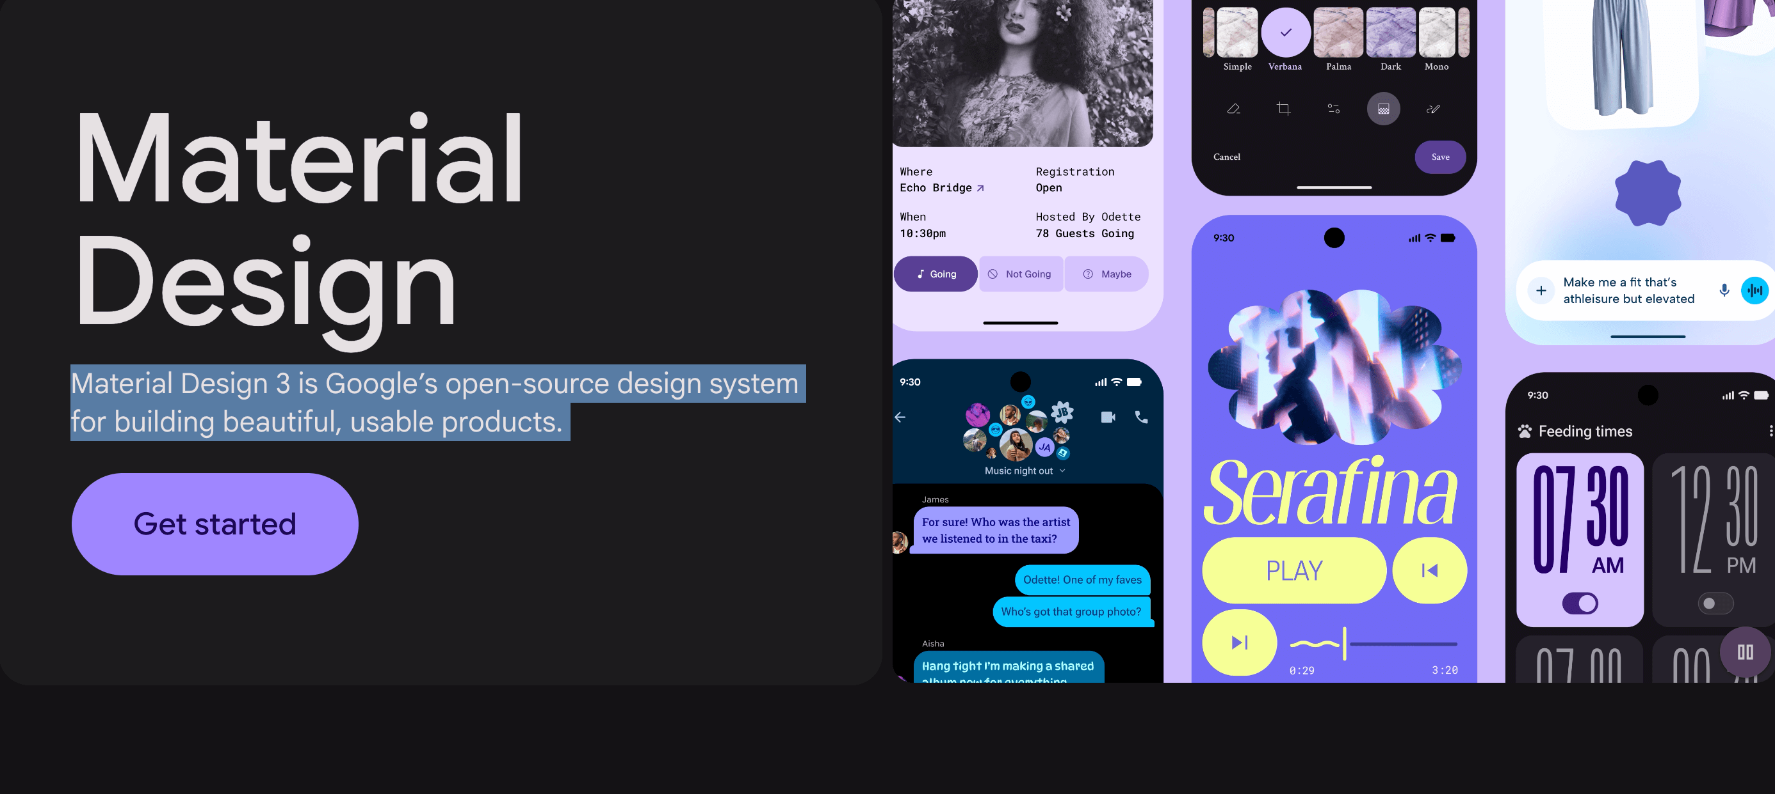
<p data-tool="mdnice编辑器" style="font-size: 16px; padding-top: 8px; padding-bottom: 8px; margin: 0; line-height: 26px; color: rgb(89,89,89);"><strong style="font-weight: bold; color: rgb(71, 193, 168);">https://m3.material.io/</strong></p>
<p data-tool="mdnice编辑器" style="font-size: 16px; padding-top: 8px; padding-bottom: 8px; margin: 0; line-height: 26px; color: black;">Material Design 3 is Google’s open-source design system for building beautiful, usable products.</p>
<h2 data-tool="mdnice编辑器" style="margin-top: 30px; padding: 0px; font-weight: bold; font-size: 22px; border-bottom: 2px solid rgb(89,89,89); margin-bottom: 5px; color: rgb(89,89,89);"><span class="content" style="font-size: 22px; display: inline-block; border-bottom: 2px solid rgb(89,89,89);">🔨好工具</span></h2>
<h3 data-tool="mdnice编辑器" style="margin-top: 30px; margin-bottom: 15px; padding: 0px; font-weight: bold; font-size: 20px; color: rgb(89,89,89);"><span class="prefix" style="display: none;"></span><span class="content">mihon</span></h3>

<p data-tool="mdnice编辑器" style="font-size: 16px; padding-top: 8px; padding-bottom: 8px; margin: 0; line-height: 26px; color: rgb(89,89,89);"><strong style="font-weight: bold; color: rgb(71, 193, 168);">https://github.com/mihonapp/mihon</strong></p>
<h3 data-tool="mdnice编辑器" style="margin-top: 30px; margin-bottom: 15px; padding: 0px; font-weight: bold; font-size: 20px; color: rgb(89,89,89);"><span class="prefix" style="display: none;"></span><span class="content">echo</span></h3>
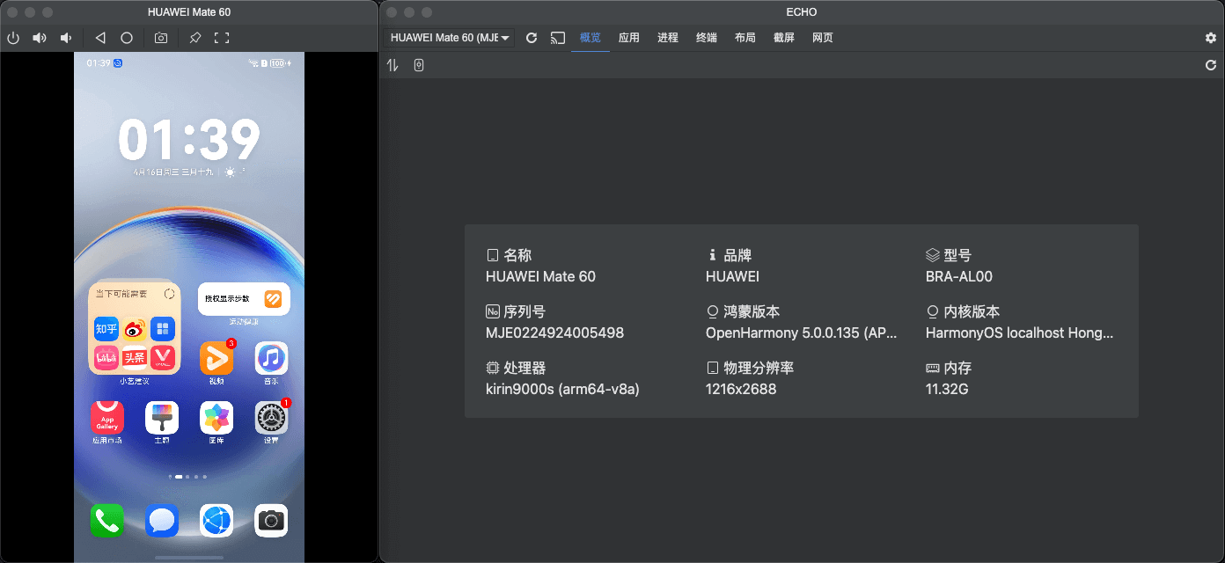
<p data-tool="mdnice编辑器" style="font-size: 16px; padding-top: 8px; padding-bottom: 8px; margin: 0; line-height: 26px; color: rgb(89,89,89);"><strong style="font-weight: bold; color: rgb(71, 193, 168);">https://github.com/liriliri/echo</strong></p>
<p data-tool="mdnice编辑器" style="font-size: 16px; padding-top: 8px; padding-bottom: 8px; margin: 0; line-height: 26px; color: black;">鸿蒙 HDC 桌面应用。</p>
<h3 data-tool="mdnice编辑器" style="margin-top: 30px; margin-bottom: 15px; padding: 0px; font-weight: bold; font-size: 20px; color: rgb(89,89,89);"><span class="prefix" style="display: none;"></span><span class="content">VERT</span></h3>
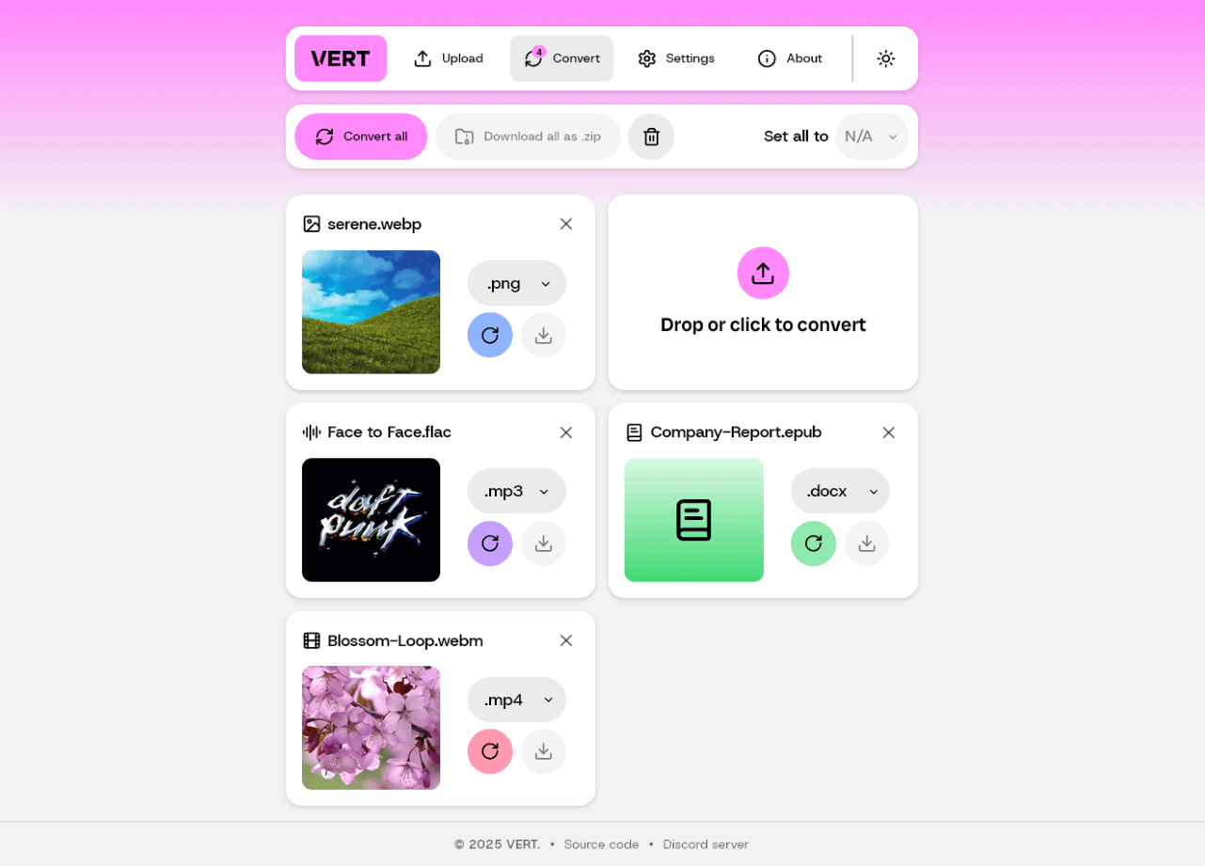
<p data-tool="mdnice编辑器" style="font-size: 16px; padding-top: 8px; padding-bottom: 8px; margin: 0; line-height: 26px; color: rgb(89,89,89);"><strong style="font-weight: bold; color: rgb(71, 193, 168);">https://github.com/VERT-sh/VERT</strong></p>
<p data-tool="mdnice编辑器" style="font-size: 16px; padding-top: 8px; padding-bottom: 8px; margin: 0; line-height: 26px; color: black;">VERT is a file conversion utility that uses WebAssembly to convert files on your device instead of a cloud. Check out the live instance at vert.sh.</p>
<h3 data-tool="mdnice编辑器" style="margin-top: 30px; margin-bottom: 15px; padding: 0px; font-weight: bold; font-size: 20px; color: rgb(89,89,89);"><span class="prefix" style="display: none;"></span><span class="content">blind_watermark</span></h3>
<p data-tool="mdnice编辑器" style="font-size: 16px; padding-top: 8px; padding-bottom: 8px; margin: 0; line-height: 26px; color: rgb(89,89,89);"><strong style="font-weight: bold; color: rgb(71, 193, 168);">https://github.com/guofei9987/blind_watermark</strong></p>
<p data-tool="mdnice编辑器" style="font-size: 16px; padding-top: 8px; padding-bottom: 8px; margin: 0; line-height: 26px; color: black;">基于频域的数字盲水印</p>
<h3 data-tool="mdnice编辑器" style="margin-top: 30px; margin-bottom: 15px; padding: 0px; font-weight: bold; font-size: 20px; color: rgb(89,89,89);"><span class="prefix" style="display: none;"></span><span class="content">HideInfo</span></h3>
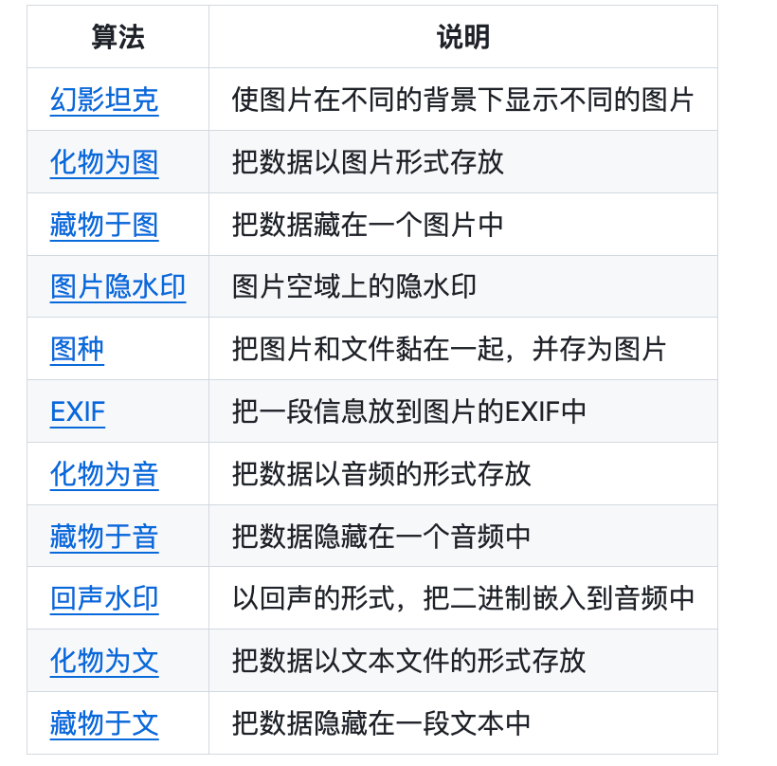
<p data-tool="mdnice编辑器" style="font-size: 16px; padding-top: 8px; padding-bottom: 8px; margin: 0; line-height: 26px; color: rgb(89,89,89);"><strong style="font-weight: bold; color: rgb(71, 193, 168);">https://github.com/guofei9987/HideInfo</strong></p>
<p data-tool="mdnice编辑器" style="font-size: 16px; padding-top: 8px; padding-bottom: 8px; margin: 0; line-height: 26px; color: black;">一些小而美的信息隐藏方法</p>

