<h2 data-tool="mdnice编辑器" style="margin-top: 30px; padding: 0px; font-weight: bold; font-size: 25px; margin-bottom: 5px; color: rgb(0,0,0); background: linear-gradient(to right, #e8f4f8, #5b86e5) 0 100% / 100% 2px no-repeat;"><span class="content" style="font-size: 25px; display: inline-block; padding-bottom: 4px; background: linear-gradient(to right, #36d1dc, #5b86e5) 0 100% / 100% 4px no-repeat;">📕 精选文章</span></h2>
<ul data-tool="mdnice编辑器" style="margin-top: 4px; margin-bottom: 4px; padding-left: 25px; color: black; list-style-type: disc;"><li><section style="margin-top: 5px; margin-bottom: 5px; line-height: 26px; text-align: left; color: rgb(1,1,1); font-weight: 500;"><span leaf="">📄最近公司烧token比招员工还贵，老板干懵了...</span><span leaf="" data-pm-slice="1 1 [&quot;para&quot;,{&quot;tagName&quot;:&quot;p&quot;,&quot;attributes&quot;:{&quot;data-tool&quot;:&quot;mdnice编辑器&quot;,&quot;style&quot;:&quot;font-size: 16px; padding-top: 8px; padding-bottom: 8px; margin: 0; line-height: 26px; color: rgb(89,89,89);&quot;},&quot;namespaceURI&quot;:&quot;http://www.w3.org/1999/xhtml&quot;}]"><span textstyle="" style="font-size: 10px; color: rgb(153, 195, 255); text-decoration: underline">🔗【https://juejin.cn/post/7646256871183024128】</span></span></section></li><li><section style="margin-top: 5px; margin-bottom: 5px; line-height: 26px; text-align: left; color: rgb(1,1,1); font-weight: 500;"><span leaf="">📄AOSP 整机源码 Harness 工程探索</span><span leaf="" data-pm-slice="1 1 [&quot;para&quot;,{&quot;tagName&quot;:&quot;p&quot;,&quot;attributes&quot;:{&quot;data-tool&quot;:&quot;mdnice编辑器&quot;,&quot;style&quot;:&quot;font-size: 16px; padding-top: 8px; padding-bottom: 8px; margin: 0; line-height: 26px; color: rgb(89,89,89);&quot;},&quot;namespaceURI&quot;:&quot;http://www.w3.org/1999/xhtml&quot;}]"><span textstyle="" style="font-size: 10px; color: rgb(153, 195, 255); text-decoration: underline">🔗【https://mp.weixin.qq.com/s/jCblt34Ea_p72YnHGRTu3g】</span></span></section></li><li><section style="margin-top: 5px; margin-bottom: 5px; line-height: 26px; text-align: left; color: rgb(1,1,1); font-weight: 500;"><span leaf="">📄Claude 对接 NanoBanana MCP</span><span leaf="" data-pm-slice="1 1 [&quot;para&quot;,{&quot;tagName&quot;:&quot;p&quot;,&quot;attributes&quot;:{&quot;data-tool&quot;:&quot;mdnice编辑器&quot;,&quot;style&quot;:&quot;font-size: 16px; padding-top: 8px; padding-bottom: 8px; margin: 0; line-height: 26px; color: rgb(89,89,89);&quot;},&quot;namespaceURI&quot;:&quot;http://www.w3.org/1999/xhtml&quot;}]"><span textstyle="" style="font-size: 10px; color: rgb(153, 195, 255); text-decoration: underline">🔗【https://mp.weixin.qq.com/s/i9xWKeg9iq3vl7muESRxIA】</span></span></section></li><li><section style="margin-top: 5px; margin-bottom: 5px; line-height: 26px; text-align: left; color: rgb(1,1,1); font-weight: 500;"><span leaf="">📄又是梁文锋，有点猛啊。</span><span leaf="" data-pm-slice="1 1 [&quot;para&quot;,{&quot;tagName&quot;:&quot;p&quot;,&quot;attributes&quot;:{&quot;data-tool&quot;:&quot;mdnice编辑器&quot;,&quot;style&quot;:&quot;font-size: 16px; padding-top: 8px; padding-bottom: 8px; margin: 0; line-height: 26px; color: rgb(89,89,89);&quot;},&quot;namespaceURI&quot;:&quot;http://www.w3.org/1999/xhtml&quot;}]"><span textstyle="" style="font-size: 10px; color: rgb(153, 195, 255); text-decoration: underline">🔗【https://juejin.cn/post/7651461757568811060】</span></span></section></li><li><section style="margin-top: 5px; margin-bottom: 5px; line-height: 26px; text-align: left; color: rgb(1,1,1); font-weight: 500;"><span leaf="">📄现在的AI热潮，恰恰证明了世界就是个草台班子</span><span leaf="" data-pm-slice="1 1 [&quot;para&quot;,{&quot;tagName&quot;:&quot;p&quot;,&quot;attributes&quot;:{&quot;data-tool&quot;:&quot;mdnice编辑器&quot;,&quot;style&quot;:&quot;font-size: 16px; padding-top: 8px; padding-bottom: 8px; margin: 0; line-height: 26px; color: rgb(89,89,89);&quot;},&quot;namespaceURI&quot;:&quot;http://www.w3.org/1999/xhtml&quot;}]"><span textstyle="" style="font-size: 10px; color: rgb(153, 195, 255); text-decoration: underline">🔗【https://juejin.cn/post/7613716728385929226】</span></span></section></li><li><section style="margin-top: 5px; margin-bottom: 5px; line-height: 26px; text-align: left; color: rgb(1,1,1); font-weight: 500;"><span leaf="">📄完整案例:Kotlin+Compose+Multiplatform跨平台之桌面端实现（二）</span><span leaf="" data-pm-slice="1 1 [&quot;para&quot;,{&quot;tagName&quot;:&quot;p&quot;,&quot;attributes&quot;:{&quot;data-tool&quot;:&quot;mdnice编辑器&quot;,&quot;style&quot;:&quot;font-size: 16px; padding-top: 8px; padding-bottom: 8px; margin: 0; line-height: 26px; color: rgb(89,89,89);&quot;},&quot;namespaceURI&quot;:&quot;http://www.w3.org/1999/xhtml&quot;}]"><span textstyle="" style="font-size: 10px; color: rgb(153, 195, 255); text-decoration: underline">🔗【https://juejin.cn/post/7535335090902532136】</span></span></section></li></ul>
<h2 data-tool="mdnice编辑器" style="margin-top: 30px; padding: 0px; font-weight: bold; font-size: 25px; margin-bottom: 5px; color: rgb(0,0,0); background: linear-gradient(to right, #e8f4f8, #5b86e5) 0 100% / 100% 2px no-repeat;"><span class="content" style="font-size: 25px; display: inline-block; padding-bottom: 4px; background: linear-gradient(to right, #36d1dc, #5b86e5) 0 100% / 100% 4px no-repeat;">🤖 AI前沿</span></h2>
<h3 data-tool="mdnice编辑器" style="margin-top: 30px; margin-bottom: 15px; padding: 0; font-weight: bold; font-size: 22px; color: #000; display: inline-block;"><span class="prefix" style="display: none;"></span><span class="content" style="padding: 1px 8px; line-height: 1.2; background: linear-gradient(to top, #e9ecef 80%, transparent 80%);background-size: 100% 100%;background-repeat: no-repeat;"># AI技术已经发展到这种地步了</span></h3>

<p data-tool="mdnice编辑器" style="font-size: 16px; padding-top: 8px; padding-bottom: 8px; margin: 0; line-height: 26px; color: rgb(89,89,89);"><span leaf=""><span textstyle="" style="font-size: 10px; color: #0269c8; text-decoration: underline">🔗【https://xmax.ai/】</span></span></p>
<p data-tool="mdnice编辑器" style="font-size: 16px; padding-top: 8px; padding-bottom: 8px; margin: 0; line-height: 26px; color: rgb(89,89,89);"><span leaf=""><span textstyle="" style="font-size: 10px; color: #0269c8; text-decoration: underline">🔗【https://www.douyin.com/video/7666784609396492515】</span></span></p>
<h3 data-tool="mdnice编辑器" style="margin-top: 30px; margin-bottom: 15px; padding: 0; font-weight: bold; font-size: 22px; color: #000; display: inline-block;"><span class="prefix" style="display: none;"></span><span class="content" style="padding: 1px 8px; line-height: 1.2; background: linear-gradient(to top, #e9ecef 80%, transparent 80%);background-size: 100% 100%;background-repeat: no-repeat;"># 我一个人做了款"4A"大作？ 一个不会写代码的人，能不能自己做出一款游戏？</span></h3>
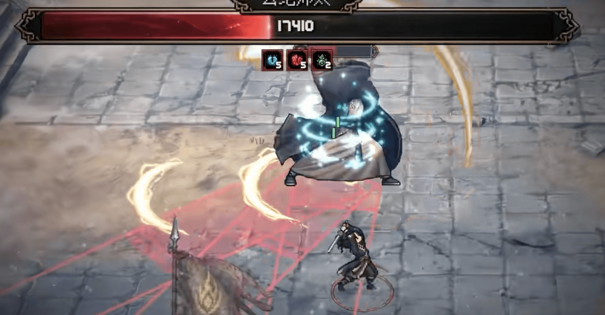
<p data-tool="mdnice编辑器" style="font-size: 16px; padding-top: 8px; padding-bottom: 8px; margin: 0; line-height: 26px; color: rgb(89,89,89);"><span leaf=""><span textstyle="" style="font-size: 10px; color: #0269c8; text-decoration: underline">🔗【https://www.douyin.com/video/7666472872021445928】</span></span></p>
<h3 data-tool="mdnice编辑器" style="margin-top: 30px; margin-bottom: 15px; padding: 0; font-weight: bold; font-size: 22px; color: #000; display: inline-block;"><span class="prefix" style="display: none;"></span><span class="content" style="padding: 1px 8px; line-height: 1.2; background: linear-gradient(to top, #e9ecef 80%, transparent 80%);background-size: 100% 100%;background-repeat: no-repeat;"># 我用AI杀死了史上最难的跑步游戏</span></h3>
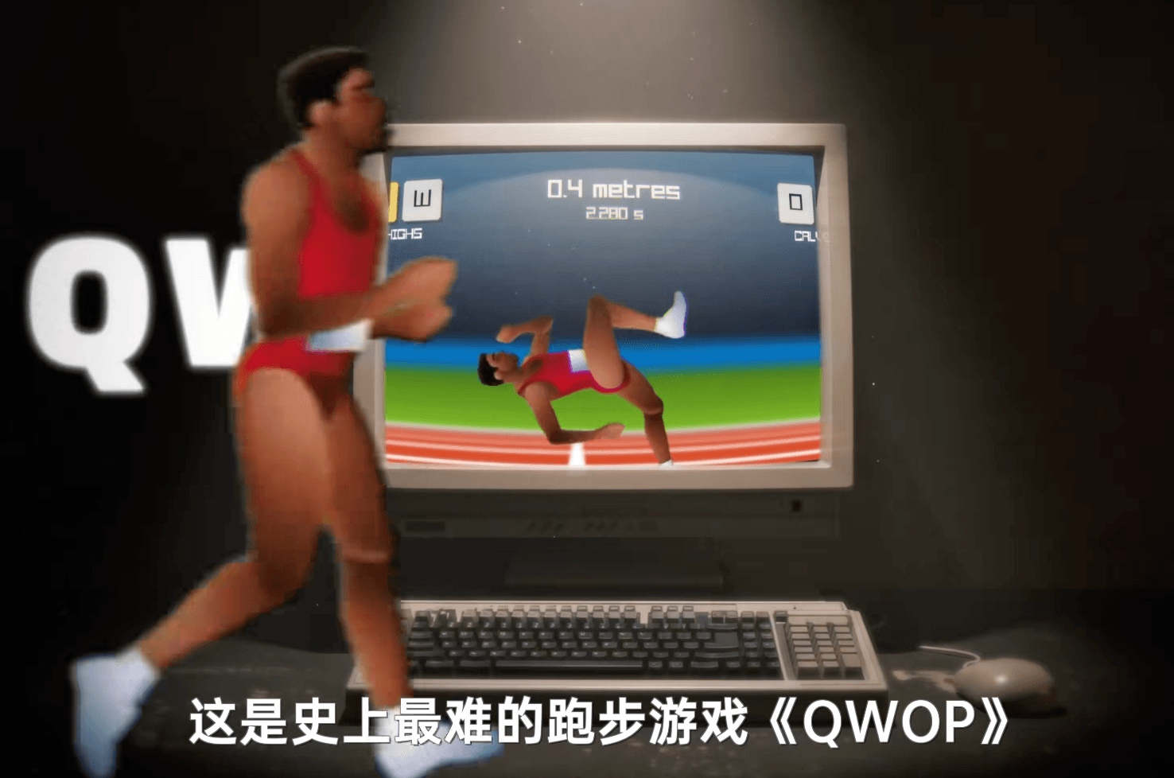
<p data-tool="mdnice编辑器" style="font-size: 16px; padding-top: 8px; padding-bottom: 8px; margin: 0; line-height: 26px; color: rgb(89,89,89);"><span leaf=""><span textstyle="" style="font-size: 10px; color: #0269c8; text-decoration: underline">🔗【https://github.com/LYiHub/QWOP_rl_training_public】</span></span></p>
<p data-tool="mdnice编辑器" style="font-size: 16px; padding-top: 8px; padding-bottom: 8px; margin: 0; line-height: 26px; color: rgb(89,89,89);"><span leaf=""><span textstyle="" style="font-size: 10px; color: #0269c8; text-decoration: underline">🔗【https://www.douyin.com/video/7664571016194084131】</span></span></p>
<h3 data-tool="mdnice编辑器" style="margin-top: 30px; margin-bottom: 15px; padding: 0; font-weight: bold; font-size: 22px; color: #000; display: inline-block;"><span class="prefix" style="display: none;"></span><span class="content" style="padding: 1px 8px; line-height: 1.2; background: linear-gradient(to top, #e9ecef 80%, transparent 80%);background-size: 100% 100%;background-repeat: no-repeat;"># Vibe Coding 能把简历玩出什么花样？？</span></h3>
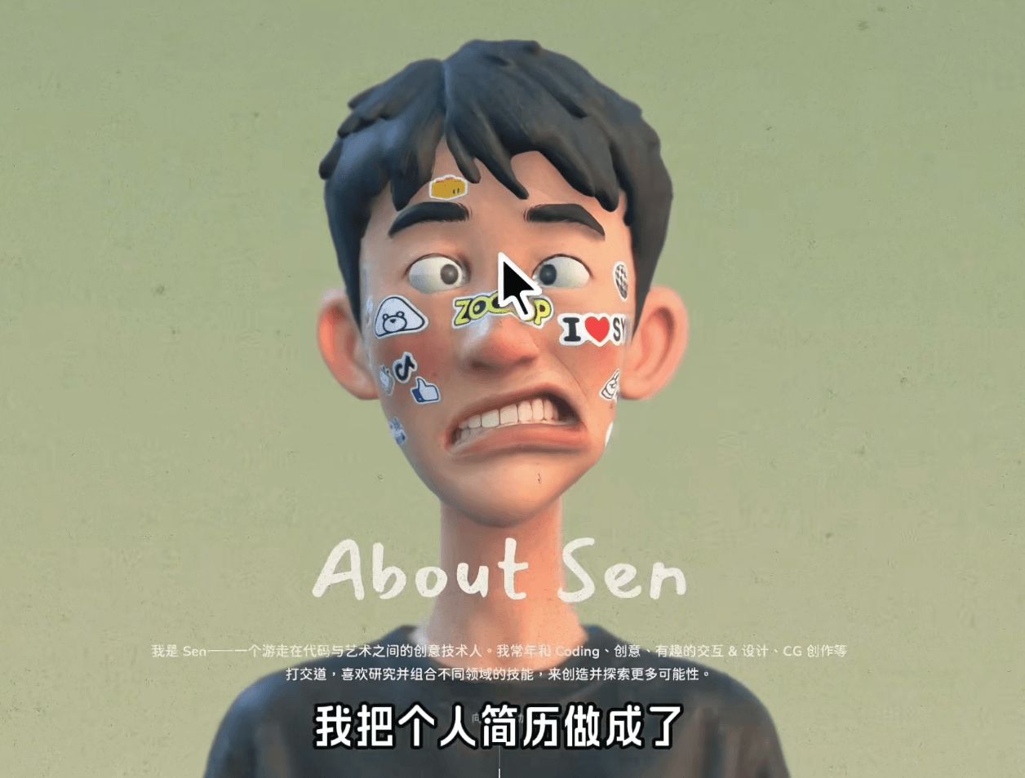
<p data-tool="mdnice编辑器" style="font-size: 16px; padding-top: 8px; padding-bottom: 8px; margin: 0; line-height: 26px; color: rgb(89,89,89);"><span leaf=""><span textstyle="" style="font-size: 10px; color: #0269c8; text-decoration: underline">🔗【https://www.douyin.com/video/7665363756997725480】</span></span></p>
<h2 data-tool="mdnice编辑器" style="margin-top: 30px; padding: 0px; font-weight: bold; font-size: 25px; margin-bottom: 5px; color: rgb(0,0,0); background: linear-gradient(to right, #e8f4f8, #5b86e5) 0 100% / 100% 2px no-repeat;"><span class="content" style="font-size: 25px; display: inline-block; padding-bottom: 4px; background: linear-gradient(to right, #36d1dc, #5b86e5) 0 100% / 100% 4px no-repeat;">🔨 实用工具</span></h2>
<h3 data-tool="mdnice编辑器" style="margin-top: 30px; margin-bottom: 15px; padding: 0; font-weight: bold; font-size: 22px; color: #000; display: inline-block;"><span class="prefix" style="display: none;"></span><span class="content" style="padding: 1px 8px; line-height: 1.2; background: linear-gradient(to top, #e9ecef 80%, transparent 80%);background-size: 100% 100%;background-repeat: no-repeat;"># o0Nomar0o/Motiv2D</span></h3>
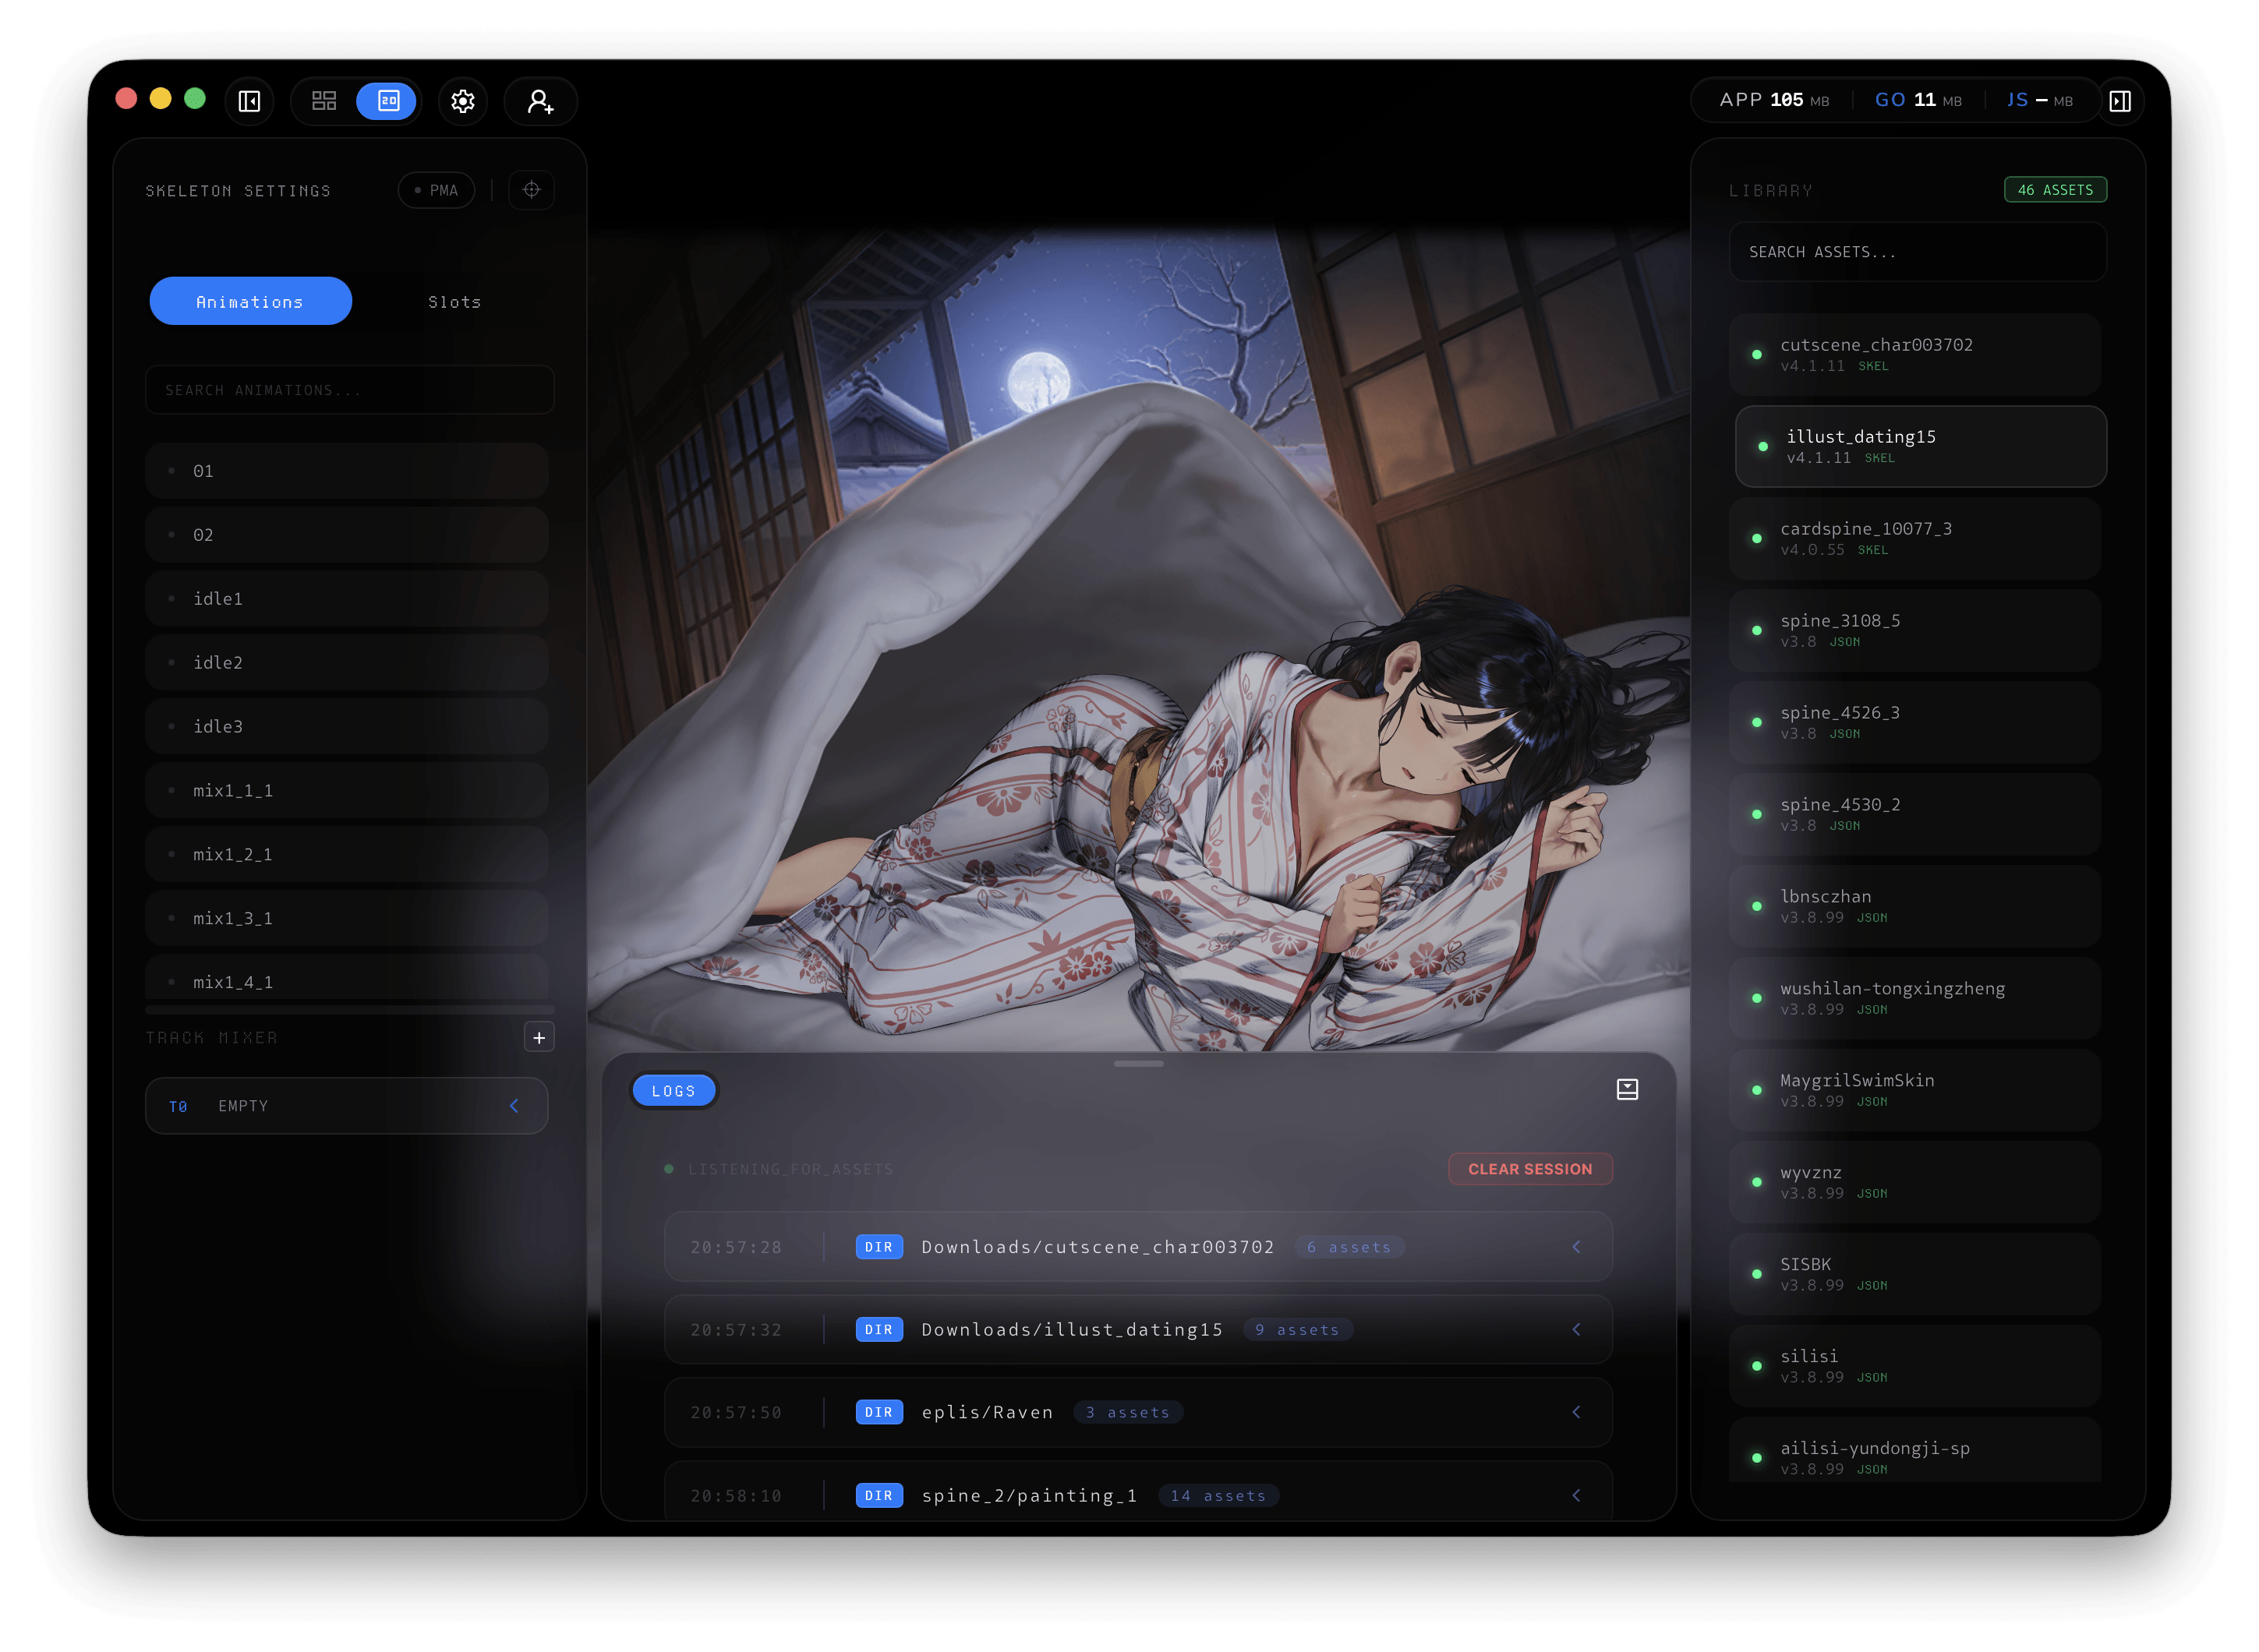
<p data-tool="mdnice编辑器" style="font-size: 16px; padding-top: 8px; padding-bottom: 8px; margin: 0; line-height: 1.5em; color: #333333;">一款专为 Spine 资产预览、管理和批量导入设计的工具。基于 Go, Wails 和 Svelte 构建，追求极致效率。</p>
<p data-tool="mdnice编辑器" style="font-size: 16px; padding-top: 8px; padding-bottom: 8px; margin: 0; line-height: 1.5em; color: #333333;">Spine2d and Live2d Viewer</p>
<p data-tool="mdnice编辑器" style="font-size: 16px; padding-top: 8px; padding-bottom: 8px; margin: 0; line-height: 26px; color: rgb(89,89,89);"><span leaf=""><span textstyle="" style="font-size: 10px; color: #0269c8; text-decoration: underline">🔗【https://github.com/o0Nomar0o/Motiv2D】</span></span></p>
<h3 data-tool="mdnice编辑器" style="margin-top: 30px; margin-bottom: 15px; padding: 0; font-weight: bold; font-size: 22px; color: #000; display: inline-block;"><span class="prefix" style="display: none;"></span><span class="content" style="padding: 1px 8px; line-height: 1.2; background: linear-gradient(to top, #e9ecef 80%, transparent 80%);background-size: 100% 100%;background-repeat: no-repeat;"># BuSung-dev/Root-My-Galaxy</span></h3>
<p data-tool="mdnice编辑器" style="font-size: 16px; padding-top: 8px; padding-bottom: 8px; margin: 0; line-height: 1.5em; color: #333333;">Root My Galaxy 是一个一键式安装程序，适用于明确支持的三星型号和内核组合。应用程序本身与设备偏移、本机漏洞利用有效负载和 KernelSU 构建工件分开。</p>
<p data-tool="mdnice编辑器" style="font-size: 16px; padding-top: 8px; padding-bottom: 8px; margin: 0; line-height: 1.5em; color: #333333;">Root My Galaxy is a one-click installer for explicitly supported Samsung model and kernel combinations. The application itself is kept separate from device offsets, native exploit payloads, and KernelSU build artifacts.</p>
<p data-tool="mdnice编辑器" style="font-size: 16px; padding-top: 8px; padding-bottom: 8px; margin: 0; line-height: 26px; color: rgb(89,89,89);"><span leaf=""><span textstyle="" style="font-size: 10px; color: #0269c8; text-decoration: underline">🔗【https://github.com/BuSung-dev/Root-My-Galaxy】</span></span></p>
<h3 data-tool="mdnice编辑器" style="margin-top: 30px; margin-bottom: 15px; padding: 0; font-weight: bold; font-size: 22px; color: #000; display: inline-block;"><span class="prefix" style="display: none;"></span><span class="content" style="padding: 1px 8px; line-height: 1.2; background: linear-gradient(to top, #e9ecef 80%, transparent 80%);background-size: 100% 100%;background-repeat: no-repeat;"># egoist/kero</span></h3>
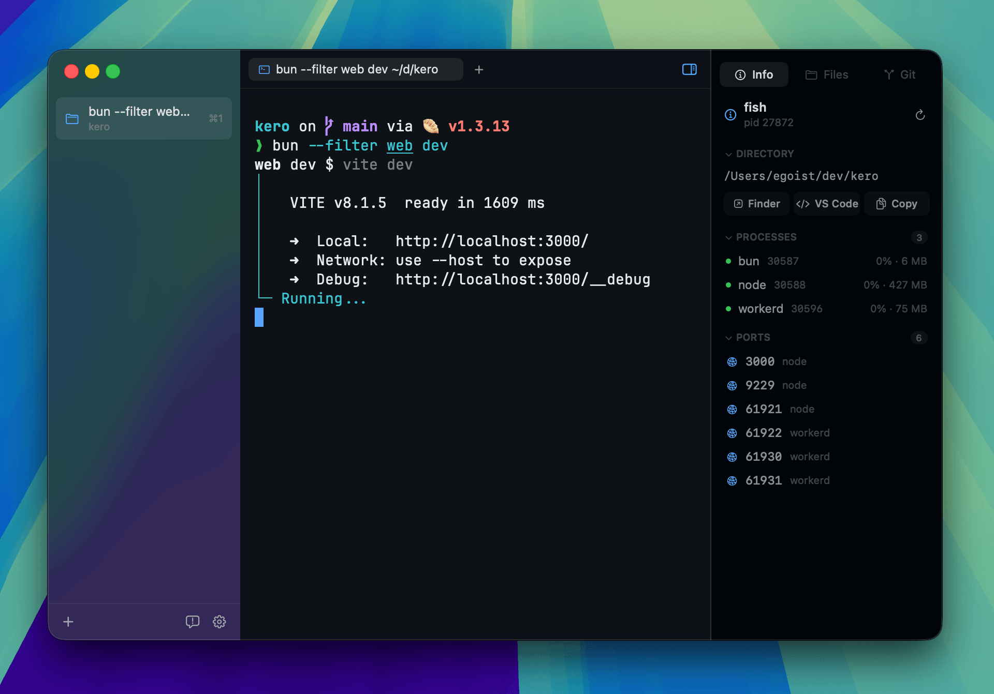
<p data-tool="mdnice编辑器" style="font-size: 16px; padding-top: 8px; padding-bottom: 8px; margin: 0; line-height: 1.5em; color: #333333;">适用于 macOS 的本机终端工作区。</p>
<p data-tool="mdnice编辑器" style="font-size: 16px; padding-top: 8px; padding-bottom: 8px; margin: 0; line-height: 1.5em; color: #333333;">A native terminal workspace for macOS.</p>
<p data-tool="mdnice编辑器" style="font-size: 16px; padding-top: 8px; padding-bottom: 8px; margin: 0; line-height: 26px; color: rgb(89,89,89);"><span leaf=""><span textstyle="" style="font-size: 10px; color: #0269c8; text-decoration: underline">🔗【https://github.com/egoist/kero】</span></span></p>
<h3 data-tool="mdnice编辑器" style="margin-top: 30px; margin-bottom: 15px; padding: 0; font-weight: bold; font-size: 22px; color: #000; display: inline-block;"><span class="prefix" style="display: none;"></span><span class="content" style="padding: 1px 8px; line-height: 1.2; background: linear-gradient(to top, #e9ecef 80%, transparent 80%);background-size: 100% 100%;background-repeat: no-repeat;"># Ferry-200/coriander_player</span></h3>
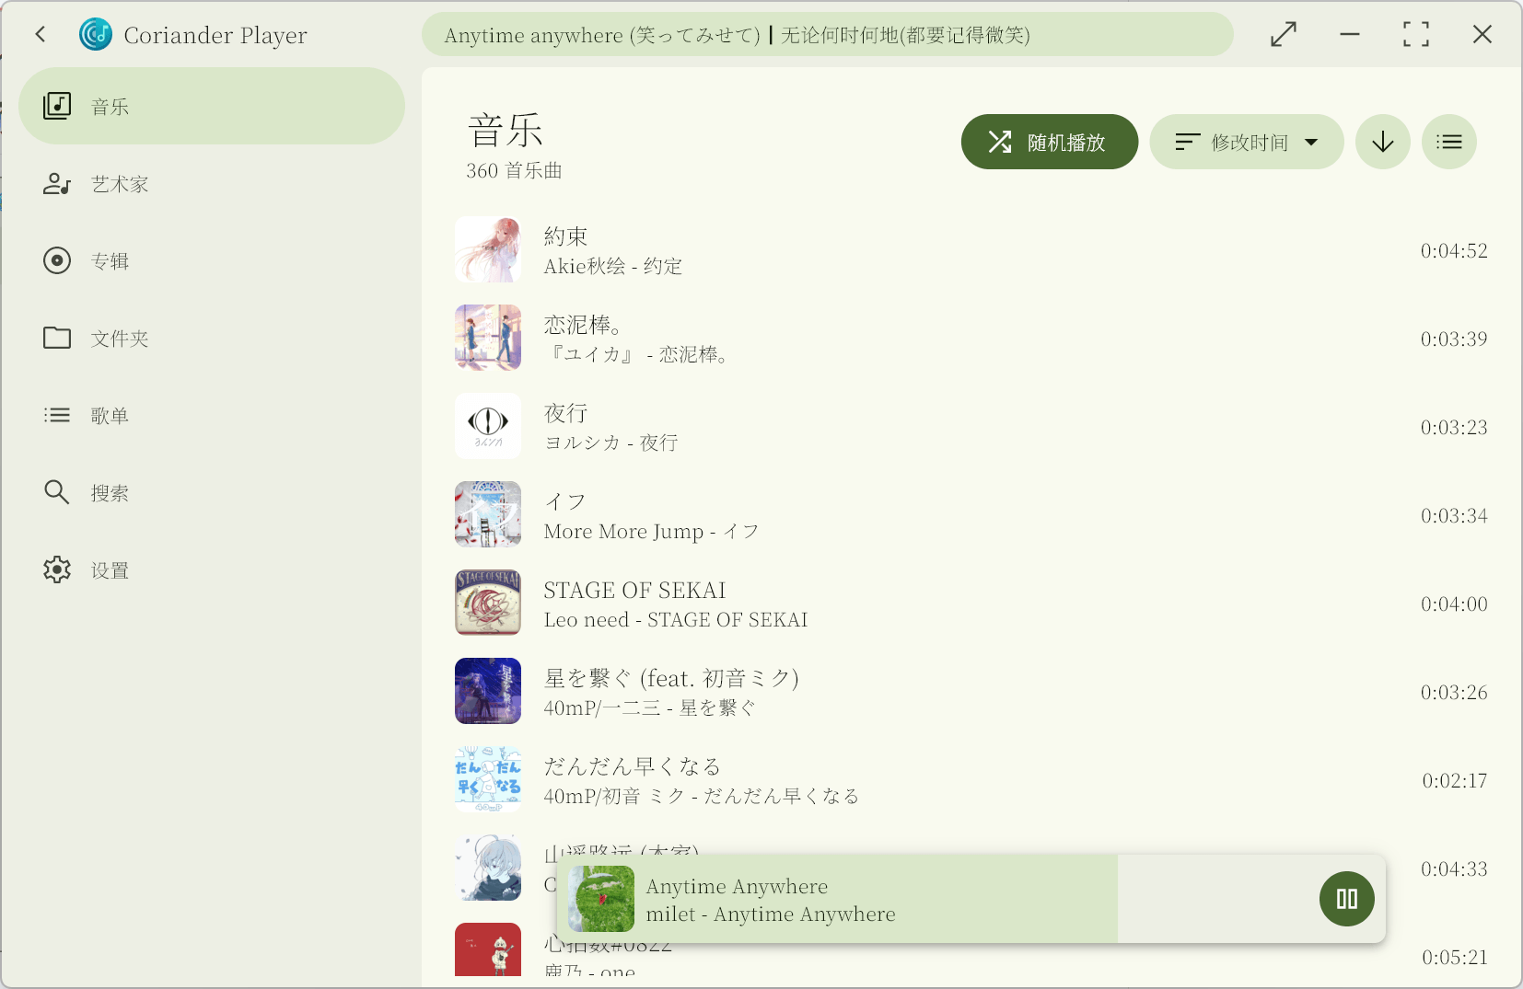
<p data-tool="mdnice编辑器" style="font-size: 16px; padding-top: 8px; padding-bottom: 8px; margin: 0; line-height: 1.5em; color: #333333;">Coriander Player：一款使用 Material You 配色的本地音乐播放器。</p>
<p data-tool="mdnice编辑器" style="font-size: 16px; padding-top: 8px; padding-bottom: 8px; margin: 0; line-height: 26px; color: rgb(89,89,89);"><span leaf=""><span textstyle="" style="font-size: 10px; color: #0269c8; text-decoration: underline">🔗【https://github.com/Ferry-200/coriander_player】</span></span></p>
<h2 data-tool="mdnice编辑器" style="margin-top: 30px; padding: 0px; font-weight: bold; font-size: 25px; margin-bottom: 5px; color: rgb(0,0,0); background: linear-gradient(to right, #e8f4f8, #5b86e5) 0 100% / 100% 2px no-repeat;"><span class="content" style="font-size: 25px; display: inline-block; padding-bottom: 4px; background: linear-gradient(to right, #36d1dc, #5b86e5) 0 100% / 100% 4px no-repeat;">📚 宝藏资源</span></h2>
<h3 data-tool="mdnice编辑器" style="margin-top: 30px; margin-bottom: 15px; padding: 0; font-weight: bold; font-size: 22px; color: #000; display: inline-block;"><span class="prefix" style="display: none;"></span><span class="content" style="padding: 1px 8px; line-height: 1.2; background: linear-gradient(to top, #e9ecef 80%, transparent 80%);background-size: 100% 100%;background-repeat: no-repeat;"># violet-wdream/GamesArchive</span></h3>
<p data-tool="mdnice编辑器" style="font-size: 16px; padding-top: 8px; padding-bottom: 8px; margin: 0; line-height: 26px; color: rgb(89,89,89);"><span leaf=""><span textstyle="" style="font-size: 10px; color: #0269c8; text-decoration: underline">🔗【https://github.com/violet-wdream/GamesArchive】</span></span></p>
<h3 data-tool="mdnice编辑器" style="margin-top: 30px; margin-bottom: 15px; padding: 0; font-weight: bold; font-size: 22px; color: #000; display: inline-block;"><span class="prefix" style="display: none;"></span><span class="content" style="padding: 1px 8px; line-height: 1.2; background: linear-gradient(to top, #e9ecef 80%, transparent 80%);background-size: 100% 100%;background-repeat: no-repeat;"># o0Nomar0o/SpineCollections</span></h3>
<p data-tool="mdnice编辑器" style="font-size: 16px; padding-top: 8px; padding-bottom: 8px; margin: 0; line-height: 1.5em; color: #333333;">Spine和 Live2D模型数据素材库。</p>
<p data-tool="mdnice编辑器" style="font-size: 16px; padding-top: 8px; padding-bottom: 8px; margin: 0; line-height: 1.5em; color: #333333;">A curated repository for Spine and Live2D model data, intended for research, learning, and digital preservation.</p>
<p data-tool="mdnice编辑器" style="font-size: 16px; padding-top: 8px; padding-bottom: 8px; margin: 0; line-height: 26px; color: rgb(89,89,89);"><span leaf=""><span textstyle="" style="font-size: 10px; color: #0269c8; text-decoration: underline">🔗【https://github.com/o0Nomar0o/SpineCollections】</span></span></p>
<h2 data-tool="mdnice编辑器" style="margin-top: 30px; padding: 0px; font-weight: bold; font-size: 25px; margin-bottom: 5px; color: rgb(0,0,0); background: linear-gradient(to right, #e8f4f8, #5b86e5) 0 100% / 100% 2px no-repeat;"><span class="content" style="font-size: 25px; display: inline-block; padding-bottom: 4px; background: linear-gradient(to right, #36d1dc, #5b86e5) 0 100% / 100% 4px no-repeat;">💡 优秀项目</span></h2>
<h3 data-tool="mdnice编辑器" style="margin-top: 30px; margin-bottom: 15px; padding: 0; font-weight: bold; font-size: 22px; color: #000; display: inline-block;"><span class="prefix" style="display: none;"></span><span class="content" style="padding: 1px 8px; line-height: 1.2; background: linear-gradient(to top, #e9ecef 80%, transparent 80%);background-size: 100% 100%;background-repeat: no-repeat;"># moeru-ai/airi</span></h3>
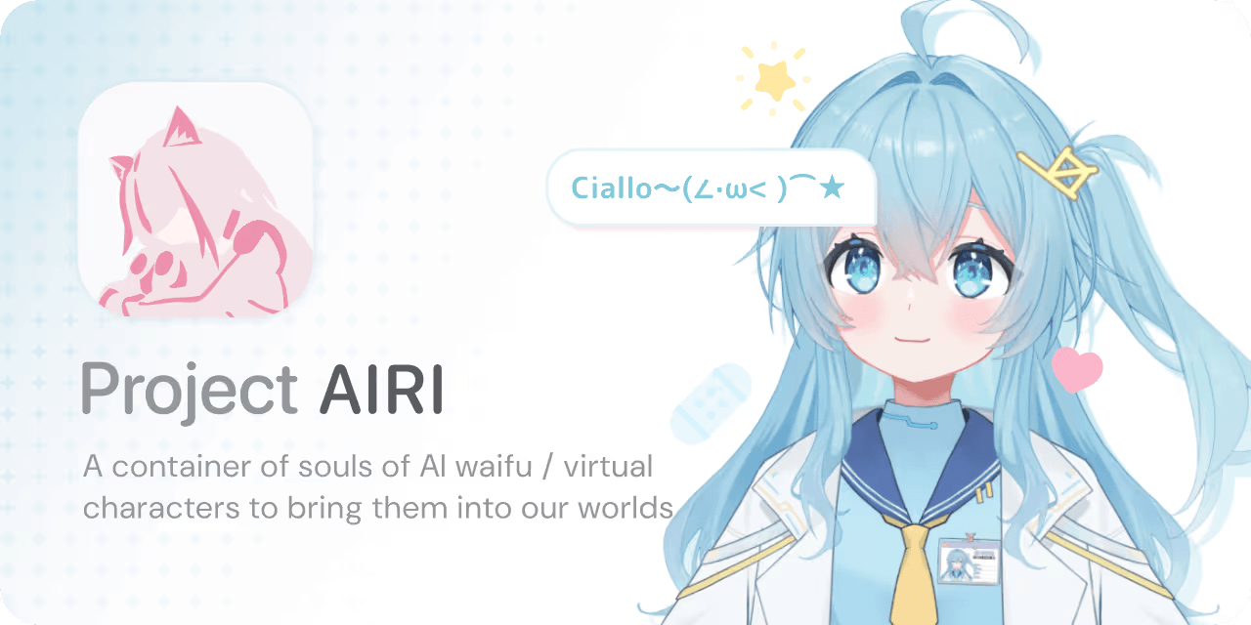
<p data-tool="mdnice编辑器" style="font-size: 16px; padding-top: 8px; padding-bottom: 8px; margin: 0; line-height: 1.5em; color: #333333;">复刻 Neuro-sama，让 AI waifu / 虚拟角色也能来到我们的世界。</p>
<p data-tool="mdnice编辑器" style="font-size: 16px; padding-top: 8px; padding-bottom: 8px; margin: 0; line-height: 1.5em; color: #333333;">💖🧸 Self hosted, you-owned Grok Companion, a container of souls of waifu, cyber livings to bring them into our worlds, wishing to achieve Neuro-sama's altitude. Capable of realtime voice chat, Minecraft, Factorio playing. Web / macOS / Windows supported.</p>
<p data-tool="mdnice编辑器" style="font-size: 16px; padding-top: 8px; padding-bottom: 8px; margin: 0; line-height: 1.5em; color: #333333;">早期介绍过该项目，近期再次关注时发现有新更新。</p>
<p data-tool="mdnice编辑器" style="font-size: 16px; padding-top: 8px; padding-bottom: 8px; margin: 0; line-height: 26px; color: rgb(89,89,89);"><span leaf=""><span textstyle="" style="font-size: 10px; color: #0269c8; text-decoration: underline">🔗【https://github.com/moeru-ai/airi】</span></span></p>
<h3 data-tool="mdnice编辑器" style="margin-top: 30px; margin-bottom: 15px; padding: 0; font-weight: bold; font-size: 22px; color: #000; display: inline-block;"><span class="prefix" style="display: none;"></span><span class="content" style="padding: 1px 8px; line-height: 1.2; background: linear-gradient(to top, #e9ecef 80%, transparent 80%);background-size: 100% 100%;background-repeat: no-repeat;"># Justin-sky/Nice-TS</span></h3>
<p data-tool="mdnice编辑器" style="font-size: 16px; padding-top: 8px; padding-bottom: 8px; margin: 0; line-height: 1.5em; color: #333333;">基于puerts的Unity游戏框架，集成fairygui，protobufjs并采用addressables管理资源</p>
<p data-tool="mdnice编辑器" style="font-size: 16px; padding-top: 8px; padding-bottom: 8px; margin: 0; line-height: 26px; color: rgb(89,89,89);"><span leaf=""><span textstyle="" style="font-size: 10px; color: #0269c8; text-decoration: underline">🔗【https://github.com/Justin-sky/Nice-TS】</span></span></p>
<h3 data-tool="mdnice编辑器" style="margin-top: 30px; margin-bottom: 15px; padding: 0; font-weight: bold; font-size: 22px; color: #000; display: inline-block;"><span class="prefix" style="display: none;"></span><span class="content" style="padding: 1px 8px; line-height: 1.2; background: linear-gradient(to top, #e9ecef 80%, transparent 80%);background-size: 100% 100%;background-repeat: no-repeat;"># alibaba/open-code-review</span></h3>

<p data-tool="mdnice编辑器" style="font-size: 16px; padding-top: 8px; padding-bottom: 8px; margin: 0; line-height: 1.5em; color: #333333;">Open Code Review 是一款 AI 驱动的代码审查 CLI 工具。它的前身是阿里集团内部官方 AI 代码审查助手，过去两年在内部服务了数万开发者，识别了数百万个代码缺陷。经过大规模充分验证后，我们将其孵化为开源项目，对社区开放。只需配置一个模型端点即可使用。</p>
<p data-tool="mdnice编辑器" style="font-size: 16px; padding-top: 8px; padding-bottom: 8px; margin: 0; line-height: 1.5em; color: #333333;">Open-source & free — Battle-tested at Alibaba's scale. Hybrid architecture code review tool: deterministic pipelines + LLM Agent, precise line-level comments, built-in fine-tuned ruleset (NPE, thread-safety, XSS, SQL injection), OpenAI & Anthropic compatible.</p>
<p data-tool="mdnice编辑器" style="font-size: 16px; padding-top: 8px; padding-bottom: 8px; margin: 0; line-height: 26px; color: rgb(89,89,89);"><span leaf=""><span textstyle="" style="font-size: 10px; color: #0269c8; text-decoration: underline">🔗【https://github.com/alibaba/open-code-review】</span></span></p>
<br/>
<br/>
<hr style="border-style: solid; border-width: 1px 0 0; border-color: rgba(0,0,0,0.1); -webkit-transform-origin: 0 0; -webkit-transform: scale(1, 0.5); transform-origin: 0 0; transform: scale(1, 0.5);" contenteditable="false" class="">
<p data-tool="mdnice编辑器" style="font-size: 16px; padding-top: 8px; padding-bottom: 8px; margin: 0px; line-height: 26px; color: black; text-align: center;"><span leaf="">你的关注是我更新的最大动力😙
💪🏻基本每周更新~</span></p>
<hr style="border-style: solid; border-width: 1px 0 0; border-color: rgba(0,0,0,0.1); -webkit-transform-origin: 0 0; -webkit-transform: scale(1, 0.5); transform-origin: 0 0; transform: scale(1, 0.5);" contenteditable="false" class="">
<section class="mp_profile_iframe_wrp custom_select_card_wrp" nodeleaf=""><mp-common-profile class="mpprofile js_uneditable custom_select_card mp_profile_iframe custom_select_card_selected ProseMirror-selectednode" data-pluginname="mpprofile" data-nickname="JulyYuStudio" data-alias="julyyu910" data-headimg="http://mmbiz.qpic.cn/mmbiz_png/bPIhNYICt0dmj4maw6wicB5vBgaVH1PibqByJuiaeZ0VR5o7he3m5grshD7EIoUOD74l0bSX1PHU1v937sPibOaOJQ/0?wx_fmt=png" data-signature="JulyYu的个人日常/技术/稀奇古怪/有的没的" data-id="MzUxODI4NTY5OA==" data-service_type="1" draggable="true"></mp-common-profile><br class="ProseMirror-trailingBreak"></section>


