<h2 data-tool="mdnice编辑器" style="margin-top: 30px; padding: 0px; font-weight: bold; font-size: 22px; border-bottom: 2px solid rgb(89,89,89); margin-bottom: 5px; color: rgb(89,89,89);"><span class="content" style="font-size: 22px; display: inline-block; border-bottom: 2px solid rgb(89,89,89);">🎈优秀开源</span></h2>

<h3 data-tool="mdnice编辑器" style="margin-top: 30px; margin-bottom: 15px; padding: 0px; font-weight: bold; font-size: 20px; color: rgb(89,89,89);"><span class="prefix" style="display: none;"></span><span class="content">AndroidWebGL</span></h3>

<p data-tool="mdnice编辑器" style="font-size: 16px; padding-top: 8px; padding-bottom: 8px; margin: 0; line-height: 26px; color: rgb(89,89,89);"><strong style="font-weight: bold; color: rgb(71, 193, 168);">https://github.com/tanpuer/AndroidWebGL</strong></p>

<p data-tool="mdnice编辑器" style="font-size: 16px; padding-top: 8px; padding-bottom: 8px; margin: 0; line-height: 26px; color: black;">Using v8 in Android to run WebGL Demo.</p>

<h3 data-tool="mdnice编辑器" style="margin-top: 30px; margin-bottom: 15px; padding: 0px; font-weight: bold; font-size: 20px; color: rgb(89,89,89);"><span class="prefix" style="display: none;"></span><span class="content">ShaderToyAndroid</span></h3>

<p data-tool="mdnice编辑器" style="font-size: 16px; padding-top: 8px; padding-bottom: 8px; margin: 0; line-height: 26px; color: rgb(89,89,89);"><strong style="font-weight: bold; color: rgb(71, 193, 168);">https://github.com/tanpuer/ShaderToyAndroid</strong></p>

<p data-tool="mdnice编辑器" style="font-size: 16px; padding-top: 8px; padding-bottom: 8px; margin: 0; line-height: 26px; color: black;">ShaderToy plugin for Android</p>

<h2 data-tool="mdnice编辑器" style="margin-top: 30px; padding: 0px; font-weight: bold; font-size: 22px; border-bottom: 2px solid rgb(89,89,89); margin-bottom: 5px; color: rgb(89,89,89);"><span class="content" style="font-size: 22px; display: inline-block; border-bottom: 2px solid rgb(89,89,89);">🔨好工具</span></h2>

<h3 data-tool="mdnice编辑器" style="margin-top: 30px; margin-bottom: 15px; padding: 0px; font-weight: bold; font-size: 20px; color: rgb(89,89,89);"><span class="prefix" style="display: none;"></span><span class="content">watabou</span></h3>

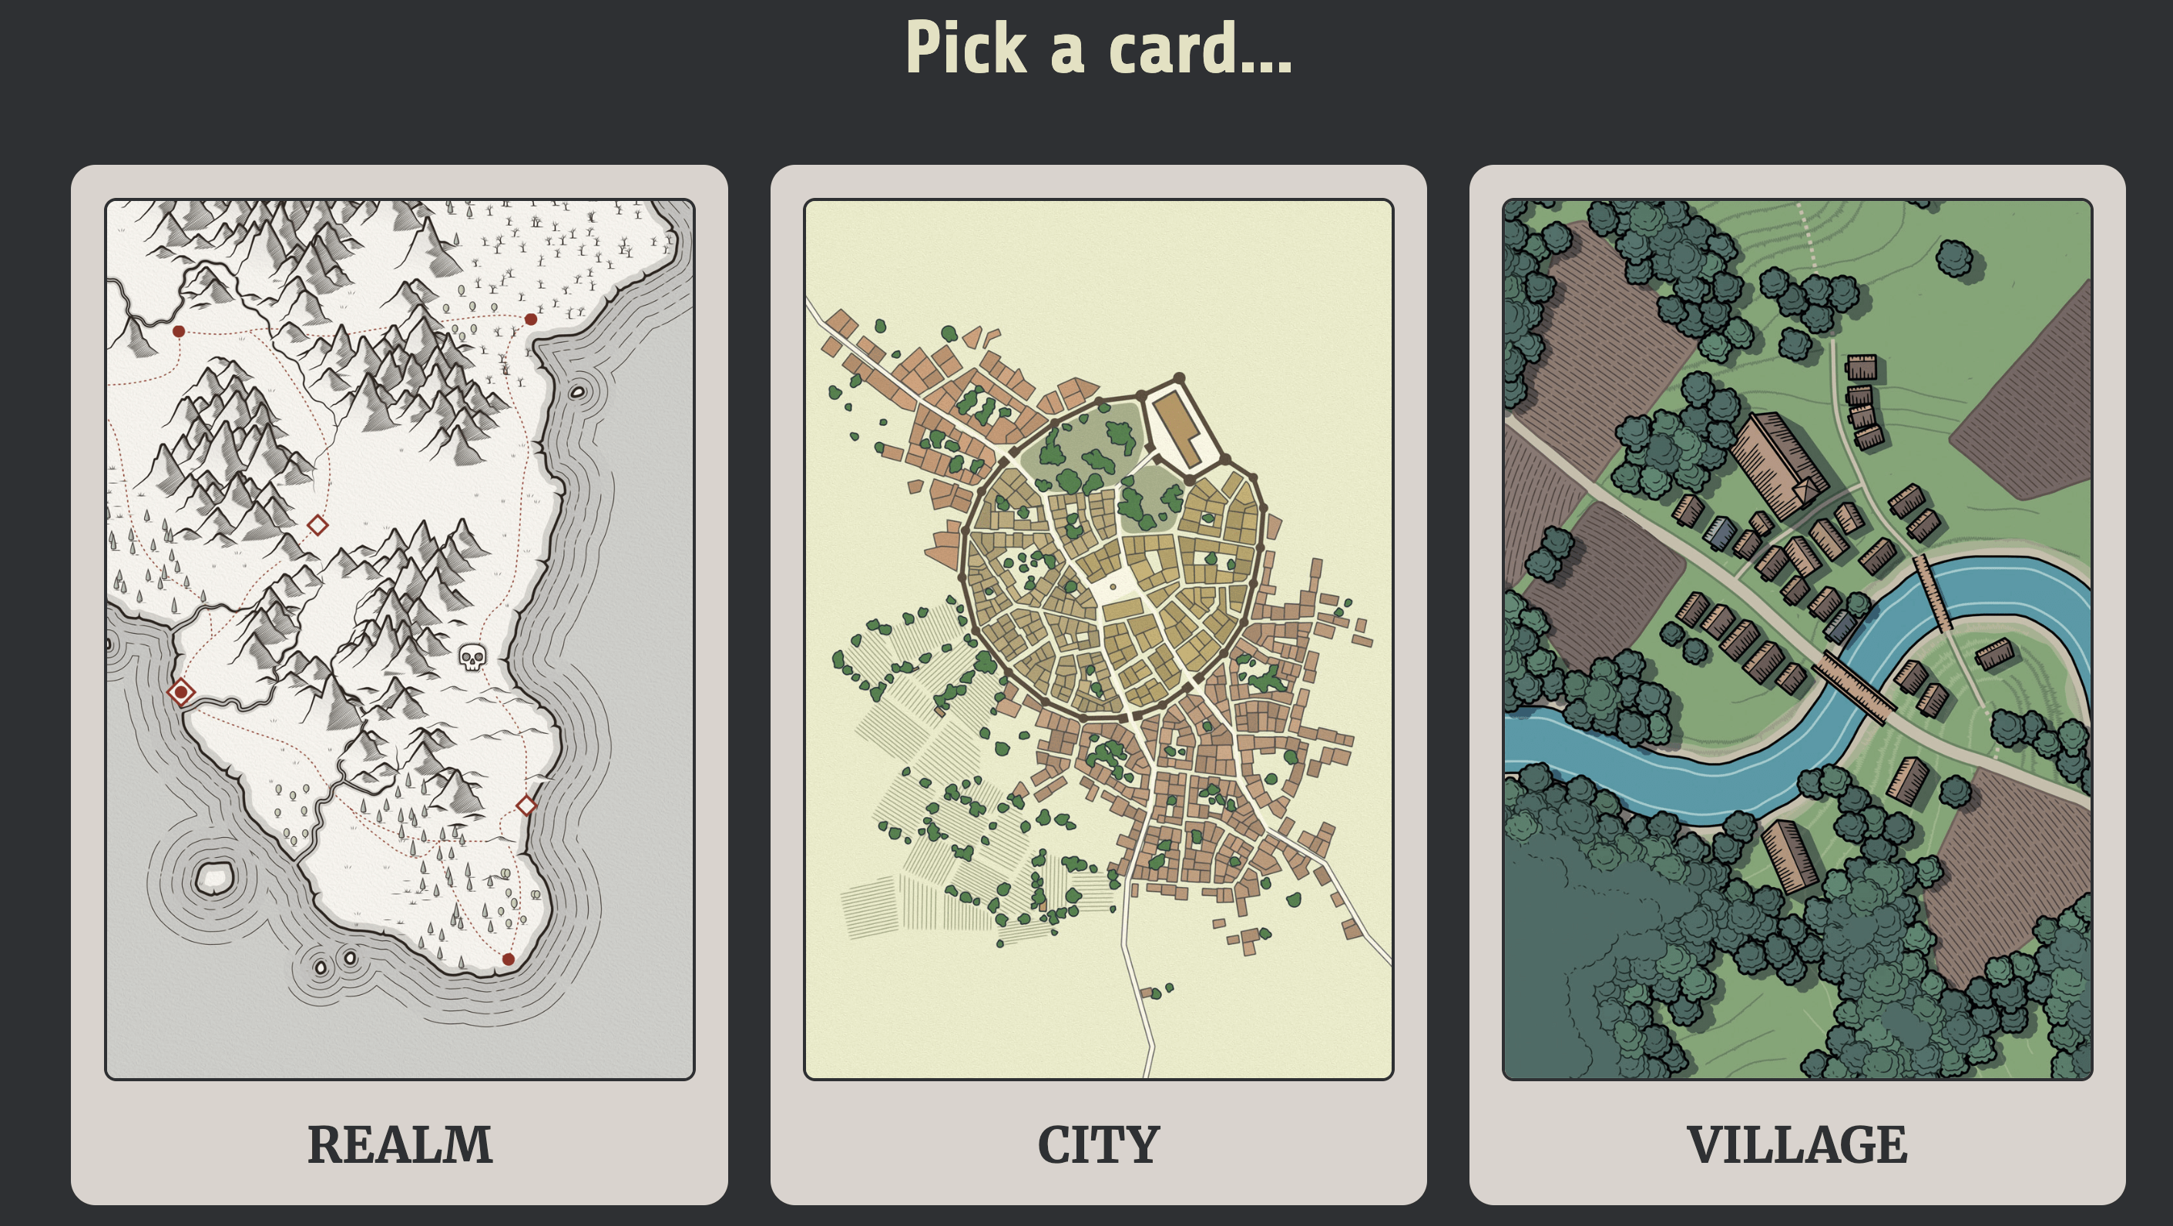

<p data-tool="mdnice编辑器" style="font-size: 16px; padding-top: 8px; padding-bottom: 8px; margin: 0; line-height: 26px; color: rgb(89,89,89);"><strong style="font-weight: bold; color: rgb(71, 193, 168);">https://watabou.github.io/</strong></p>

<p data-tool="mdnice编辑器" style="font-size: 16px; padding-top: 8px; padding-bottom: 8px; margin: 0; line-height: 26px; color: black;">地图生成工具</p>

<h3 data-tool="mdnice编辑器" style="margin-top: 30px; margin-bottom: 15px; padding: 0px; font-weight: bold; font-size: 20px; color: rgb(89,89,89);"><span class="prefix" style="display: none;"></span><span class="content">md2card</span></h3>



<p data-tool="mdnice编辑器" style="font-size: 16px; padding-top: 8px; padding-bottom: 8px; margin: 0; line-height: 26px; color: rgb(89,89,89);"><strong style="font-weight: bold; color: rgb(71, 193, 168);">https://md2card.com/zh</strong></p>

<p data-tool="mdnice编辑器" style="font-size: 16px; padding-top: 8px; padding-bottom: 8px; margin: 0; line-height: 26px; color: black;">Markdown转知识卡片</p>

<h2 data-tool="mdnice编辑器" style="margin-top: 30px; padding: 0px; font-weight: bold; font-size: 22px; border-bottom: 2px solid rgb(89,89,89); margin-bottom: 5px; color: rgb(89,89,89);"><span class="content" style="font-size: 22px; display: inline-block; border-bottom: 2px solid rgb(89,89,89);">📚好资源</span></h2>

<h3 data-tool="mdnice编辑器" style="margin-top: 30px; margin-bottom: 15px; padding: 0px; font-weight: bold; font-size: 20px; color: rgb(89,89,89);"><span class="prefix" style="display: none;"></span><span class="content">Awesome-Android-NDK</span></h3>

<p data-tool="mdnice编辑器" style="font-size: 16px; padding-top: 8px; padding-bottom: 8px; margin: 0; line-height: 26px; color: rgb(89,89,89);"><strong style="font-weight: bold; color: rgb(71, 193, 168);">https://github.com/JsonChao/Awesome-Android-NDK</strong></p>

<p data-tool="mdnice编辑器" style="font-size: 16px; padding-top: 8px; padding-bottom: 8px; margin: 0; line-height: 26px; color: black;">全面深入地掌握NDK技术，成为下一波5G时代的浪潮儿~</p>

<h3 data-tool="mdnice编辑器" style="margin-top: 30px; margin-bottom: 15px; padding: 0px; font-weight: bold; font-size: 20px; color: rgb(89,89,89);"><span class="prefix" style="display: none;"></span><span class="content">codekk</span></h3>

<p data-tool="mdnice编辑器" style="font-size: 16px; padding-top: 8px; padding-bottom: 8px; margin: 0; line-height: 26px; color: rgb(89,89,89);"><strong style="font-weight: bold; color: rgb(71, 193, 168);">https://p.codekk.com/</strong></p>

<p data-tool="mdnice编辑器" style="font-size: 16px; padding-top: 8px; padding-bottom: 8px; margin: 0; line-height: 26px; color: black;">Android开发老站点：KK 专注于开发效率提升、开源分享、技术内推、源码解析、框架设计、好文推荐</p>

<h3 data-tool="mdnice编辑器" style="margin-top: 30px; margin-bottom: 15px; padding: 0px; font-weight: bold; font-size: 20px; color: rgb(89,89,89);"><span class="prefix" style="display: none;"></span><span class="content">diygod</span></h3>

<p data-tool="mdnice编辑器" style="font-size: 16px; padding-top: 8px; padding-bottom: 8px; margin: 0; line-height: 26px; color: rgb(89,89,89);"><strong style="font-weight: bold; color: rgb(71, 193, 168);">https://diygod.cc/about</strong></p>

<p data-tool="mdnice编辑器" style="font-size: 16px; padding-top: 8px; padding-bottom: 8px; margin: 0; line-height: 26px; color: black;">一个前端大佬的博客</p>

<h3 data-tool="mdnice编辑器" style="margin-top: 30px; margin-bottom: 15px; padding: 0px; font-weight: bold; font-size: 20px; color: rgb(89,89,89);"><span class="prefix" style="display: none;"></span><span class="content">wix</span></h3>

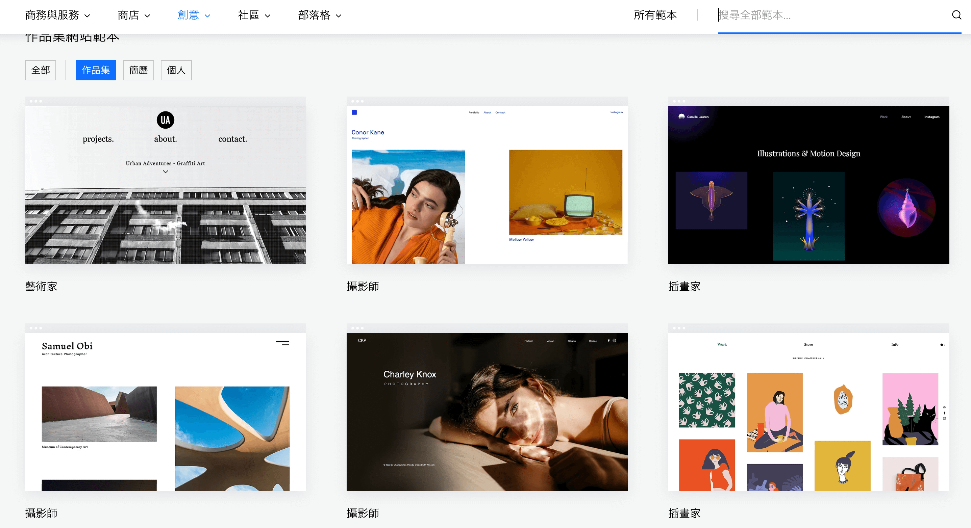

<p data-tool="mdnice编辑器" style="font-size: 16px; padding-top: 8px; padding-bottom: 8px; margin: 0; line-height: 26px; color: rgb(89,89,89);"><strong style="font-weight: bold; color: rgb(71, 193, 168);">https://zh.wix.com/website/templates/html/portfolio-cv/portfolios</strong></p>

<p data-tool="mdnice编辑器" style="font-size: 16px; padding-top: 8px; padding-bottom: 8px; margin: 0; line-height: 26px; color: black;">網站範本参考</p>

<h3 data-tool="mdnice编辑器" style="margin-top: 30px; margin-bottom: 15px; padding: 0px; font-weight: bold; font-size: 20px; color: rgb(89,89,89);"><span class="prefix" style="display: none;"></span><span class="content">OpenGLESDemo</span></h3>

<p data-tool="mdnice编辑器" style="font-size: 16px; padding-top: 8px; padding-bottom: 8px; margin: 0; line-height: 26px; color: rgb(89,89,89);"><strong style="font-weight: bold; color: rgb(71, 193, 168);">https://github.com/ouyangpeng/OpenGLESDemo</strong></p>

<p data-tool="mdnice编辑器" style="font-size: 16px; padding-top: 8px; padding-bottom: 8px; margin: 0; line-height: 26px; color: black;">Android客户端OpenGLES学习资料</p>

<h2 data-tool="mdnice编辑器" style="margin-top: 30px; padding: 0px; font-weight: bold; font-size: 22px; border-bottom: 2px solid rgb(89,89,89); margin-bottom: 5px; color: rgb(89,89,89);"><span class="content" style="font-size: 22px; display: inline-block; border-bottom: 2px solid rgb(89,89,89);">🎮好玩的</span></h2>

<h3 data-tool="mdnice编辑器" style="margin-top: 30px; margin-bottom: 15px; padding: 0px; font-weight: bold; font-size: 20px; color: rgb(89,89,89);"><span class="prefix" style="display: none;"></span><span class="content">HTWKR</span></h3>

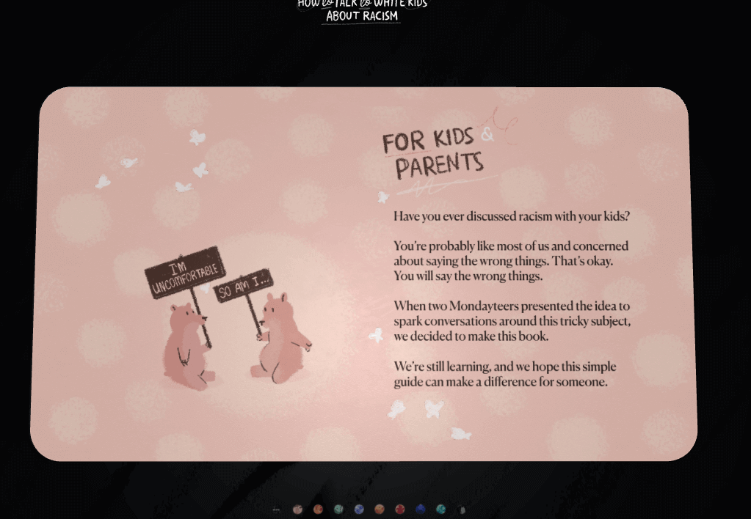

<p data-tool="mdnice编辑器" style="font-size: 16px; padding-top: 8px; padding-bottom: 8px; margin: 0; line-height: 26px; color: rgb(89,89,89);"><strong style="font-weight: bold; color: rgb(71, 193, 168);">https://howtotalktowhitekidsaboutracism.com/</strong></p>

<p data-tool="mdnice编辑器" style="font-size: 16px; padding-top: 8px; padding-bottom: 8px; margin: 0; line-height: 26px; color: black;">H5前端优秀案例，采用treejs实现的儿童翻页图书</p>

<h3 data-tool="mdnice编辑器" style="margin-top: 30px; margin-bottom: 15px; padding: 0px; font-weight: bold; font-size: 20px; color: rgb(89,89,89);"><span class="prefix" style="display: none;"></span><span class="content">greweb-plots</span></h3>

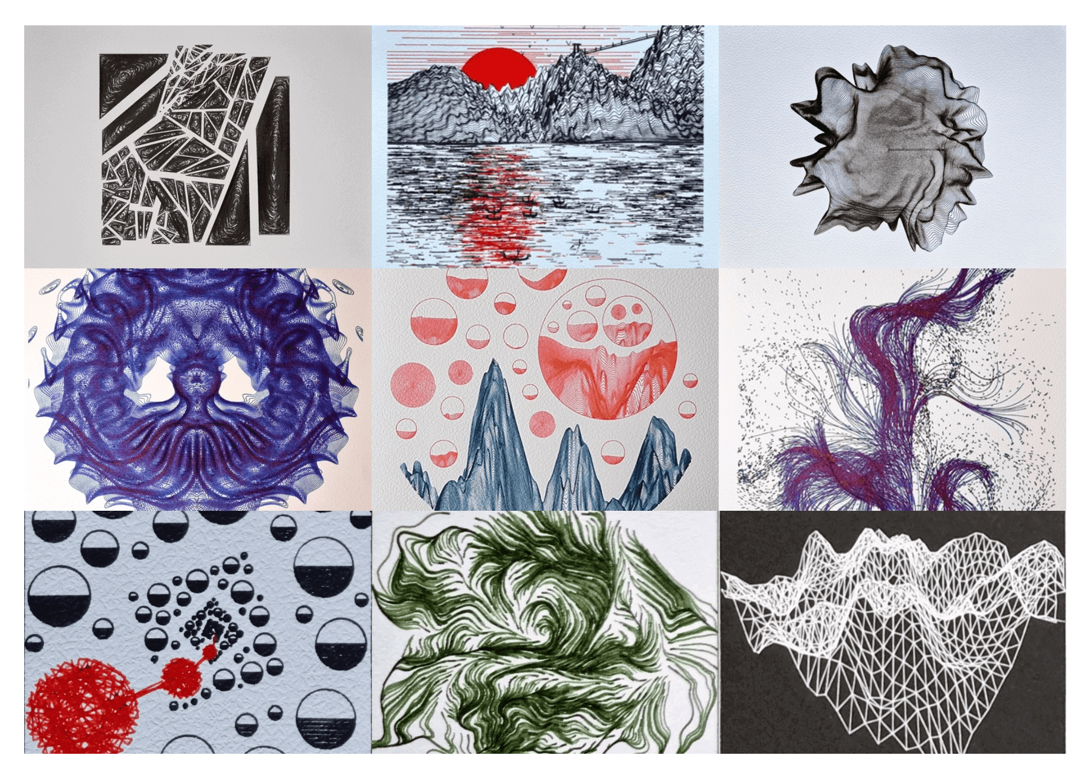

<p data-tool="mdnice编辑器" style="font-size: 16px; padding-top: 8px; padding-bottom: 8px; margin: 0; line-height: 26px; color: rgb(89,89,89);"><strong style="font-weight: bold; color: rgb(71, 193, 168);">https://greweb.me/plots</strong></p>

<p data-tool="mdnice编辑器" style="font-size: 16px; padding-top: 8px; padding-bottom: 8px; margin: 0; line-height: 26px; color: black;">一个外国博主使用代码来生成艺术（创意编码）</p>

<h3 data-tool="mdnice编辑器" style="margin-top: 30px; margin-bottom: 15px; padding: 0px; font-weight: bold; font-size: 20px; color: rgb(89,89,89);"><span class="prefix" style="display: none;"></span><span class="content">pixie.haus</span></h3>

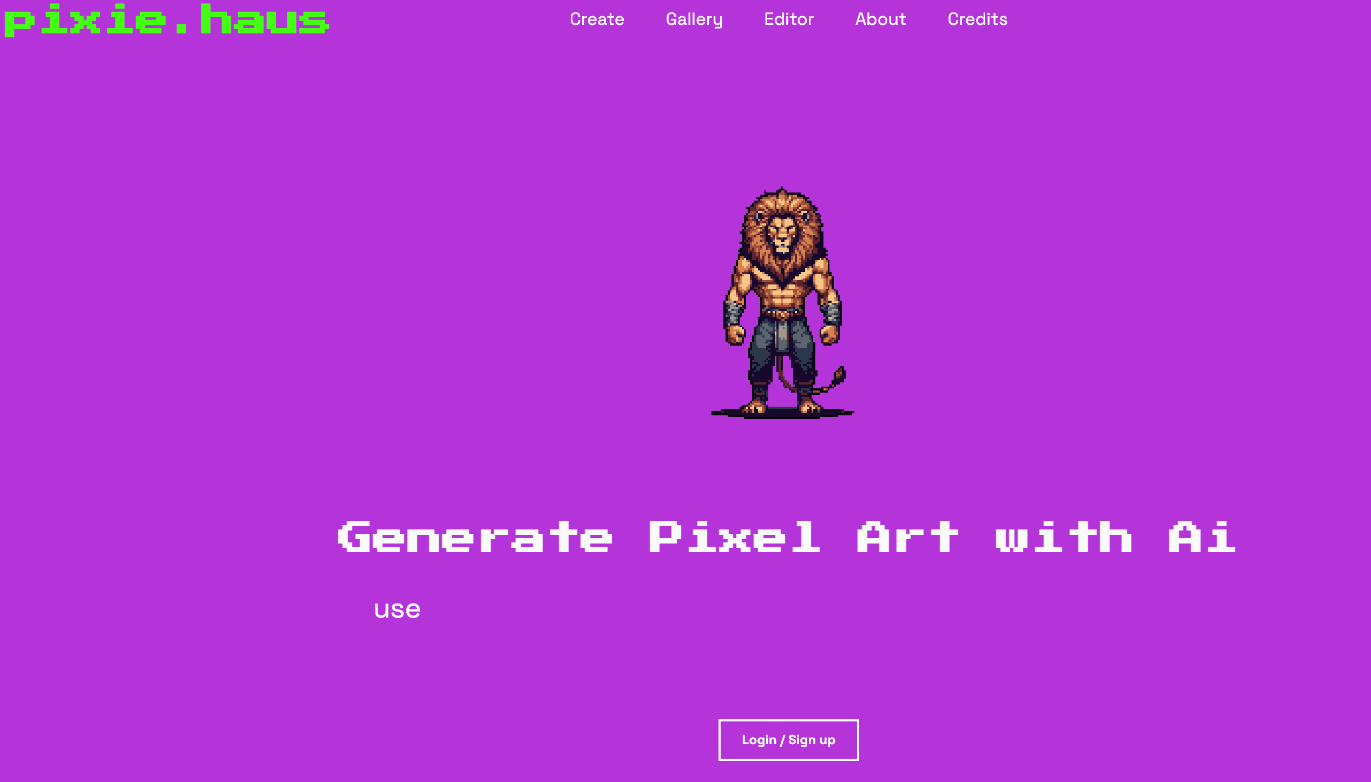

<p data-tool="mdnice编辑器" style="font-size: 16px; padding-top: 8px; padding-bottom: 8px; margin: 0; line-height: 26px; color: rgb(89,89,89);"><strong style="font-weight: bold; color: rgb(71, 193, 168);">https://pixie.haus/</strong></p>

<p data-tool="mdnice编辑器" style="font-size: 16px; padding-top: 8px; padding-bottom: 8px; margin: 0; line-height: 26px; color: black;">像素风格一键生成工具</p>