1. Install WordPress in Windows.
2. Working with themes.
   1. Install themes

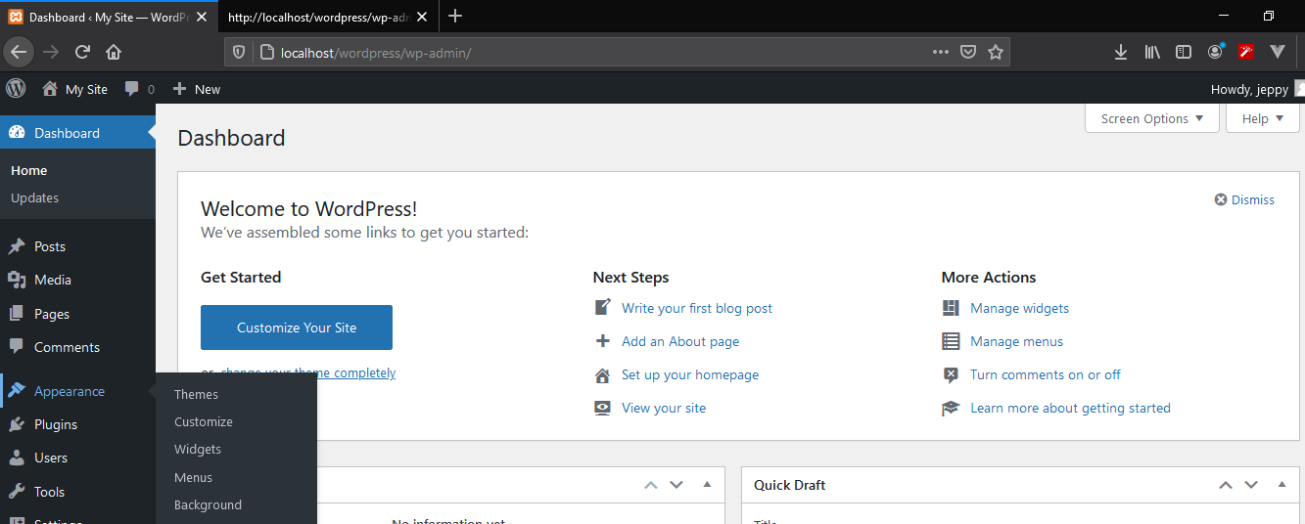

1. Working with plugins.

