L’impact des médias sociaux sur la mobilisation politique des jeunes

2024-11-27

# Introduction

The Tufte handout style is a style that Edward Tufte uses in his books and handouts. # Tables

You can use the kable() function from the **knitr** package to format tables that integrate well with the rest of the Tufte handout style. The table captions are placed in the margin like figures in the HTML output.

knitr::kable(  
 mtcars[1:6, 1:6], caption = 'A subset of mtcars.'  
)

A subset of mtcars.

|  | mpg | cyl | disp | hp | drat | wt |
| --- | --- | --- | --- | --- | --- | --- |
| Mazda RX4 | 21.0 | 6 | 160 | 110 | 3.90 | 2.620 |
| Mazda RX4 Wag | 21.0 | 6 | 160 | 110 | 3.90 | 2.875 |
| Datsun 710 | 22.8 | 4 | 108 | 93 | 3.85 | 2.320 |
| Hornet 4 Drive | 21.4 | 6 | 258 | 110 | 3.08 | 3.215 |
| Hornet Sportabout | 18.7 | 8 | 360 | 175 | 3.15 | 3.440 |
| Valiant | 18.1 | 6 | 225 | 105 | 2.76 | 3.460 |

## Including Plots

You can also embed plots, for example: library(readxl) df <- read_xlsx(“documents/sondage médias sociaux.xlsx”) 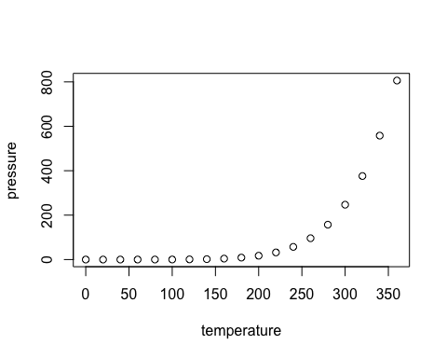

Note that the echo = FALSE parameter was added to the code chunk to prevent printing of the R code that generated the plot.