Research question

Which features of the cars influence the production of carbon dioxide in cars. The cars has features such as model of the car, volume of the car, the weight and the type of the car. Which of the features influence the production of carbon dioxide and by how much.

The dataset is provide online through the link <https://raw.githubusercontent.com/girirajv10/Linear-Regression/main/cars.csv>. Data is scraped by Excel and loaded into the working space. The data has 36 rows and five columns. The names of the columns are Car, Model, Volume, C02 and Weight.

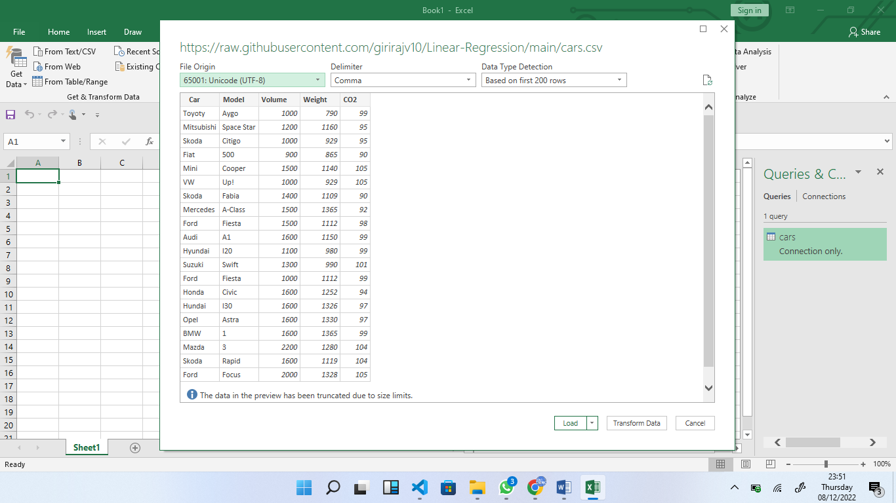

The descriptive statistics of the dataset is given below

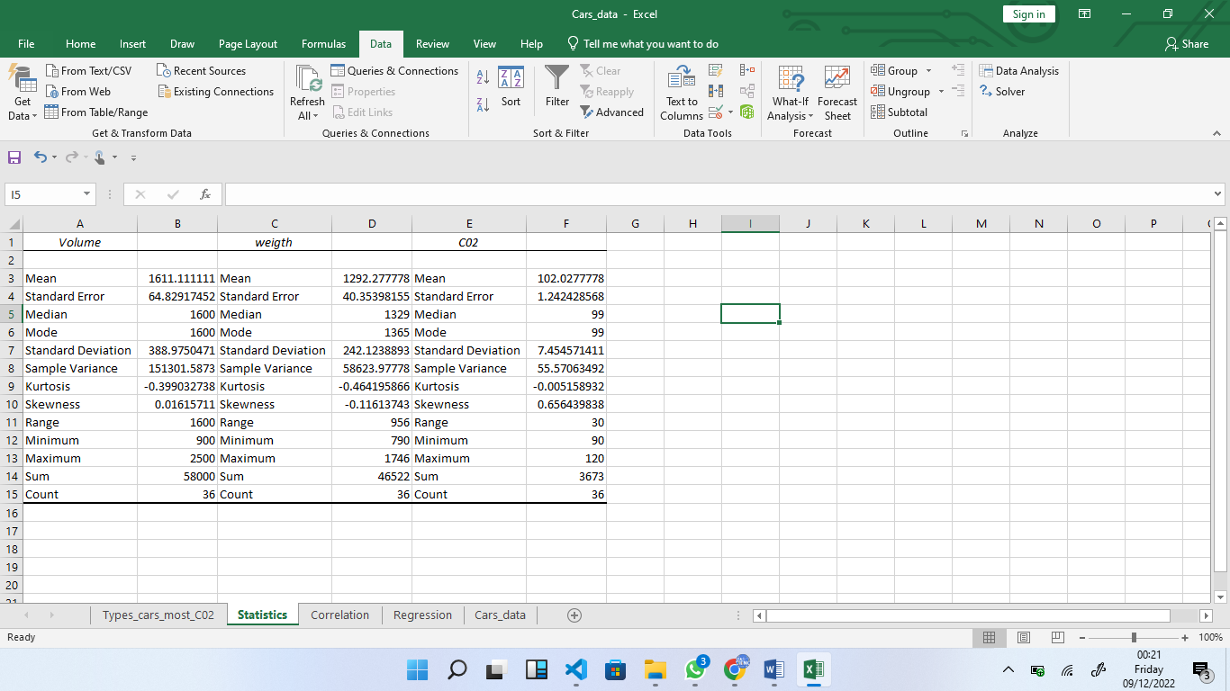

Let’s find out the relationship types of the car and gas production

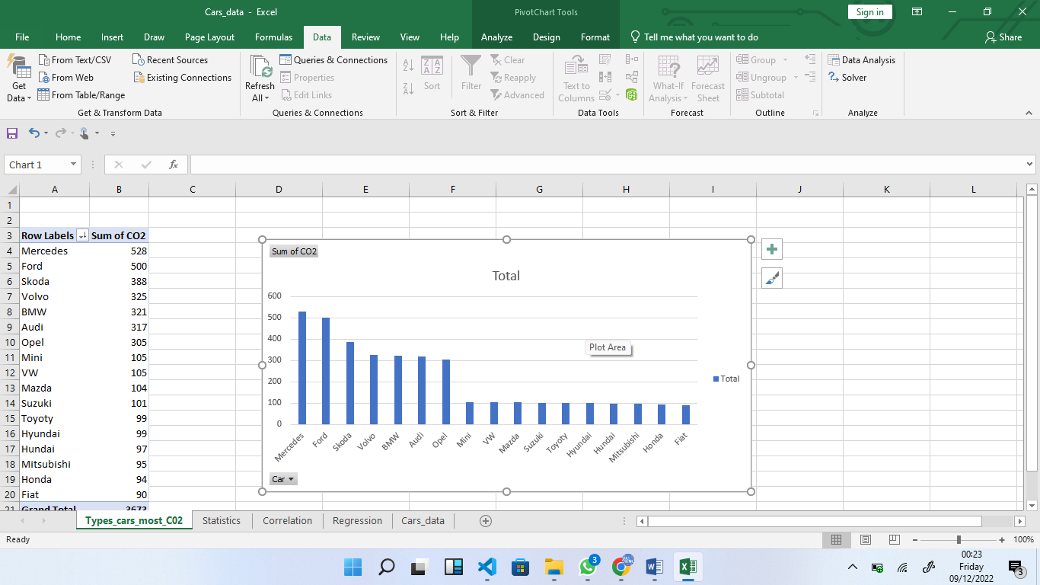

The Mercedes, Ford and Skoda produce the highest carbon dioxide.

The correlation between volume, weight and gas production is given below

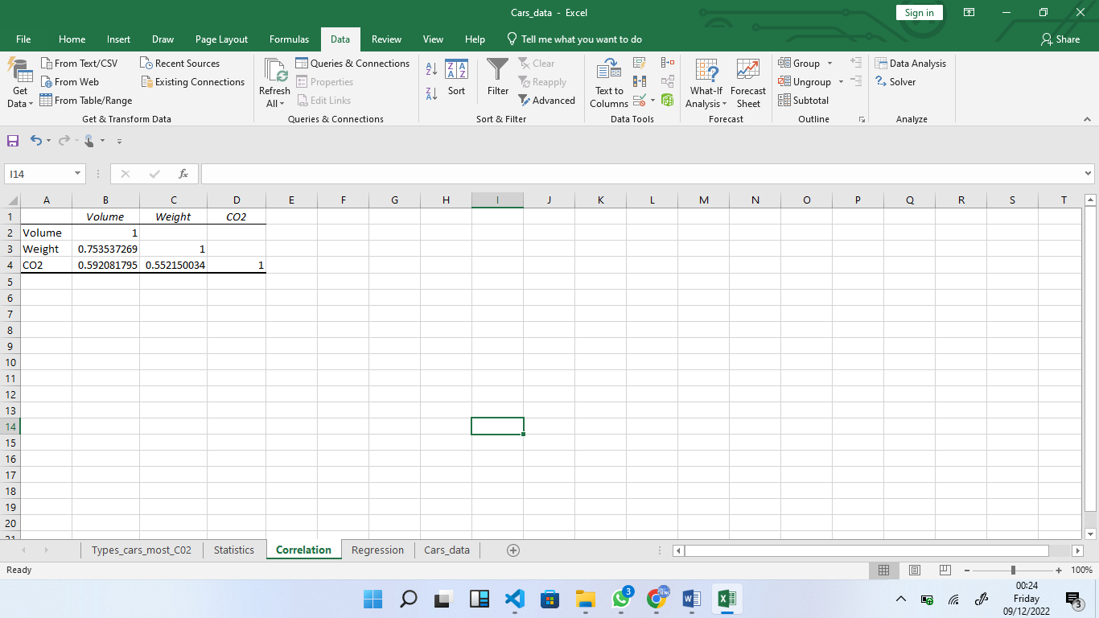

The simple linear regression of the variables Volume and Weight is given as follows;

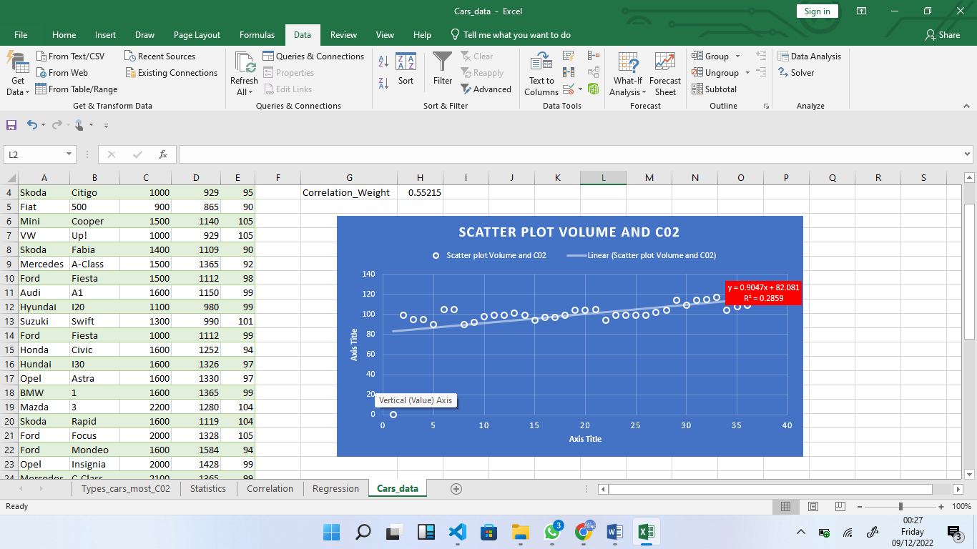

The R2 is 0.39. The model performs poorly due to limited data used in training the model

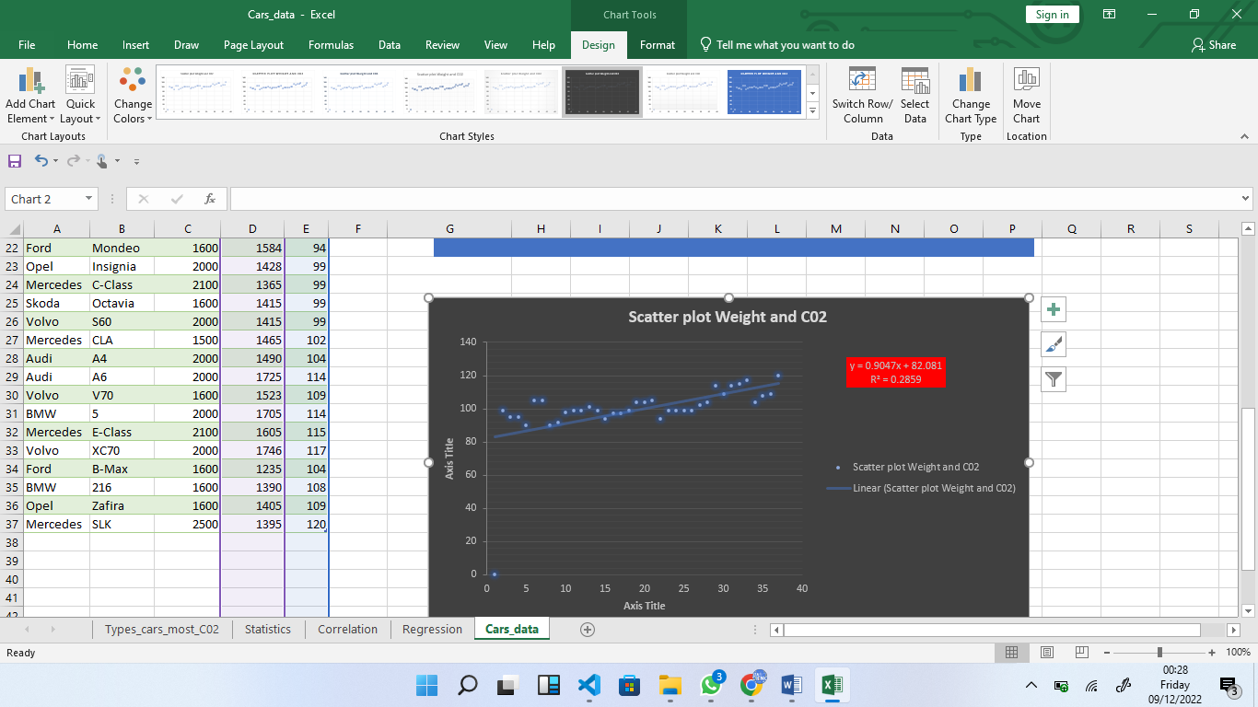

Volume and weight facilitate the mass production of the carbon dioxide gas in manufactures cars

The multiple linear regression is provided below

