**Research question**:

How different types of advertising influence the sales.? In this question, there are values of sales and the cost of different types of advertising platforms. The advertising platforms are TV, Newspaper and Radio. Therefore, lets find out whether advertising influence the sales positively or negatively.

**Dataset**

The data has been scraped from the Github website with the following link <https://raw.githubusercontent.com/justmarkham/scikit-learn-videos/master/data/Advertising.csv>. The dataset has 200 rows and four columns.

The column names are Sales, Radio, Newspaper and TV

.

The dependent valuable in this scenario is Sales and the other remaining variables are predictors.

**Univariate analysis**

In this case, a regression equation is produced for each independent variable and then analyze the relationship.

* **The relationship between Sales and TV**

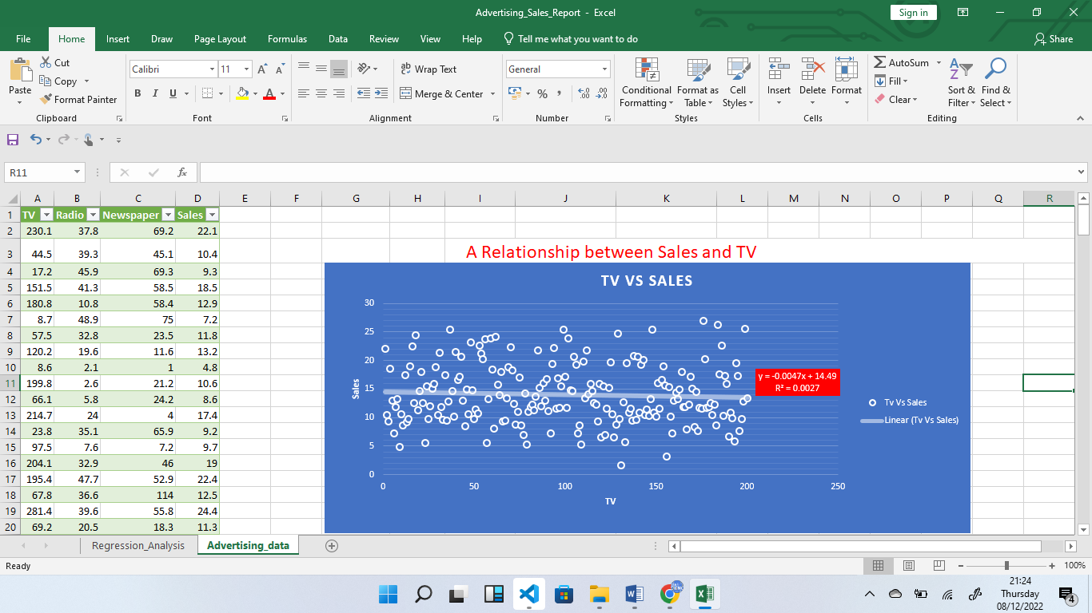

The equation created is y= -0.0047x + 14.49 and the R2 = 0.0027

This means that spend in one unit of TV results to a loss of 0.004 units of sales

* **Relationship between Sales and Newspaper**

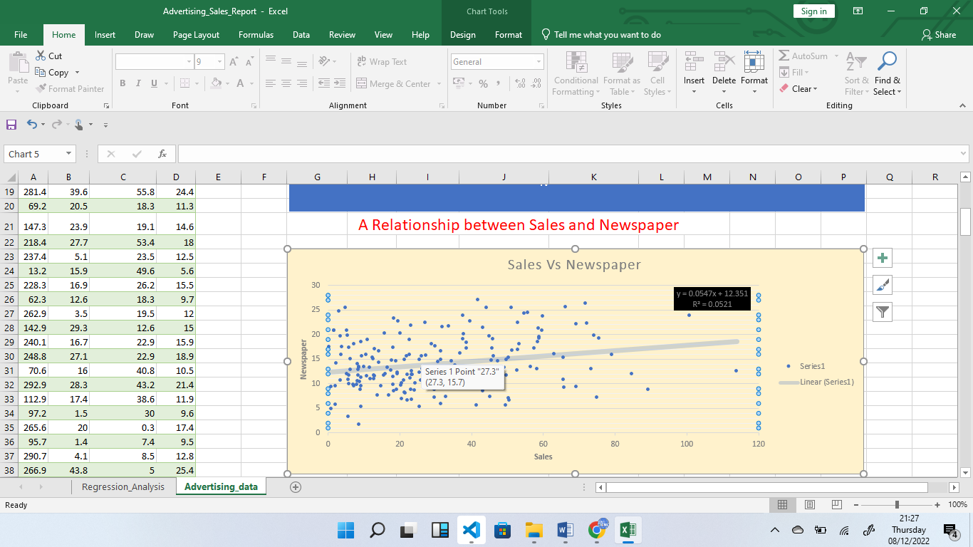  
 The result of the equation is y = 0.0547x + 12.351 and R2 is 0.0521

This means that spend on one unit of Newspaper result to an increase of 0.0547 units of Sales

* **Relationship between Sales and Radio**

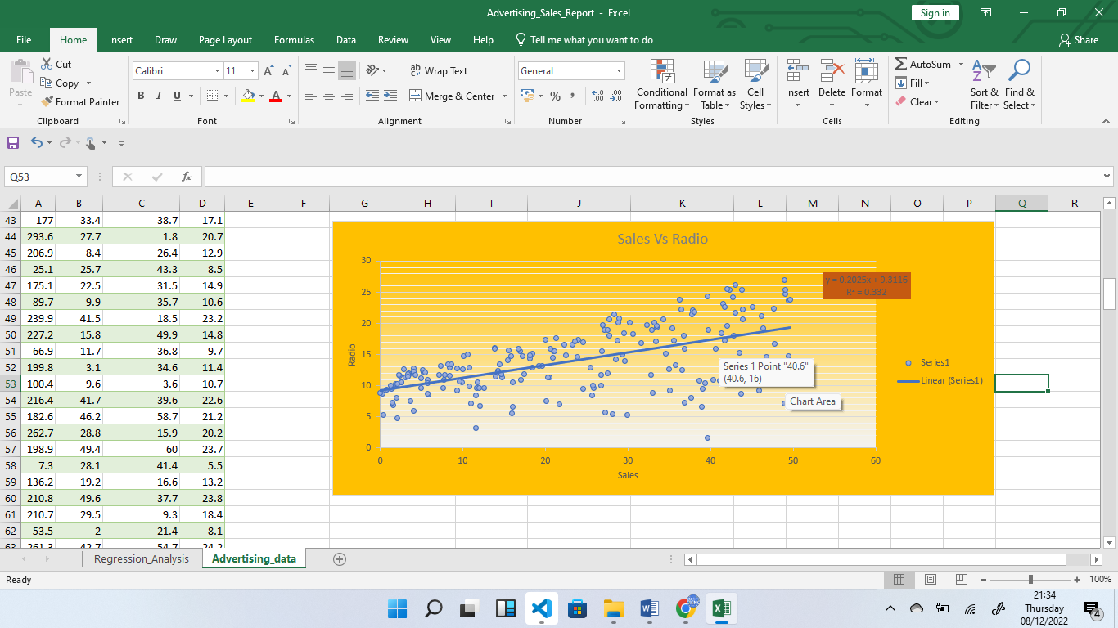

This results an equation of y = 0.2025x +9.3116 and R2 of 0.332

**Multivariate Analysis**

Using the previous results, It can be concluded that spend on advertising on TV, affects the sales negatively thus, in multivariate analysis, the TV advert is excluded. The results to the following.

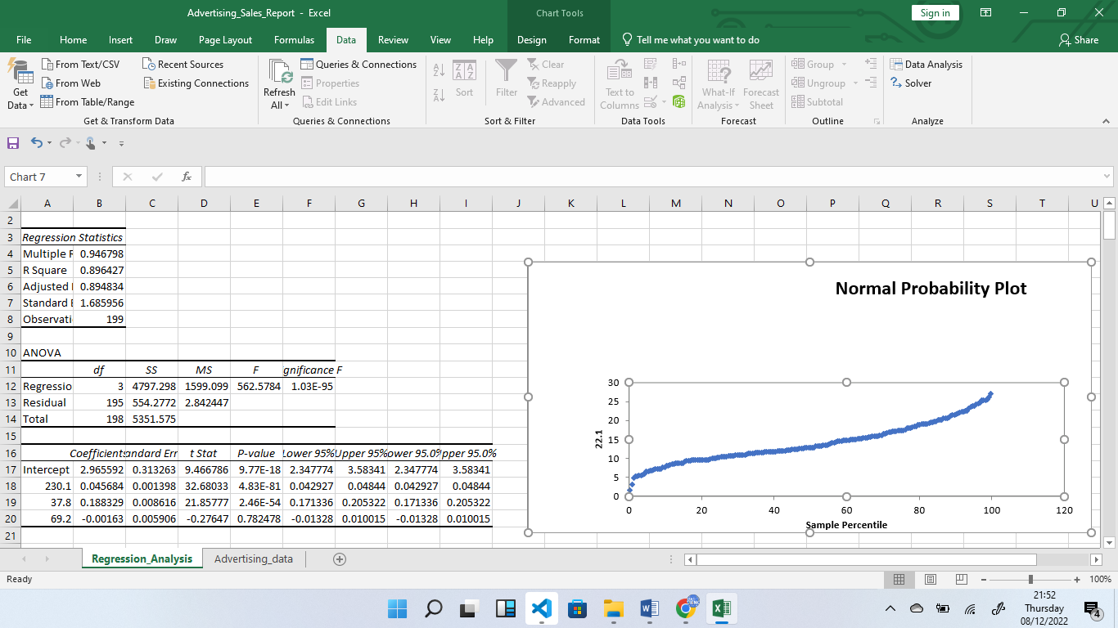

The R2 is 0.8964