Research question

Is there a linear relationship between the Target and other variables? There exist a dataset with 3 features and therefore, there is a need to determine if there exist a linear relationship between the features and Target variable.

Data already stored in github and can be accessed through the link <https://raw.githubusercontent.com/bhattbhavesh91/linear-regression-assumptions/master/data.csv> . Excel is used as data analytic tool to extract data and do the analysis.

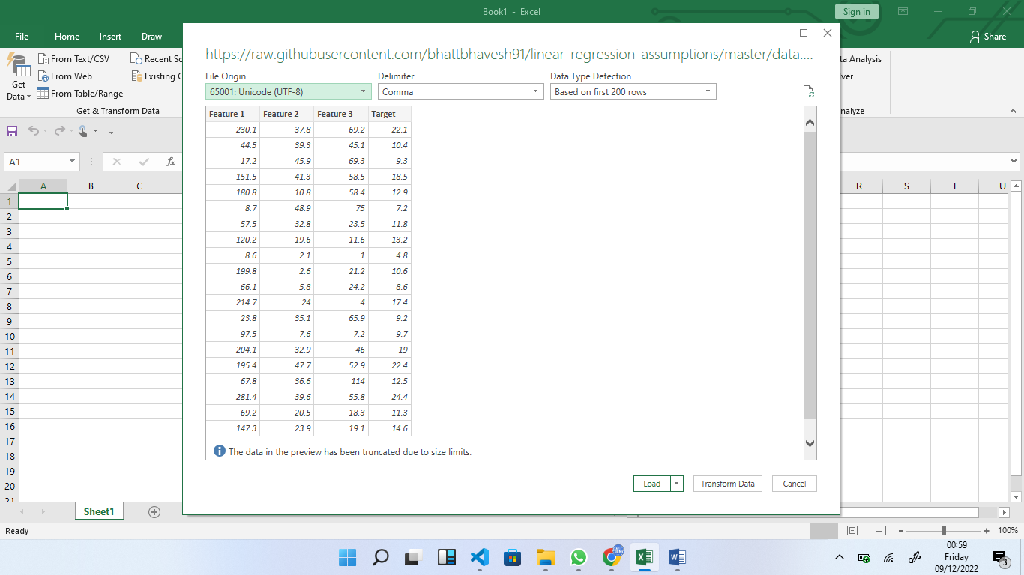

The data contains 200 rows and four columns. The names of the columns are Feature1, Feature2, Feature and Target

The correlation matrix is shown in the screenshot below

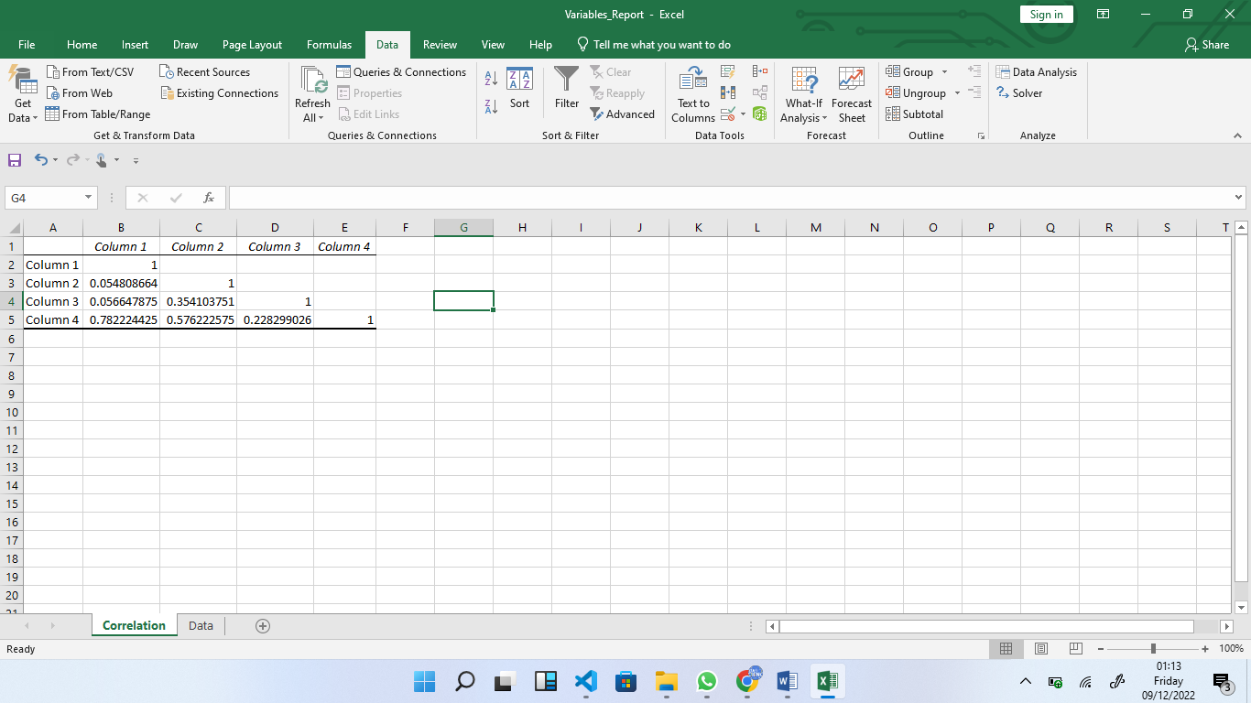

The relationship between Target and Features is show below in various screenshots

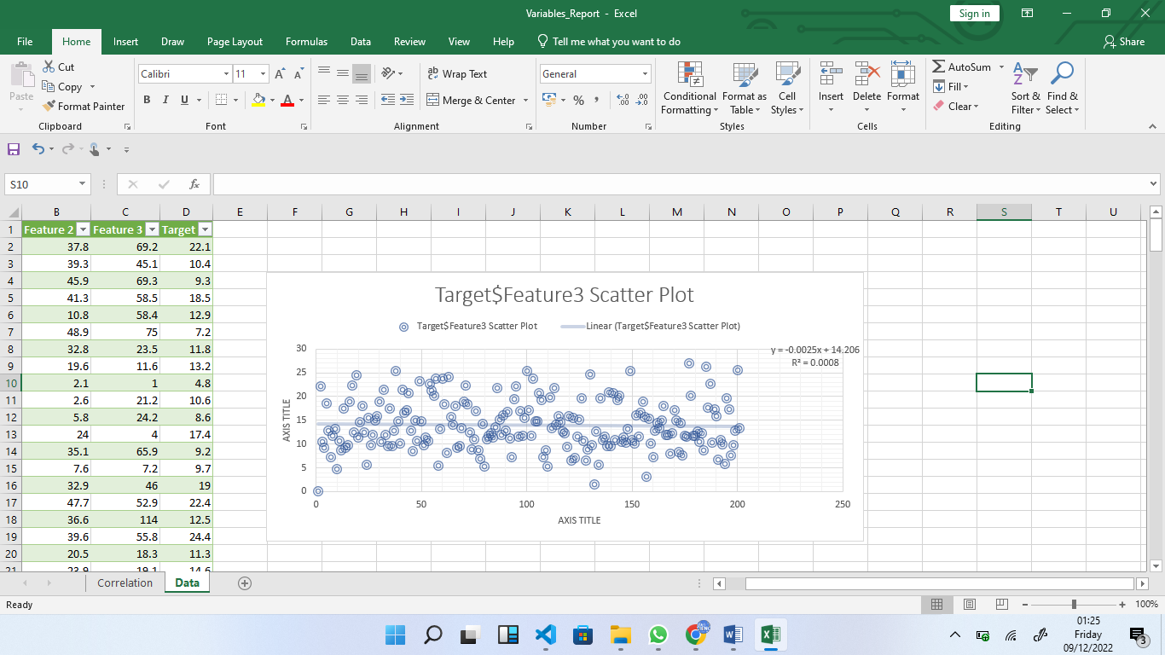

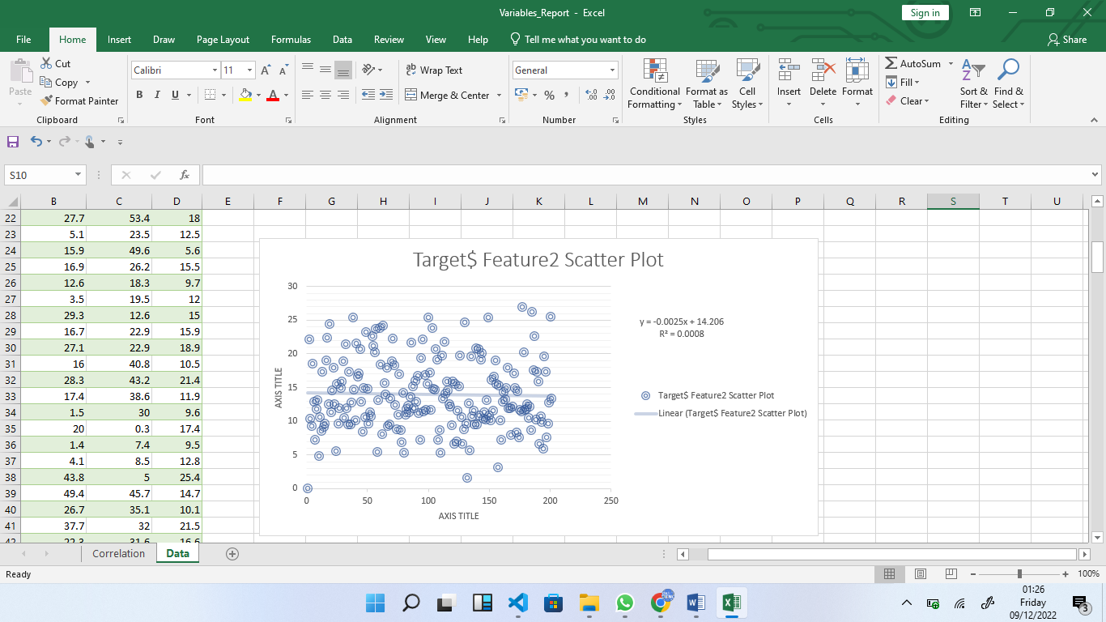

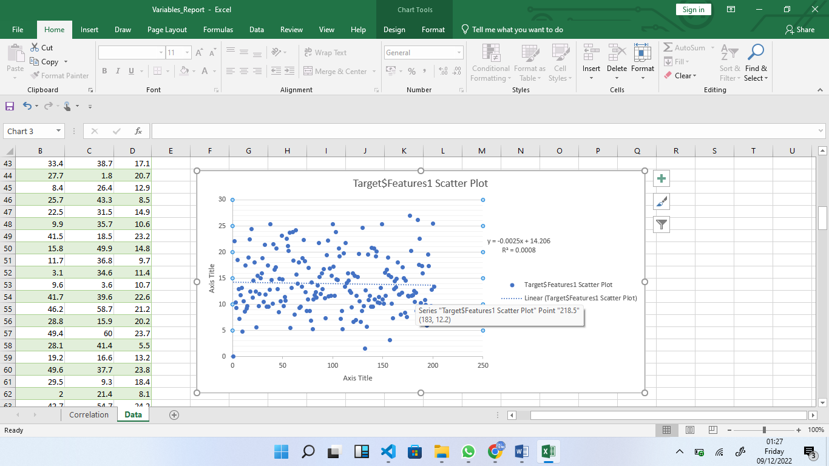

The Analysis of Variance (ANOVA) has been provided below.

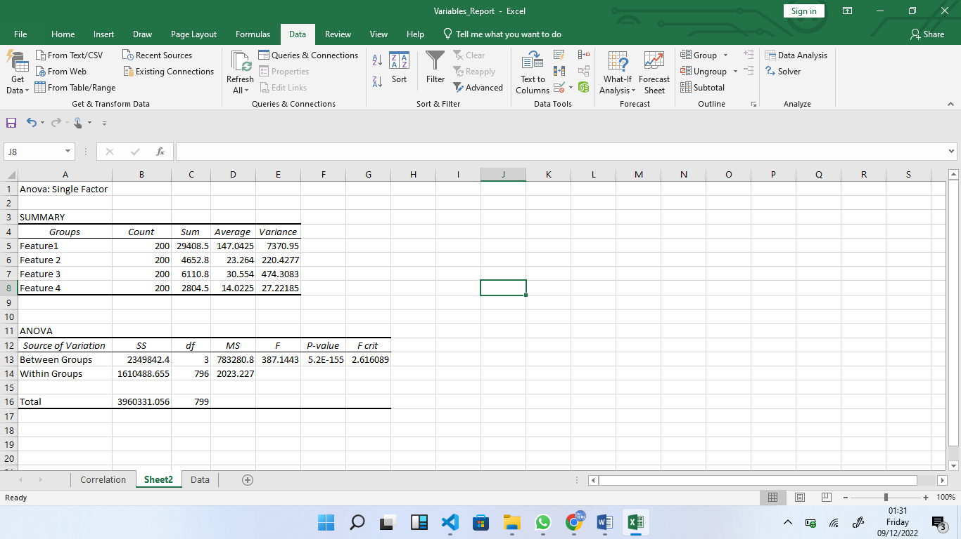

The Multiple linear regression is as follows;

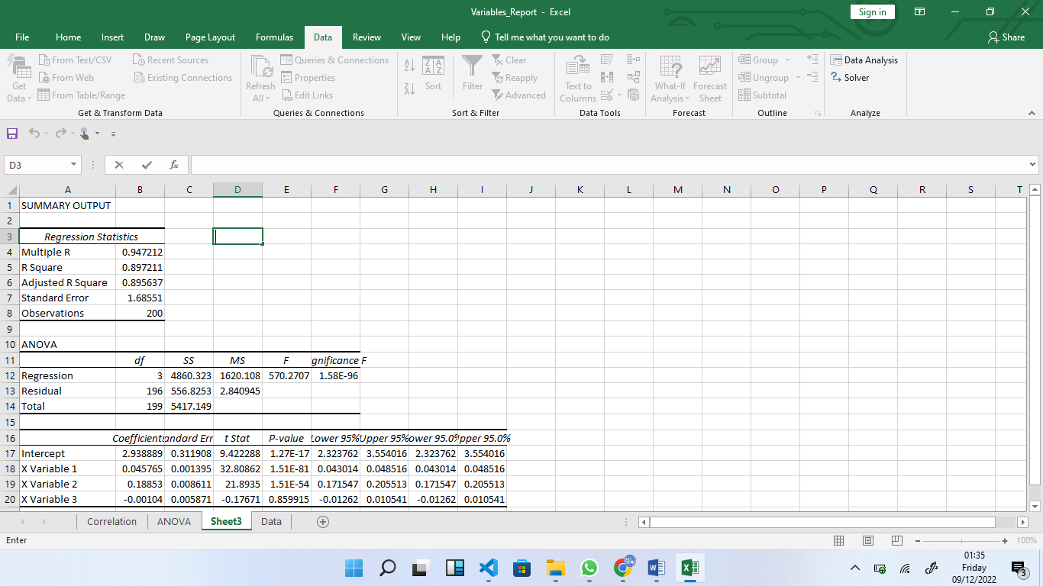

The R2 is 0.89 and therefore the model performs better.