Research Question

Discover Factors influencing crop production. In this question, data has been collected and stored, therefore need to determine which of the most factors affects production and by how much.

Dataset

The dataset is stored by the link <https://raw.githubusercontent.com/komalmenger/Automatic-irrigation-and-crop-prediction/master/ML%20Codes%20and%20datasets/production.csv> . The dataset has 1523 rows and four columns. The columns are PH value, Temperate, rainfall and Production. The dependent variable is the Production while the others are independent variables. By use of excel, data is extracted and loaded into excel workbook and then proceeded for analysis.

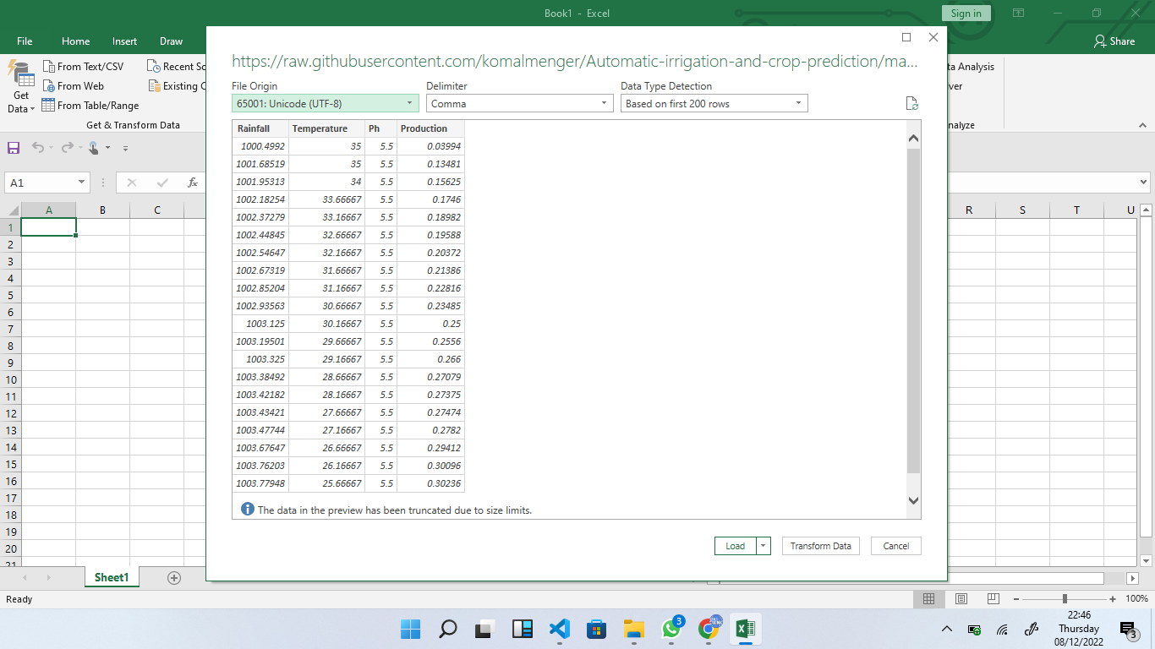

The descriptive analysis of the dataset is as follows:

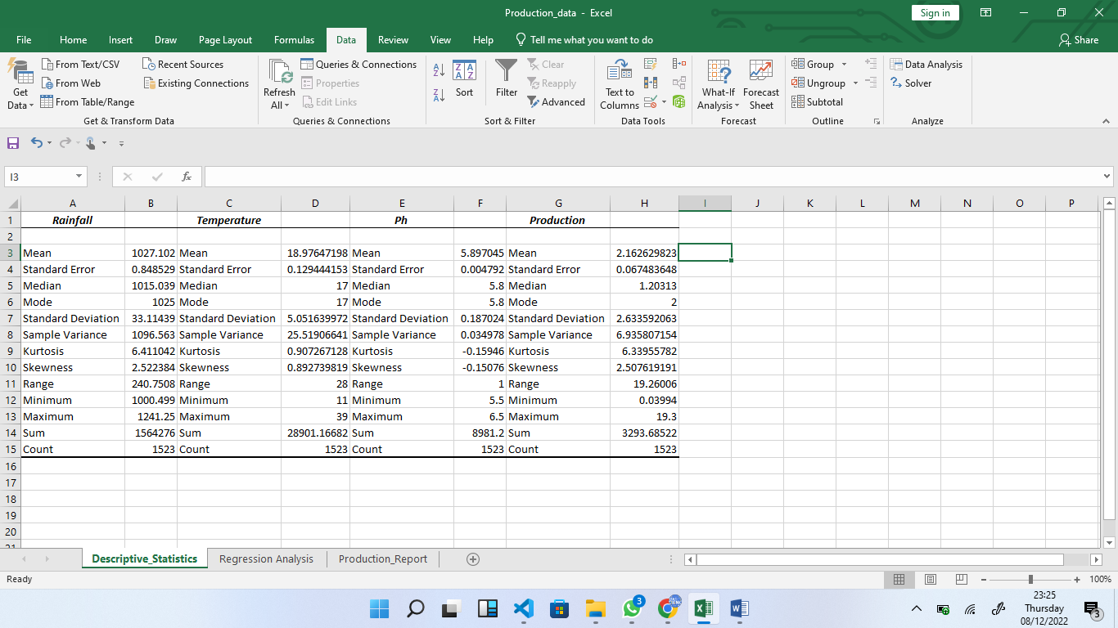

The temperature ranges from 11 to 39 degrees Celsius, Rainfall from 1000 to 1242 mm and the PH is from 5.5 to 6.5

The correlation coefficients are as follows;

PH is 0.49, Temperature is 0.78 and Rainfall is 0.9998

The relationship between production and PH is shown below

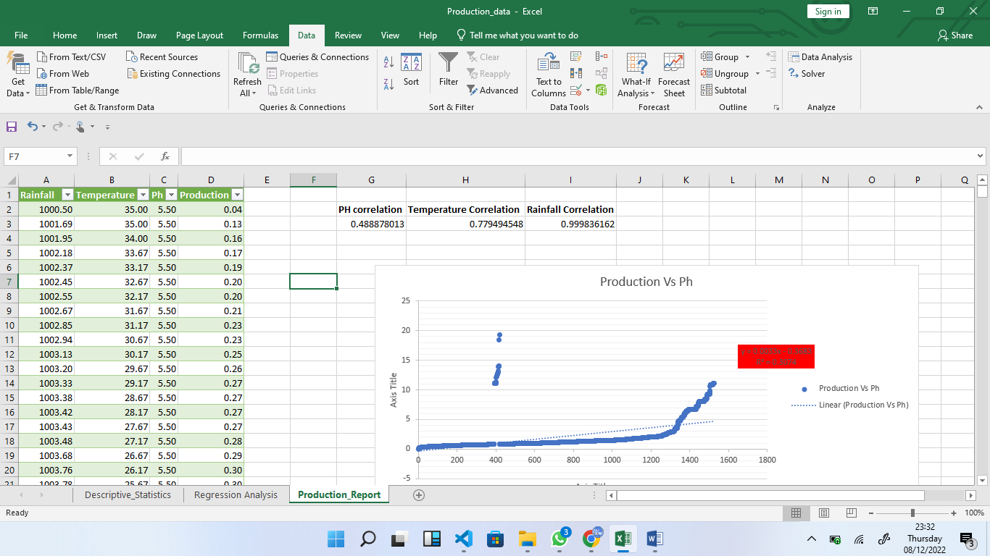

The relationship between production and Temperature is shown below

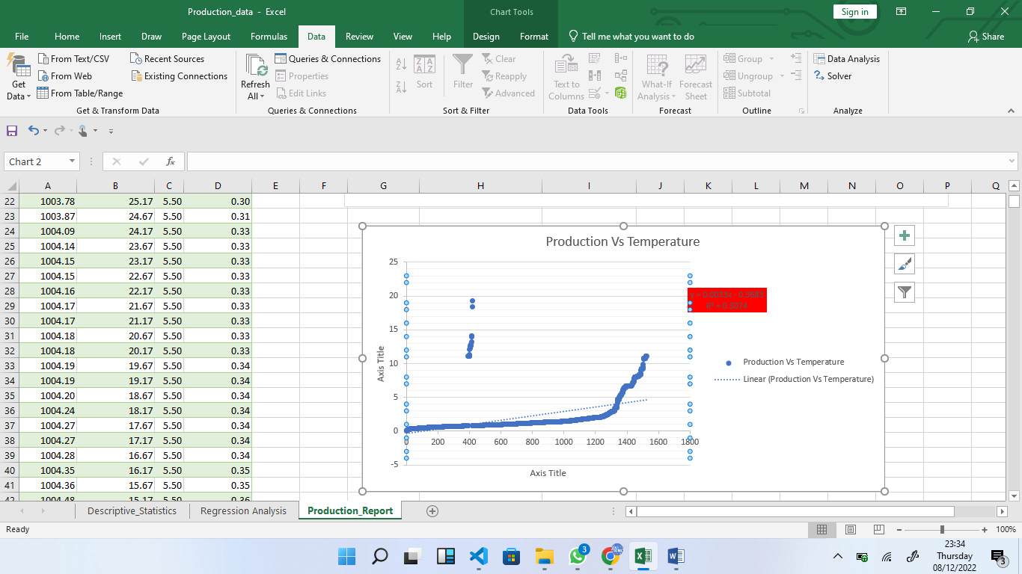

The relationship between Production and Rainfall is given below

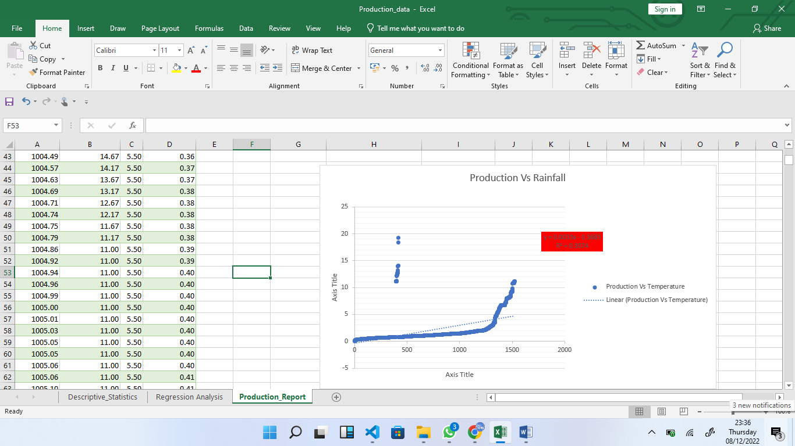

The regression equation is given below

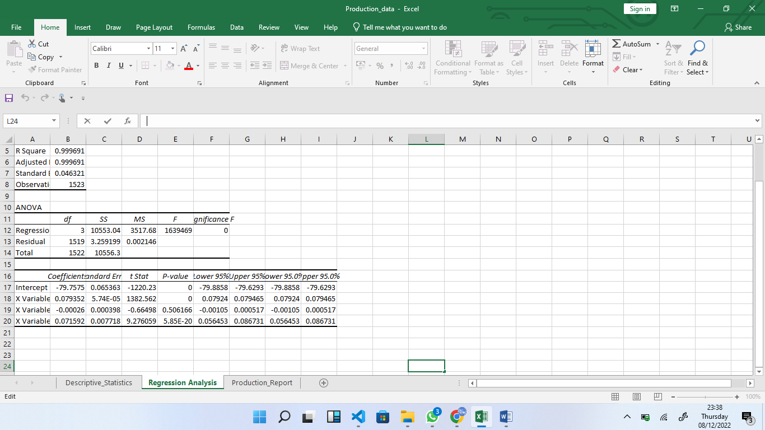

R2 is given as 0.9998

We have also an ANOVA to analyze the means of the four groups.

Therefore, we can conclude that Rainfall, Temperature and PH values influence the production of the crops.