- Searching Algorithms in Java
A simple Java console-based program demonstrating two fundamental searching algorithms:
- Linear Search
- Binary Search
This project is designed for beginners who are learning Data Structures and Algorithms (DSA) using Java.

📌 Features
- 🔹 Linear Search implementation
- 🔹 Binary Search implementation
- 🔹 Menu-driven console interface
- 🔹 User-defined array size
- 🔹 User input for array elements
- 🔹 Displays the index when an element is found
- 🔹 Displays a message when an element is not found
- 🔹 Exit option

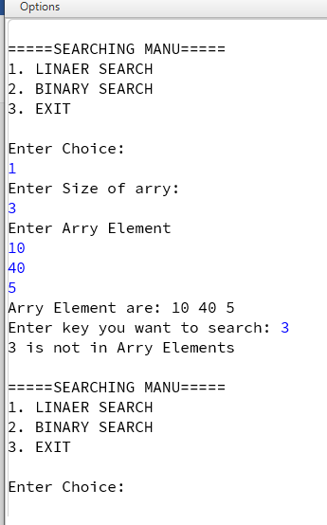
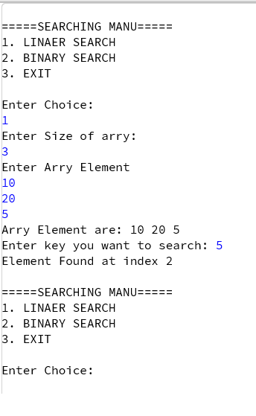
Screenshots

