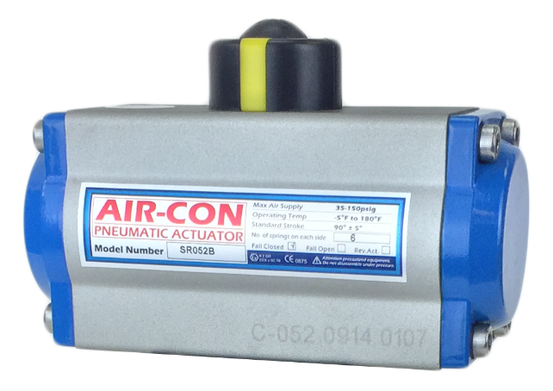
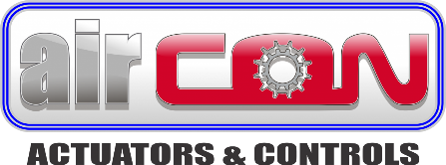

Models:53
Size Range 2" - 12"

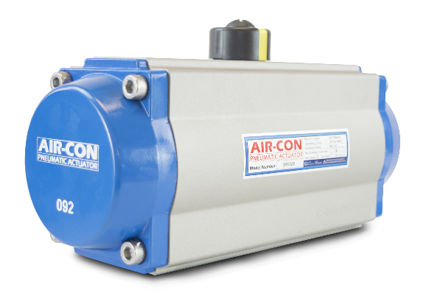
Torque Range:
50 Thru 28500 in-LBS
Independent Travel Stop Adjustment
Range of 5° for the 90° Rotation

DESIGN ADVANTAGES

• Extruded Aluminum Body with standard hard anodized finish and polished internal surfaces.
• Die Cast Aluminum End Caps powder polyester paint, PTFE or nickel plated.
• Position Indicator with NAMUR slot for ease of accessory mounting.
• High Precision Nickel Alloy Steel Blow-out Proof Pinion provides corrosion protection and fully confirms to ISO 5211 and NAMUR standards.
• Dual Opposed Rack Pistons with low friction bearings and guides for high performance, long cycle life and fast response. Pistons can be easily inverted for reversing rotation.
• Linear Torque Output from 0° through 90° stroke.
• Independent Travel Stop Adjustments of ±5° in both open and closed positions for precise valve alignment.

• High Performance Pre-loaded Spring Cartridges allow for greater safety and longer spring life.
• Double acting units can be easily converted to spring return by adding the appropriate quantity of cartridges. Different torque requirements can also be easily achieved by changing the quantity of springs.

• NAMUR Solenoid Mounting Design permits direct mounting of solenoid valves.
• Stainless Steel 304 Fasteners as standard.
• High Quality O-rings provides trouble-free operation for a wide range of temperature applications.
• Optional Corrosion Protection available for body and end caps.

