
Home | controlseal™
Double Block and Bleed Valve (DBBV)
On / Off non lubricated expanding plug valve with provable zero leakage
- Size range:1” ~ 48”
- Pressure class:150# ~ 2500#
- Temperature range:-196°C ~ +250°C
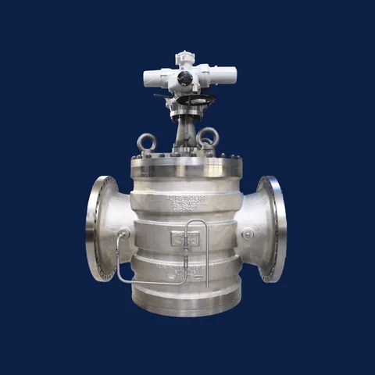

Rising Stem Ball Valve (RSBV)
On / Off metal-to-metal ball valve for extreme conditions
- Size range:1” ~ 36”
- Bore:Reduced or Fullbore
- Pressure class:150# ~ 2500#
- Temperature range:-196°C ~ +538°C
