

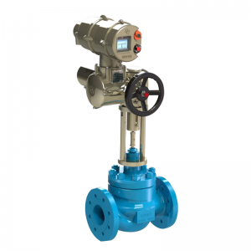
Control Valve, Valve Actuator, Electric Actuator - Hankun
Single Seated Valve(Cage)
Cage Type Single Seated Control Valves are designed for high differential pressure heavy duty service where flashing/cavitation may occur.Further, they are ideal for preventing erosion from the valve body, because their guides are sturdy and the valve body is protected by a cage. The compact valve body, with an S-shaped flow passage that features low pressure loss, allows a large flow capacity and range ability.
The valve plug is highly vibration-resistant as it is held by a top guide section which has a large sliding area. The flow shut-off performance complies with the IEC or JIS Standards. The actuator, integrated with simplest mechanisms, utilizes a compact yet powerful diaphragm actuator loaded with multiple springs.
Cage Type Single Seated Control Valves are widely applicable for reliable control of flows in high or low temperature, high differential pressure process lines.

