

Protectoseal - Flame Arresters and Pressure/Vacuum Relief Vents
Flame Arresters
In-Line Detonation Flame Arresters
Every flame starts out unstable before it can ever become stable. That’s why the safest choice is an unstable detonation flame arrester. In modern vapor piping systems, flame acceleration can happen very quickly, and once ignition occurs, there may be little or no time to react. Choosing the right flame arrester from the start helps prevent serious, catastrophic events.
Closed piping systems with long runs, bends, and direction changes create turbulence that speeds up flames. What begins as a small ignition can quickly escalate from deflagration to unstable detonation and then to stable detonation, creating extreme pressure. Protectoseal’s unstable detonation flame arresters are designed to stop the flame at every stage before it can cause damage.
Unlike traditional flame arresters, Protectoseal’s unstable detonation flame arresters provide complete protection in a single device. They stop deflagration, unstable detonation, and stable detonation flame fronts, while delivering exceptional flow performance with very low pressure drop. They also offer best-in-class shock absorption and heat dissipation for added safety.
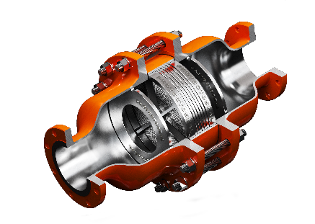
Protectoseal is dedicated to ongoing research and innovation in flame arrester technology. Our unstable detonation flame arresters have undergone rigorous testing to ensure maximum safety and reliable performance. When you choose Protectoseal, you’re investing in state-of-the-art technology that meets the highest safety standards and delivers lasting peace of mind.

Conservation Vents
Conservation Vents are employed where it is necessary or desirable to reduce evaporation of tank contents to atmosphere. These vents are generally designated as the conservation type. They are typically mounted to a flange or pipe that connects to the vapor space (space within the tank that is above the liquid surface) of a storage tank. The pressure in this vapor space increases or decreases as liquid is pumped into or out of the tank, respectively. Atmospheric temperature changes cause an expansion or contraction of the vapors in this space, again resulting in pressure increases or decreases.
These vents are factory set to your specifications so that the pallet assemblies in the housings open when specific pressure and vacuum levels are sensed. The set points for these vents are achieved either by weight loading or spring loading of the pallet assemblies, depending on the setting required. The tank’s vapor space pressure/vacuum works in opposition to the force (weight or spring) applied to the pallet assemblies. Once the excess pressure or vacuum condition has been relieved, the pallet assemblies reseal automatically. The tank’s vapor space is always maintained within the safe range of its pressure and vacuum operating design limits.
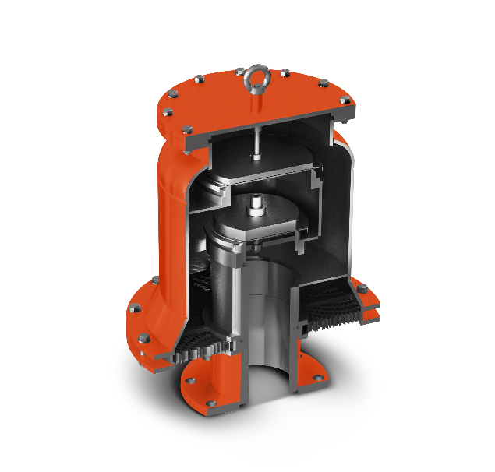
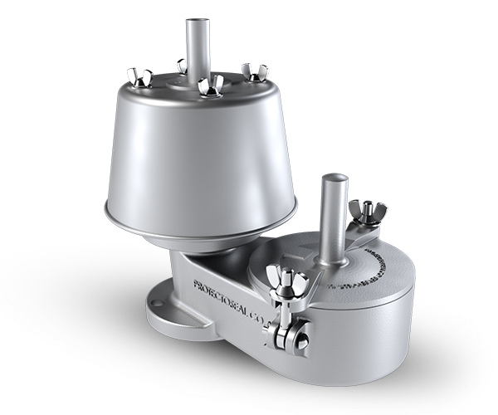

Emergency Pressure Relief Vents
In addition to the normal venting capacity provided by Protectoseal’s Pressure / Vacuum Relief Vents and/or Flame Arresters, every large above ground flammable liquid storage tank should be provided with some means of relieving excessive internal pressure caused by exposure of the tank to a fire. Depending upon the strength of the tank structure, a vent sized to handle the normal venting requirements (for day-to-day operations) may be inadequate to handle the abnormal vapor efflux generated by heat from an exposure fire.
When a fire occurs near a flammable liquid storage tank, heat transmitted through the tank wall to the contents will cause the liquid to vaporize readily. In the case of petroleum based products, this vaporization may amount to roughly 30 or more cubic feet of vapor for every gallon of solvent vaporized. This generates a relatively high pressure within the confined area of the tank’s vapor space. In the absence of sufficient emergency relief a tank rupture could occur, with disastrous effect on life and property and the environment.
Explosions caused by such conditions may be readily avoided by providing adequate emergency relief vents which permit the vapors to escape from the tank. These emergency vents usually include pallet assemblies which are weighted to stay closed under normal pressure conditions and which open only when a predetermined pressure is attained, thus relieving the abnormal volume of vapor generated under the fire conditions described above. Emergency relief vents should be sized and specified in accordance with NFPA 30 Flammable and Combustible Liquids Code (Emergency Relief Venting for Fire Exposure for Above Ground Storage Tanks).

