# Brief introduction of Brian-Cup 1.0

**1 General introduction**

**1.1 Basic elements of brain images**

There are several objects can be show in your final figures, each of which is useful in showing your results more accurately and clearly. We defined several classes of objects that can be appeared in you figures as below.

**Masks:** In medical imaging, mask is a set of spatial constraints that make computation or display occur within a certain geometric range. Three levels of masks can be presented in your figures.

**Global level masks** like the whole brain, the entire head or the skull. These macro masks are generally used to show empirical spatial location knowledge. For example, through the global brain mask, we can roughly see whether a result is in the frontal lobe or the parietal lobe.

**Tissue masks** are the geometric space information that is set up in order to be able to see the different positioning in the organization difference. For example, masks that can distinguish white matter from gray matter and those that can distinguish cerebellum, brain stem and cortex are widely used.

**Region of interest (ROI)** localization is an important basis for target feature extraction, target recognition and tracking. It is often better suited to the particular purpose of a particular study. In the display of neuroimaging results, ROI is usually calibrated to show the applicable range of the results.

**Slices:** In medical imaging, images are usually analyzed and stored in the form of two-dimensional images, or higher dimensional images which can be deconstructed into 2-D slices. Section images can often be rich in texture information which mostly cannot be provided by masks, so volume rendering based on this texture information is an important research direction in 3D reconstruction. Experienced doctors and researchers often have a strong insight into single-layer imaging information. As a result, slices plotted in figures are helpful to provide useful information.

**Results:** in neuroimaging studies, results were often showed in many aspects and in a bunch of methods. Most of the results are presented based on rendering mask or slice.

**Cluster rendering:** The cluster rendering method is derived from the focus display of medical imaging. The method of volume rendering or patch rendering is usually used to show that the tissues in some spatial positions are pathological, or have special structural and functional characteristics.

**Mask mapping:** This is a method to show the results on the mask by constructing some kind of mathematical mapping. Based on the complexity of human histomorphology, the selection of mapping method is very important.

**Directed graph:** It usually shows the directed relationship between multiple ROIs. For example, the analysis of physiological and psychological interactions often requires the drawing of directed maps between individual brain regions. However, DCM or complex network methods need to construct more directed maps between brain regions.

**Undirected graph:** As above, many methods of brain science require us to draw the relationship between the two brain regions. In many cases, this relationship has no specific direction.

* 1. **Modes of Brain-Cup**

Three models of Brain-Cup can be used to present results.

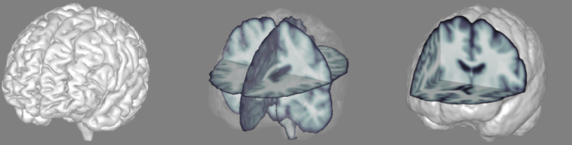

Figure 1.2.1 Milk mode (left), tea mode (middle) and coffee mode (right) in Brain-Cup

**Milk mode:** the milk mode refers to a mapping-to-mask method to present your results. This model is helpful to show clusters of specified structural and functional voxels in the gray matter cortex. In this mode, the transparency of the mask surface is 0, and mostly showed pure white color except for the result-mapped surfaces, because of which I name it as milk mode. You can see nothing inside the mask. This is achieved by the surface mapping functions in Matlab. Several templates were offered.

**Tea mode:** the tea mode refers to a transparent-mask-method to show your results. Tissue masks (for example, white matter skeletons or cerebella) and ROIs can be plotted in the global mask, which can also be transparent but with different colors to label brain regions. Result regions (such as fiber tracts, specific brain structures and activation areas) will be rendered as clusters. Slices can also be plotted in the mask with where its colormap can be defined based on your selection. Furthermore, I've designed a toolkit so that you can add stereoscopic icons, such as arrows and lines that indicate the relationship between brain regions. This mode is named as tea mode because you can see the elements you present (drink) through transparent masks (water).

**Coffee mode:** the coffee mode refers to a volume rendering method to present your result. Using the relevant functions in MATLAB, brain cup simulates the voxel rendering method by patch modeling. Several methods are used to speed up that the voxel rendering (simulated by patch rendering) time in MATLAB. At present, you can manually condition the MNI coordinates of cut face by operating a bar. In this mode, you can also add masks This mode is named as coffee mode because you can see texture of slices without transparent masks.