Umeå University 2004-04-18
Department of Physics

Florian Schmidt
Leif Hassmyr
Ludvig Edman
Updated: Tobias Nilsson,
Jesper Vesterberg



Solid State Physics

Electrical Conductivity

The Aim______________
The aim of this laboratory is to deepen your understanding of different types of solids, such as a superconductor or metal, in terms of their electrical conductivity. Furthermore, you should get an insight in the usage of vacuum systems for the generation of low temperatures (cryogenic equipment). You will also see how a computer can be used to control temperature and measure electrical quantities.

The Task_______________
Your task in this laboratory is to study and to explain the temperature dependence of the electrical conductivity of a superconductor, a semiconductor and a metal in the temperature range from 10 to 300 K.
- Equipment

  - Cryogenic equipment (compressor, cooling head, flexible pressure tubes).
  - Two vacuum pumps: a coarse vacuum pump and a turbo-molecular pump.
  - Temperature control.
  - Control for the turbo-molecular pump including a pressure indicator.
  - Samples of three different materials (metal, semiconductor, and superconductor).
  - "4-pole resistance measurement system" (multimeter, computer).
  - Compendium with excerpts from various "Solid State Physics" books.

- Cryogenic equipment

The cryogenic equipment consists of a compressor (HC-2D), a two-stage cooling head (DE-202, Fig. 1) and flexible pressure tubes. The cooling system has two cooling stages. The cooling capacity of the second stage is approximately 2 W at 20 K and diminishes quickly towards lower temperatures until close to 0 W at 10 K (Fig. 2).

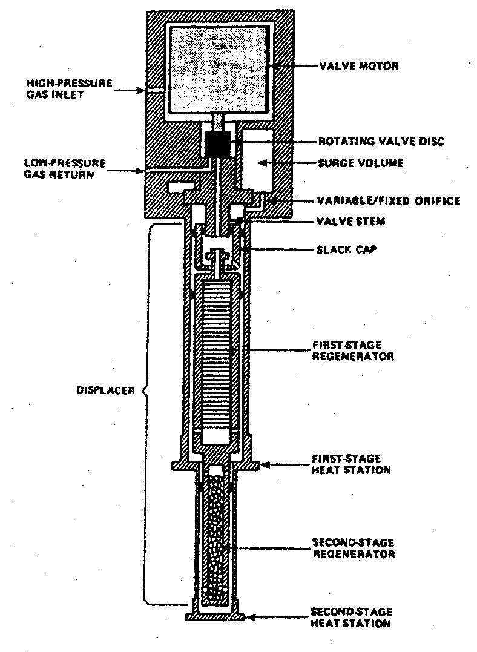
Fig. 1: The cooling head DE-202. The drawing is up side down with respect to the position of the cooling head in the experimental setup!

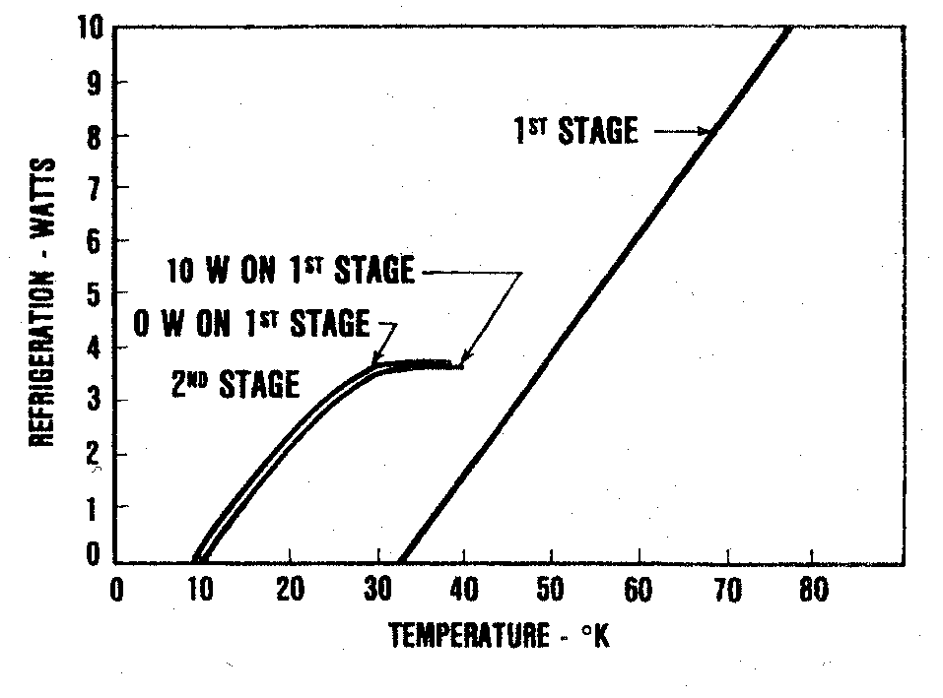
Fig. 2: Cooling capacity versus temperature of the 1st and 2nd cooling stage.

How does the cryogenic equipment work to establish such low temperatures as 10 K? The underlying method is the so-called Gifford-McMahon principle (Appendix A).

Before cooling the samples, however, a vacuum has to be established in the cryo-equipment. Use first the coarse vacuum pump (down to 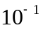 bar) and then the turbo-molecular pump to reach a reasonable well vacuum (lower than 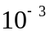 bar).

Information about how to run this instrumentation practically is given in Appendix B.

- Experimental

The three different samples that ought to be studied are mounted on a copper plate (Fig. 3), which already resides inside the 2nd stage of the cooling head. The three samples are:

  - Metal: Platinum
  - Semiconductor: InSb
  - Superconductor: YBa₂Cu₃O₇

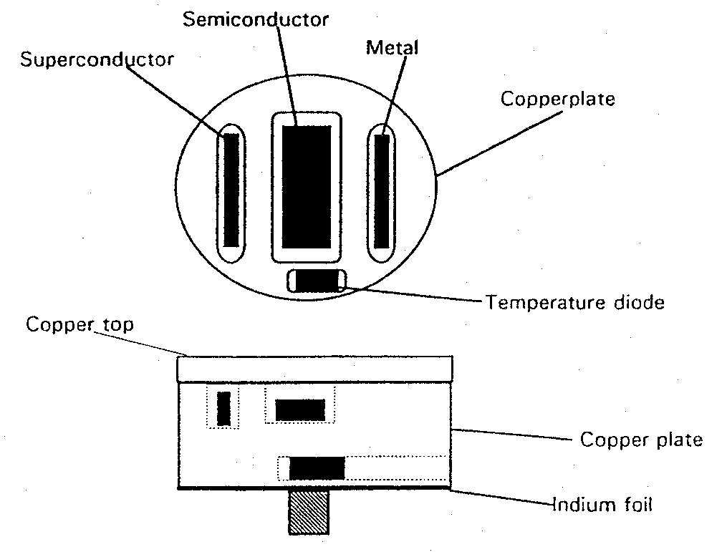
Fig. 3: Schematic drawing of the mounting of the samples on the copper plate.

To avoid temperature gradients between the samples and the copper plate, the samples are attached with a heat conducting paste, especially made for vacuum and low temperature applications. This paste contains a copper power, to increase heat conduction. The electrical conduction, however, must not be too high as that would short-circuit the electrodes of the samples. When the copper plate is screwed to the cooling head, indium foil is placed between them. Since indium is a very soft material at room temperature, it will smear out and thereby even out irregularities on the copper surface. That leads to a better surface contact between the copper plate and the cooling head and increases heat conduction.

Together with the samples, a temperature sensor (silicon diode DT-500 P/GR) is attached to the copper plate. Because of temperature gradients and inaccurate calibration, this sensor will not always show the correct temperature. For your measurements it is not that critical whether you refer to the exact temperature of the samples or a slightly different one since we are interested in the general behavior of the resistivity/conductivity with temperature (and not in absolute values).

The resistance is measured with a "4-pole resistance measurement system" consisting of a digital multimeter connected to a computer that collects the measurements.

To start your experiment, follow the instructions of how to run the cryogenic equipment and the program "ResSolidLabV1" (Appendices B and C).

Tasks in detail

    - Make yourself acquainted to the experimental setup.

    - Cool down the samples to approximately 10 K. This may take a while (> 30 min).

    - With the program "ResSolidLabV1" raise the temperature stepwise and record the electrical resistance for the three materials for a number of temperatures.

    - Plot the electrical resistance (related inversely proportional to the electrical conductivity) as a function of temperature. You can do this with matlab.

    - Analyze your measurement curves. Can you tell which curve corresponds to which sample?

    - Present the results to your supervisor! Explain all features of the three curves in detail. If you need information about metals, semiconductors or superconductors refer to your course book or the compendium next to the experimental setup.

Discuss also the following questions and outline your answers in the presentation:

Additional questions

- For what purpose is vacuum established in the cryo-equipment?

- Why is the resistance measured with a "4-pole resistance measurement"?

- Why is the direction of the current through the samples altered for each measurement?

- Why does the cooling rate increase at low temperatures?

  - Appendix A: The Gifford-McMahon principle
The cryogenic equipment is working according to the Gifford-McMahon principle, with two isochores and two isobars, in a closed helium-gas cycle.
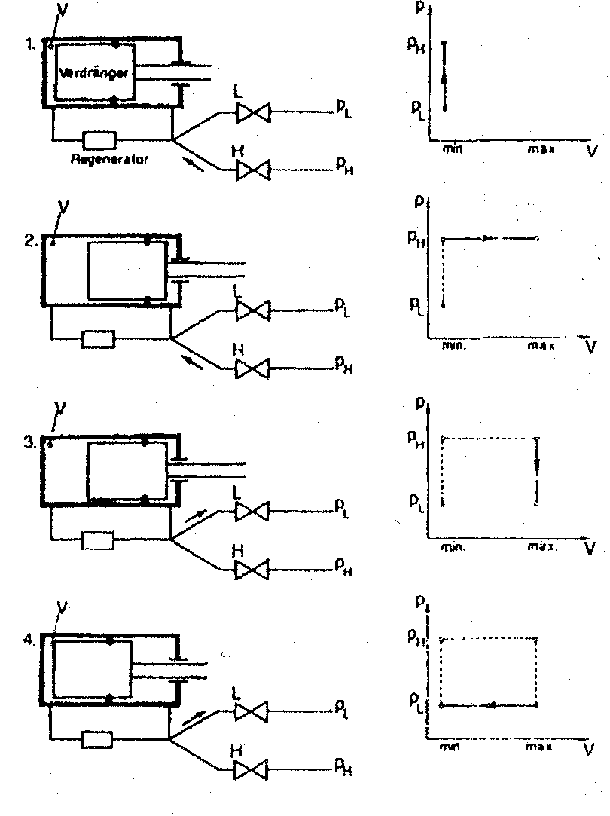
Fig. 4: The working cycle for the closed helium cryogenic system.
1st phase | The displacement piston is on the left side of the expansion volume , which in this position corresponds to the dead volume. The valve of the low-pressure side is closed but the valve of the high-pressure side is opened. This causes the pressure to increase from a low pressure, 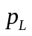, to a high pressure, 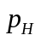, at a constant volume 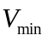 (see the pV-diagram).
2nd phase | The displacement piston is withdrawn, while the high-pressure valve is still open. The volume increases to a maximum volume, 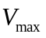, at constant pressure .
3rd phase | The high-pressure valve, H, is now closed and the low-pressure valve, L, is opened. The pressure of the helium gas changes from to at constant volume 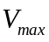
4th phase | The displacement piston is brought to its original position at constant pressure and the gas cycle is completed. The theoretical value of the heat absorbed during one cycle corresponds to the rectangular area in the pV-diagram, e.g.  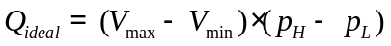

  - Appendix B: How to operate the cryogenic equipment

Start:
1. | Check if the water-cooling is connected to the cryogenic equipment. The green main tap should be open.
2. | Check if the main switch is ON.
3. | Turn on ALL measurement equipment and the computer.
4. | Press the button 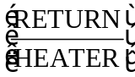 on the temperature control. The light on the temperature control should now be ON and the temperature can be regulated by a computer.
5. | Start the coarse vacuum pump.
6. | After 1 minute open the read vacuum valve (between the turbo-molecular pump and the cryotank) Carefully turn counterclockwise until it stops. Do not break the valve!)
7. | Pump until the pressure is smaller than 0.1 mbar.
8. | Start the turbo-molecular pump. Press [START] on the control unit TURBOTRONIK NT10. You should hear a high frequency sound and the pressure soon reaches values 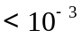.
9. | Press the start-button on the compressor. A magnetic valve will open up the cooling-water pipe.
10. | Start the program "ResSolidLabV1".
Stop:
1. | The temperature should be around 300 K.
2. | Turn OFF the compressor (the temperature control stays ON).
3. | Close the read vacuum valve (turn clockwise carefully).
4. | Turn OFF the turbo-molecular pump. Press [STOP] on the control unit and wait for 5 minutes.
5. | Turn OFF the coarse vacuum pump.
6. | Close the (green) main tap for the cooling water.
7. | Turn OFF the main switch for the cryo equipment.
8. | Turn OFF all other measurement equipment.
  - Appendix C: The computer program "ResSolidLabV1"

The temperature regulation and data acquisition are accomplished through a computer program called "ResSolidLabV1" that is written in Labview. Both the temperature of the cryogenic equipment and the measurements with the multimeter (Keithley 2001) are controlled via an IEEE 488 (GPIB) interface.

After starting the program, a window is opened. There are two important things to do for the program to run as intended. First make sure that LED light on the temperature controller is on, this indicates that the temperature controller will accept commands from the computer. If it is not on then press the button .

The second important thing is that the program needs to be provided a path to a file where the measurements are saved. To do this click on the drop list in the upper right part of the window. When the file browser is opened select an or create a “.txt” file where you want the data file.

This data file is a text file that can easily be opened in matlab for plotting. It consist of rows with the data measurements, each row will be made of four columns, the first with temperature in Kelvin and the others are the resistivity of the three samples given in Ohm, see table 1.

See fig. 5 to see how the program looks like, and table 2. describes how to use it.

Table 1: Example row from the data file.
Temperature (K) | First sample (Ω) | Second sample (Ω) | Third sample (Ω)
080.5 | 0.000000E+0 | 2.356242E+0 | 2.110754E+1

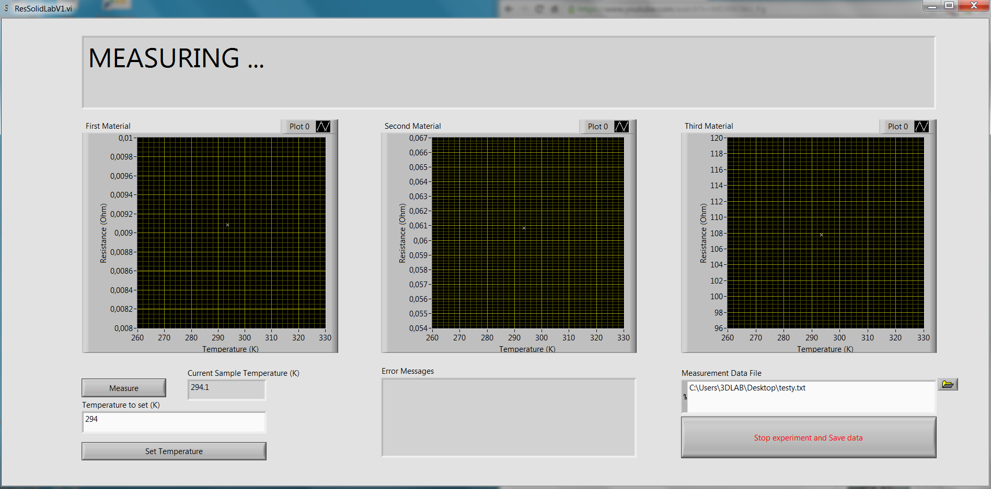Fig. 5: Snapshot of ResSolidLabV1

Table 2: Description of the program ResSolidLabV1, see fig 5.
1: | Measurement data file  Click on the folder icon to bring up the file browser. Choose/create a file for data storage.  Warning! The program writes over the file.  If you for some reason has to restart the program, choose another file. You can read in/append several files in matlab later.
2: | Temperature to Set (K)  Choose the next temperature, in Kelvin, at which you want to measure. Suitable measurement intervals are, for example:  10-80 K: one measurement every 5 K  80-100 K: one measurement every 2 K  100-300 K: one measurement every 10 K
3: | Set Temperature  Tells the cryogenic system to go to the new temperature.  This might take awhile, remember to let the temperature stabilize before taking measurements.
4: | Current Sample Temperature  Shows the current temperature of the cooling chamber that the samples are placed in.
5: | Measure  Take a new measurement, let the temperature stabilize to get smoother curves.  The large text “MEASURING ...” will flash red and the program will not respond to commands while the measurements are taken.
6: | Error Messages  Shows error messages.
7: | First-, Second-, Third Material  Shows graphs of resistance versus temperature from the present data.
8: | Stop Experiment and Save data  Terminates the program.

