

Functional Safety Concept Lane Assistance

**Document Version: [Version]**

**Template Version 1.0, Released on 2017-06-21**



# Document history

|  |  |  |  |
| --- | --- | --- | --- |
| Date | Version | Editor | Description |
| 8/25/2018 | Ver0.1 | Jun Imamura | First Attempt |
|  |  |  |  |
|  |  |  |  |
|  |  |  |  |
|  |  |  |  |

# Table of Contents

Document history

Table of Contents

Purpose of the Functional Safety Concept

Inputs to the Functional Safety Analysis

Safety goals from the Hazard Analysis and Risk Assessment

Preliminary Architecture

Description of architecture elements

Functional Safety Concept

Functional Safety Analysis

Functional Safety Requirements

Refinement of the System Architecture

Allocation of Functional Safety Requirements to Architecture Elements

Warning and Degradation Concept

# Purpose of the Functional Safety Concept

Functional safety concept is a documentation activity to identify which subsystem has the risk of hazardous situation. At first, examine the safety goals and list up functional safety requirements. Then, allocate them to respective subsystems accordingly.

# Inputs to the Functional Safety Concept

## Safety goals from the Hazard Analysis and Risk Assessment

|  |  |
| --- | --- |
| **ID** | **Safety Goal** |
| Safety_Goal_01 | The oscillating steering torque from the Lane Departure Warning function shall be limited. |
| Safety_Goal_02 | The Lane Keeping Assistance function shall be time limited, and additional steering torque shall end after a given time interval so the driver cannot misuse the system for autonomous driving. |
|  |  |
|  |  |

## Preliminary Architecture

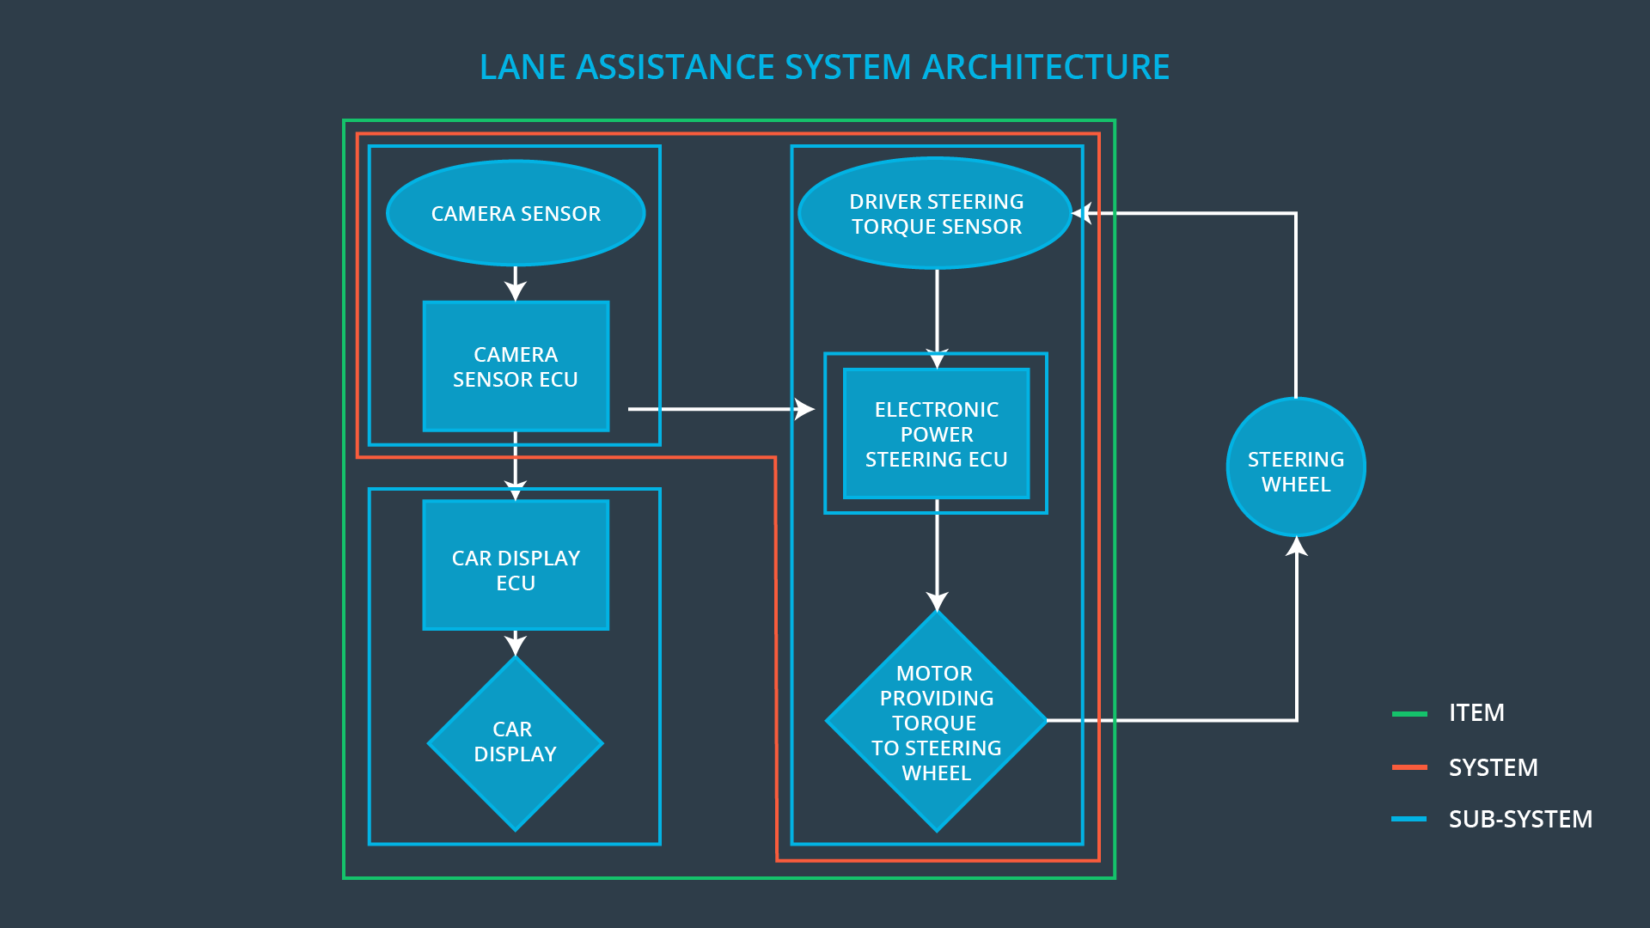

### Description of architecture elements

|  |  |
| --- | --- |
| **Element** | **Description** |
| Camera Sensor | Capture the images ahead of the vehicle and provide them to the Camera Sensor ECU |
| Camera Sensor ECU | Process the provided sensor raw values and detect / calculate the position of the car on the road. Then request a desirable torque to the electronic power steering ECU. |
| Car Display | Provide both activation status and operating status of the lane assistance functionality. |
| Car Display ECU | Receive activation status an operating status from the camera sensor ECU and drive indicator in the car display to show received status to the driver. |
| Driver Steering Torque Sensor | Measure the torque applied to the steering wheel by the driver. |
| Electronic Power Steering ECU | Receive currently applied torque from driving steering torque sensor and desired torque from camera sensor ECU respectively. Then decide and request to apply necessary torque. |
| Motor | Apply the torque which is requested by electronic power steering ECU to the steering wheel. |

# Functional Safety Concept

The functional safety concept consists of:

* Functional safety analysis
* Functional safety requirements
* Functional safety architecture
* Warning and degradation concept

## Functional Safety Analysis

|  |  |  |  |
| --- | --- | --- | --- |
| **Malfunction ID** | **Main Function of the Item Related to Safety Goal Violations** | **Guidewords (NO, WRONG, EARLY, LATE, MORE, LESS)** | **Resulting Malfunction** |
| Malfunction_01 | Lane Departure Warning (LDW) function shall apply an oscillating steering torque to provide the driver a haptic feedback | MORE | The lane departure warning function applies an oscillating torque with very high torque amplitude (above limit) |
| Malfunction_02 | Lane Departure Warning (LDW) function shall apply an oscillating steering torque to provide the driver a haptic feedback | MORE | The lane departure warning function applies an oscillating torque with very high torque frequency (above limit) |
| Malfunction_03 | Lane Keeping Assistance (LKA) function shall apply the steering torque when active in order to stay in ego lane | NO | The lane keeping assistance function is not limited in time duration which leads to misuse as an autonomous driving function |
|  |  |  |  |
|  |  |  |  |

## Functional Safety Requirements

Lane Departure Warning (LDW) Requirements:

|  |  |  |  |  |
| --- | --- | --- | --- | --- |
| **ID** | **Functional Safety Requirement** | **ASIL** | **Fault Tolerant Time Interval** | **Safe State** |
| Functional  Safety  Requirement  01-01 | The lane keeping item shall ensure that the lane departure oscillating torque amplitude is below Max_Torque_Amplitude | C | 50ms | Torque amplitude request set to zero. |
| Functional  Safety  Requirement  01-02 | The lane keeping item shall ensure that the lane departure oscillating torque frequency is blow Max_Torque_Frequency | C | 50ms | Torque amplitude request set to zero. |
|  |  |  |  |  |

Lane Departure Warning (LDW) Verification and Validation Acceptance Criteria:

|  |  |  |
| --- | --- | --- |
| **ID** | **Validation Acceptance**  **Criteria and Method** | **Verification Acceptance**  **Criteria and Method** |
| Functional  Safety  Requirement  01-01 | Validate Max_Torque_Amplitude becomes not too high so that the driver doesn’t lose control of steering. | Verify the system does turn off in time if the strength of the torque exceeds Max_Torque_Amplitude. |
| Functional  Safety  Requirement  01-02 | Validate Max_Torque_Frequency becomes not too high so that the driver doesn’t lose control of steering. | Verify the system does turn off in time if the frequency of the torque exceeds Max_Torque_Frequency. |
|  |  |  |

Lane Keeping Assistance (LKA) Requirements:

|  |  |  |  |  |
| --- | --- | --- | --- | --- |
| **ID** | **Functional Safety Requirement** | **ASIL** | **Fault Tolerant Time Interval** | **Safe State** |
| Functional  Safety  Requirement  02-01 | The electronic power steering ECU shall ensure that the lane keeping assistance torque is applied for only Max_Duration. | B | 500ms | System turned off |
|  |  |  |  |  |

Lane Keeping Assistance (LKA) Verification and Validation Acceptance Criteria:

|  |  |  |
| --- | --- | --- |
| **ID** | **Validation Acceptance**  **Criteria and Method** | **Verification Acceptance**  **Criteria and Method** |
| Functional  Safety  Requirement  02-01 | Test and validate that the electric power steering stop providing assistant torque to avoid the driver misusing the functionality as the autonomous driving. |  |

## Refinement of the System Architecture

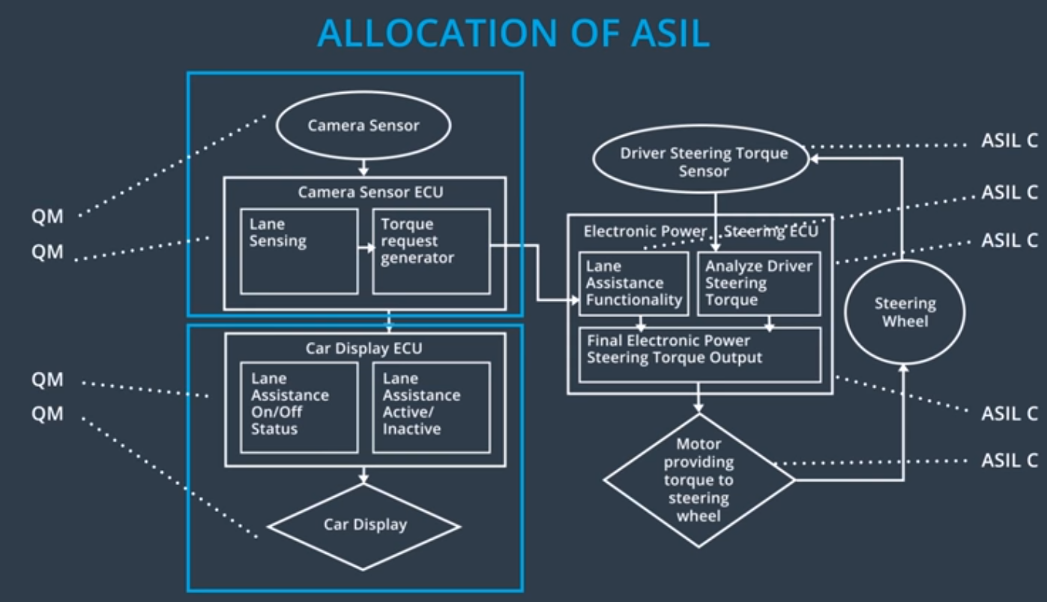

## Allocation of Functional Safety Requirements to Architecture Elements

|  |  |  |  |  |
| --- | --- | --- | --- | --- |
| **ID** | **Functional Safety Requirement** | **Electronic Power Steering ECU** | **Camera ECU** | **Car Display ECU** |
| Functional  Safety  Requirement  01-01 | The lane keeping item shall ensure that the lane departure oscillating torque amplitude is below Max_Torque_Amplitude | **X** |  |  |
| Functional  Safety  Requirement  01-02 | The lane keeping item shall ensure that the lane departure oscillating torque frequency is blow Max_Torque_Frequency | **x** |  |  |
| Functional  Safety  Requirement  02-01 | The electronic power steering ECU shall ensure that the lane keeping assistance torque is applied for only Max_Duration. | **x** |  |  |

## Warning and Degradation Concept

|  |  |  |  |  |
| --- | --- | --- | --- | --- |
| **ID** | **Degradation Mode** | **Trigger for Degradation Mode** | **Safe State invoked?** | **Driver Warning** |
| WDC-01 | System turned off | Malfunction_01  Malfunction_02 | Yes | Warning indication on the car display |
| WDC-02 | System turned off | Malfunction_03 | Yes | Warning indication of the car display |