

Technical Safety Concept Lane Assistance

**Document Version: [Version]**

**Template Version 1.0, Released on 2017-06-21**



# Document history

|  |  |  |  |
| --- | --- | --- | --- |
| Date | Version | Editor | Description |
| 8/25/2018 | Ver 1.0 | Jun Imamura | First attempt |
|  |  |  |  |
|  |  |  |  |
|  |  |  |  |
|  |  |  |  |

# 

# Table of Contents

Document history

Table of Contents

Purpose of the Technical Safety Concept

Inputs to the Technical Safety Concept

Functional Safety Requirements

Refined System Architecture from Functional Safety Concept

Functional overview of architecture elements

Technical Safety Concept

Technical Safety Requirements

Refinement of the System Architecture

Allocation of Technical Safety Requirements to Architecture Elements

Warning and Degradation Concept

# Purpose of the Technical Safety Concept

Technical safety concept is a documentation activity to define requirements in more detail. This will define the requirement for each sensor/controller/actuator level.

# Inputs to the Technical Safety Concept

## Functional Safety Requirements

|  |  |  |  |  |
| --- | --- | --- | --- | --- |
| **ID** | **Functional Safety Requirement** | **ASIL** | **Fault Tolerant Time Interval** | **Safe State** |
| Functional  Safety  Requirement  01-01 | The lane keeping item shall ensure that the lane departure oscillating torque amplitude is below Max_Torque_Amplitude | C | 50ms | System turned off |
| Functional  Safety  Requirement  01-02 | The lane keeping item shall ensure that the lane departure oscillating torque frequency is blow Max_Torque_Frequency | C | 50ms | System turned off |
| Functional  Safety  Requirement  02-01 | The electronic power steering ECU shall ensure that the lane keeping assistance torque is applied for only Max_Duration. | B | 500ms | System turned off |

## Refined System Architecture from Functional Safety Concept

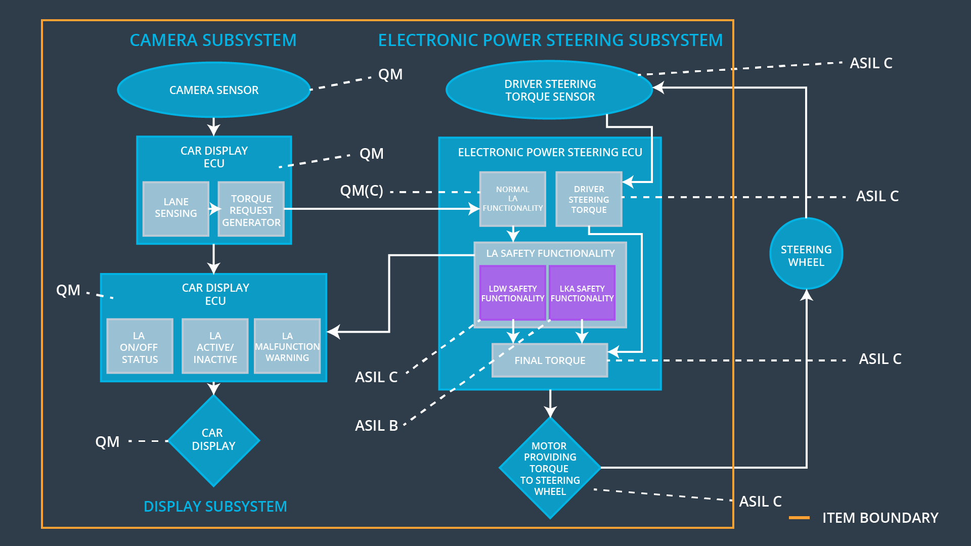

### Functional overview of architecture elements

|  |  |
| --- | --- |
| **Element** | **Description** |
| Camera Sensor | Capture the images ahead of the vehicle and provide them to the Camera Sensor ECU |
| Camera Sensor ECU - Lane Sensing | Process the provided sensor raw values and detect / calculate the position of the car on the road. |
| Camera Sensor ECU - Torque request generator | Request a desirable torque to the electronic power steering ECU. |
| Car Display | Provide both activation status and operating status of the lane assistance functionality. |
| Car Display ECU - Lane Assistance On/Off Status | Indicate the ON/OFF status of the lane assistance functionality. |
| Car Display ECU - Lane Assistant Active/Inactive | Indicate the activation status of the lane assistance functionality. |
| Car Display ECU - Lane Assistance malfunction warning | Indicate a malfunction status of the lane assistance functionality. |
| Driver Steering Torque Sensor | Measure the torque applied to the steering wheel by the driver. |
| Electronic Power Steering (EPS) ECU - Driver Steering Torque | Receive steering torque value from driver steering torque sensor. |
| EPS ECU - Normal Lane Assistance Functionality | Receive torque request from camera sensor ECU torque request. |
| EPS ECU - Lane Departure Warning Safety Functionality | Ensure the torque amplitude and frequency are below Max_Torque_Amplitude / Max_Torque_Frequency respectively. |
| EPS ECU - Lane Keeping Assistant Safety Functionality | Ensure the lane keeping assistance functionality won’t be activated longer than Max_duration. |
| EPS ECU - Final Torque | Integrate the information from lane safety functionality and driver steering torque sensor. Then send and steering torque request to the motor. |
| Motor | Apply required torque to the steering wheel. |

# Technical Safety Concept

## Technical Safety Requirements

**Lane Departure Warning (LDW) Requirements:**

Functional Safety Requirement 01-01 with its associated system elements

(derived in the functional safety concept)

|  |  |  |  |  |
| --- | --- | --- | --- | --- |
| **ID** | **Functional Safety Requirement** | **Electronic Power Steering ECU** | **Camera ECU** | **Car Display ECU** |
| Functional  Safety  Requirement  01-01 | The lane keeping item shall ensure that the lane departure oscillating torque amplitude is below Max_Torque_Amplitude | X |  |  |

Technical Safety Requirements related to Functional Safety Requirement 01-01 are:

|  |  |  |  |  |  |
| --- | --- | --- | --- | --- | --- |
| **ID** | **Technical Safety Requirement** | **ASIL** | **Fault Tolerant Time Interval** | **Architecture Allocation** | **Safe State** |
| Technical  Safety  Requirement 01-01-01 | The LDW safety component shall ensure that the amplitude of the ‘LDW_Torque_Request’ sent to the ‘Final electronic power steering Torque’ component is below ‘Max_Torque_Amplitude’ | C | 50ms | EPS ECU - Lane Departure Warning Safety Functionality | LDW Torque Request Amplitude set to zero. |
| Technical  Safety  Requirement 01-01-02 | As soon as the LDW function deactivates the LDW feature, the ‘LDW Safety’ software block shall send a signal to the car display ECU to turn on a warning light. | C | 50ms | EPS ECU - Lane Departure Warning Safety Functionality | LDW Torque Request Amplitude set to zero. |
| Technical  Safety  Requirement 01-01-03 | As soon as a failure is detected by the LDW function, the ‘LDW_Torque_Request’ shall be set to zero | C | 50ms | EPS ECU - Lane Departure Warning Safety Functionality | LDW Torque Request Amplitude set to zero. |
| Technical  Safety  Requirement 01-01-04 | The validity and integrity of the data transmission for ‘LDW_Torque_Request’ signal shall be ensured. | C | 50ms | EPS ECU - Lane Departure Warning Safety Functionality |  |
| Technical  Safety  Requirement 01-01-05 | Memory test shall be conducted at start up of the EPS ECU to check for any faults in memory. | A | Ignition cycle | Data Transmission Integrity Check |  |

Functional Safety Requirement 01-2 with its associated system elements

(derived in the functional safety concept)

|  |  |  |  |  |
| --- | --- | --- | --- | --- |
| **ID** | **Functional Safety Requirement** | **Electronic Power Steering ECU** | **Camera ECU** | **Car Display ECU** |
| Functional  Safety  Requirement  01-02 | The lane keeping item shall ensure that the lane departure oscillating torque frequency is below Max_Torque_Frequency | X |  |  |

Technical Safety Requirements related to Functional Safety Requirement 01-02 are:

|  |  |  |  |  |  |
| --- | --- | --- | --- | --- | --- |
| **ID** | **Technical Safety Requirement** | **ASIL** | **Fault Tolerant Time Interval** | **Architecture Allocation** | **Safe State** |
| Technical  Safety  Requirement  01-02-01 | The LDW safety component shall ensure that the amplitude of the ‘LDW_Torque_Request’ sent to the ‘Final electronic power steering Torque’ component is below ‘Max_Torque_Frequency | C | 50ms | EPS ECU - Lane Departure Warning Safety Functionality | LDW Torque Request Amplitude set to zero. |
| Technical  Safety  Requirement  01-02-02 | As soon as the LDW function deactivates the LDW feature, the ‘LDW Safety’ software block shall send a signal to the car display ECU to turn on a warning light. | C | 50ms | EPS ECU - Lane Departure Warning Safety Functionality |  |
| Technical  Safety  Requirement  01-02-03 | As soon as a failure is detected by the LDW function, the ‘LDW_Torque_Request’ shall be set to zero | C | 50ms | EPS ECU - Lane Departure Warning Safety Functionality |  |
| Technical  Safety  Requirement  01-02-04 | The validity and integrity of the data transmission for ‘LDW_Torque_Request’ signal shall be ensured. | C | 50ms | EPS ECU - Lane Departure Warning Safety Functionality |  |
| Technical  Safety  Requirement  01-02-05 | Memory test shall be conducted at start up of the EPS ECU to check for any faults in memory. | A | Ignition cycle | Data Transmission Integrity Check |  |

**Lane Keeping Assistance (LKA) Requirements:**

Functional Safety Requirement 02-1 with its associated system elements

(derived in the functional safety concept)

|  |  |  |  |  |
| --- | --- | --- | --- | --- |
| **ID** | **Functional Safety Requirement** | **Electronic Power Steering ECU** | **Camera ECU** | **Car Display ECU** |
| Functional  Safety  Requirement  02-01 | The lane keeping item shall ensure that the lane keeping assistance torque is applied for only Max_Duration | X |  |  |

Technical Safety Requirements related to Functional Safety Requirement 02-01 are:

|  |  |  |  |  |  |
| --- | --- | --- | --- | --- | --- |
| **ID** | **Technical Safety Requirement** | **ASIL** | **Fault Tolerant Time Interval** | **Allocation to Architecture** | **Safe State** |
| Technical  Safety  Requirement 02-01-01 | The LKA safety component shall ensure that the duration of the lane keeping assistance torque is applied for less than ‘Max_Duration’. | B | 50ms | EPS ECU - Lane Keeping Assistance Safety Functionality | Lane Keeing Assistance torque set to zero. |
| Technical  Safety  Requirement 02-01-02 | As soon as the LKA function deactivates the LKA feature, the ‘LKA Safety’ software block shall send a signal to the car display ECU to turn on a warning light. | B | 50ms | EPS ECU - Lane Keeping Assistance Safety Functionality |  |
| Technical  Safety  Requirement 02-01-03 | As soon as a failure is detected by the LKA function, the ‘LKA_Torque_Request’ shall be set to zero | B | 50ms | EPS ECU - Lane Keeping Assistance Safety Functionality |  |
| Technical  Safety  Requirement 02-01-04 | The validity and integrity of the data transmission for ‘LKA_Torque_Request’ signal shall be ensured. | B | 50ms | EPS ECU - Lane Keeping Assistance Safety Functionality |  |
| Technical  Safety  Requirement 02-01-05 | Memory test shall be conducted at start up of the EPS ECU to check for any faults in memory. | A | Ignition cycle | Data Transmission Integrity Check |  |

## Refinement of the System Architecture

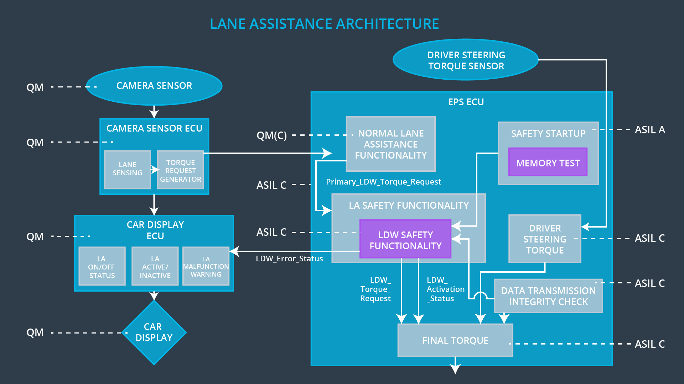

## Allocation of Technical Safety Requirements to Architecture Elements

|  |  |  |  |  |
| --- | --- | --- | --- | --- |
| **ID** | **Technical Safety Requirement** | **Electronic Power Steering ECU** | **Camera ECU** | **Car Display ECU** |
| Technical  Safety  Requirement 01-01-01 | The LDW safety component shall ensure that the amplitude of the ‘LDW_Torque_Request’ sent to the ‘Final electronic power steering Torque’ component is below ‘Max_Torque_Amplitude’ | **X** |  |  |
| Technical  Safety  Requirement 01-01-02 | As soon as the LDW function deactivates the LDW feature, the ‘LDW Safety’ software block shall send a signal to the car display ECU to turn on a warning light. | **X** |  |  |
| Technical  Safety  Requirement 01-01-03 | As soon as a failure is detected by the LDW function, the ‘LDW_Torque_Request’ shall be set to zero | **X** |  |  |
| Technical  Safety  Requirement 01-01-04 | The validity and integrity of the data transmission for ‘LDW_Torque_Request’ signal shall be ensured. | **X** |  |  |
| Technical  Safety  Requirement 01-01-05 | Memory test shall be conducted at start up of the EPS ECU to check for any faults in memory. | **X** |  |  |
| Technical  Safety  Requirement  01-02-01 | The LDW safety component shall ensure that the amplitude of the ‘LDW_Torque_Request’ sent to the ‘Final electronic power steering Torque’ component is below ‘Max_Torque_Frequency | **X** |  |  |
| Technical  Safety  Requirement  01-02-02 | As soon as the LDW function deactivates the LDW feature, the ‘LDW Safety’ software block shall send a signal to the car display ECU to turn on a warning light. | **X** |  |  |
| Technical  Safety  Requirement  01-02-03 | As soon as a failure is detected by the LDW function, the ‘LDW_Torque_Request’ shall be set to zero | **X** |  |  |
| Technical  Safety  Requirement  01-02-04 | The validity and integrity of the data transmission for ‘LDW_Torque_Request’ signal shall be ensured. | **X** |  |  |
| Technical  Safety  Requirement  01-02-05 | Memory test shall be conducted at start up of the EPS ECU to check for any faults in memory. | **X** |  |  |
| Technical  Safety  Requirement 02-01-01 | The LKA safety component shall ensure that the duration of the lane keeping assistance torque is applied for less than ‘Max_Duration’. | **X** |  |  |
| Technical  Safety  Requirement 02-01-02 | As soon as the LKA function deactivates the LKA feature, the ‘LKA Safety’ software block shall send a signal to the car display ECU to turn on a warning light. | **X** |  |  |
| Technical  Safety  Requirement 02-01-03 | As soon as a failure is detected by the LKA function, the ‘LKA_Torque_Request’ shall be set to zero | **X** |  |  |
| Technical  Safety  Requirement 02-01-04 | The validity and integrity of the data transmission for ‘LKA_Torque_Request’ signal shall be ensured. | **X** |  |  |
| Technical  Safety  Requirement 02-01-05 | Memory test shall be conducted at start up of the EPS ECU to check for any faults in memory. | **X** |  |  |

## Warning and Degradation Concept

|  |  |  |  |  |
| --- | --- | --- | --- | --- |
| **ID** | **Degradation Mode** | **Trigger for Degradation Mode** | **Safe State invoked?** | **Driver Warning** |
| WDC-01 | System turned off | Malfunction_01  Malfunction_02 | Yes | Warning indication on the car display |
| WDC-02 | System turned off | Malfunction_03 | Yes | Warning indication of the car display |