**OpenHiCAMM Workflow Instructions**

First, create a new workflow directory. Click the “Choose” button to show the Open Workflow dialog box.

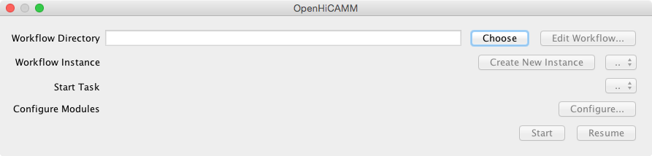

Click the “New Folder” button to create and select a new workflow folder. Then click “Choose Workflow Directory”.

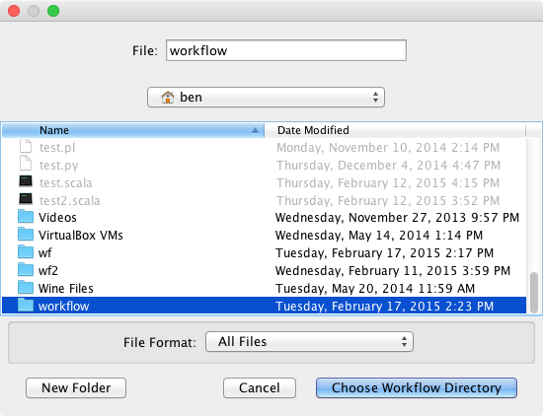

Now click the “Edit Workflow…” directory to add processing modules to the workflow.

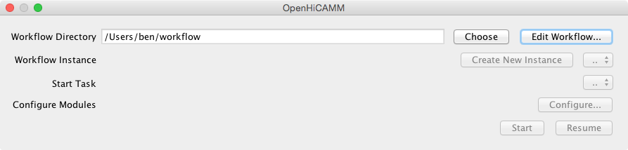

The “Slide imaging workflow” dialog appears. Workflow modules can be arranged in a tree-like structure to define automation and processing steps.

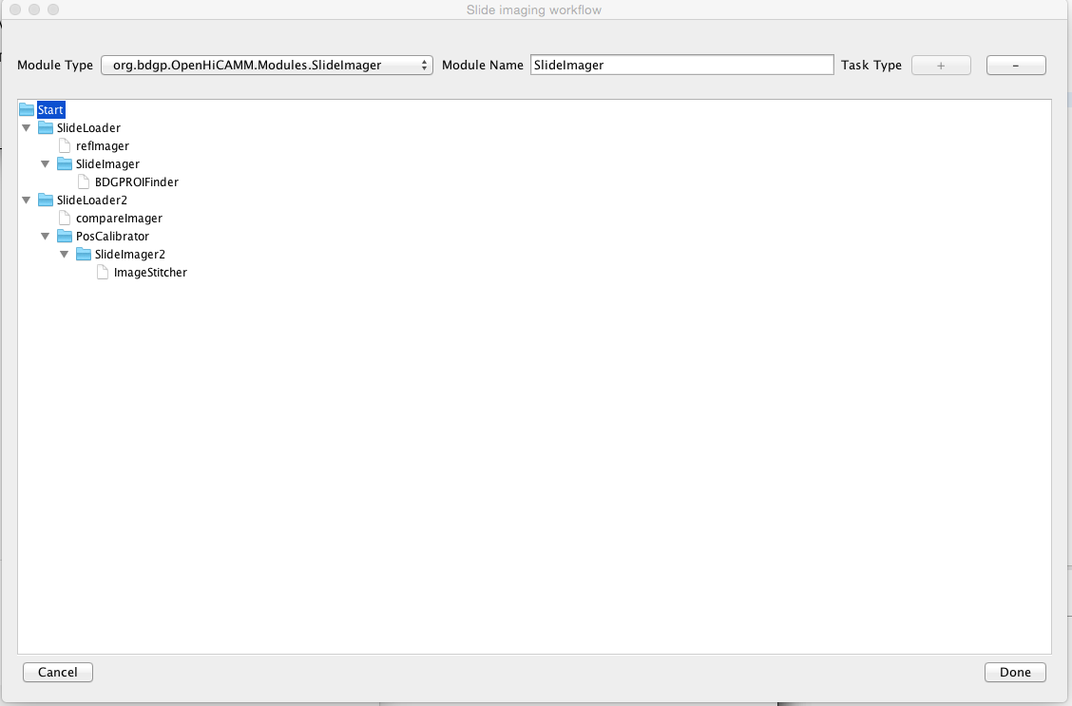

Click the “Configure…” button to configure each workflow module.

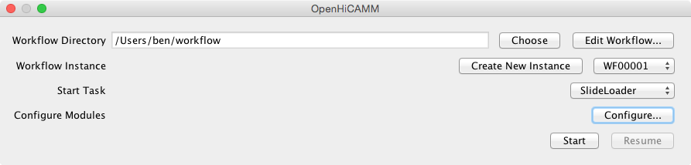

A configuration wizard appears. Each workflow module’s configuration is represented as an individual tab in the configuration wizard. Clicking the “Next” button cycles through all the workflow configuration panes.

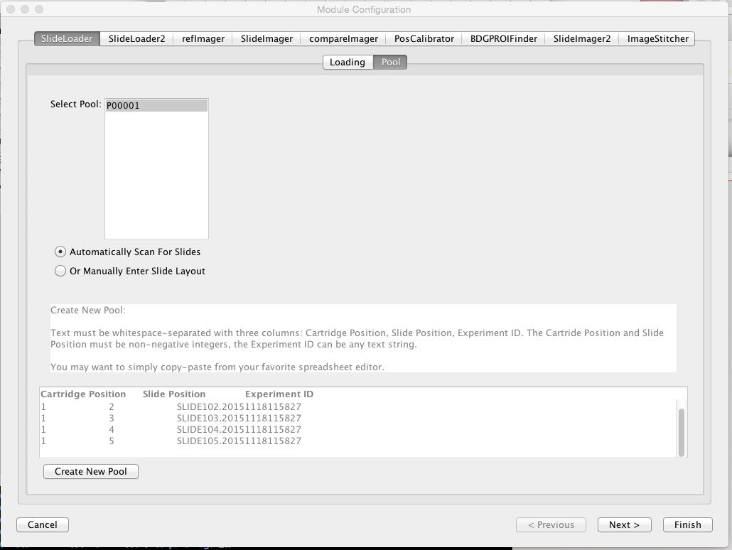

Example configuration for a slide loader workflow module.

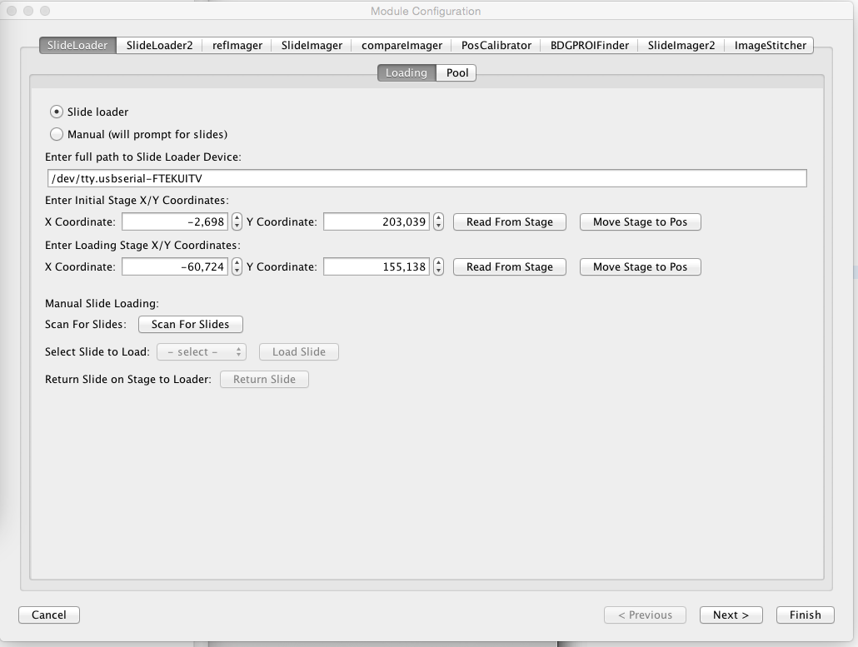

Example configuration of the slide imaging configuration module. Click “Finish” to close the configuration window and store the settings.

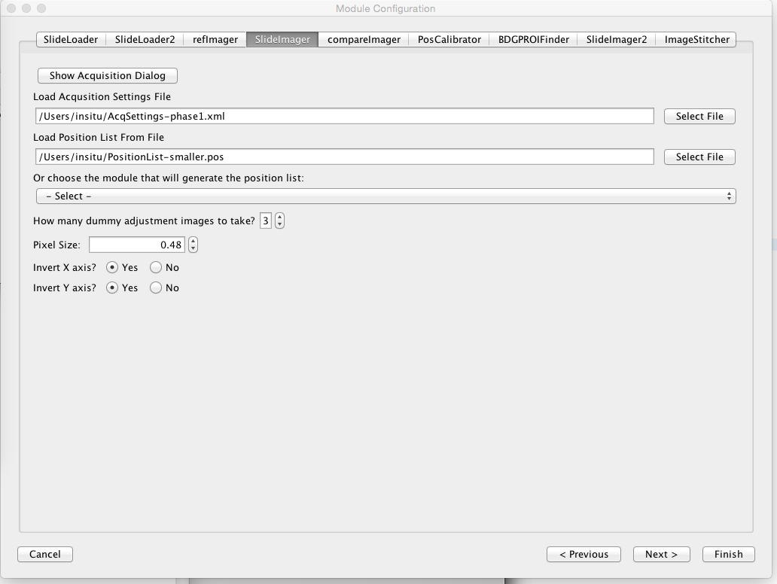

The ROI configuration dialog contains settings for determining ROI areas of acquired images.

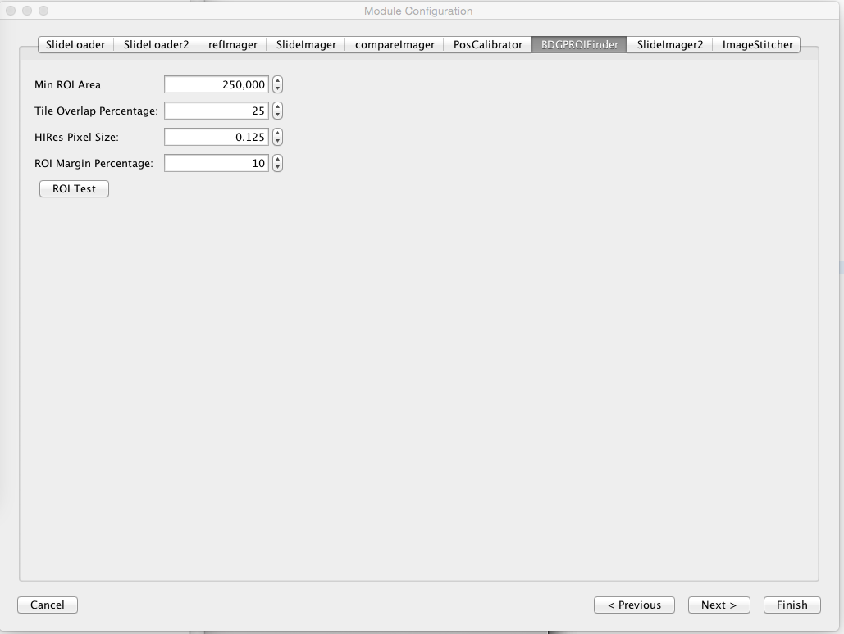

Now click “Start” to begin the automation workflow.

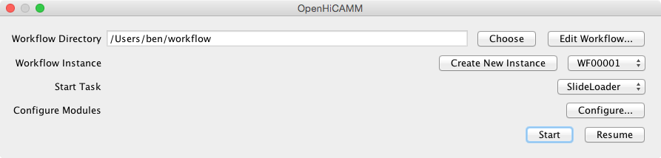

A “Workflow Runner” dialog appears. A progress bar indicates the task completion status. A log window gives detailed information about each task. When the workflow completes, a task summary is displayed in the log window.

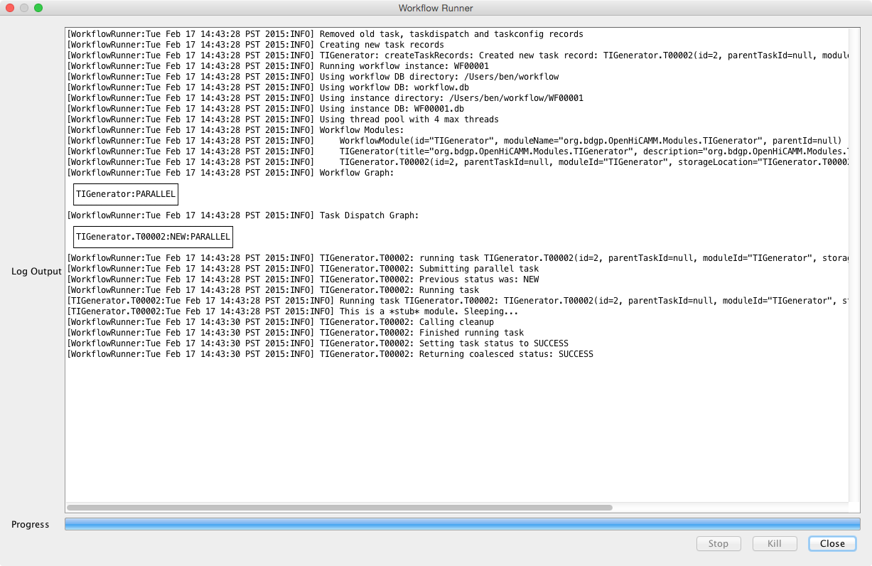

Once the workflow completes, the user can select a report to view the acquired images and quality check the results. The above is a thumbnail view of an imaged slide. Each red box is an ROI area.

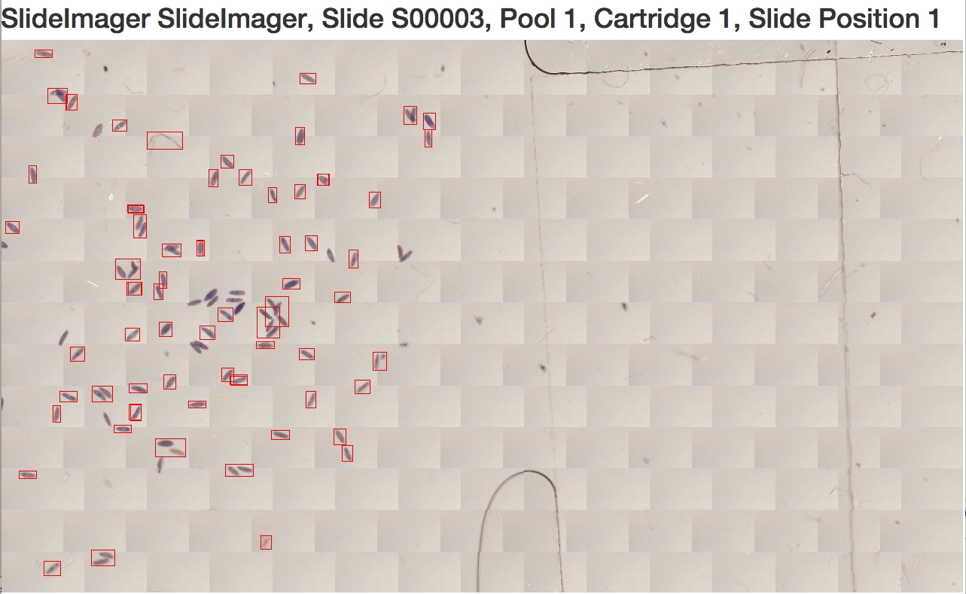

Each ROI has an ROI details section. The first column is a ROI cutout from the low-res scan image. The second column contains the hi-res imaging results before stitching. The third column shows the hi-res images stitched into a single image.

