**Netcat**

Netcat(calling nc) is the tools for debugging network or hacking. It can running two modes Server and Client. Basically use the client mode because it have many have options for testing. The tools can use Linux, Windows, Mac OS. And Kali is defaultly installed it.

Usage is very simple. Run the terminal and enter like “nc [options]”. If you want running server mode, following this syntax.

**“nc -lvp [Port Number]”**

l options is mean listen. You can defined use which port to the p option. v is verbose option. Run above command, console is changed nc mode like the picture.



Whenever Connected to Server from Client, print connection information.



And typing any string or character from client, you can see the message at the server. It also apply server to client.

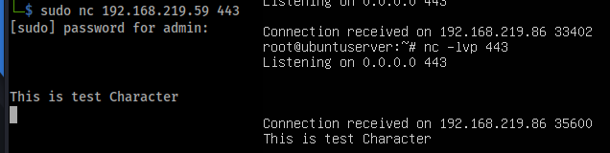

If you use the pipe on server, output is saved specified file too. As you can see the picture, client can connect the server use following command.

**nc [Server IP Address] [Port Number]**