# **PHP Project—E-Shop**

**Team: Jun Yang and Chen Chen**

Demo : <https://www.amegoev.com/>

<http://www.vespamontreal.com/qc/945-piaggio>

## Introduction

E-Shop is an online shopping website for a set of scooters in PHP/MySQL which works on any hosting. We want to build a simple online shop website. It is using PHP, Bootstrap templates, twig, HTML, JavaScript, MySQL, jQuery, etc. Allow online shop owners to manage his e-shop. It was supposed to be easy to add more products and maintain the website by the owners. The e-shop has basic e-commerce online system features. Products listing, Product details page; each product has a title, tagline, description, price and an image; Shopping basket; Simple administration; Different payment providers.

|  |  |  |  |
| --- | --- | --- | --- |
| **No** | **Basic Feature:** | **URL** | **Technology** |
| 1 | login in with Facebook | URL: /login | AJAX Login  Password encryption |
| 2 | Email password reset |  |  |
| 3 | register by email/register by/Facebook/Gmail | URL: /register |  |
| 4 | List products | URL: /category/: id products |  |
| 5 | Each product has detail page | /product/: id |  |
| 6 | Wishes List/Favorite product | URL: wishes Lists/URL: favorite product |  |
| 7 | Add to Cart *****/Buy directly | URL: /Cart |  |
| 8 | List Categories | /category/: catid |  |
| 9 | About us | About us | Google Map for Owner shop location |
| 10 | Manage web site | Manage web site when administrator login.  Categories / {add, edit, list, delete}  Products / {add, edit, list, delete}  Users / {edit, list, block}. | Administrator Panel  Photo upload  Flash messages  File storage in BLOBs |
| 11 | Cart Management | View the cart and then turn to/cart ->view cart—>checkbox choose product and buy—> turn to buy URL/ |  |
| 12 | Placing an Order | /order |  |
| 13 | Payment (google pay) | To be determined |  |
| 14 | Delivery | Chose different delivery |  |
| 15 | Administration panel | Owner login/validate/upload new product/upload photo/ Reporting/summary/about/print orders |  |
| 16 | Multilingual support | To be determined | multilingual support |

### Homepage

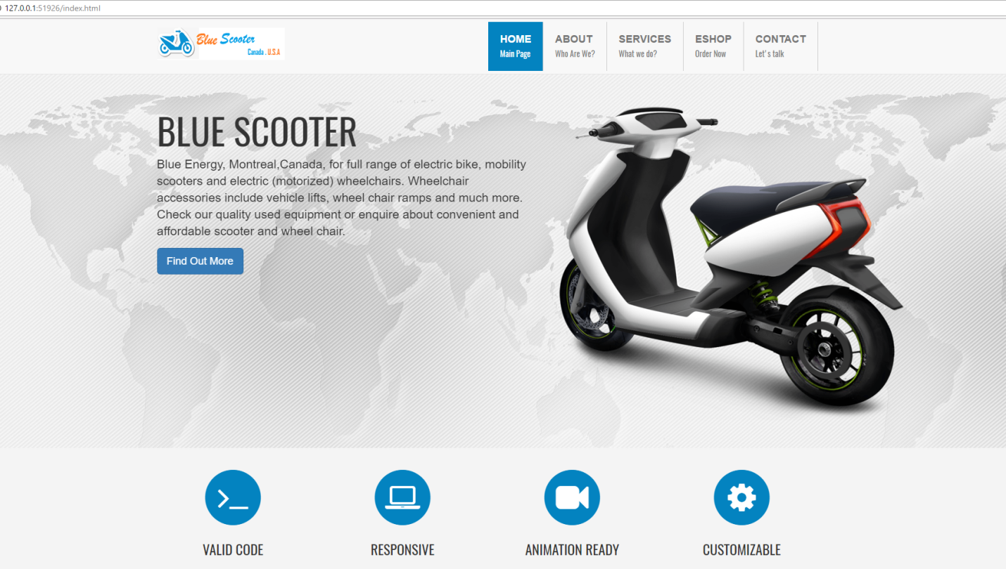

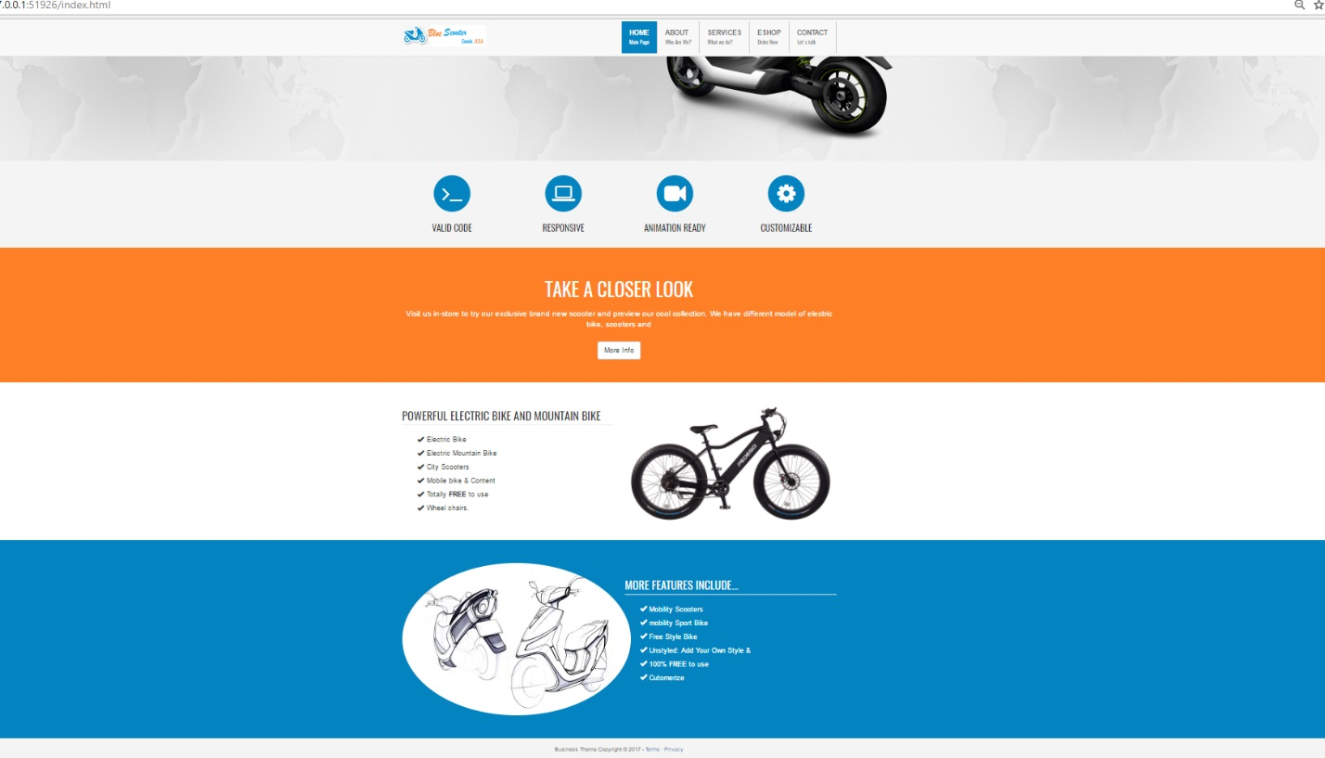

### Categories

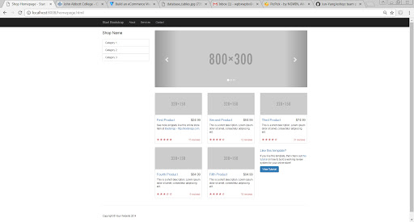

### Product items

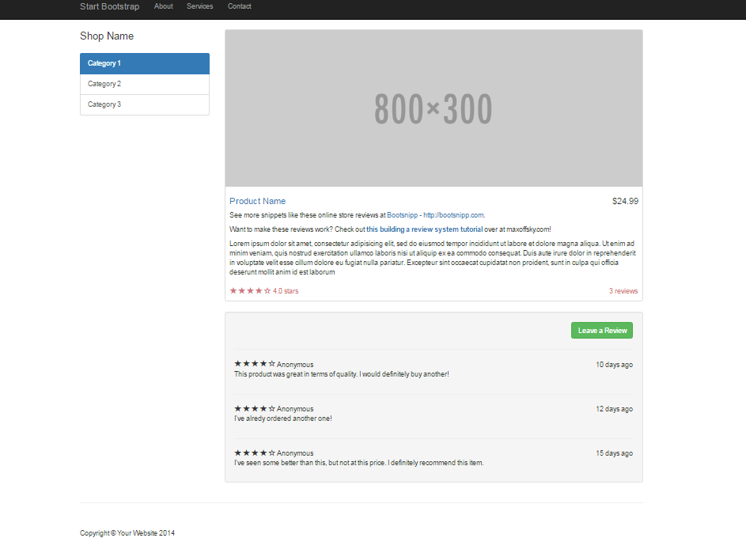

## 

## 

## <https://app.moqups.com/unsaved/d294894a/edit/page/af629bb04>

## Business processing

1 Display products->Choose single product-> Product Detail Page—> two buttons—> one is add to cart and anther is buy it directly

2 Display View the cart and then turn to /cart

->view cart—>checkbox choose product and buy—> go to buy URL/

## Database

1. categories – (PK) -> id AI | FK->products(cat_id)
2. products – (PK) -> id AI | FK-> (cat_id) category
3. users – (PK) -> id AI | FK—>id —(orders)(user_id)
4. orders – (PK) -> id AI | FK-> users(id) FK product_id->(products[id])
5. carts- (PK) -> id AI | FK-> users(id)
6. payments - (PK) -> id AI | FK-> users(id) |FK order_id-> (orders(id))

Database

