Create service account, write down email as the following:
dbt-new@weighty-media-368907.iam.gserviceaccount.com

add roles: Bigquery owner, Admin, data editor, data viewer, job user.
Use dbt-new@weighty-media-368907.iam.gserviceaccount.com as email
Create key (json file such as weighty-media-368907-760ec903e31d.json)
download the key and move to .dbt folder

Edit .dbt/profiles.yml as following
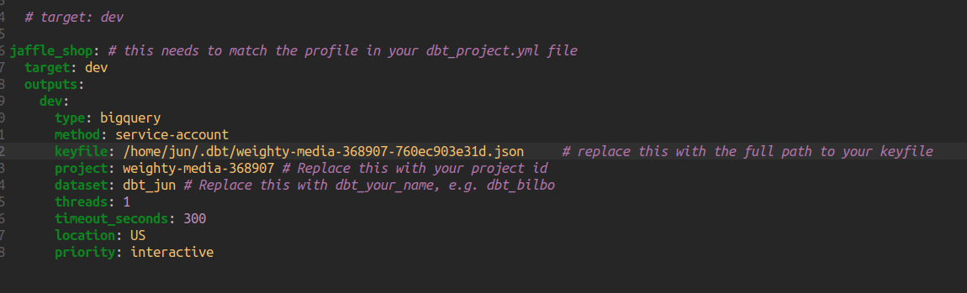

At terminal auth service account as following:
gcloud auth activate-service-account –key-file="/home/jun/.dbt/weighty-media-368907-760ec903e31d.json"

Inside Jaffle_shop directory
dbt debug
dbt run

