NUC980学习笔记
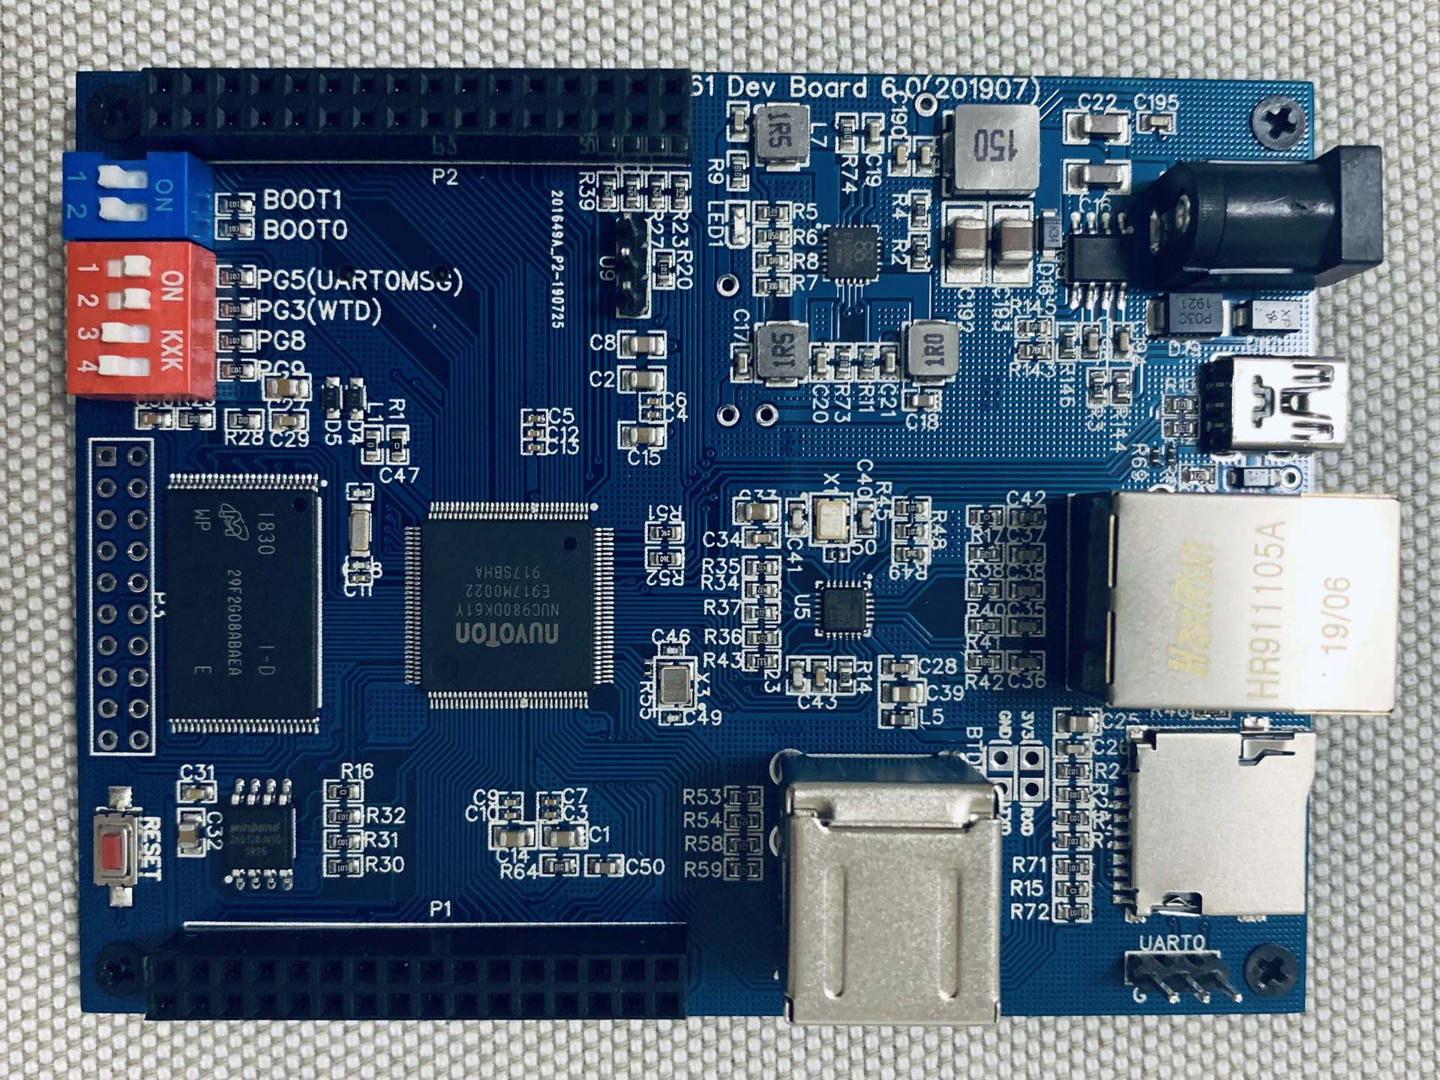

编者：
时间：2020/2/

目录
一、 开发环境安装 2
1.1安装必须的库 2

- 开发环境安装

1.1更新源
打开系统的软件中心
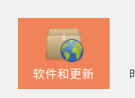
选择自己想要使用的源
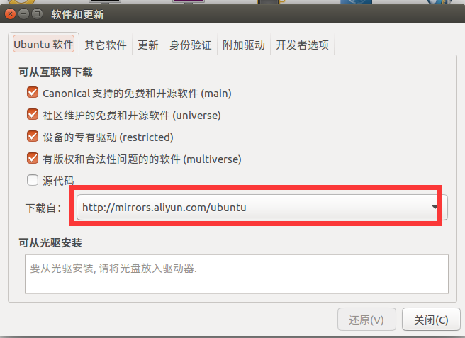
更新缓存
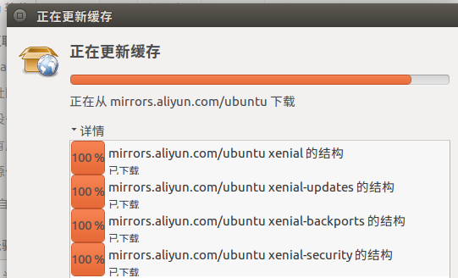

1.2安装必须的库
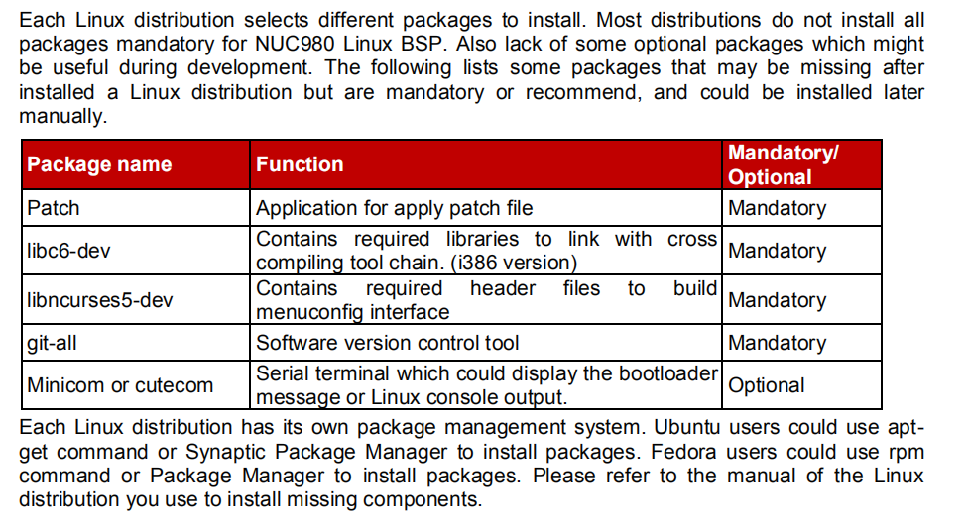
- apt-get install patch
- apt-get install libc6-dev
- apt-get install libncurses5-dev
- apt-get install git-all
- apt-get install minicom
如果遇到以下错误
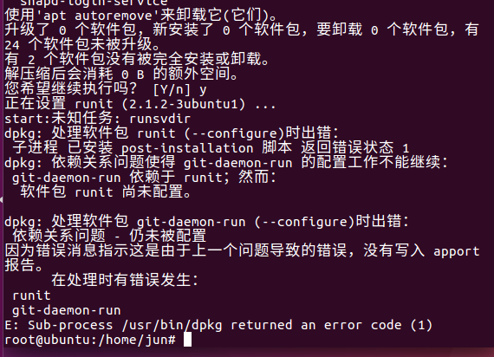
上述碰到的错误，大部分是由于runit 不兼容，需要先卸载，再重新安装。

解决方案如下：
- sudo apt-get purge runit
- sudo apt-get purge git-all
- sudo apt-get purge git
- sudo apt-get autoremove
- sudo apt update
- sudo apt install git

1.3安装Python3.6
因为新唐通过repo获取bsp需要Python3.6以上的支持，所以要更新自己的python版本，一般系统安装之后，python2.7是比较常见的。

- # 官网下载安装包
- 1. wget http://www.python.org/ftp/python/3.6.4/Python-3.6.4.tgz

- # 解压
- 2. tar -xvzf Python-3.6.4.tgz

- # 安装
- 3. cd Python-3.6.4
- 4. ./configure --with-ssl

- 编辑 取消注释 以下几行：~ python/Modules/Setup.dist
- 大约在 209 行
- 209 SSL=/usr/local/ssl210 _ssl _ssl.c \211 -DUSE_SSL -I$(SSL)/include -I$(SSL)/include/openssl \212 -L$(SSL)/lib -lssl -lcrypto

- # 编译
- 5. sudo make
- 6. sudo make install

- # 创建软连接，先查看python3.6.4的安装路径
- 7. cd /usr/bin/
- 8. sudo cp /usr/bin/python /usr/bin/python_bak
- 9. rm -rf python
- 10. which python3 # /usr/local/bin/python3
- 11. sudo ln -s /usr/local/bin/python3 python

1.4 REPO安装
1、根目录下创建bin文件夹
mkdir ~/bin
2、配置为临时环境变量(也可配置为永久的)
PATH=~/bin:$PATH
3、下载repo
git clone https://gerrit-googlesource.lug.ustc.edu.cn/git-repo
4、将git-repo中的repo文件复制到 1 创建的.bin目录中
cd git-repo
cp repo ~/bin/
5、修改权限
chmod a+x ~/bin/repo
6、创建同步源码的工作目录
mkdir source
7、在工作目录中创建repo目录
cd source
mkdir repo
8、将下载的git-repo拷贝到.repo下,并改名为 repo
9、可以重新初始化了
repo init -u xxxxxxxxx -b xxxx
10、开始同步
repo sync
- BSP安装

2.1直接下载BSP
下载地址是：http://www.nuvoton.com.cn/products/iot-solution/application/gateway/numaker-nuc980-iiot/?tab=2&group=Software&rt=Board%20Support%20Package%20(BSP)
文件解压之后
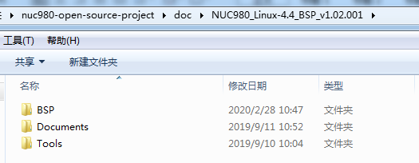
这个文件在git资源中有提供。
推荐使用这个办法获取文件，因为repo可能会搞出一些问题。

2.2通过GIT下载
- mkdir nuc980
- cd nuc980/
- export PATH=/home/jun/nuc980/:$PATH
- curl https://storage.googleapis.com/git-repo-downloads/repo > /home/jun/nuc980/repo
- chmod a+x repo
- git config --global user.name "jun"
- git config --global user.email "2839084093@qq.com"
- mkdir linux_bsp
- cd linux_bsp
- repo init -u git://github.com/OpenNuvoton/manifest.git -b nuc980-2019.09 -m github.xml
- //或者
- repo init -u https://gitee.com/OpenNuvoton/manifest.git -b nuc980-2019.09 -m gitee.xml
- repo sync

2.3独立下载
源碼 | 倉庫鏈結
Applications | https://github.com/OpenNuvoton/NUC980_Linux_Applications.git  https://gitlab.com/OpenNuvoton/NuMicro-ARM7-ARM9-  Family/NUC980_Linux_Applications.git  https://gitee.com/OpenNuvoton/NUC980_Linux_Applications.git
buildroot | https://github.com/OpenNuvoton/NUC980_Buildroot.git  https://gitlab.com/OpenNuvoton/NuMicro-ARM7-ARM9-  Family/NUC980_Buildroot.git  https://gitee.com/OpenNuvoton/NUC980_Buildroot.git
linux-4.4.y | https://github.com/OpenNuvoton/NUC980-linux-4.4.y.git  https://gitlab.com/OpenNuvoton/NuMicro-ARM7-ARM9-Family/NUC980-  linux-4.4.y.git  https://gitee.com/OpenNuvoton/NUC980-linux-4.4.y.git
uboot.v2016.11 | https://github.com/OpenNuvoton/NUC970_U-Boot_v2016.11.git  https://gitlab.com/OpenNuvoton/NuMicro-ARM7-ARM9-Family/NUC970_U  Boot_v2016.11.git  https://gitee.com/OpenNuvoton/NUC970_U-Boot_v2016.11.git
NuWriter | https://github.com/OpenNuvoton/NUC980_NuWriter.git  https://gitlab.com/OpenNuvoton/NuMicro-ARM7-ARM9-  Family/NUC980_NuWriter.git  https://gitee.com/OpenNuvoton/NUC980_NuWriter.git
Linux Command  Line NuWriter | https://github.com/OpenNuvoton/NUC980_NuWriter_CMD.git  https://gitlab.com/OpenNuvoton/NuMicro-ARM7-ARM9-  Family/NUC980_NuWriter_CMD.git  https://gitee.com/OpenNuvoton/NUC980_NuWriter_CMD.git
SD Writer | https://github.com/OpenNuvoton/NUC980_SDWriter.git  https://gitlab.com/OpenNuvoton/NuMicro-ARM7-ARM9-  Family/NUC980_SDWriter.git  https://gitee.com/OpenNuvoton/NUC980_SDWriter.git

