1. Focus on the service:[1]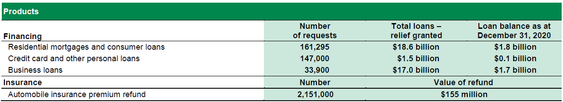

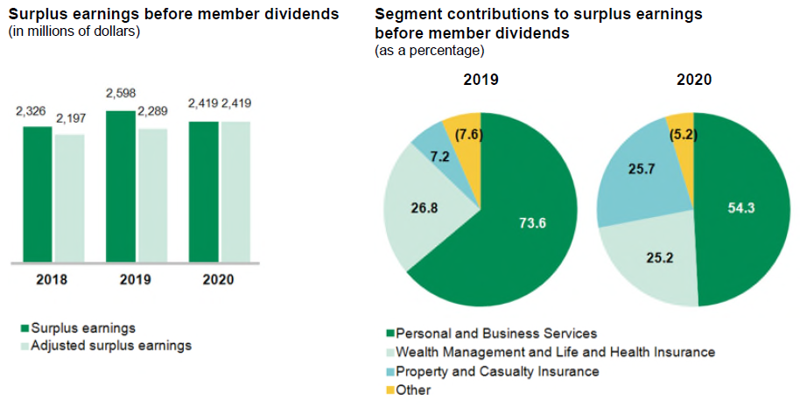

PERSONAL & BUSINESS SERVICES

• Everyday financial management:

- Transaction services carried out at the caisse counter and at ATMs, requests for information and specialty services, such as purchasing foreign

exchange, money orders, drafts and safety deposit boxes. These services are increasingly available on the Web and mobile devices.

• Savings and investments:

- Products distributed by the caisses such as investment funds (Desjardins Funds), market-linked guaranteed investments (MLGI), the guaranteed

savings offer, the guaranteed investment fund offer, and annuity products.

• Integrated business offer:

- Customized solutions to support businesses of all sizes in their expansion plans, whether on Québec, Canadian or international markets.

• Financing:

- Residential mortgages, for the purchase of land, new or existing homes and for renovations;

- Consumer loans, such as loans for the purchase of automobiles and durable goods, personal lines of credit, student loans and Accord D financing

solutions;

- Commercial credit, which makes it possible to offer financing in the commercial and industrial, agricultural and agri-food, and public and

institutional sectors, as well as for commercial and multi-residential real estate.

• Payment:

- Debit, credit and prepaid card payment services for individuals and businesses, merchant payment acceptance services, electronic payment

services and both domestic and international funds transfers.

• *AccèsD*:

- Desjardins Group products and services are available at anytime, anywhere in the world, by phone, online and via applications for mobile devices.

• Wealth management advisory services:

- Online brokerage: High-performance tools that enable members and clients to trade and invest independently. Whether they are beginners or

seasoned investors, the tools offer a rich and unique experience that will help them grow their portfolios.

- Signature Service: A turnkey service to help high net worth clients move from saving to investing. It guides members with complex requirements in

building their wealth.

- Private wealth management: An integrated service that takes charge of wealthy members and their families, down to the last detail. It meets

sophisticated requirements by providing members with a trustworthy team they can count on.

- Securities: Customized service that enables high net worth and wealthy members and clients a way to be involved in their financial decisions. It

provides members and clients with a personalized offer for growing their wealth.

• Capital markets:

- Meeting the financing needs of Canadian corporations, institutions and cooperatives, and providing advisory services for mergers and acquisitions,

as well as intermediation and execution services on the stock and fixed income securities markets;

- Carried out by seasoned sales and trading teams who are supported by a research team that is renowned in the industry for its excellence.

• Development capital:

- Facilitating investment, both directly and through funds, in small and medium-sized enterprises (SMEs) and cooperatives in every region of Québec;

- Desjardins Capital Management Inc., which manages *Capital régional et coopératif Desjardins*, supports the growth of businesses, especially in

business ownership transfers;

- With the backing of a team of specialists operating throughout Québec, this segment helps to develop and maintain the highest calibre of

entrepreneurship in Québec by providing entrepreneurs with assistance at every stage of their company’s growth.

• Specialized services:

- International services, factoring, banking and cash management services, Desjardins employer solutions (payroll and human resources

management, as well as group retirement savings), specialized financing for institutional clients, the franchise sector, health care and professional firms.

PROPERTY AND CASUALTY INSURANCE

Automobile insurance, including motorcycle and recreational vehicle insurance:

- Offers insurance coverage tailored to clients’ specific needs and their vehicle features;

- Also includes the necessary coverage to obtain financial compensation for bodily injury in provinces where such coverage is not provided by a

public plan.

• Property insurance:

- Offers owners and tenants insurance coverage to protect their physical property, with all-risk insurance coverage and optional coverages for primary

and secondary residences.

• Business insurance:

- Covers the insurance requirements for commercial vehicles, commercial property and public liability for businesses;

- Service is provided to the following sectors, among others: service firms, retailers and wholesalers, garages, self-employed workers, general or

specialized contractors, restaurants, offices, health care professionals, commercial buildings, condominiums and apartment buildings.

• Prevention:

- Provides advisory services as well as loss prevention services to members and clients to help them protect their assets and guard against disaster.

1. https://www.desjardins.com/ca/about-us/investor-relations/annual-quarterly-reports/index.jsp