苏州大学实验报告
院、系 | 计算机学院 |  | 年级专业 |  |  |  | 姓名 |  | 学号
课程名称 |  | JAVA |  |  |  |  |  |  | 成绩
指导教师 |  | 李蓥 |  | 同组实验者 |  | 无 |  | 实验日期

实 验 名 称 | 实验七 网络通信程序设计

- 实验目的
掌握GUI界面设计
掌握界面布局
掌握事件处理

- 实验内容
完成实验后，请大家上传至实验教学平台，文件名为 你的学号，加上你的姓名，加上“实验1.doc”，比如学生学号是1417401001， 姓名为张三，则文件名为 141740101张三实验1.doc，中间无需加上任何空格等符号

实现GUI网络聊天器的客户端和服务器端。

三．实验步骤和结果（程序代码）

UI.java

package Thread;

import java.awt.Dimension;
import java.awt.FlowLayout;
import java.awt.event.ActionEvent;
import java.awt.event.ActionListener;
import java.awt.event.KeyAdapter;
import java.awt.event.KeyEvent;
import java.io.DataInput;
import java.io.DataInputStream;
import java.io.DataOutputStream;
import java.io.IOException;
import java.io.InputStream;
import java.io.OutputStream;
import java.net.ServerSocket;
import java.net.Socket;
import java.net.UnknownHostException;
import javax.swing.JButton;
import javax.swing.JFrame;
import javax.swing.JScrollPane;
import javax.swing.JTextArea;
import javax.swing.JTextField;

public class UI {
private String UsrName;
private JTextArea txt1 = new JTextArea();
private JTextField Contxt = new JTextField("");
private int LastInput = 0;
private JButton Send = new JButton("发送");
private JButton Clear = new JButton("清屏");
private String Input = "";
public boolean Sended = false;

public void AddTxt(String UsrName,String s)
{
txt1.append(UsrName+": "+s+"\n");
}

public String getTxt()
{
this.Sended = false;
return Contxt.getText();
}

public UI(String Name)
{
this.UsrName = Name;
JFrame f = new JFrame(UsrName+"的聊天室");
f.setSize(700,800);
f.setLayout(new FlowLayout());

txt1.setPreferredSize(new Dimension(600,600));
txt1.setText(Input);
txt1.setLineWrap(true);
txt1.setEditable(false);
f.add(txt1);
f.add(new JScrollPane(txt1));

Contxt.setText("");
Contxt.setPreferredSize(new Dimension(640, 100));
f.add(Contxt);
f.add(Send);
f.add(Clear);
f.setDefaultCloseOperation(JFrame.EXIT_ON_CLOSE);
f.setVisible(true);
Contxt.grabFocus();

//Send按钮

Clear.addActionListener(new ActionListener(){
public void actionPerformed(ActionEvent e) {
txt1.setText("");
}

});

// 如果能直接连接到相应地址和端口，则连接成功，否则创建一个端口等待其他人连接连接
// 这里暂定IP地址为本地地址
client c = new client(Name,8888);

if(!c.IsConnectted)
{
new server(Name,8888);
}
}

public class client {
public boolean IsConnectted=false;
private String UsrName;
public client(String name,int n) {
try {
this.UsrName = name;
Socket s = new Socket("127.0.0.1",n);
IsConnectted = true;
txt1.append("连接成功！！ \n");
new Send(s,this.UsrName).start();
new Receive(s,this.UsrName).start();
} catch (UnknownHostException e) {
txt1.append("未连接到端口，正在等待连接...\n");
} catch (IOException e) {
txt1.append("未连接到端口，正在等待连接...\n");
}
}
}

public class server {
private String UsrName = "";
public server(String name,int n)//监听端口n
{
try {
this.UsrName = name;
ServerSocket ss = new ServerSocket(n);
txt1.append("正在等待连接端口"+n+"\n");
Socket s = ss.accept();
txt1.append("连接成功！！！\n");
new Send(s,this.UsrName).start();
new Receive(s,this.UsrName).start();
} catch (IOException e) {
// TODO Auto-generated catch block
e.printStackTrace();
}
}
}

public class Receive extends Thread{

private Socket s;
private String usrname;

public Receive(Socket s,String name)
{
this.usrname = name;
this.s = s;
}

public void run()
{
try {
InputStream is = s.getInputStream();
DataInput dis = new DataInputStream(is);
while(true)
{
String msg = dis.readUTF();
txt1.append(msg);
}
} catch (IOException e2) {
// TODO Auto-generated catch block
e2.printStackTrace();
}
}
}

public class Send extends Thread {

private Socket s;
private String UsrName;

public Send(Socket s,String name)
{
this.UsrName = name;
this.s = s;
}

public void run()
{
try {
OutputStream os;
os = s.getOutputStream();
DataOutputStream dos = new DataOutputStream(os);

Contxt.addKeyListener(new KeyAdapter() {
public void keyPressed(KeyEvent e) {
int code=e.getKeyCode();
if(code==KeyEvent.VK_ENTER)
{
if(Contxt.getText().contentEquals("")) return;
String str = UsrName+": "+Contxt.getText()+"\n";
txt1.append(str);
Sended = true;
try {
dos.writeUTF(str);
} catch (IOException e1) {
// TODO Auto-generated catch block
e1.printStackTrace();
}
Contxt.setText("");
}
}
});

Send.addActionListener(new ActionListener(){
public void actionPerformed(ActionEvent e) {
if(Contxt.getText().contentEquals("")) return;
String str = UsrName+": "+Contxt.getText()+"\n";
txt1.append(str);
Sended = true;
try {
dos.writeUTF(str);
} catch (IOException e1) {
// TODO Auto-generated catch block
e1.printStackTrace();
}
Contxt.setText("");
}
});
} catch (IOException e2) {
// TODO Auto-generated catch block
e2.printStackTrace();
}
}
}

}

RUN.java

package Thread;

import java.awt.Font;
import java.util.Enumeration;

import javax.swing.UIManager;
import javax.swing.plaf.FontUIResource;

public class RUN extends Thread{
private static void InitGlobalFont(Font font) {
FontUIResource fontRes = new FontUIResource(font);
for (Enumeration<Object> keys = UIManager.getDefaults().keys();
keys.hasMoreElements(); ) {
Object key = keys.nextElement();
Object value = UIManager.get(key);
if (value instanceof FontUIResource) {
UIManager.put(key, fontRes);
}
}
}
public String Name;
public RUN(String name)
{
this.Name = name;
}
public void run()
{
InitGlobalFont(new Font("微软雅黑", Font.PLAIN, 18)); //设置聊天框字体
UI u = new UI(Name);
}

public static void main(String[] args) {
new RUN("小明").start();
try {
Thread.sleep(1000);
} catch (InterruptedException e) {
// TODO Auto-generated catch block
e.printStackTrace();
}
new RUN("小王").start();

}
}

运行结果：
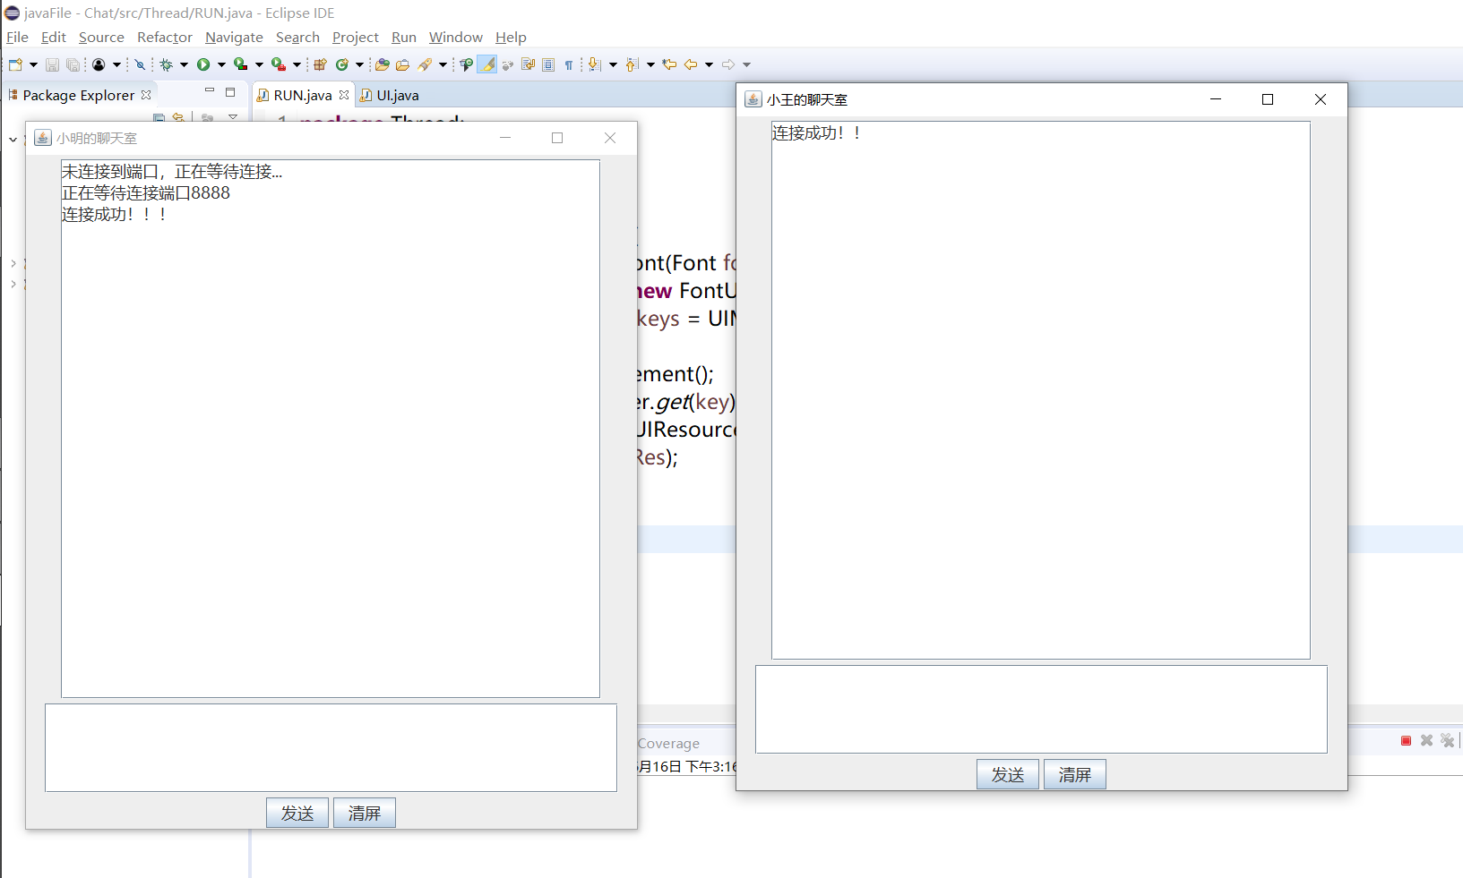

功能测试：

- 建立窗口，运行（RUN.java），创建两个UI线程，分别为小王和小明，并成功连接

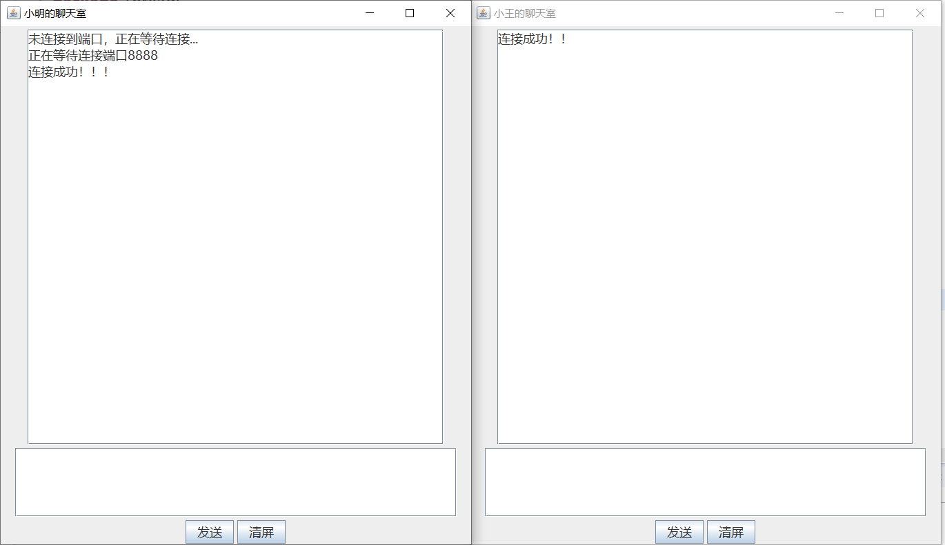

- 发送消息与接收消息（点击发送按钮或者按回车键发送消息）

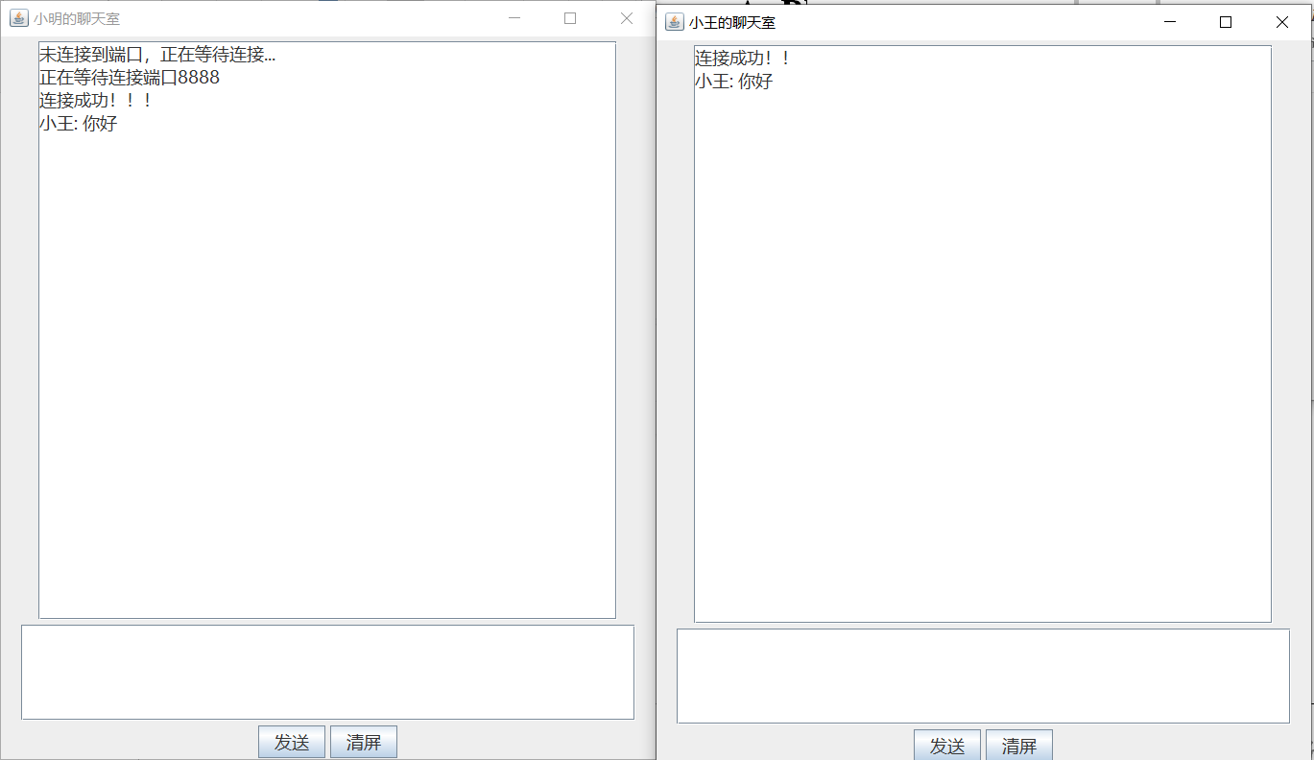
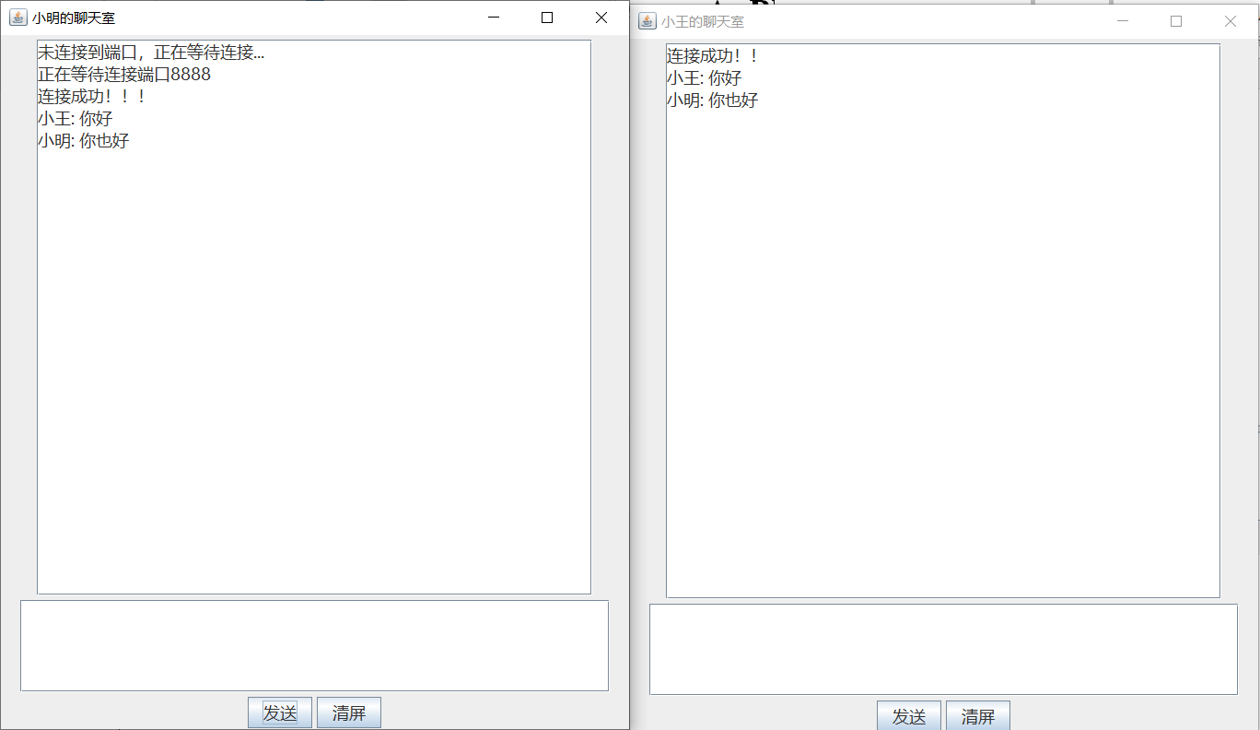

- 点击清屏键
