苏州大学实验报告
院、系 | 计算机学院 |  | 年级专业 |  | 17计科 |  | 姓名 | 魏军杰 | 学号 | 1727405175
课程名称 |  | 操作系统课程实践 |  |  |  |  |  |  | 成绩
指导教师 |  | 褚晓敏 |  | 同组实验者 |  | 无 |  | 实验日期 | 2020/4/17

实 验 名 称 | 实验四：进程管理

实验目的
- 重温进程管理概念，理解Linux中的进程。
- 理解Linux中进程的产生方式，理解fork()和clone()的差别。
- 了解Linux中的线程。

实验内容
1、分析系统调用sys_exit.
2、用fork()系统调用创建一个子进程。
3、用clone()系统调用创建一个子进程。

实验过程
- 打开kernel/exit.c文件，找到do_exit()函数

具体代码分析在注释中：

void __noreturn do_exit(long code)
{
//获取当前要释放的进程
struct task_struct *tsk = current;
int group_dead;

//触发task_exit_nb通知链实例的处理函数
profile_task_exit(tsk);
kcov_task_exit(tsk);

//检查进程的blk_plug是否为空
//保证task_struct中的plug字段是空的，或者plug字段指向的队列是空的。
WARN_ON(blk_needs_flush_plug(tsk));

//中断上下文不能执行do_exit函数, 也不能终止PID为0的进程。
if (unlikely(in_interrupt()))
panic("Aiee, killing interrupt handler!");
if (unlikely(!tsk->pid))
panic("Attempted to kill the idle task!");

// 设定进程可以使用的虚拟地址的上限（用户空间）
/*
* If do_exit is called because this processes oopsed, it's possible
* that get_fs() was left as KERNEL_DS, so reset it to USER_DS before
* continuing. Amongst other possible reasons, this is to prevent
* mm_release()->clear_child_tid() from writing to a user-controlled
* kernel address.
*/
set_fs(USER_DS);

ptrace_event(PTRACE_EVENT_EXIT, code);

validate_creds_for_do_exit(tsk);

//检查并设置进程PF_EXITING标志
/*
* We're taking recursive faults here in do_exit. Safest is to just
* leave this task alone and wait for reboot.
*/

//检查PF_EXITING标识, 此标识表示进程正在退出
/*如果此标识已被设置, 则进一步设置PF_EXITPIDONE标识,
并将进程的状态设置为不可中断状态TASK_UNINTERRUPTIBLE,并进程一次进程调度*/
if (unlikely(tsk->flags & PF_EXITING)) {
pr_alert("Fixing recursive fault but reboot is needed!\n");
/*
* We can do this unlocked here. The futex code uses
* this flag just to verify whether the pi state
* cleanup has been done or not. In the worst case it
* loops once more. We pretend that the cleanup was
* done as there is no way to return. Either the
* OWNER_DIED bit is set by now or we push the blocked
* task into the wait for ever nirwana as well.
*/
tsk->flags |= PF_EXITPIDONE;
set_current_state(TASK_UNINTERRUPTIBLE);
schedule(); //调度
}

//如果此标识未被设置, 则通过exit_signals来设置
exit_signals(tsk); /* sets PF_EXITING */
/*
* Ensure that all new tsk->pi_lock acquisitions must observe
* PF_EXITING. Serializes against futex.c:attach_to_pi_owner().
*/

//内存屏障，用于确保在它之后的操作开始执行之前，它之前的操作已经完成
smp_mb();
/*
* Ensure that we must observe the pi_state in exit_mm() ->
* mm_release() -> exit_pi_state_list().
*/
//获得current->pi_lock锁
raw_spin_lock_irq(&tsk->pi_lock);
raw_spin_unlock_irq(&tsk->pi_lock);

if (unlikely(in_atomic())) {
pr_info("note: %s[%d] exited with preempt_count %d\n",
current->comm, task_pid_nr(current),
preempt_count());
preempt_count_set(PREEMPT_ENABLED);
}

//同步进程的mm的rss_stat
/* sync mm's RSS info before statistics gathering */
if (tsk->mm)
sync_mm_rss(tsk->mm);

//获取进程运行时间
acct_update_integrals(tsk);

//清除定时器
group_dead = atomic_dec_and_test(&tsk->signal->live);
if (group_dead) {
#ifdef CONFIG_POSIX_TIMERS
hrtimer_cancel(&tsk->signal->real_timer);
exit_itimers(tsk->signal);
#endif
if (tsk->mm)
setmax_mm_hiwater_rss(&tsk->signal->maxrss, tsk->mm);
}

acct_collect(code, group_dead);
if (group_dead)
tty_audit_exit();
audit_free(tsk);

tsk->exit_code = code;
taskstats_exit(tsk, group_dead);
//释放占用的资源
exit_mm(); //释放内存

if (group_dead)
acct_process();
trace_sched_process_exit(tsk);

exit_sem(tsk); //释放用户空间的信号量
exit_shm(tsk); //释放锁
exit_files(tsk);//释放已经打开的文件
exit_fs(tsk); //释放fs_struct结构体
//脱离控制终端
if (group_dead)
disassociate_ctty(1);
//释放namespace
exit_task_namespaces(tsk);
exit_task_work(tsk);
exit_thread(tsk);//释放task_struct中的thread_struct结构

/*
* Flush inherited counters to the parent - before the parent
* gets woken up by child-exit notifications.
*
* because of cgroup mode, must be called before cgroup_exit()
*/
perf_event_exit_task(tsk);

sched_autogroup_exit_task(tsk);
cgroup_exit(tsk);

/*
* FIXME: do that only when needed, using sched_exit tracepoint
*/
flush_ptrace_hw_breakpoint(tsk);

exit_tasks_rcu_start();

exit_notify(tsk, group_dead); //更新所有子进程的父进程

proc_exit_connector(tsk);

mpol_put_task_policy(tsk);
#ifdef CONFIG_FUTEX
if (unlikely(current->pi_state_cache))
kfree(current->pi_state_cache);
#endif
/*
* Make sure we are holding no locks:
*/
debug_check_no_locks_held();
/*
* We can do this unlocked here. The futex code uses this flag
* just to verify whether the pi state cleanup has been done
* or not. In the worst case it loops once more.
*/
tsk->flags |= PF_EXITPIDONE;

if (tsk->io_context)
exit_io_context(tsk);

if (tsk->splice_pipe)
free_pipe_info(tsk->splice_pipe);

if (tsk->task_frag.page)
put_page(tsk->task_frag.page);

validate_creds_for_do_exit(tsk);

/*检查有多少未使用的进程内核栈*/
check_stack_usage();

preempt_disable();
if (tsk->nr_dirtied)
__this_cpu_add(dirty_throttle_leaks, tsk->nr_dirtied);
exit_rcu();
exit_tasks_rcu_finish();

lockdep_free_task(tsk);
//设置进程为TASK_DEAD状态，进程无法再被调度，此时该进程为僵尸进程
do_task_dead();
}

- 编写fork.c
#include<unistd.h>
#include<sys/types.h>
#include<errno.h>
#include<stdio.h>
#include<sys/wait.h>
#include<stdlib.h>

int main()
{
pid_t childpid;
int retval;
int status;
childpid = fork();
if(childpid == 0)
{
printf("CHILD: This is CHILD process!!\n");
printf("CHILD: PID = %d\n",getpid());
printf("CHILD: parent's PID = %d\n",getppid());
printf("CHILD: fork return is : %d\n",childpid);
printf("CHILD: sleep for 1 second\n");
sleep(1);
printf("CHILD: Enter an exit value(0,255):");
scanf("%d",&retval);
printf("CHILD: Goodbye!!\n");
exit(retval);
}
if(childpid>0)
{
printf("PARENT: This is parent process\n");
printf("PARENT: Here's my PID : %d\n",getpid());
printf("PARENT: The value of my child's PID is : %d\n",childpid);
printf("PARENT: I will wait for my child to exit, and store its status\n");
wait(&status);
printf("PARENT: Child's exit code is %d\n",WEXITSTATUS(status));
printf("PARENT: Goodbye!!\n");
exit(0);
}
if(childpid<0)
{
perror("fork");
exit(0);
}
}

编译运行：
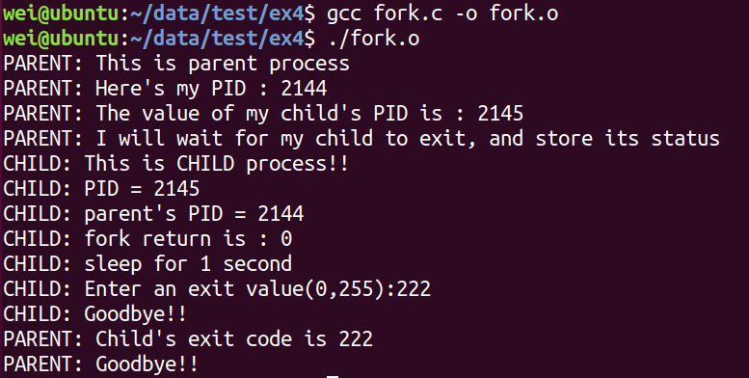

- 编写clone.c
#define _GNU_SOURCE
#include<unistd.h>
#include<stdio.h>
#include<stdlib.h>
#include<sched.h>
#include<signal.h>
#include<malloc.h>
#include<fcntl.h>
#include<sys/types.h>
#include<sys/wait.h>
#include<sys/stat.h>

char *prog_argv[4];
int foo;
int fd;
#define CHILD_STACK (1024*64)
int thread_function(void * argu)
{
printf("CHILD: child thread begin...\n");
foo = 2008;
close(fd);
execvp(prog_argv[0],prog_argv);
printf("CHILD: child thread exit, this line won't print out.\n");
return 0;
}
int main()
{
char c;
char * stack;
pid_t pid;
foo = 2007;
fd = open("/etc/passwd",O_RDONLY);
if(fd < 0)
{
perror("open");
exit(-1);
}
printf("PARENT: The variable foo was %d\n",foo);
if(read(fd,&c,1)<1)
{
perror("PARENT: File Read Error!");
exit(1);
}
else
{
printf("PARENT: We could read from the file : %c\n",c);
}
prog_argv[0] = "/bin/ls";
prog_argv[1] = "-1";
prog_argv[2] = "/usr";
prog_argv[3] = NULL;

stack = (char*)malloc(CHILD_STACK);
if(stack==0)
{
perror("malloc : could not allocate stack");
exit(2);
}
printf("PARENT: Creating child thread\n");

pid = clone(thread_function,(void*)(stack + CHILD_STACK),SIGCHLD | CLONE_FS | CLONE_FILES | CLONE_SIGHAND | CLONE_VM,NULL);
if(pid == -1)
{
perror("clone");
exit(3);

}

printf("PARENT: Waiting for the finish of child thread: %d\n",pid);
pid = waitpid(pid,0,0);
if(pid == -1)
{
perror("wait");
exit(4);
}
free(stack);
printf("PARENT: Child thread returned and stack freed\n");\
printf("PARENT: The variable foo now is : %d\n",foo);
if(read(fd,&c,1)<1)
{
perror("PARENT: File Read Error!");
exit(5);
}
else
{
printf("PARENT: We could read from the file: %c\n",c);
}
return 0;
}

编译运行：
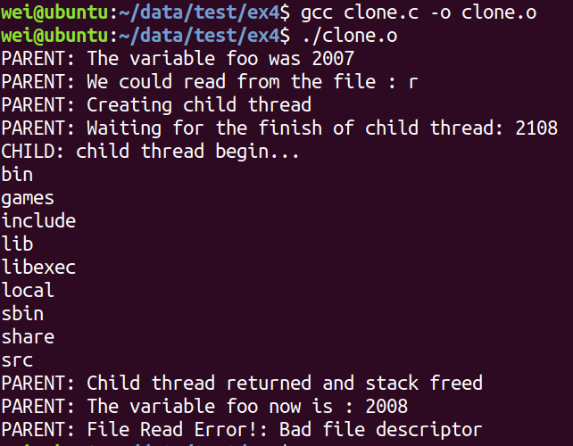

讨论、心得、
在实验三中，需要在开头加上 #define _GNU_SOURCE这个宏，因为sys/stat.h include了一个头文件，features.h，它是让用户配置编译环境的头文件，加上这个宏可以让用户打开所有的feature，否则会报错找不到标志

