Formulario de evaluación (CON RESPUESTAS)
Caso 1 / 33
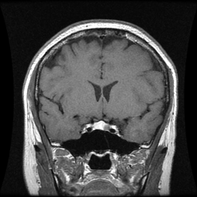
Overlay Grad-CAM:
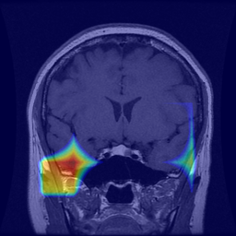
GT → Clase: pituitary | Tipo: REAL_GRADCAM | PID: 105475 | WITH GRAD-CAM OVERLAY
Tumor: □ glioma □ meningioma □ pituitary
Real/Fake: □ Real □ Fake
Confianza (1–5): 1 □ 2 □ 3 □ 4 □ 5 □
Utilidad diagnóstica (1–5): 1 □ 2 □ 3 □ 4 □ 5 □
Notas: _________________________________________________
------------------------------------------------------------
Caso 2 / 33
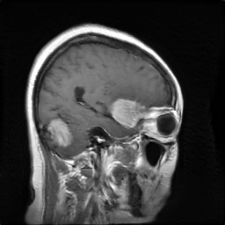
GT → Clase: meningioma | Tipo: FAKE | PID: | Truncation: 1.0
Tumor: □ glioma □ meningioma □ pituitary
Real/Fake: □ Real □ Fake
Confianza (1–5): 1 □ 2 □ 3 □ 4 □ 5 □
Utilidad diagnóstica (1–5): 1 □ 2 □ 3 □ 4 □ 5 □
Notas: _________________________________________________
------------------------------------------------------------
Caso 3 / 33
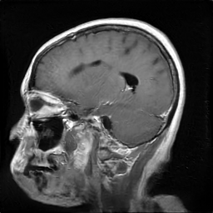
Overlay Grad-CAM:
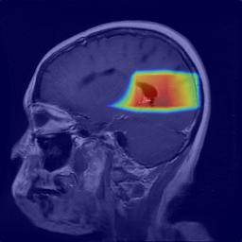
GT → Clase: glioma | Tipo: FAKE_GRADCAM | PID: | Truncation: 1.0 | WITH GRAD-CAM OVERLAY
Tumor: □ glioma □ meningioma □ pituitary
Real/Fake: □ Real □ Fake
Confianza (1–5): 1 □ 2 □ 3 □ 4 □ 5 □
Utilidad diagnóstica (1–5): 1 □ 2 □ 3 □ 4 □ 5 □
Notas: _________________________________________________
------------------------------------------------------------
Caso 4 / 33
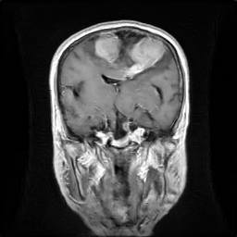
Overlay Grad-CAM:
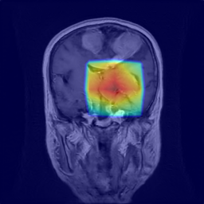
GT → Clase: meningioma | Tipo: FAKE_GRADCAM | PID: | Truncation: 1.0 | WITH GRAD-CAM OVERLAY
Tumor: □ glioma □ meningioma □ pituitary
Real/Fake: □ Real □ Fake
Confianza (1–5): 1 □ 2 □ 3 □ 4 □ 5 □
Utilidad diagnóstica (1–5): 1 □ 2 □ 3 □ 4 □ 5 □
Notas: _________________________________________________
------------------------------------------------------------
Caso 5 / 33
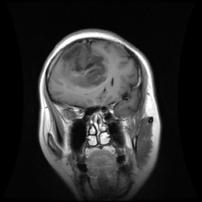
Overlay Grad-CAM:
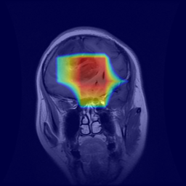
GT → Clase: glioma | Tipo: REAL_GRADCAM | PID: 97609 | WITH GRAD-CAM OVERLAY
Tumor: □ glioma □ meningioma □ pituitary
Real/Fake: □ Real □ Fake
Confianza (1–5): 1 □ 2 □ 3 □ 4 □ 5 □
Utilidad diagnóstica (1–5): 1 □ 2 □ 3 □ 4 □ 5 □
Notas: _________________________________________________
------------------------------------------------------------
Caso 6 / 33
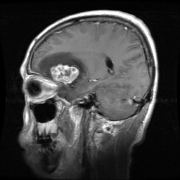
Overlay Grad-CAM:
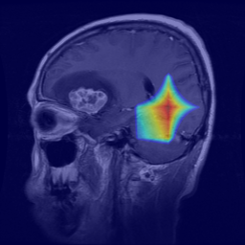
GT → Clase: meningioma | Tipo: REAL_GRADCAM | PID: 102960 | WITH GRAD-CAM OVERLAY
Tumor: □ glioma □ meningioma □ pituitary
Real/Fake: □ Real □ Fake
Confianza (1–5): 1 □ 2 □ 3 □ 4 □ 5 □
Utilidad diagnóstica (1–5): 1 □ 2 □ 3 □ 4 □ 5 □
Notas: _________________________________________________
------------------------------------------------------------
Caso 7 / 33
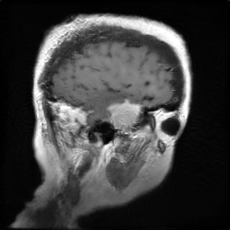
Overlay Grad-CAM:
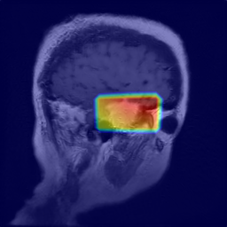
GT → Clase: meningioma | Tipo: FAKE_GRADCAM | PID: | Truncation: 1.0 | WITH GRAD-CAM OVERLAY
Tumor: □ glioma □ meningioma □ pituitary
Real/Fake: □ Real □ Fake
Confianza (1–5): 1 □ 2 □ 3 □ 4 □ 5 □
Utilidad diagnóstica (1–5): 1 □ 2 □ 3 □ 4 □ 5 □
Notas: _________________________________________________
------------------------------------------------------------
Caso 8 / 33
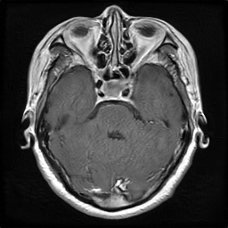
Overlay Grad-CAM:
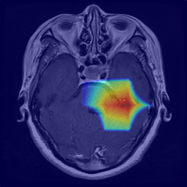
GT → Clase: pituitary | Tipo: FAKE_GRADCAM | PID: | Truncation: 1.0 | WITH GRAD-CAM OVERLAY
Tumor: □ glioma □ meningioma □ pituitary
Real/Fake: □ Real □ Fake
Confianza (1–5): 1 □ 2 □ 3 □ 4 □ 5 □
Utilidad diagnóstica (1–5): 1 □ 2 □ 3 □ 4 □ 5 □
Notas: _________________________________________________
------------------------------------------------------------
Caso 9 / 33
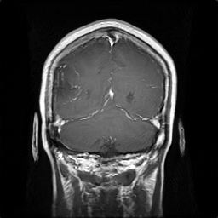
Overlay Grad-CAM:
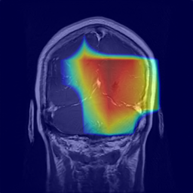
GT → Clase: glioma | Tipo: FAKE_GRADCAM | PID: | Truncation: 1.0 | WITH GRAD-CAM OVERLAY
Tumor: □ glioma □ meningioma □ pituitary
Real/Fake: □ Real □ Fake
Confianza (1–5): 1 □ 2 □ 3 □ 4 □ 5 □
Utilidad diagnóstica (1–5): 1 □ 2 □ 3 □ 4 □ 5 □
Notas: _________________________________________________
------------------------------------------------------------
Caso 10 / 33
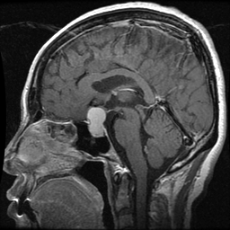
GT → Clase: pituitary | Tipo: REAL | PID: 98472
Tumor: □ glioma □ meningioma □ pituitary
Real/Fake: □ Real □ Fake
Confianza (1–5): 1 □ 2 □ 3 □ 4 □ 5 □
Utilidad diagnóstica (1–5): 1 □ 2 □ 3 □ 4 □ 5 □
Notas: _________________________________________________
------------------------------------------------------------
Caso 11 / 33
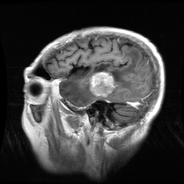
Overlay Grad-CAM:
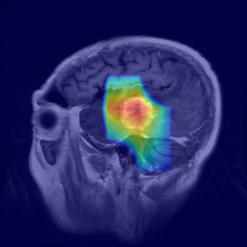
GT → Clase: meningioma | Tipo: REAL_GRADCAM | PID: 113614 | WITH GRAD-CAM OVERLAY
Tumor: □ glioma □ meningioma □ pituitary
Real/Fake: □ Real □ Fake
Confianza (1–5): 1 □ 2 □ 3 □ 4 □ 5 □
Utilidad diagnóstica (1–5): 1 □ 2 □ 3 □ 4 □ 5 □
Notas: _________________________________________________
------------------------------------------------------------
Caso 12 / 33
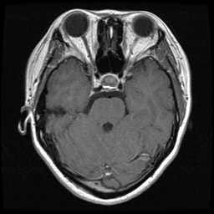
Overlay Grad-CAM:
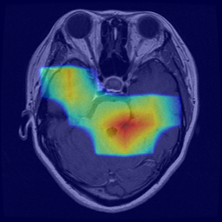
GT → Clase: pituitary | Tipo: REAL_GRADCAM | PID: 111125 | WITH GRAD-CAM OVERLAY
Tumor: □ glioma □ meningioma □ pituitary
Real/Fake: □ Real □ Fake
Confianza (1–5): 1 □ 2 □ 3 □ 4 □ 5 □
Utilidad diagnóstica (1–5): 1 □ 2 □ 3 □ 4 □ 5 □
Notas: _________________________________________________
------------------------------------------------------------
Caso 13 / 33
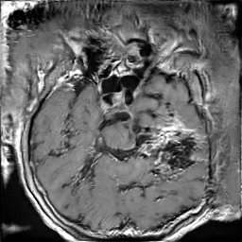
GT → Clase: pituitary | Tipo: FAKE | PID: | Truncation: 1.0
Tumor: □ glioma □ meningioma □ pituitary
Real/Fake: □ Real □ Fake
Confianza (1–5): 1 □ 2 □ 3 □ 4 □ 5 □
Utilidad diagnóstica (1–5): 1 □ 2 □ 3 □ 4 □ 5 □
Notas: _________________________________________________
------------------------------------------------------------
Caso 14 / 33
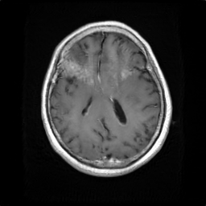
GT → Clase: meningioma | Tipo: FAKE | PID: | Truncation: 1.0
Tumor: □ glioma □ meningioma □ pituitary
Real/Fake: □ Real □ Fake
Confianza (1–5): 1 □ 2 □ 3 □ 4 □ 5 □
Utilidad diagnóstica (1–5): 1 □ 2 □ 3 □ 4 □ 5 □
Notas: _________________________________________________
------------------------------------------------------------
Caso 15 / 33
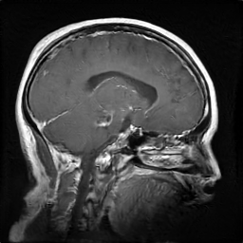
GT → Clase: glioma | Tipo: FAKE | PID: | Truncation: 1.0
Tumor: □ glioma □ meningioma □ pituitary
Real/Fake: □ Real □ Fake
Confianza (1–5): 1 □ 2 □ 3 □ 4 □ 5 □
Utilidad diagnóstica (1–5): 1 □ 2 □ 3 □ 4 □ 5 □
Notas: _________________________________________________
------------------------------------------------------------
Caso 16 / 33
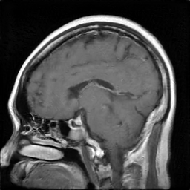
GT → Clase: pituitary | Tipo: FAKE | PID: | Truncation: 1.0
Tumor: □ glioma □ meningioma □ pituitary
Real/Fake: □ Real □ Fake
Confianza (1–5): 1 □ 2 □ 3 □ 4 □ 5 □
Utilidad diagnóstica (1–5): 1 □ 2 □ 3 □ 4 □ 5 □
Notas: _________________________________________________
------------------------------------------------------------
Caso 17 / 33
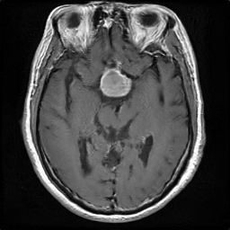
Overlay Grad-CAM:
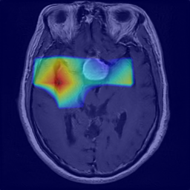
GT → Clase: pituitary | Tipo: FAKE_GRADCAM | PID: | Truncation: 1.0 | WITH GRAD-CAM OVERLAY
Tumor: □ glioma □ meningioma □ pituitary
Real/Fake: □ Real □ Fake
Confianza (1–5): 1 □ 2 □ 3 □ 4 □ 5 □
Utilidad diagnóstica (1–5): 1 □ 2 □ 3 □ 4 □ 5 □
Notas: _________________________________________________
------------------------------------------------------------
Caso 18 / 33
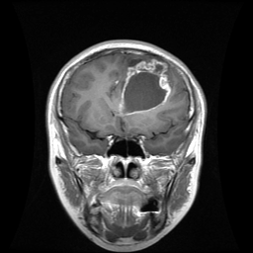
Overlay Grad-CAM:
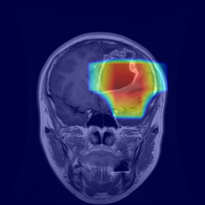
GT → Clase: glioma | Tipo: REAL_GRADCAM | PID: mr048994 | WITH GRAD-CAM OVERLAY
Tumor: □ glioma □ meningioma □ pituitary
Real/Fake: □ Real □ Fake
Confianza (1–5): 1 □ 2 □ 3 □ 4 □ 5 □
Utilidad diagnóstica (1–5): 1 □ 2 □ 3 □ 4 □ 5 □
Notas: _________________________________________________
------------------------------------------------------------
Caso 19 / 33
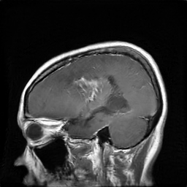
GT → Clase: glioma | Tipo: FAKE | PID: | Truncation: 1.0
Tumor: □ glioma □ meningioma □ pituitary
Real/Fake: □ Real □ Fake
Confianza (1–5): 1 □ 2 □ 3 □ 4 □ 5 □
Utilidad diagnóstica (1–5): 1 □ 2 □ 3 □ 4 □ 5 □
Notas: _________________________________________________
------------------------------------------------------------
Caso 20 / 33
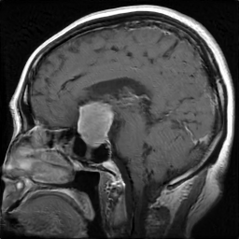
Overlay Grad-CAM:
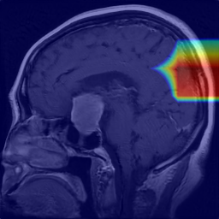
GT → Clase: pituitary | Tipo: FAKE_GRADCAM | PID: | Truncation: 1.0 | WITH GRAD-CAM OVERLAY
Tumor: □ glioma □ meningioma □ pituitary
Real/Fake: □ Real □ Fake
Confianza (1–5): 1 □ 2 □ 3 □ 4 □ 5 □
Utilidad diagnóstica (1–5): 1 □ 2 □ 3 □ 4 □ 5 □
Notas: _________________________________________________
------------------------------------------------------------
Caso 21 / 33
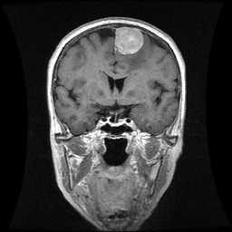
Overlay Grad-CAM:
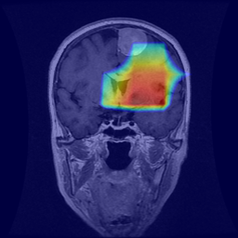
GT → Clase: meningioma | Tipo: REAL_GRADCAM | PID: 99089 | WITH GRAD-CAM OVERLAY
Tumor: □ glioma □ meningioma □ pituitary
Real/Fake: □ Real □ Fake
Confianza (1–5): 1 □ 2 □ 3 □ 4 □ 5 □
Utilidad diagnóstica (1–5): 1 □ 2 □ 3 □ 4 □ 5 □
Notas: _________________________________________________
------------------------------------------------------------
Caso 22 / 33
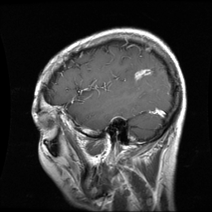
Overlay Grad-CAM:
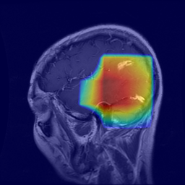
GT → Clase: glioma | Tipo: REAL_GRADCAM | PID: mr024780e | WITH GRAD-CAM OVERLAY
Tumor: □ glioma □ meningioma □ pituitary
Real/Fake: □ Real □ Fake
Confianza (1–5): 1 □ 2 □ 3 □ 4 □ 5 □
Utilidad diagnóstica (1–5): 1 □ 2 □ 3 □ 4 □ 5 □
Notas: _________________________________________________
------------------------------------------------------------
Caso 23 / 33
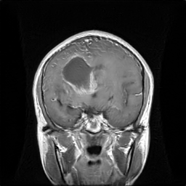
Overlay Grad-CAM:
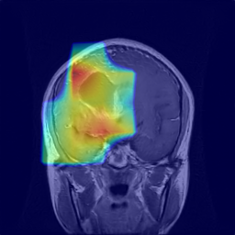
GT → Clase: glioma | Tipo: FAKE_GRADCAM | PID: | Truncation: 1.0 | WITH GRAD-CAM OVERLAY
Tumor: □ glioma □ meningioma □ pituitary
Real/Fake: □ Real □ Fake
Confianza (1–5): 1 □ 2 □ 3 □ 4 □ 5 □
Utilidad diagnóstica (1–5): 1 □ 2 □ 3 □ 4 □ 5 □
Notas: _________________________________________________
------------------------------------------------------------
Caso 24 / 33
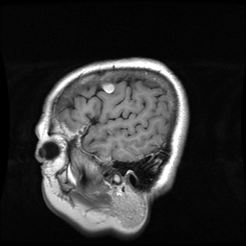
GT → Clase: meningioma | Tipo: REAL | PID: 109411
Tumor: □ glioma □ meningioma □ pituitary
Real/Fake: □ Real □ Fake
Confianza (1–5): 1 □ 2 □ 3 □ 4 □ 5 □
Utilidad diagnóstica (1–5): 1 □ 2 □ 3 □ 4 □ 5 □
Notas: _________________________________________________
------------------------------------------------------------
Caso 25 / 33
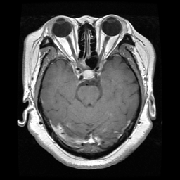
GT → Clase: pituitary | Tipo: REAL | PID: 101145
Tumor: □ glioma □ meningioma □ pituitary
Real/Fake: □ Real □ Fake
Confianza (1–5): 1 □ 2 □ 3 □ 4 □ 5 □
Utilidad diagnóstica (1–5): 1 □ 2 □ 3 □ 4 □ 5 □
Notas: _________________________________________________
------------------------------------------------------------
Caso 26 / 33
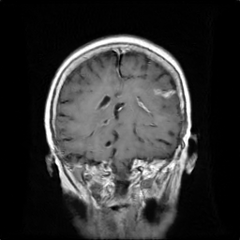
GT → Clase: meningioma | Tipo: FAKE | PID: | Truncation: 1.0
Tumor: □ glioma □ meningioma □ pituitary
Real/Fake: □ Real □ Fake
Confianza (1–5): 1 □ 2 □ 3 □ 4 □ 5 □
Utilidad diagnóstica (1–5): 1 □ 2 □ 3 □ 4 □ 5 □
Notas: _________________________________________________
------------------------------------------------------------
Caso 27 / 33
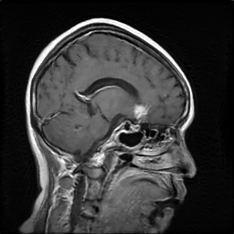
Overlay Grad-CAM:
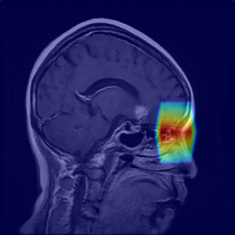
GT → Clase: meningioma | Tipo: FAKE_GRADCAM | PID: | Truncation: 1.0 | WITH GRAD-CAM OVERLAY
Tumor: □ glioma □ meningioma □ pituitary
Real/Fake: □ Real □ Fake
Confianza (1–5): 1 □ 2 □ 3 □ 4 □ 5 □
Utilidad diagnóstica (1–5): 1 □ 2 □ 3 □ 4 □ 5 □
Notas: _________________________________________________
------------------------------------------------------------
Caso 28 / 33
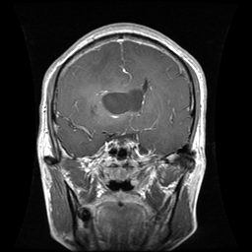
GT → Clase: glioma | Tipo: REAL | PID: mr033420
Tumor: □ glioma □ meningioma □ pituitary
Real/Fake: □ Real □ Fake
Confianza (1–5): 1 □ 2 □ 3 □ 4 □ 5 □
Utilidad diagnóstica (1–5): 1 □ 2 □ 3 □ 4 □ 5 □
Notas: _________________________________________________
------------------------------------------------------------
Caso 29 / 33
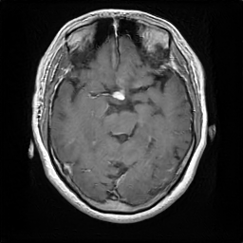
GT → Clase: pituitary | Tipo: FAKE | PID: | Truncation: 1.0
Tumor: □ glioma □ meningioma □ pituitary
Real/Fake: □ Real □ Fake
Confianza (1–5): 1 □ 2 □ 3 □ 4 □ 5 □
Utilidad diagnóstica (1–5): 1 □ 2 □ 3 □ 4 □ 5 □
Notas: _________________________________________________
------------------------------------------------------------
Caso 30 / 33
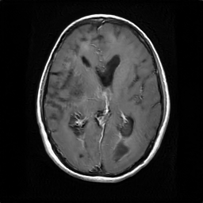
GT → Clase: glioma | Tipo: FAKE | PID: | Truncation: 1.0
Tumor: □ glioma □ meningioma □ pituitary
Real/Fake: □ Real □ Fake
Confianza (1–5): 1 □ 2 □ 3 □ 4 □ 5 □
Utilidad diagnóstica (1–5): 1 □ 2 □ 3 □ 4 □ 5 □
Notas: _________________________________________________
------------------------------------------------------------
Caso 31 / 33
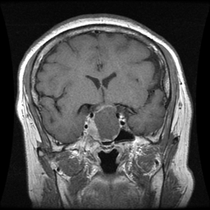
Overlay Grad-CAM:
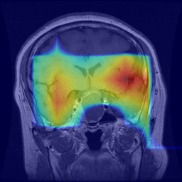
GT → Clase: pituitary | Tipo: REAL_GRADCAM | PID: 97461 | WITH GRAD-CAM OVERLAY
Tumor: □ glioma □ meningioma □ pituitary
Real/Fake: □ Real □ Fake
Confianza (1–5): 1 □ 2 □ 3 □ 4 □ 5 □
Utilidad diagnóstica (1–5): 1 □ 2 □ 3 □ 4 □ 5 □
Notas: _________________________________________________
------------------------------------------------------------
Caso 32 / 33
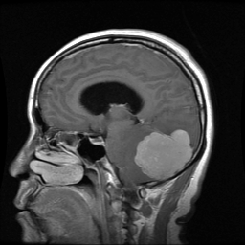
GT → Clase: meningioma | Tipo: REAL | PID: 97374
Tumor: □ glioma □ meningioma □ pituitary
Real/Fake: □ Real □ Fake
Confianza (1–5): 1 □ 2 □ 3 □ 4 □ 5 □
Utilidad diagnóstica (1–5): 1 □ 2 □ 3 □ 4 □ 5 □
Notas: _________________________________________________
------------------------------------------------------------
Caso 33 / 33
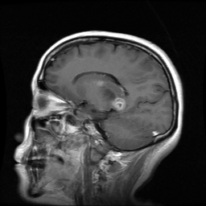
GT → Clase: glioma | Tipo: REAL | PID: 112027
Tumor: □ glioma □ meningioma □ pituitary
Real/Fake: □ Real □ Fake
Confianza (1–5): 1 □ 2 □ 3 □ 4 □ 5 □
Utilidad diagnóstica (1–5): 1 □ 2 □ 3 □ 4 □ 5 □
Notas: _________________________________________________
------------------------------------------------------------

