Formulario de evaluación (BLIND)
Para cada imagen, marque la clase de tumor, si es Real o Fake, y la confianza (1–5). 1=Poco confiable, 5=Muy confiable.
Caso 1 / 30
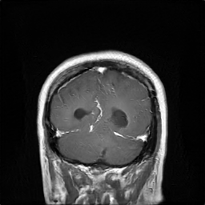
Tumor: □ glioma □ meningioma □ pituitary
Real/Fake: □ Real □ Fake
Confianza (1–5): 1 □ 2 □ 3 □ 4 □ 5 □
Utilidad diagnóstica (1–5): 1 □ 2 □ 3 □ 4 □ 5 □
Notas: _________________________________________________
------------------------------------------------------------
Caso 2 / 30
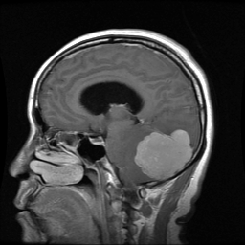
Tumor: □ glioma □ meningioma □ pituitary
Real/Fake: □ Real □ Fake
Confianza (1–5): 1 □ 2 □ 3 □ 4 □ 5 □
Utilidad diagnóstica (1–5): 1 □ 2 □ 3 □ 4 □ 5 □
Notas: _________________________________________________
------------------------------------------------------------
Caso 3 / 30
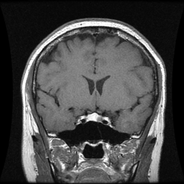
Tumor: □ glioma □ meningioma □ pituitary
Real/Fake: □ Real □ Fake
Confianza (1–5): 1 □ 2 □ 3 □ 4 □ 5 □
Utilidad diagnóstica (1–5): 1 □ 2 □ 3 □ 4 □ 5 □
Notas: _________________________________________________
------------------------------------------------------------
Caso 4 / 30
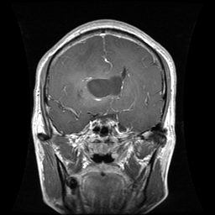
Tumor: □ glioma □ meningioma □ pituitary
Real/Fake: □ Real □ Fake
Confianza (1–5): 1 □ 2 □ 3 □ 4 □ 5 □
Utilidad diagnóstica (1–5): 1 □ 2 □ 3 □ 4 □ 5 □
Notas: _________________________________________________
------------------------------------------------------------
Caso 5 / 30
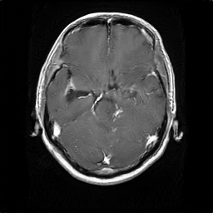
Tumor: □ glioma □ meningioma □ pituitary
Real/Fake: □ Real □ Fake
Confianza (1–5): 1 □ 2 □ 3 □ 4 □ 5 □
Utilidad diagnóstica (1–5): 1 □ 2 □ 3 □ 4 □ 5 □
Notas: _________________________________________________
------------------------------------------------------------
Caso 6 / 30
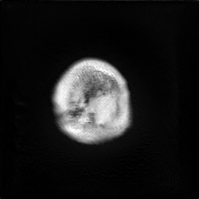
Tumor: □ glioma □ meningioma □ pituitary
Real/Fake: □ Real □ Fake
Confianza (1–5): 1 □ 2 □ 3 □ 4 □ 5 □
Utilidad diagnóstica (1–5): 1 □ 2 □ 3 □ 4 □ 5 □
Notas: _________________________________________________
------------------------------------------------------------
Caso 7 / 30
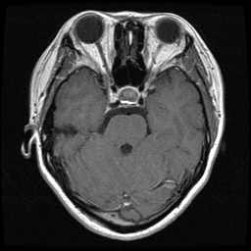
Tumor: □ glioma □ meningioma □ pituitary
Real/Fake: □ Real □ Fake
Confianza (1–5): 1 □ 2 □ 3 □ 4 □ 5 □
Utilidad diagnóstica (1–5): 1 □ 2 □ 3 □ 4 □ 5 □
Notas: _________________________________________________
------------------------------------------------------------
Caso 8 / 30
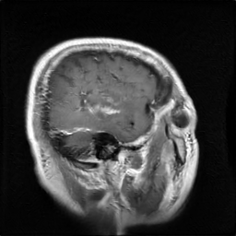
Tumor: □ glioma □ meningioma □ pituitary
Real/Fake: □ Real □ Fake
Confianza (1–5): 1 □ 2 □ 3 □ 4 □ 5 □
Utilidad diagnóstica (1–5): 1 □ 2 □ 3 □ 4 □ 5 □
Notas: _________________________________________________
------------------------------------------------------------
Caso 9 / 30
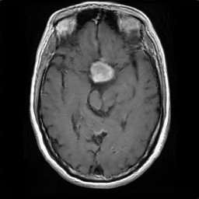
Tumor: □ glioma □ meningioma □ pituitary
Real/Fake: □ Real □ Fake
Confianza (1–5): 1 □ 2 □ 3 □ 4 □ 5 □
Utilidad diagnóstica (1–5): 1 □ 2 □ 3 □ 4 □ 5 □
Notas: _________________________________________________
------------------------------------------------------------
Caso 10 / 30
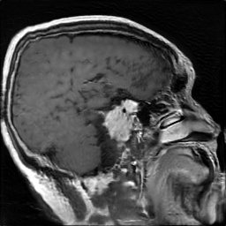
Tumor: □ glioma □ meningioma □ pituitary
Real/Fake: □ Real □ Fake
Confianza (1–5): 1 □ 2 □ 3 □ 4 □ 5 □
Utilidad diagnóstica (1–5): 1 □ 2 □ 3 □ 4 □ 5 □
Notas: _________________________________________________
------------------------------------------------------------
Caso 11 / 30
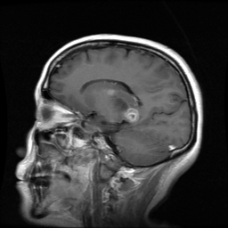
Tumor: □ glioma □ meningioma □ pituitary
Real/Fake: □ Real □ Fake
Confianza (1–5): 1 □ 2 □ 3 □ 4 □ 5 □
Utilidad diagnóstica (1–5): 1 □ 2 □ 3 □ 4 □ 5 □
Notas: _________________________________________________
------------------------------------------------------------
Caso 12 / 30
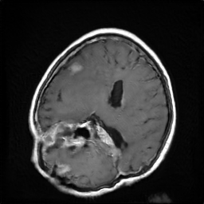
Tumor: □ glioma □ meningioma □ pituitary
Real/Fake: □ Real □ Fake
Confianza (1–5): 1 □ 2 □ 3 □ 4 □ 5 □
Utilidad diagnóstica (1–5): 1 □ 2 □ 3 □ 4 □ 5 □
Notas: _________________________________________________
------------------------------------------------------------
Caso 13 / 30
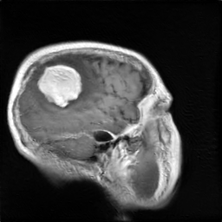
Tumor: □ glioma □ meningioma □ pituitary
Real/Fake: □ Real □ Fake
Confianza (1–5): 1 □ 2 □ 3 □ 4 □ 5 □
Utilidad diagnóstica (1–5): 1 □ 2 □ 3 □ 4 □ 5 □
Notas: _________________________________________________
------------------------------------------------------------
Caso 14 / 30
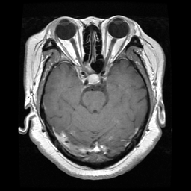
Tumor: □ glioma □ meningioma □ pituitary
Real/Fake: □ Real □ Fake
Confianza (1–5): 1 □ 2 □ 3 □ 4 □ 5 □
Utilidad diagnóstica (1–5): 1 □ 2 □ 3 □ 4 □ 5 □
Notas: _________________________________________________
------------------------------------------------------------
Caso 15 / 30
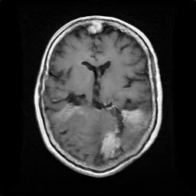
Tumor: □ glioma □ meningioma □ pituitary
Real/Fake: □ Real □ Fake
Confianza (1–5): 1 □ 2 □ 3 □ 4 □ 5 □
Utilidad diagnóstica (1–5): 1 □ 2 □ 3 □ 4 □ 5 □
Notas: _________________________________________________
------------------------------------------------------------
Caso 16 / 30
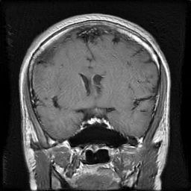
Tumor: □ glioma □ meningioma □ pituitary
Real/Fake: □ Real □ Fake
Confianza (1–5): 1 □ 2 □ 3 □ 4 □ 5 □
Utilidad diagnóstica (1–5): 1 □ 2 □ 3 □ 4 □ 5 □
Notas: _________________________________________________
------------------------------------------------------------
Caso 17 / 30
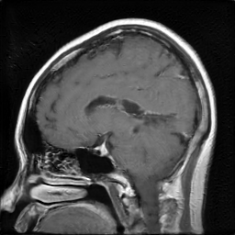
Tumor: □ glioma □ meningioma □ pituitary
Real/Fake: □ Real □ Fake
Confianza (1–5): 1 □ 2 □ 3 □ 4 □ 5 □
Utilidad diagnóstica (1–5): 1 □ 2 □ 3 □ 4 □ 5 □
Notas: _________________________________________________
------------------------------------------------------------
Caso 18 / 30
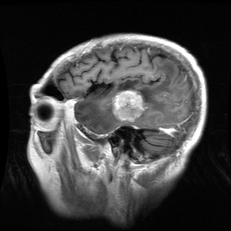
Tumor: □ glioma □ meningioma □ pituitary
Real/Fake: □ Real □ Fake
Confianza (1–5): 1 □ 2 □ 3 □ 4 □ 5 □
Utilidad diagnóstica (1–5): 1 □ 2 □ 3 □ 4 □ 5 □
Notas: _________________________________________________
------------------------------------------------------------
Caso 19 / 30
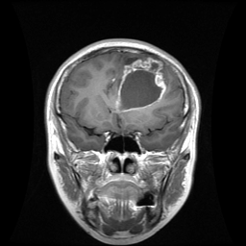
Tumor: □ glioma □ meningioma □ pituitary
Real/Fake: □ Real □ Fake
Confianza (1–5): 1 □ 2 □ 3 □ 4 □ 5 □
Utilidad diagnóstica (1–5): 1 □ 2 □ 3 □ 4 □ 5 □
Notas: _________________________________________________
------------------------------------------------------------
Caso 20 / 30
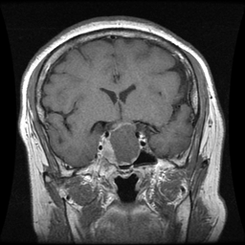
Tumor: □ glioma □ meningioma □ pituitary
Real/Fake: □ Real □ Fake
Confianza (1–5): 1 □ 2 □ 3 □ 4 □ 5 □
Utilidad diagnóstica (1–5): 1 □ 2 □ 3 □ 4 □ 5 □
Notas: _________________________________________________
------------------------------------------------------------
Caso 21 / 30
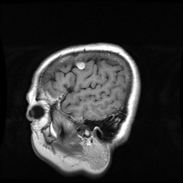
Tumor: □ glioma □ meningioma □ pituitary
Real/Fake: □ Real □ Fake
Confianza (1–5): 1 □ 2 □ 3 □ 4 □ 5 □
Utilidad diagnóstica (1–5): 1 □ 2 □ 3 □ 4 □ 5 □
Notas: _________________________________________________
------------------------------------------------------------
Caso 22 / 30
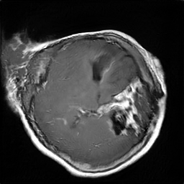
Tumor: □ glioma □ meningioma □ pituitary
Real/Fake: □ Real □ Fake
Confianza (1–5): 1 □ 2 □ 3 □ 4 □ 5 □
Utilidad diagnóstica (1–5): 1 □ 2 □ 3 □ 4 □ 5 □
Notas: _________________________________________________
------------------------------------------------------------
Caso 23 / 30
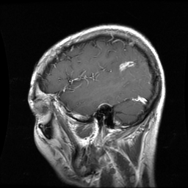
Tumor: □ glioma □ meningioma □ pituitary
Real/Fake: □ Real □ Fake
Confianza (1–5): 1 □ 2 □ 3 □ 4 □ 5 □
Utilidad diagnóstica (1–5): 1 □ 2 □ 3 □ 4 □ 5 □
Notas: _________________________________________________
------------------------------------------------------------
Caso 24 / 30
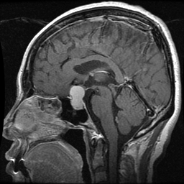
Tumor: □ glioma □ meningioma □ pituitary
Real/Fake: □ Real □ Fake
Confianza (1–5): 1 □ 2 □ 3 □ 4 □ 5 □
Utilidad diagnóstica (1–5): 1 □ 2 □ 3 □ 4 □ 5 □
Notas: _________________________________________________
------------------------------------------------------------
Caso 25 / 30
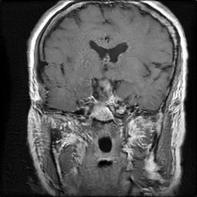
Tumor: □ glioma □ meningioma □ pituitary
Real/Fake: □ Real □ Fake
Confianza (1–5): 1 □ 2 □ 3 □ 4 □ 5 □
Utilidad diagnóstica (1–5): 1 □ 2 □ 3 □ 4 □ 5 □
Notas: _________________________________________________
------------------------------------------------------------
Caso 26 / 30
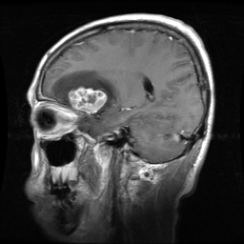
Tumor: □ glioma □ meningioma □ pituitary
Real/Fake: □ Real □ Fake
Confianza (1–5): 1 □ 2 □ 3 □ 4 □ 5 □
Utilidad diagnóstica (1–5): 1 □ 2 □ 3 □ 4 □ 5 □
Notas: _________________________________________________
------------------------------------------------------------
Caso 27 / 30
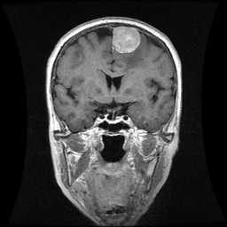
Tumor: □ glioma □ meningioma □ pituitary
Real/Fake: □ Real □ Fake
Confianza (1–5): 1 □ 2 □ 3 □ 4 □ 5 □
Utilidad diagnóstica (1–5): 1 □ 2 □ 3 □ 4 □ 5 □
Notas: _________________________________________________
------------------------------------------------------------
Caso 28 / 30
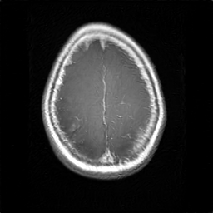
Tumor: □ glioma □ meningioma □ pituitary
Real/Fake: □ Real □ Fake
Confianza (1–5): 1 □ 2 □ 3 □ 4 □ 5 □
Utilidad diagnóstica (1–5): 1 □ 2 □ 3 □ 4 □ 5 □
Notas: _________________________________________________
------------------------------------------------------------
Caso 29 / 30
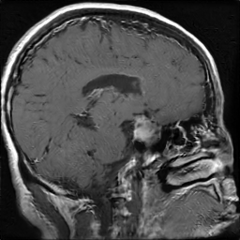
Tumor: □ glioma □ meningioma □ pituitary
Real/Fake: □ Real □ Fake
Confianza (1–5): 1 □ 2 □ 3 □ 4 □ 5 □
Utilidad diagnóstica (1–5): 1 □ 2 □ 3 □ 4 □ 5 □
Notas: _________________________________________________
------------------------------------------------------------
Caso 30 / 30
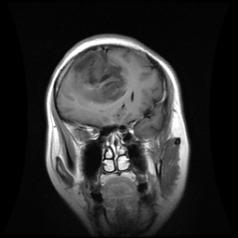
Tumor: □ glioma □ meningioma □ pituitary
Real/Fake: □ Real □ Fake
Confianza (1–5): 1 □ 2 □ 3 □ 4 □ 5 □
Utilidad diagnóstica (1–5): 1 □ 2 □ 3 □ 4 □ 5 □
Notas: _________________________________________________
------------------------------------------------------------

