Formulario de evaluación (CON RESPUESTAS)
Caso 1 / 12
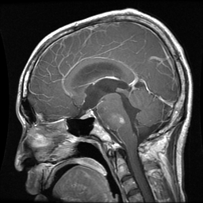
GT → Clase: glioma | Tipo: REAL | PID: mr049104
Tumor: □ glioma □ meningioma □ pituitary
Real/Fake: □ Real □ Fake
Confianza (1–5): 1 □ 2 □ 3 □ 4 □ 5 □
Utilidad diagnóstica (1–5): 1 □ 2 □ 3 □ 4 □ 5 □
Notas: _________________________________________________
------------------------------------------------------------
Caso 2 / 12
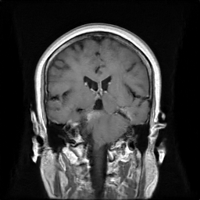
GT → Clase: meningioma | Tipo: FAKE | PID:
Tumor: □ glioma □ meningioma □ pituitary
Real/Fake: □ Real □ Fake
Confianza (1–5): 1 □ 2 □ 3 □ 4 □ 5 □
Utilidad diagnóstica (1–5): 1 □ 2 □ 3 □ 4 □ 5 □
Notas: _________________________________________________
------------------------------------------------------------
Caso 3 / 12
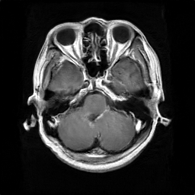
GT → Clase: glioma | Tipo: FAKE | PID:
Tumor: □ glioma □ meningioma □ pituitary
Real/Fake: □ Real □ Fake
Confianza (1–5): 1 □ 2 □ 3 □ 4 □ 5 □
Utilidad diagnóstica (1–5): 1 □ 2 □ 3 □ 4 □ 5 □
Notas: _________________________________________________
------------------------------------------------------------
Caso 4 / 12
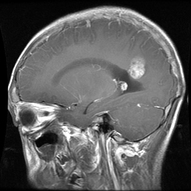
GT → Clase: glioma | Tipo: REAL | PID: mr033389b
Tumor: □ glioma □ meningioma □ pituitary
Real/Fake: □ Real □ Fake
Confianza (1–5): 1 □ 2 □ 3 □ 4 □ 5 □
Utilidad diagnóstica (1–5): 1 □ 2 □ 3 □ 4 □ 5 □
Notas: _________________________________________________
------------------------------------------------------------
Caso 5 / 12
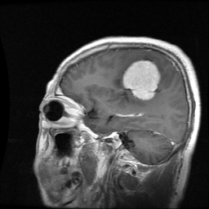
GT → Clase: meningioma | Tipo: REAL | PID: 99815
Tumor: □ glioma □ meningioma □ pituitary
Real/Fake: □ Real □ Fake
Confianza (1–5): 1 □ 2 □ 3 □ 4 □ 5 □
Utilidad diagnóstica (1–5): 1 □ 2 □ 3 □ 4 □ 5 □
Notas: _________________________________________________
------------------------------------------------------------
Caso 6 / 12
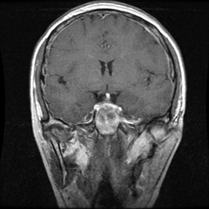
GT → Clase: pituitary | Tipo: REAL | PID: 108858
Tumor: □ glioma □ meningioma □ pituitary
Real/Fake: □ Real □ Fake
Confianza (1–5): 1 □ 2 □ 3 □ 4 □ 5 □
Utilidad diagnóstica (1–5): 1 □ 2 □ 3 □ 4 □ 5 □
Notas: _________________________________________________
------------------------------------------------------------
Caso 7 / 12
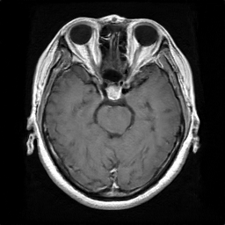
GT → Clase: pituitary | Tipo: FAKE | PID:
Tumor: □ glioma □ meningioma □ pituitary
Real/Fake: □ Real □ Fake
Confianza (1–5): 1 □ 2 □ 3 □ 4 □ 5 □
Utilidad diagnóstica (1–5): 1 □ 2 □ 3 □ 4 □ 5 □
Notas: _________________________________________________
------------------------------------------------------------
Caso 8 / 12
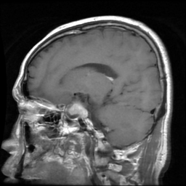
GT → Clase: pituitary | Tipo: REAL | PID: 107429
Tumor: □ glioma □ meningioma □ pituitary
Real/Fake: □ Real □ Fake
Confianza (1–5): 1 □ 2 □ 3 □ 4 □ 5 □
Utilidad diagnóstica (1–5): 1 □ 2 □ 3 □ 4 □ 5 □
Notas: _________________________________________________
------------------------------------------------------------
Caso 9 / 12
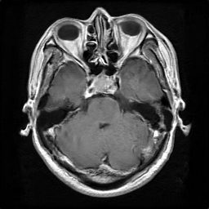
GT → Clase: pituitary | Tipo: FAKE | PID:
Tumor: □ glioma □ meningioma □ pituitary
Real/Fake: □ Real □ Fake
Confianza (1–5): 1 □ 2 □ 3 □ 4 □ 5 □
Utilidad diagnóstica (1–5): 1 □ 2 □ 3 □ 4 □ 5 □
Notas: _________________________________________________
------------------------------------------------------------
Caso 10 / 12
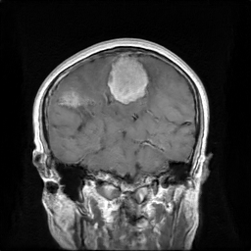
GT → Clase: meningioma | Tipo: FAKE | PID:
Tumor: □ glioma □ meningioma □ pituitary
Real/Fake: □ Real □ Fake
Confianza (1–5): 1 □ 2 □ 3 □ 4 □ 5 □
Utilidad diagnóstica (1–5): 1 □ 2 □ 3 □ 4 □ 5 □
Notas: _________________________________________________
------------------------------------------------------------
Caso 11 / 12
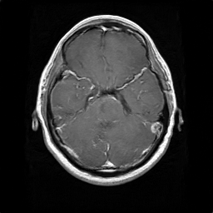
GT → Clase: glioma | Tipo: FAKE | PID:
Tumor: □ glioma □ meningioma □ pituitary
Real/Fake: □ Real □ Fake
Confianza (1–5): 1 □ 2 □ 3 □ 4 □ 5 □
Utilidad diagnóstica (1–5): 1 □ 2 □ 3 □ 4 □ 5 □
Notas: _________________________________________________
------------------------------------------------------------
Caso 12 / 12
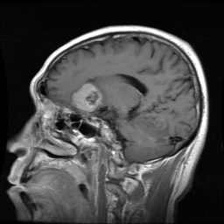
GT → Clase: meningioma | Tipo: REAL | PID: 100920
Tumor: □ glioma □ meningioma □ pituitary
Real/Fake: □ Real □ Fake
Confianza (1–5): 1 □ 2 □ 3 □ 4 □ 5 □
Utilidad diagnóstica (1–5): 1 □ 2 □ 3 □ 4 □ 5 □
Notas: _________________________________________________
------------------------------------------------------------

