Formulario de evaluación (BLIND)
Para cada imagen, marque la clase de tumor, si es Real o Fake, y la confianza (1–5). 1=Poco confiable, 5=Muy confiable.
Caso 1 / 12
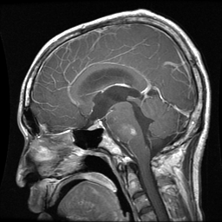
Tumor: □ glioma □ meningioma □ pituitary
Real/Fake: □ Real □ Fake
Confianza (1–5): 1 □ 2 □ 3 □ 4 □ 5 □
Utilidad diagnóstica (1–5): 1 □ 2 □ 3 □ 4 □ 5 □
Notas: _________________________________________________
------------------------------------------------------------
Caso 2 / 12
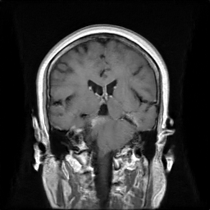
Tumor: □ glioma □ meningioma □ pituitary
Real/Fake: □ Real □ Fake
Confianza (1–5): 1 □ 2 □ 3 □ 4 □ 5 □
Utilidad diagnóstica (1–5): 1 □ 2 □ 3 □ 4 □ 5 □
Notas: _________________________________________________
------------------------------------------------------------
Caso 3 / 12
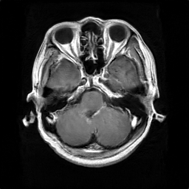
Tumor: □ glioma □ meningioma □ pituitary
Real/Fake: □ Real □ Fake
Confianza (1–5): 1 □ 2 □ 3 □ 4 □ 5 □
Utilidad diagnóstica (1–5): 1 □ 2 □ 3 □ 4 □ 5 □
Notas: _________________________________________________
------------------------------------------------------------
Caso 4 / 12
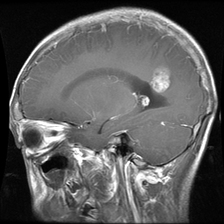
Tumor: □ glioma □ meningioma □ pituitary
Real/Fake: □ Real □ Fake
Confianza (1–5): 1 □ 2 □ 3 □ 4 □ 5 □
Utilidad diagnóstica (1–5): 1 □ 2 □ 3 □ 4 □ 5 □
Notas: _________________________________________________
------------------------------------------------------------
Caso 5 / 12
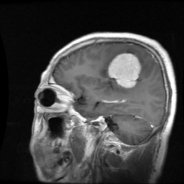
Tumor: □ glioma □ meningioma □ pituitary
Real/Fake: □ Real □ Fake
Confianza (1–5): 1 □ 2 □ 3 □ 4 □ 5 □
Utilidad diagnóstica (1–5): 1 □ 2 □ 3 □ 4 □ 5 □
Notas: _________________________________________________
------------------------------------------------------------
Caso 6 / 12
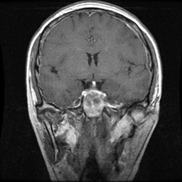
Tumor: □ glioma □ meningioma □ pituitary
Real/Fake: □ Real □ Fake
Confianza (1–5): 1 □ 2 □ 3 □ 4 □ 5 □
Utilidad diagnóstica (1–5): 1 □ 2 □ 3 □ 4 □ 5 □
Notas: _________________________________________________
------------------------------------------------------------
Caso 7 / 12
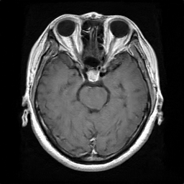
Tumor: □ glioma □ meningioma □ pituitary
Real/Fake: □ Real □ Fake
Confianza (1–5): 1 □ 2 □ 3 □ 4 □ 5 □
Utilidad diagnóstica (1–5): 1 □ 2 □ 3 □ 4 □ 5 □
Notas: _________________________________________________
------------------------------------------------------------
Caso 8 / 12
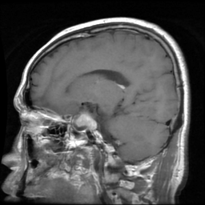
Tumor: □ glioma □ meningioma □ pituitary
Real/Fake: □ Real □ Fake
Confianza (1–5): 1 □ 2 □ 3 □ 4 □ 5 □
Utilidad diagnóstica (1–5): 1 □ 2 □ 3 □ 4 □ 5 □
Notas: _________________________________________________
------------------------------------------------------------
Caso 9 / 12
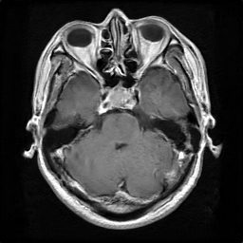
Tumor: □ glioma □ meningioma □ pituitary
Real/Fake: □ Real □ Fake
Confianza (1–5): 1 □ 2 □ 3 □ 4 □ 5 □
Utilidad diagnóstica (1–5): 1 □ 2 □ 3 □ 4 □ 5 □
Notas: _________________________________________________
------------------------------------------------------------
Caso 10 / 12
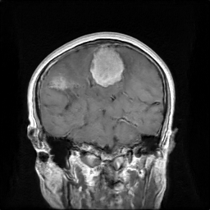
Tumor: □ glioma □ meningioma □ pituitary
Real/Fake: □ Real □ Fake
Confianza (1–5): 1 □ 2 □ 3 □ 4 □ 5 □
Utilidad diagnóstica (1–5): 1 □ 2 □ 3 □ 4 □ 5 □
Notas: _________________________________________________
------------------------------------------------------------
Caso 11 / 12
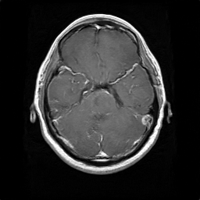
Tumor: □ glioma □ meningioma □ pituitary
Real/Fake: □ Real □ Fake
Confianza (1–5): 1 □ 2 □ 3 □ 4 □ 5 □
Utilidad diagnóstica (1–5): 1 □ 2 □ 3 □ 4 □ 5 □
Notas: _________________________________________________
------------------------------------------------------------
Caso 12 / 12
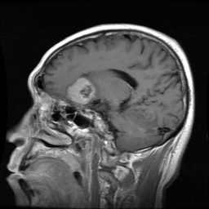
Tumor: □ glioma □ meningioma □ pituitary
Real/Fake: □ Real □ Fake
Confianza (1–5): 1 □ 2 □ 3 □ 4 □ 5 □
Utilidad diagnóstica (1–5): 1 □ 2 □ 3 □ 4 □ 5 □
Notas: _________________________________________________
------------------------------------------------------------

