Formulario de evaluación (CON RESPUESTAS)
Caso 1 / 54
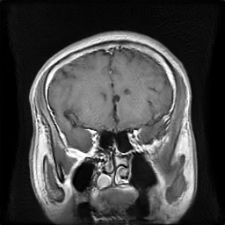
GT → Clase: pituitary | Tipo: FAKE | PID: | Truncation: 1.0
Tumor: □ glioma □ meningioma □ pituitary
Real/Fake: □ Real □ Fake
Confianza (1–5): 1 □ 2 □ 3 □ 4 □ 5 □
Utilidad diagnóstica (1–5): 1 □ 2 □ 3 □ 4 □ 5 □
Notas: _________________________________________________
------------------------------------------------------------
Caso 2 / 54
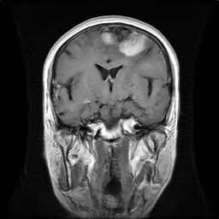
GT → Clase: meningioma | Tipo: FAKE | PID: | Truncation: 0.8
Tumor: □ glioma □ meningioma □ pituitary
Real/Fake: □ Real □ Fake
Confianza (1–5): 1 □ 2 □ 3 □ 4 □ 5 □
Utilidad diagnóstica (1–5): 1 □ 2 □ 3 □ 4 □ 5 □
Notas: _________________________________________________
------------------------------------------------------------
Caso 3 / 54
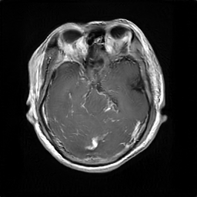
GT → Clase: glioma | Tipo: FAKE | PID: | Truncation: 1.2
Tumor: □ glioma □ meningioma □ pituitary
Real/Fake: □ Real □ Fake
Confianza (1–5): 1 □ 2 □ 3 □ 4 □ 5 □
Utilidad diagnóstica (1–5): 1 □ 2 □ 3 □ 4 □ 5 □
Notas: _________________________________________________
------------------------------------------------------------
Caso 4 / 54
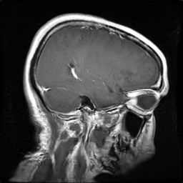
GT → Clase: glioma | Tipo: FAKE | PID: | Truncation: 1.0
Tumor: □ glioma □ meningioma □ pituitary
Real/Fake: □ Real □ Fake
Confianza (1–5): 1 □ 2 □ 3 □ 4 □ 5 □
Utilidad diagnóstica (1–5): 1 □ 2 □ 3 □ 4 □ 5 □
Notas: _________________________________________________
------------------------------------------------------------
Caso 5 / 54
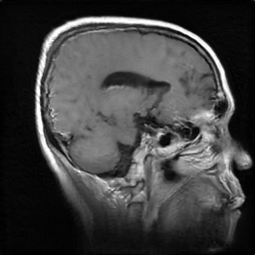
GT → Clase: meningioma | Tipo: FAKE | PID: | Truncation: 1.2
Tumor: □ glioma □ meningioma □ pituitary
Real/Fake: □ Real □ Fake
Confianza (1–5): 1 □ 2 □ 3 □ 4 □ 5 □
Utilidad diagnóstica (1–5): 1 □ 2 □ 3 □ 4 □ 5 □
Notas: _________________________________________________
------------------------------------------------------------
Caso 6 / 54
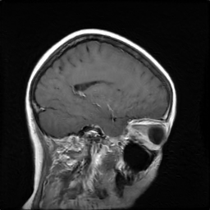
GT → Clase: meningioma | Tipo: FAKE | PID: | Truncation: 1.0
Tumor: □ glioma □ meningioma □ pituitary
Real/Fake: □ Real □ Fake
Confianza (1–5): 1 □ 2 □ 3 □ 4 □ 5 □
Utilidad diagnóstica (1–5): 1 □ 2 □ 3 □ 4 □ 5 □
Notas: _________________________________________________
------------------------------------------------------------
Caso 7 / 54
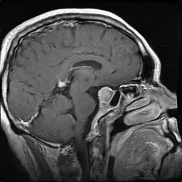
GT → Clase: pituitary | Tipo: FAKE | PID: | Truncation: 0.8
Tumor: □ glioma □ meningioma □ pituitary
Real/Fake: □ Real □ Fake
Confianza (1–5): 1 □ 2 □ 3 □ 4 □ 5 □
Utilidad diagnóstica (1–5): 1 □ 2 □ 3 □ 4 □ 5 □
Notas: _________________________________________________
------------------------------------------------------------
Caso 8 / 54
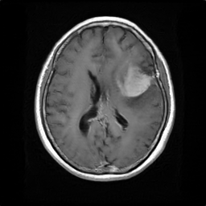
GT → Clase: meningioma | Tipo: FAKE | PID: | Truncation: 0.8
Tumor: □ glioma □ meningioma □ pituitary
Real/Fake: □ Real □ Fake
Confianza (1–5): 1 □ 2 □ 3 □ 4 □ 5 □
Utilidad diagnóstica (1–5): 1 □ 2 □ 3 □ 4 □ 5 □
Notas: _________________________________________________
------------------------------------------------------------
Caso 9 / 54
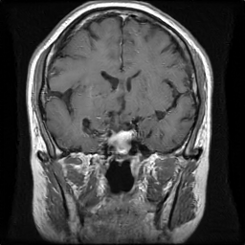
GT → Clase: pituitary | Tipo: FAKE | PID: | Truncation: 0.8
Tumor: □ glioma □ meningioma □ pituitary
Real/Fake: □ Real □ Fake
Confianza (1–5): 1 □ 2 □ 3 □ 4 □ 5 □
Utilidad diagnóstica (1–5): 1 □ 2 □ 3 □ 4 □ 5 □
Notas: _________________________________________________
------------------------------------------------------------
Caso 10 / 54
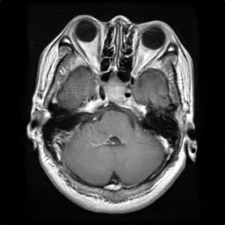
GT → Clase: pituitary | Tipo: FAKE | PID: | Truncation: 1.2
Tumor: □ glioma □ meningioma □ pituitary
Real/Fake: □ Real □ Fake
Confianza (1–5): 1 □ 2 □ 3 □ 4 □ 5 □
Utilidad diagnóstica (1–5): 1 □ 2 □ 3 □ 4 □ 5 □
Notas: _________________________________________________
------------------------------------------------------------
Caso 11 / 54
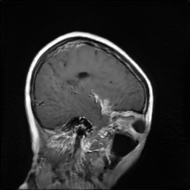
GT → Clase: meningioma | Tipo: FAKE | PID: | Truncation: 1.2
Tumor: □ glioma □ meningioma □ pituitary
Real/Fake: □ Real □ Fake
Confianza (1–5): 1 □ 2 □ 3 □ 4 □ 5 □
Utilidad diagnóstica (1–5): 1 □ 2 □ 3 □ 4 □ 5 □
Notas: _________________________________________________
------------------------------------------------------------
Caso 12 / 54
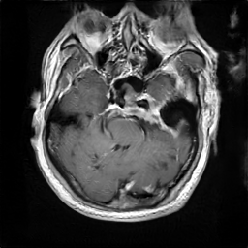
GT → Clase: meningioma | Tipo: FAKE | PID: | Truncation: 1.0
Tumor: □ glioma □ meningioma □ pituitary
Real/Fake: □ Real □ Fake
Confianza (1–5): 1 □ 2 □ 3 □ 4 □ 5 □
Utilidad diagnóstica (1–5): 1 □ 2 □ 3 □ 4 □ 5 □
Notas: _________________________________________________
------------------------------------------------------------
Caso 13 / 54
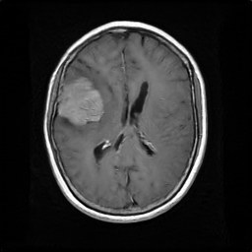
GT → Clase: meningioma | Tipo: FAKE | PID: | Truncation: 0.8
Tumor: □ glioma □ meningioma □ pituitary
Real/Fake: □ Real □ Fake
Confianza (1–5): 1 □ 2 □ 3 □ 4 □ 5 □
Utilidad diagnóstica (1–5): 1 □ 2 □ 3 □ 4 □ 5 □
Notas: _________________________________________________
------------------------------------------------------------
Caso 14 / 54
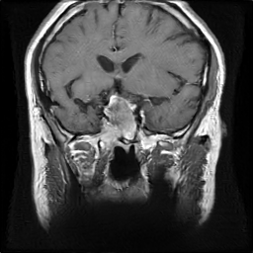
GT → Clase: pituitary | Tipo: FAKE | PID: | Truncation: 1.0
Tumor: □ glioma □ meningioma □ pituitary
Real/Fake: □ Real □ Fake
Confianza (1–5): 1 □ 2 □ 3 □ 4 □ 5 □
Utilidad diagnóstica (1–5): 1 □ 2 □ 3 □ 4 □ 5 □
Notas: _________________________________________________
------------------------------------------------------------
Caso 15 / 54
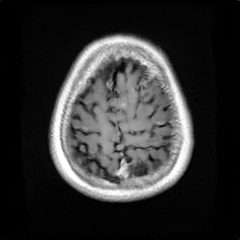
GT → Clase: meningioma | Tipo: FAKE | PID: | Truncation: 1.2
Tumor: □ glioma □ meningioma □ pituitary
Real/Fake: □ Real □ Fake
Confianza (1–5): 1 □ 2 □ 3 □ 4 □ 5 □
Utilidad diagnóstica (1–5): 1 □ 2 □ 3 □ 4 □ 5 □
Notas: _________________________________________________
------------------------------------------------------------
Caso 16 / 54
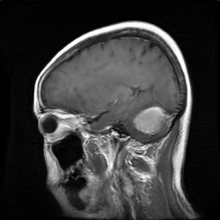
GT → Clase: meningioma | Tipo: FAKE | PID: | Truncation: 1.2
Tumor: □ glioma □ meningioma □ pituitary
Real/Fake: □ Real □ Fake
Confianza (1–5): 1 □ 2 □ 3 □ 4 □ 5 □
Utilidad diagnóstica (1–5): 1 □ 2 □ 3 □ 4 □ 5 □
Notas: _________________________________________________
------------------------------------------------------------
Caso 17 / 54
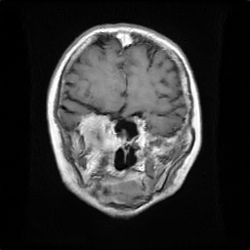
GT → Clase: meningioma | Tipo: FAKE | PID: | Truncation: 0.8
Tumor: □ glioma □ meningioma □ pituitary
Real/Fake: □ Real □ Fake
Confianza (1–5): 1 □ 2 □ 3 □ 4 □ 5 □
Utilidad diagnóstica (1–5): 1 □ 2 □ 3 □ 4 □ 5 □
Notas: _________________________________________________
------------------------------------------------------------
Caso 18 / 54
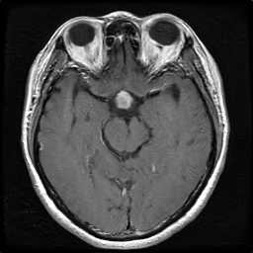
GT → Clase: pituitary | Tipo: FAKE | PID: | Truncation: 1.2
Tumor: □ glioma □ meningioma □ pituitary
Real/Fake: □ Real □ Fake
Confianza (1–5): 1 □ 2 □ 3 □ 4 □ 5 □
Utilidad diagnóstica (1–5): 1 □ 2 □ 3 □ 4 □ 5 □
Notas: _________________________________________________
------------------------------------------------------------
Caso 19 / 54
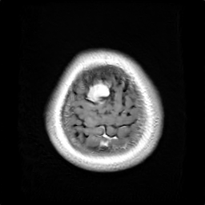
GT → Clase: meningioma | Tipo: FAKE | PID: | Truncation: 1.2
Tumor: □ glioma □ meningioma □ pituitary
Real/Fake: □ Real □ Fake
Confianza (1–5): 1 □ 2 □ 3 □ 4 □ 5 □
Utilidad diagnóstica (1–5): 1 □ 2 □ 3 □ 4 □ 5 □
Notas: _________________________________________________
------------------------------------------------------------
Caso 20 / 54
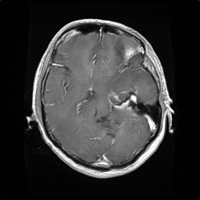
GT → Clase: glioma | Tipo: FAKE | PID: | Truncation: 0.8
Tumor: □ glioma □ meningioma □ pituitary
Real/Fake: □ Real □ Fake
Confianza (1–5): 1 □ 2 □ 3 □ 4 □ 5 □
Utilidad diagnóstica (1–5): 1 □ 2 □ 3 □ 4 □ 5 □
Notas: _________________________________________________
------------------------------------------------------------
Caso 21 / 54
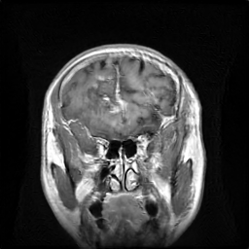
GT → Clase: glioma | Tipo: FAKE | PID: | Truncation: 1.2
Tumor: □ glioma □ meningioma □ pituitary
Real/Fake: □ Real □ Fake
Confianza (1–5): 1 □ 2 □ 3 □ 4 □ 5 □
Utilidad diagnóstica (1–5): 1 □ 2 □ 3 □ 4 □ 5 □
Notas: _________________________________________________
------------------------------------------------------------
Caso 22 / 54
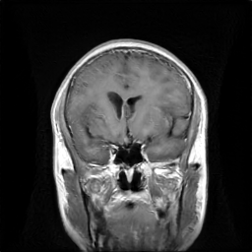
GT → Clase: glioma | Tipo: FAKE | PID: | Truncation: 1.2
Tumor: □ glioma □ meningioma □ pituitary
Real/Fake: □ Real □ Fake
Confianza (1–5): 1 □ 2 □ 3 □ 4 □ 5 □
Utilidad diagnóstica (1–5): 1 □ 2 □ 3 □ 4 □ 5 □
Notas: _________________________________________________
------------------------------------------------------------
Caso 23 / 54
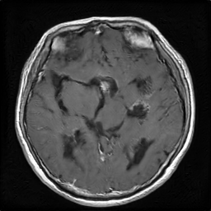
GT → Clase: pituitary | Tipo: FAKE | PID: | Truncation: 0.8
Tumor: □ glioma □ meningioma □ pituitary
Real/Fake: □ Real □ Fake
Confianza (1–5): 1 □ 2 □ 3 □ 4 □ 5 □
Utilidad diagnóstica (1–5): 1 □ 2 □ 3 □ 4 □ 5 □
Notas: _________________________________________________
------------------------------------------------------------
Caso 24 / 54
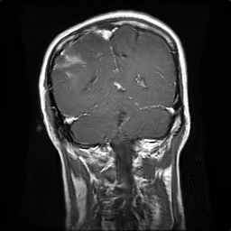
GT → Clase: glioma | Tipo: FAKE | PID: | Truncation: 0.8
Tumor: □ glioma □ meningioma □ pituitary
Real/Fake: □ Real □ Fake
Confianza (1–5): 1 □ 2 □ 3 □ 4 □ 5 □
Utilidad diagnóstica (1–5): 1 □ 2 □ 3 □ 4 □ 5 □
Notas: _________________________________________________
------------------------------------------------------------
Caso 25 / 54
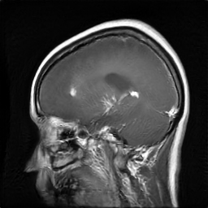
GT → Clase: glioma | Tipo: FAKE | PID: | Truncation: 1.2
Tumor: □ glioma □ meningioma □ pituitary
Real/Fake: □ Real □ Fake
Confianza (1–5): 1 □ 2 □ 3 □ 4 □ 5 □
Utilidad diagnóstica (1–5): 1 □ 2 □ 3 □ 4 □ 5 □
Notas: _________________________________________________
------------------------------------------------------------
Caso 26 / 54
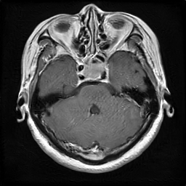
GT → Clase: pituitary | Tipo: FAKE | PID: | Truncation: 1.0
Tumor: □ glioma □ meningioma □ pituitary
Real/Fake: □ Real □ Fake
Confianza (1–5): 1 □ 2 □ 3 □ 4 □ 5 □
Utilidad diagnóstica (1–5): 1 □ 2 □ 3 □ 4 □ 5 □
Notas: _________________________________________________
------------------------------------------------------------
Caso 27 / 54
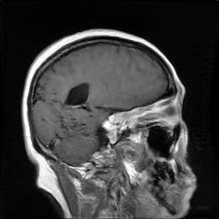
GT → Clase: meningioma | Tipo: FAKE | PID: | Truncation: 1.0
Tumor: □ glioma □ meningioma □ pituitary
Real/Fake: □ Real □ Fake
Confianza (1–5): 1 □ 2 □ 3 □ 4 □ 5 □
Utilidad diagnóstica (1–5): 1 □ 2 □ 3 □ 4 □ 5 □
Notas: _________________________________________________
------------------------------------------------------------
Caso 28 / 54
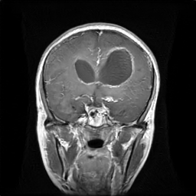
GT → Clase: glioma | Tipo: FAKE | PID: | Truncation: 1.0
Tumor: □ glioma □ meningioma □ pituitary
Real/Fake: □ Real □ Fake
Confianza (1–5): 1 □ 2 □ 3 □ 4 □ 5 □
Utilidad diagnóstica (1–5): 1 □ 2 □ 3 □ 4 □ 5 □
Notas: _________________________________________________
------------------------------------------------------------
Caso 29 / 54
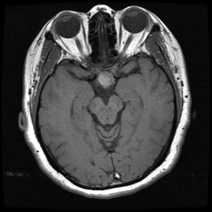
GT → Clase: pituitary | Tipo: REAL | PID: 103837
Tumor: □ glioma □ meningioma □ pituitary
Real/Fake: □ Real □ Fake
Confianza (1–5): 1 □ 2 □ 3 □ 4 □ 5 □
Utilidad diagnóstica (1–5): 1 □ 2 □ 3 □ 4 □ 5 □
Notas: _________________________________________________
------------------------------------------------------------
Caso 30 / 54
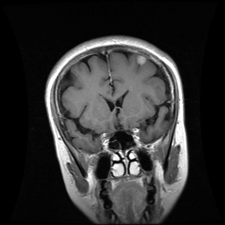
GT → Clase: meningioma | Tipo: REAL | PID: 113805
Tumor: □ glioma □ meningioma □ pituitary
Real/Fake: □ Real □ Fake
Confianza (1–5): 1 □ 2 □ 3 □ 4 □ 5 □
Utilidad diagnóstica (1–5): 1 □ 2 □ 3 □ 4 □ 5 □
Notas: _________________________________________________
------------------------------------------------------------
Caso 31 / 54
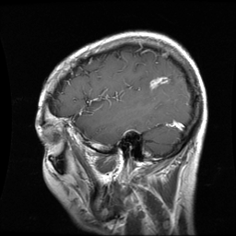
GT → Clase: glioma | Tipo: REAL | PID: mr024780e
Tumor: □ glioma □ meningioma □ pituitary
Real/Fake: □ Real □ Fake
Confianza (1–5): 1 □ 2 □ 3 □ 4 □ 5 □
Utilidad diagnóstica (1–5): 1 □ 2 □ 3 □ 4 □ 5 □
Notas: _________________________________________________
------------------------------------------------------------
Caso 32 / 54
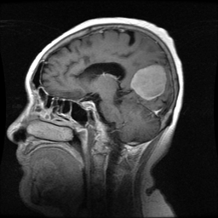
GT → Clase: meningioma | Tipo: REAL | PID: 53669
Tumor: □ glioma □ meningioma □ pituitary
Real/Fake: □ Real □ Fake
Confianza (1–5): 1 □ 2 □ 3 □ 4 □ 5 □
Utilidad diagnóstica (1–5): 1 □ 2 □ 3 □ 4 □ 5 □
Notas: _________________________________________________
------------------------------------------------------------
Caso 33 / 54
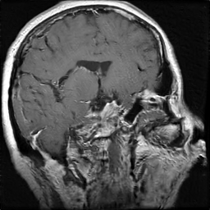
GT → Clase: pituitary | Tipo: FAKE | PID: | Truncation: 1.2
Tumor: □ glioma □ meningioma □ pituitary
Real/Fake: □ Real □ Fake
Confianza (1–5): 1 □ 2 □ 3 □ 4 □ 5 □
Utilidad diagnóstica (1–5): 1 □ 2 □ 3 □ 4 □ 5 □
Notas: _________________________________________________
------------------------------------------------------------
Caso 34 / 54
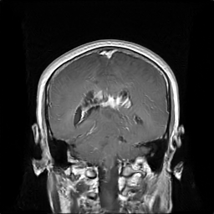
GT → Clase: glioma | Tipo: FAKE | PID: | Truncation: 1.0
Tumor: □ glioma □ meningioma □ pituitary
Real/Fake: □ Real □ Fake
Confianza (1–5): 1 □ 2 □ 3 □ 4 □ 5 □
Utilidad diagnóstica (1–5): 1 □ 2 □ 3 □ 4 □ 5 □
Notas: _________________________________________________
------------------------------------------------------------
Caso 35 / 54
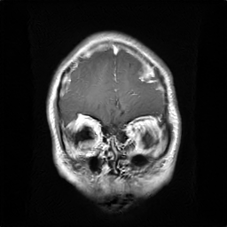
GT → Clase: glioma | Tipo: FAKE | PID: | Truncation: 1.0
Tumor: □ glioma □ meningioma □ pituitary
Real/Fake: □ Real □ Fake
Confianza (1–5): 1 □ 2 □ 3 □ 4 □ 5 □
Utilidad diagnóstica (1–5): 1 □ 2 □ 3 □ 4 □ 5 □
Notas: _________________________________________________
------------------------------------------------------------
Caso 36 / 54
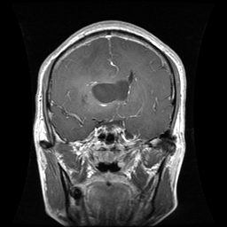
GT → Clase: glioma | Tipo: REAL | PID: mr033420
Tumor: □ glioma □ meningioma □ pituitary
Real/Fake: □ Real □ Fake
Confianza (1–5): 1 □ 2 □ 3 □ 4 □ 5 □
Utilidad diagnóstica (1–5): 1 □ 2 □ 3 □ 4 □ 5 □
Notas: _________________________________________________
------------------------------------------------------------
Caso 37 / 54
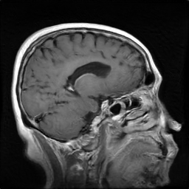
GT → Clase: meningioma | Tipo: FAKE | PID: | Truncation: 0.8
Tumor: □ glioma □ meningioma □ pituitary
Real/Fake: □ Real □ Fake
Confianza (1–5): 1 □ 2 □ 3 □ 4 □ 5 □
Utilidad diagnóstica (1–5): 1 □ 2 □ 3 □ 4 □ 5 □
Notas: _________________________________________________
------------------------------------------------------------
Caso 38 / 54
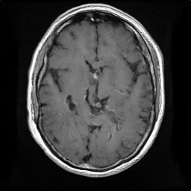
GT → Clase: pituitary | Tipo: FAKE | PID: | Truncation: 0.8
Tumor: □ glioma □ meningioma □ pituitary
Real/Fake: □ Real □ Fake
Confianza (1–5): 1 □ 2 □ 3 □ 4 □ 5 □
Utilidad diagnóstica (1–5): 1 □ 2 □ 3 □ 4 □ 5 □
Notas: _________________________________________________
------------------------------------------------------------
Caso 39 / 54
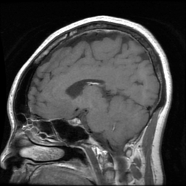
GT → Clase: pituitary | Tipo: REAL | PID: 105475
Tumor: □ glioma □ meningioma □ pituitary
Real/Fake: □ Real □ Fake
Confianza (1–5): 1 □ 2 □ 3 □ 4 □ 5 □
Utilidad diagnóstica (1–5): 1 □ 2 □ 3 □ 4 □ 5 □
Notas: _________________________________________________
------------------------------------------------------------
Caso 40 / 54
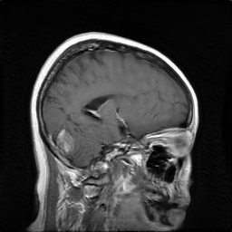
GT → Clase: meningioma | Tipo: FAKE | PID: | Truncation: 1.0
Tumor: □ glioma □ meningioma □ pituitary
Real/Fake: □ Real □ Fake
Confianza (1–5): 1 □ 2 □ 3 □ 4 □ 5 □
Utilidad diagnóstica (1–5): 1 □ 2 □ 3 □ 4 □ 5 □
Notas: _________________________________________________
------------------------------------------------------------
Caso 41 / 54
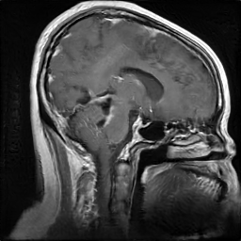
GT → Clase: glioma | Tipo: FAKE | PID: | Truncation: 1.0
Tumor: □ glioma □ meningioma □ pituitary
Real/Fake: □ Real □ Fake
Confianza (1–5): 1 □ 2 □ 3 □ 4 □ 5 □
Utilidad diagnóstica (1–5): 1 □ 2 □ 3 □ 4 □ 5 □
Notas: _________________________________________________
------------------------------------------------------------
Caso 42 / 54
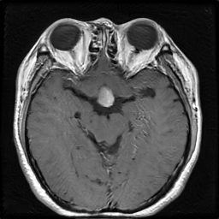
GT → Clase: pituitary | Tipo: FAKE | PID: | Truncation: 1.2
Tumor: □ glioma □ meningioma □ pituitary
Real/Fake: □ Real □ Fake
Confianza (1–5): 1 □ 2 □ 3 □ 4 □ 5 □
Utilidad diagnóstica (1–5): 1 □ 2 □ 3 □ 4 □ 5 □
Notas: _________________________________________________
------------------------------------------------------------
Caso 43 / 54
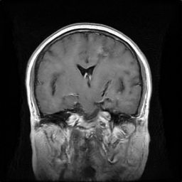
GT → Clase: glioma | Tipo: FAKE | PID: | Truncation: 0.8
Tumor: □ glioma □ meningioma □ pituitary
Real/Fake: □ Real □ Fake
Confianza (1–5): 1 □ 2 □ 3 □ 4 □ 5 □
Utilidad diagnóstica (1–5): 1 □ 2 □ 3 □ 4 □ 5 □
Notas: _________________________________________________
------------------------------------------------------------
Caso 44 / 54
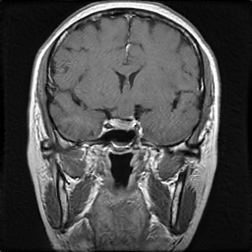
GT → Clase: pituitary | Tipo: FAKE | PID: | Truncation: 1.2
Tumor: □ glioma □ meningioma □ pituitary
Real/Fake: □ Real □ Fake
Confianza (1–5): 1 □ 2 □ 3 □ 4 □ 5 □
Utilidad diagnóstica (1–5): 1 □ 2 □ 3 □ 4 □ 5 □
Notas: _________________________________________________
------------------------------------------------------------
Caso 45 / 54
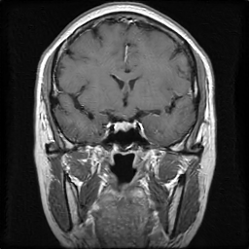
GT → Clase: pituitary | Tipo: FAKE | PID: | Truncation: 0.8
Tumor: □ glioma □ meningioma □ pituitary
Real/Fake: □ Real □ Fake
Confianza (1–5): 1 □ 2 □ 3 □ 4 □ 5 □
Utilidad diagnóstica (1–5): 1 □ 2 □ 3 □ 4 □ 5 □
Notas: _________________________________________________
------------------------------------------------------------
Caso 46 / 54
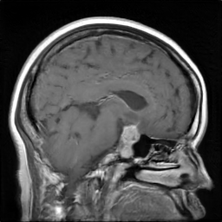
GT → Clase: pituitary | Tipo: FAKE | PID: | Truncation: 1.0
Tumor: □ glioma □ meningioma □ pituitary
Real/Fake: □ Real □ Fake
Confianza (1–5): 1 □ 2 □ 3 □ 4 □ 5 □
Utilidad diagnóstica (1–5): 1 □ 2 □ 3 □ 4 □ 5 □
Notas: _________________________________________________
------------------------------------------------------------
Caso 47 / 54
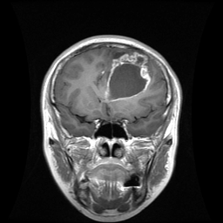
GT → Clase: glioma | Tipo: REAL | PID: mr048994
Tumor: □ glioma □ meningioma □ pituitary
Real/Fake: □ Real □ Fake
Confianza (1–5): 1 □ 2 □ 3 □ 4 □ 5 □
Utilidad diagnóstica (1–5): 1 □ 2 □ 3 □ 4 □ 5 □
Notas: _________________________________________________
------------------------------------------------------------
Caso 48 / 54
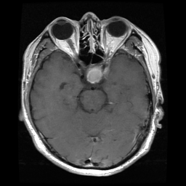
GT → Clase: pituitary | Tipo: REAL | PID: 114094
Tumor: □ glioma □ meningioma □ pituitary
Real/Fake: □ Real □ Fake
Confianza (1–5): 1 □ 2 □ 3 □ 4 □ 5 □
Utilidad diagnóstica (1–5): 1 □ 2 □ 3 □ 4 □ 5 □
Notas: _________________________________________________
------------------------------------------------------------
Caso 49 / 54
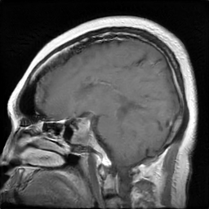
GT → Clase: pituitary | Tipo: FAKE | PID: | Truncation: 1.0
Tumor: □ glioma □ meningioma □ pituitary
Real/Fake: □ Real □ Fake
Confianza (1–5): 1 □ 2 □ 3 □ 4 □ 5 □
Utilidad diagnóstica (1–5): 1 □ 2 □ 3 □ 4 □ 5 □
Notas: _________________________________________________
------------------------------------------------------------
Caso 50 / 54
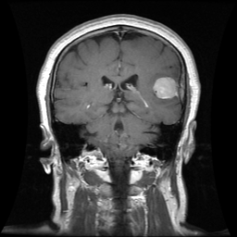
GT → Clase: meningioma | Tipo: REAL | PID: 111077
Tumor: □ glioma □ meningioma □ pituitary
Real/Fake: □ Real □ Fake
Confianza (1–5): 1 □ 2 □ 3 □ 4 □ 5 □
Utilidad diagnóstica (1–5): 1 □ 2 □ 3 □ 4 □ 5 □
Notas: _________________________________________________
------------------------------------------------------------
Caso 51 / 54
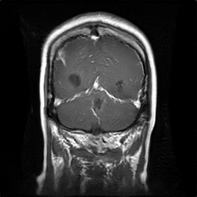
GT → Clase: glioma | Tipo: FAKE | PID: | Truncation: 1.2
Tumor: □ glioma □ meningioma □ pituitary
Real/Fake: □ Real □ Fake
Confianza (1–5): 1 □ 2 □ 3 □ 4 □ 5 □
Utilidad diagnóstica (1–5): 1 □ 2 □ 3 □ 4 □ 5 □
Notas: _________________________________________________
------------------------------------------------------------
Caso 52 / 54
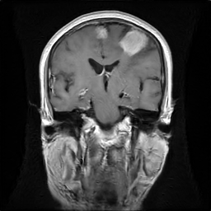
GT → Clase: meningioma | Tipo: FAKE | PID: | Truncation: 1.0
Tumor: □ glioma □ meningioma □ pituitary
Real/Fake: □ Real □ Fake
Confianza (1–5): 1 □ 2 □ 3 □ 4 □ 5 □
Utilidad diagnóstica (1–5): 1 □ 2 □ 3 □ 4 □ 5 □
Notas: _________________________________________________
------------------------------------------------------------
Caso 53 / 54
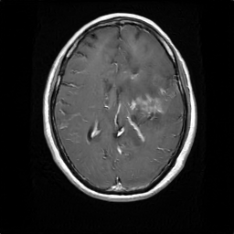
GT → Clase: glioma | Tipo: FAKE | PID: | Truncation: 0.8
Tumor: □ glioma □ meningioma □ pituitary
Real/Fake: □ Real □ Fake
Confianza (1–5): 1 □ 2 □ 3 □ 4 □ 5 □
Utilidad diagnóstica (1–5): 1 □ 2 □ 3 □ 4 □ 5 □
Notas: _________________________________________________
------------------------------------------------------------
Caso 54 / 54
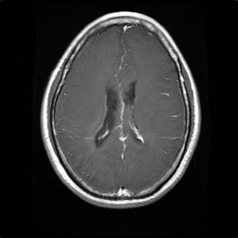
GT → Clase: glioma | Tipo: FAKE | PID: | Truncation: 0.8
Tumor: □ glioma □ meningioma □ pituitary
Real/Fake: □ Real □ Fake
Confianza (1–5): 1 □ 2 □ 3 □ 4 □ 5 □
Utilidad diagnóstica (1–5): 1 □ 2 □ 3 □ 4 □ 5 □
Notas: _________________________________________________
------------------------------------------------------------

