Initial Program Flow:
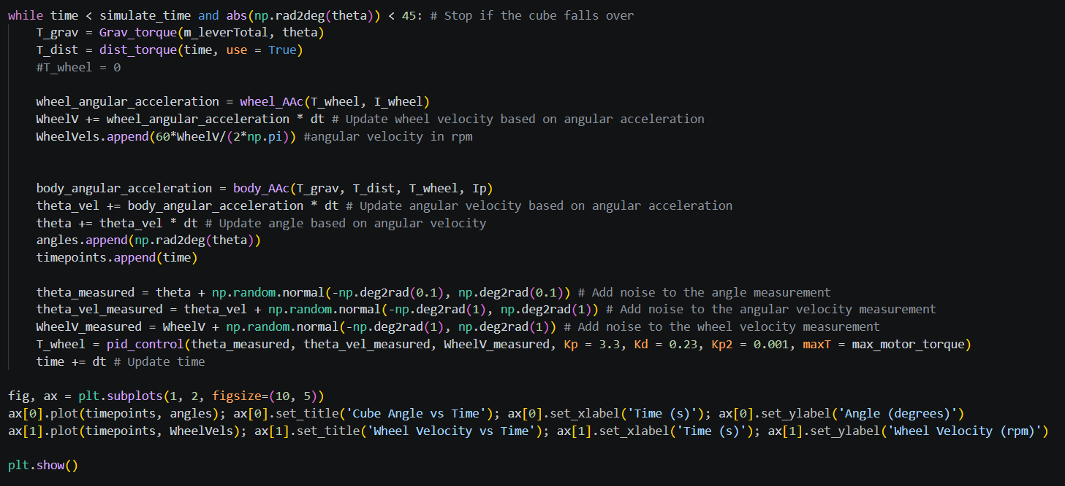
Loop runs for simulation time, and while the angle of the system is between -45 and +45 deg (the simulation stops if the cube falls)

T_grav: torque from the weight of the system – changes based on the mass of the system (which is constant) and the angle of the cube (as a sin term – T_grav increases as |theta| increases).

T_dist: disturbance torque, can set use = False to remove disturbances
Current function applies either an impulse torque for 0.02s, or a series of impulse torques at set times.
Maybe update this function to have a wider variety of disturbances with increasingly larger forces.

Wheel AAc: wheel angular acceleration based on torque and I, used for updating wheel velocity (which is controlled by P control later) – likewise for bodyAAc
List types are used for mpl plots
Measured values are used to feed into the controller (allow for artificial sensor noise)
T_wheel: determined using the PID control, limited to a max torque of maxT

Things to update:
Change values of I and m to match those of the CAD
update value of max_motor_torque to match procured motor
Include integral control for the wheel speed (so wheel tends to 0rpm at centre)
Look into Arduino clock timings (how often output can be updated)
Apply filters to “measured” data to try to re-remove randomness
Visualisation panel showing cube model (potentially using pyglet library?)
Other control methods (LQR)

Pyglet library seems promising, has build in functions for quarternions

04/10/2026:
Altered sensor noise calculations – normal distribution was improperly implemented, leading to overall bias, switched to random library.
Added values of M_total from solidworks simplified model
Now used mass moment of inertia values directly from solidworks – subtract wheel rotational inertia as this is covered by the wheel torque:
Introduced inherent bias in the gravity torque from the offset of the centre of mass from the central axis – this currently leads to an offset in both the cube angle and the wheel speed (can be removed by integral control)
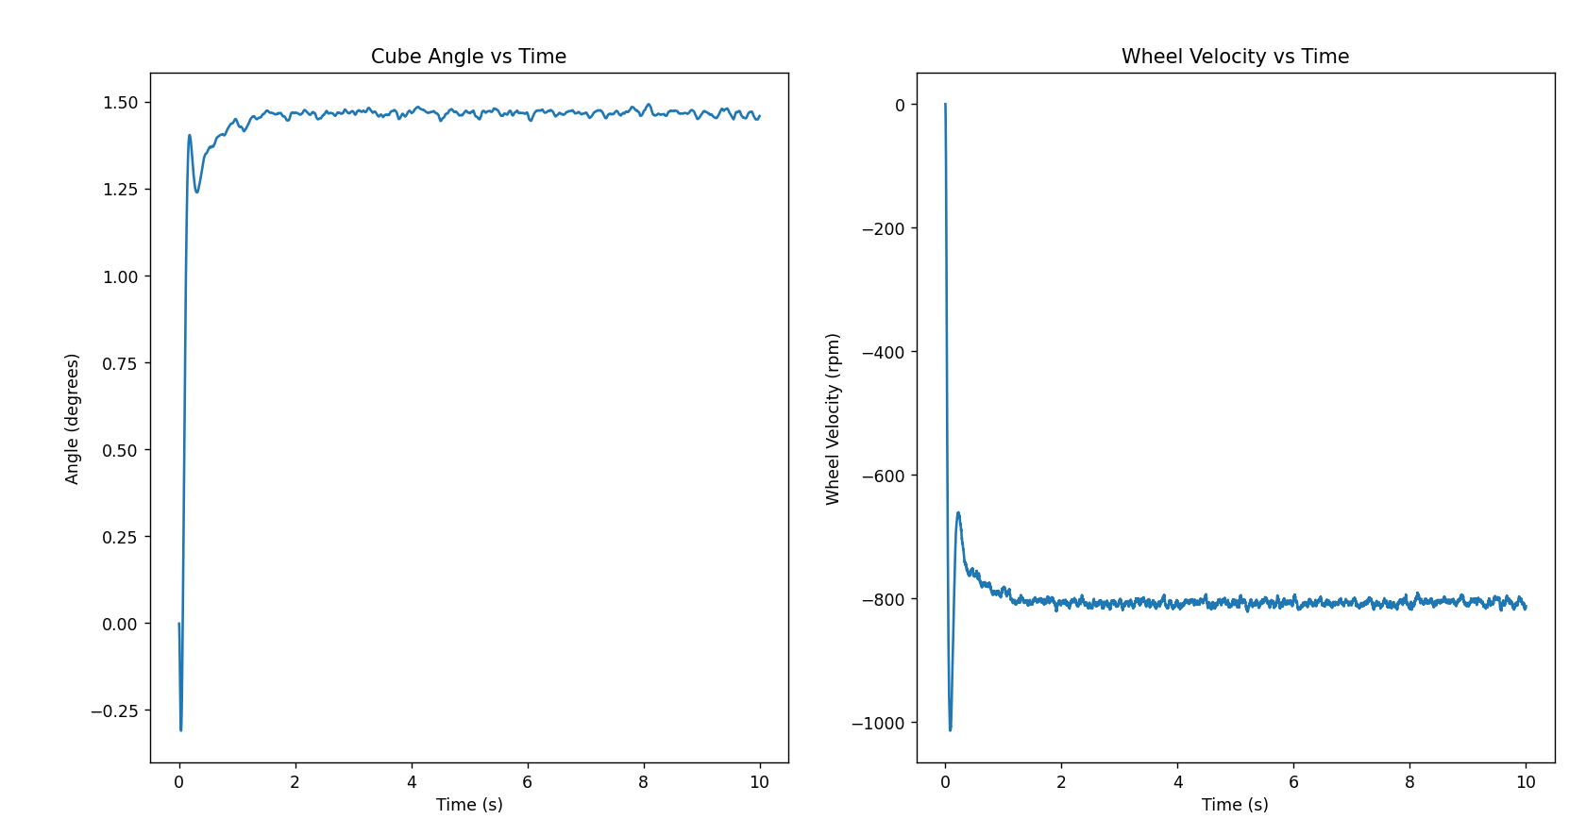

Boolean statement at start of code to allow for switching between plastic / 3D printed parts and metal parts

Starting integral control (need to tune further):
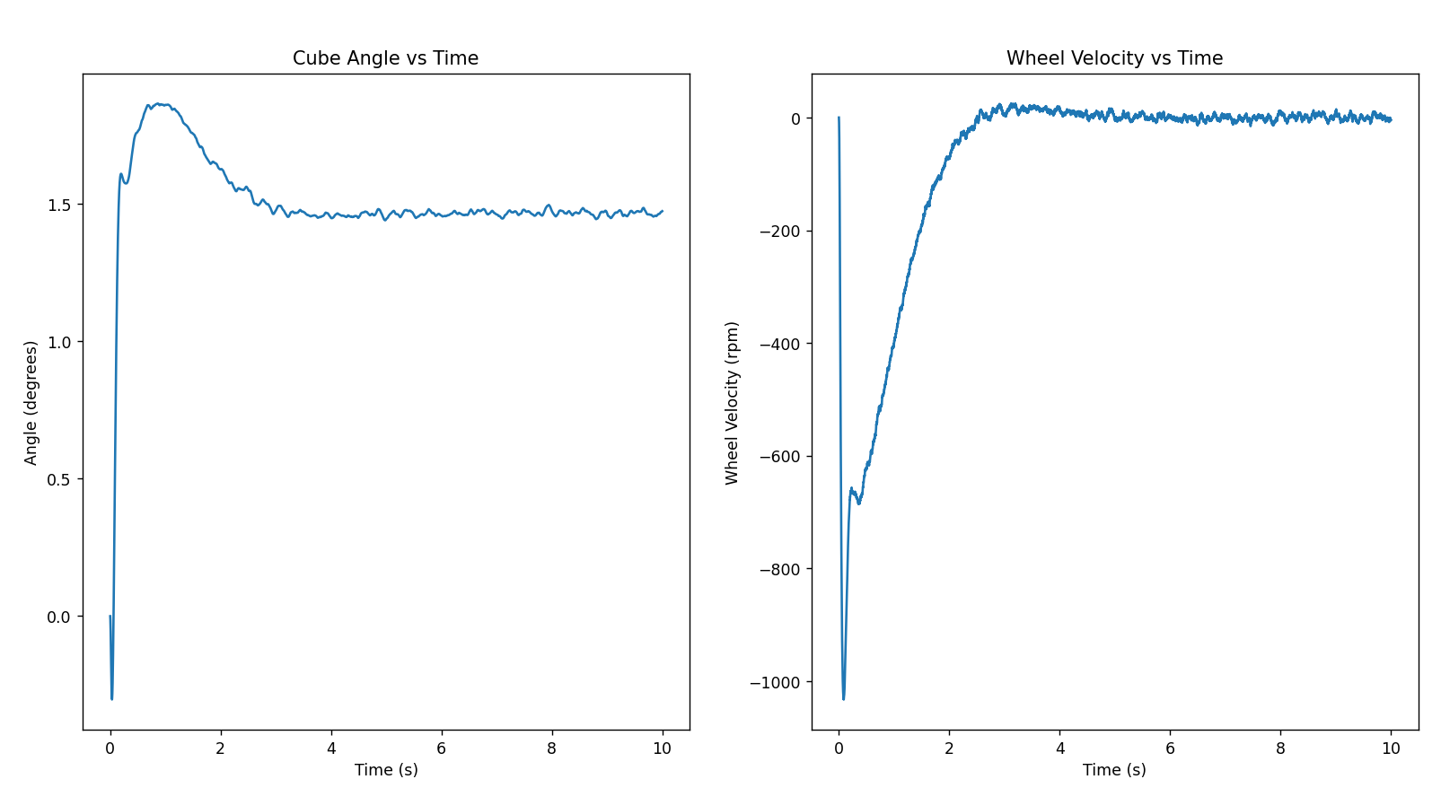
Capped integral control when the motor is saturated – prevents large error values accumulating from the motor being physically unable to rectify the state of the system.

Currently want to update the maximum torque as this will vary with speed

Updated Items
- Will upload updated file at the end of each session
- Updated items listed here (please message if you want the new file before file upload)

Motor Characteristics:

New file added (in the motor dynamics folder) that more accurately maps the available torque of the motor + motor driver dependant on the current rpm on the wheel

- Motor characteristic function currently wants speed in radians/s, going to change this to be rpm

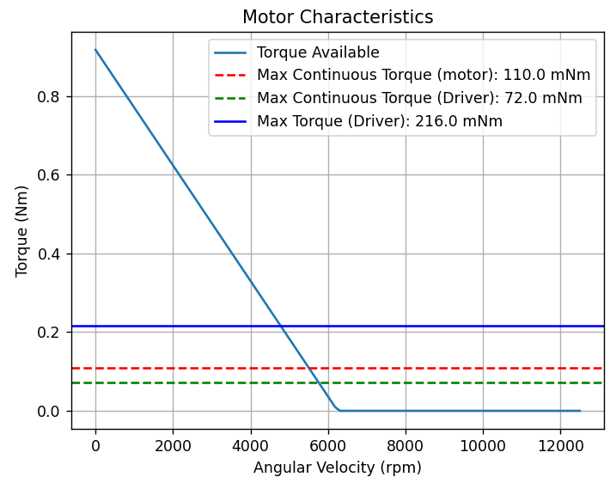 (http://lancet.mit.edu/motors/motors3.html talks about the linear approximation here)

Version 3 of the main code file does not yet implement these motor dynamics, this includes a tkinter GUI with the matplotlib graph integrated into it to allow for future display of both a visual representation of the cube as well as the data (ideally with the data updating real-time)

For now it may be best just to use matplot lib and focus on ensuring the dynamics are correctly modelled because I think live-updating code is going to be more complicated + computationally taxing (moving to Simulink could help this)

