Summary of testing

This API test suite is implemented with Karate framework with Maven Project via Java programming. It can be integrated with CICD if need. It covers basic 3 API Positive and Negative testing, E2E car booking workflow as well performance testing. Total 63 (pass: 31, failed: 32)

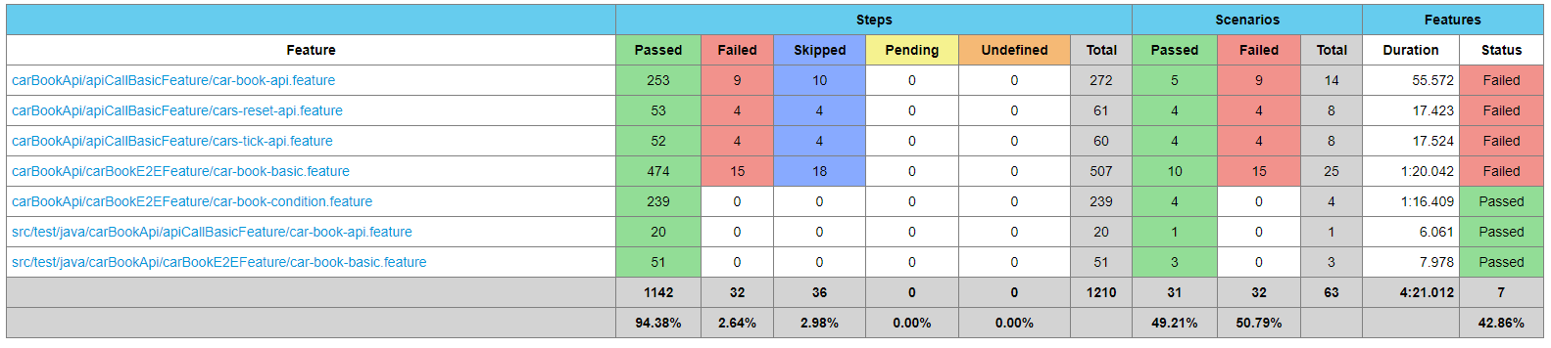

**Suggest to**

1. Fix high priority issue
2. Apply to standardized response payload following API approach (API Standardization Session)
3. Improve API performance (Response Time, Response Failure Rate)

**Highlighted Defects:**

1. High Priority: 1 (Unexpected payload returned for car book API success call)
2. Medium Priority: 1 (Expect missing content type while sending post book without content type)
3. Low Priority: 1 (Expected missing authentication token for post book and reset API without signature)
4. Low priority: 1 (Returned response code 403 for put tick API without signature)

(Noted: issue 3 , issue 4 are the same execution with signature, but returned response code are not the same.)

**API Standardization**

Below items are founded during negative testing. It is confusion for the returned message and response code. (Due to unclear information in QA Take Home Exercise, marked as further clarification. Meanwhile it implemented a config file for response message / code verification, once the corresponding response data structure is defined well, it is simple to modify this config file to apply to all test.)

1. Response HTTP status code, message not standard
2. Response structure is not well formatted
3. Response internal failure error for all invalid source (book API)

**Performance**

This report was generated for 3 APIs call with 1000 users in 60seconds. Total 1001 requests, average 5 requests as per seconds for induvial call.

1. It presents 5% requested failed, 5% requested got response more than 1200ms. Max response 5553ms.
2. As per error table, V1/tick, and V1/book have failed 38 call, which was accounted for 82.60% of all failures.

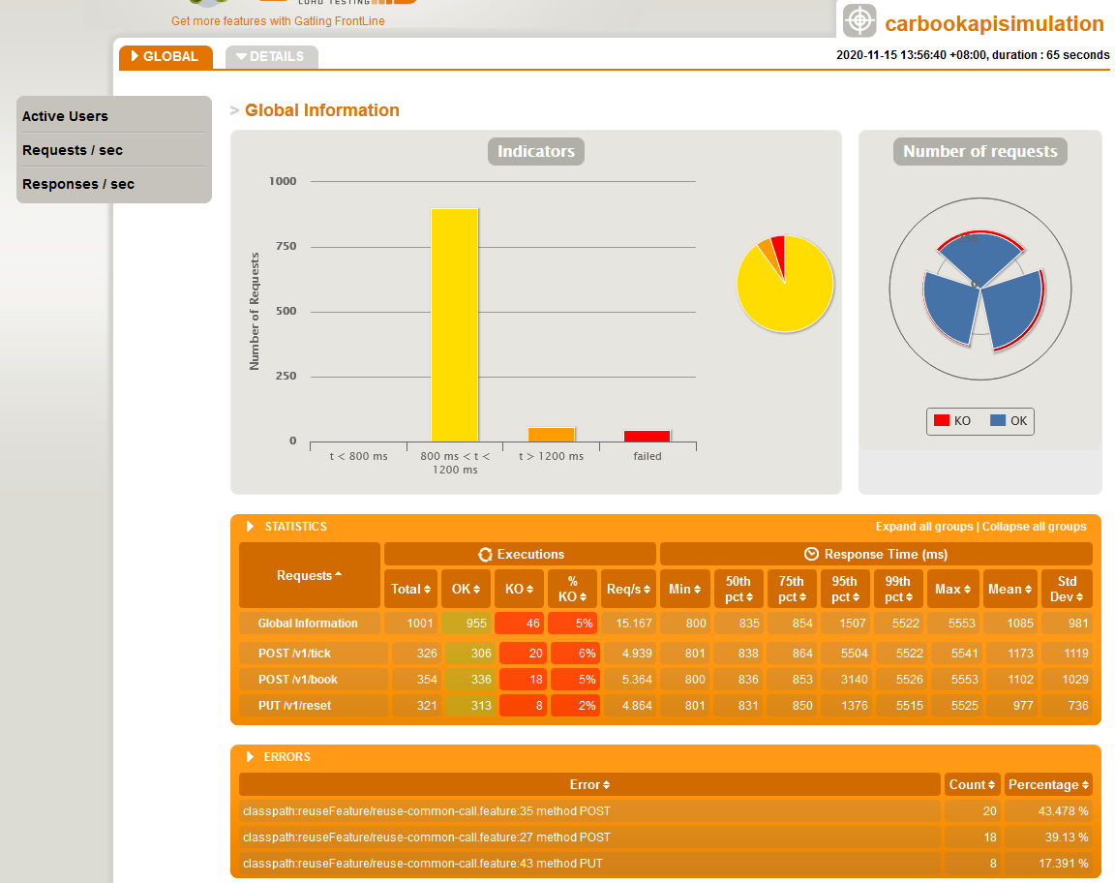

---------

You need to implement end-to-end test for the 3 REST API endpoints.

1. Your solution should Be implemented using any open source testing framework and language of your own choice. We do however recommend using a language/framework that is easy to install and can run on any machine.

Answer: This API assignment is designed to use an open source testing framework Karate to create a Maven project with Java Language, which is easy to install and run on any machine.

1. Contain clear instructions on how to run the test suite

Answer: Kindly refer to README.md in the project for instructions.

1. Contain the appropriate level(s) of testing

Answer: This test suite includes Smoke test, E2E test, Destructive test as well Performance test. For more details refer to TestCoverage&Defect_HuJunYing.xlsx

1. Demonstrate proper software testing design and engineering practices

Answer: The test analysis and design are documented well.

1. Explain the reasoning behind your choice of testing framework, the tests structure

Answer: 1) This Karate framework continuity integrate all-updates third party to make API test-automation easy and fast

2) Flexible configuration for verification part adapting changes of application

3) Good scalability to call Java functions for specific logic validation

1. Be of production quality

Answer: The verification is very clear and detailed according to the step. Once the case fails, it is easy to know where went wrong.

1. Be able to run on a Linux machine

Answer: Maven project with Java programming can run Linux machine