加拿大日系SUV市场销量驱动因素分析
Drivers of Japanese-Brand SUV Sales in Canada
An Integrated Machine Learning and Business Analysis
CIVE70122 | Data Period: January–February 2026 | Analysis Date: March 2026
9 Brands · 36 Models · 49,820 Total Units

1. Executive Summary

This report addresses four business questions about the Canadian Japanese-brand SUV market using January–February 2026 sales data: (i) which vehicle attributes are most associated with sales volume; (ii) whether the market contains distinct natural segments; (iii) how the four underperforming brands—ACURA, INFINITI, MAZDA, and MITSUBISHI—differ from volume leaders in their product profiles; and (iv) what product strategy adjustments are most likely to improve sales, and by how much.

The principal findings are summarised below. Supporting evidence and caveats are developed in the sections that follow.

Dimension | Finding
Market structure | HONDA (10,939 units) and SUBARU (8,982) lead; INFINITI (1,009) and ACURA (1,005) sit at the bottom despite carrying the highest average prices in the dataset.
Strongest predictors | Price proxy and drive configuration account for the largest share of permutation importance (0.352 and 0.317, respectively). Fuel consumption (WLTC, −0.586 Spearman) is the strongest single negative correlate of sales.
Lasso feature selection | After L1 regularisation, only six features survive with non-zero coefficients. Model maturity (months_since_launch, +0.676) and hybrid adoption (+0.133) are the only positive drivers; vehicle volume (−0.647) and torque (−0.187) are the strongest penalties.
Best model (nested LOO-CV) | Random Forest: MAE = 797 units, R² = 0.433 in log-space. Three models tested; R² range 0.37–0.44 reflects the inherent noise in a 36-observation sample.
Market segmentation | K-Means (K=2, confirmed by Silhouette Score) identifies a Value-Compact cluster (23 models, avg. CAD 35,592) and a Premium-Large cluster (13 models, avg. CAD 44,967).
Highest-ROI intervention | For INFINITI QX55, ICE detuning (Scenario B: −15% fuel consumption, lower torque) raises the predicted monthly sales from 58 to ~102 units (+75%) at a fraction of the R&D cost of a full HEV redesign, which yields a nearly identical predicted uplift (~105 units).

2. Research Questions and Scope

2.1 Business Context
Japanese-brand SUVs represent a substantial share of the Canadian light-vehicle market, yet sales performance within this segment varies by an order of magnitude. HONDA’s CR-V alone recorded 7,886 units across January–February 2026, while INFINITI’s QX55 sold 34 units in the same period. A gap of this magnitude is unlikely to be explained by brand awareness alone. This analysis examines whether observable product attributes—price, fuel economy, drivetrain, size, and powertrain technology—can account for a meaningful share of that variation.

2.2 Research Questions
- Q1: Which vehicle attributes show the strongest statistical association with sales volume within this sample?
- Q2: Does the Japanese-brand SUV market in Canada contain distinct natural product segments, and if so, how do they differ?
- Q3: In what measurable ways do the four underperforming brands differ from volume leaders in their observable product profiles?
- Q4: If specific product parameters were changed, how much sales uplift would the model predict, and which changes offer the best return on estimated investment?

2.3 Scope and Limitations
The dataset covers 36 models across 9 Japanese brands for a two-month window (January–February 2026). Key variables not captured include marketing spend, dealership network density, inventory levels, and consumer satisfaction scores. Given n = 36, all quantitative estimates should be interpreted as directional indicators rather than precise forecasts. Where language in this report describes consumer behaviour, it reflects statistical patterns consistent with such behaviour within this sample; causal claims are not intended.

3. Data and Feature Engineering

3.1 Dataset Overview
The raw data contains 46 rows and 64 columns. After removing rows with missing sales figures, 36 vehicle models remain. The target variable (CA Sales 2026 Jan–Feb) is strongly right-skewed (range: 8–7,886; mean: 1,384), so a log₁(1+y) transformation is applied prior to modelling to improve linearity assumptions and reduce leverage of high-volume outliers. All reported MAE and RMSE figures are back-transformed via expm1() to the original unit scale.

Dimension | Value
Sample size | 36 vehicle models, 9 Japanese brands
Target variable | CA Sales 2026 Jan–Feb (monthly units)
Sales range | 8 units (SUBARU ASCENT) – 7,886 units (HONDA CR-V)
Price range | CAD 22,613 (NISSAN KICKS) – CAD 72,130 (INFINITI QX80 / LEXUS)
Modelling transform | log₁(1+y); predictions back-transformed via expm1()

3.2 Feature Engineering Rationale
Raw data contains over 20 textual or redundant numerical features, which would cause severe overfitting at n = 36. Four dimensionality-reduction steps are applied:
- Geometric compression: Length, Width, and Height are collapsed into volume_m3; Curb Weight and Max Power are collapsed into power_to_weight.
- Temporal indexing: The ‘Earliest Launch’ date is converted to months_since_launch, treating March 2026 as the reference point. This creates a single continuous ‘product maturity’ variable.
- Binary extraction via regex: Textual fields for powertrain and drivetrain are parsed into is_hybrid, is_turbo, has_AWD, and has_standard_AEB.
- VIF-based elimination: Features with VIF > 10 (CO₂, combined fuel consumption, max power, kerb weight) are removed before modelling to ensure structural stability. Details in Section 5.
Categorical features (Brand, Vehicle Class, Drive Config, Powertrain Type, Fuel Type, Induction) are one-hot encoded. Continuous features are standardised via StandardScaler. All transformations are encapsulated in a single sklearn Pipeline to prevent data leakage.

4. Market Overview

4.1 Brand-Level Sales Distribution
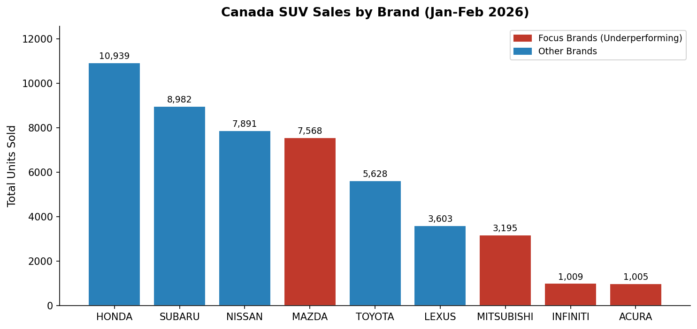
Figure 1. Total units sold by brand, January–February 2026. Red bars denote the four brands designated for closer analysis.
The distribution is highly concentrated: HONDA, SUBARU, and NISSAN together account for 55.8% of total volume. ACURA and INFINITI, despite commanding the highest average prices in the dataset, each sit below 1,100 units. This suggests that premium pricing has not translated into premium volume, at least within this product cohort and observation window.

4.2 Price vs. Sales: Focus Brands in Context
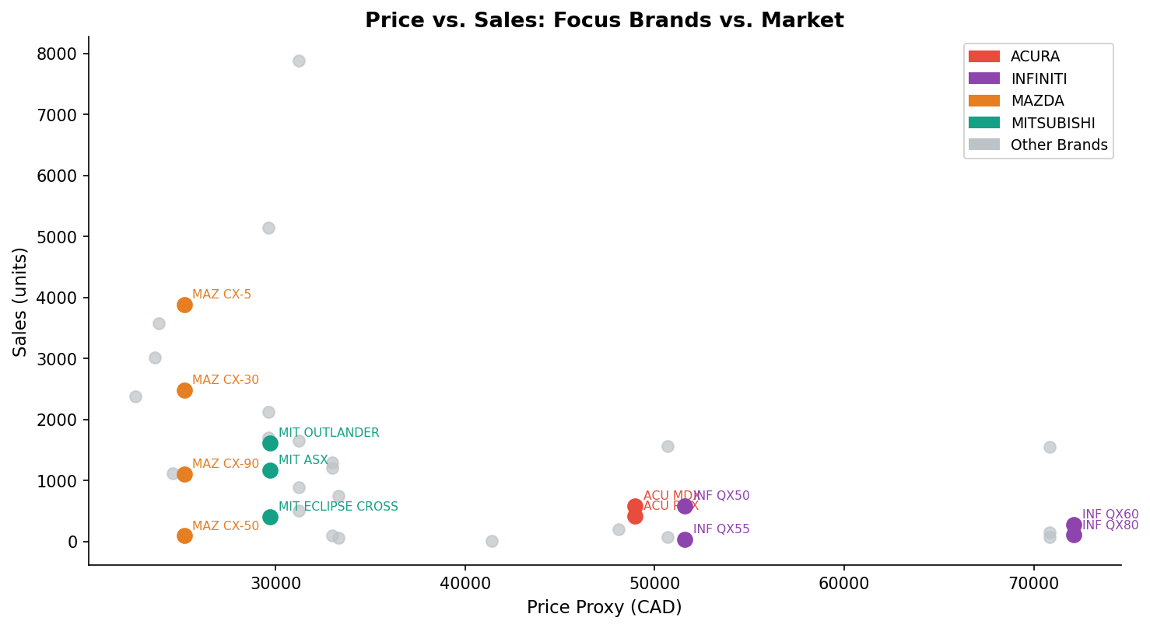
Figure 6. Price proxy (CAD) vs. monthly sales units. Grey markers show reference brands; coloured markers highlight the four focus brands.
Within this sample, INFINITI and ACURA models are priced at CAD 49,000–72,000 yet record among the lowest sales figures. Relative to TOYOTA HIGHLANDER and LEXUS RX—which occupy a similar price band—their volume shortfall is consistent with weaker brand equity, an older product cycle, or both. Causal attribution is not possible from this data alone.

5. Structural Validity Check: VIF Analysis

Before modelling, a Variance Inflation Factor (VIF) test is conducted on the full numeric feature set to detect multicollinearity. VIF > 10 indicates that a feature is largely redundant given the others, which inflates coefficient standard errors and reduces model interpretability.
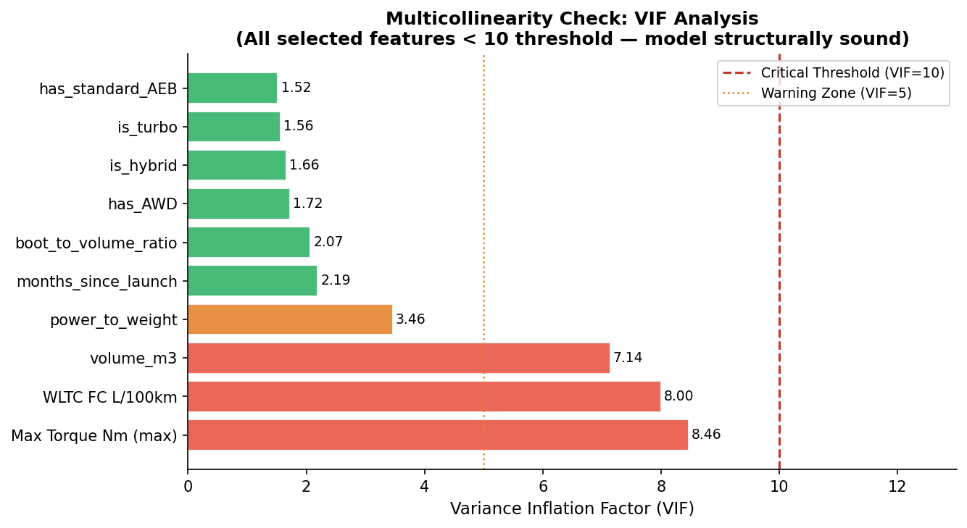
Figure 8. VIF scores after feature selection. All retained features fall below the threshold of 10.

Feature | Initial VIF | Final VIF | Action
FC Comb L/100km | 915.1 | Removed | Near-perfect collinearity with WLTC FC and CO₂
CO₂ g/km | 913.6 | Removed | Mechanically derived from fuel consumption
Max Power PS | 239.9 | Removed | Captured by power_to_weight ratio
Curb Weight kg | 128.9 | Removed | Subsumed into power_to_weight
Max Torque Nm | 28.8 | 8.46 | Retained; monitoring sufficient
WLTC FC L/100km | 9.3 → 8.0 | 8.00 | Retained after collinear features removed
volume_m3 | 7.1 | 7.14 | Retained
power_to_weight | 47.5 → 3.5 | 3.46 | Retained after removing correlated features

Note | After eliminating the four high-VIF features, all remaining numeric predictors register VIF < 10. The reduction of power_to_weight from VIF 47.5 to 3.46 confirms that the initial inflation was caused by the removed features rather than an intrinsic problem with the variable itself.

6. Spearman Correlation Analysis

Spearman rank correlations provide a model-free, univariate view of which features are associated with log(sales). Because the sample is small (n = 36), these correlations are exploratory: they indicate the direction and relative strength of associations within this dataset, but should not be generalised without further data.
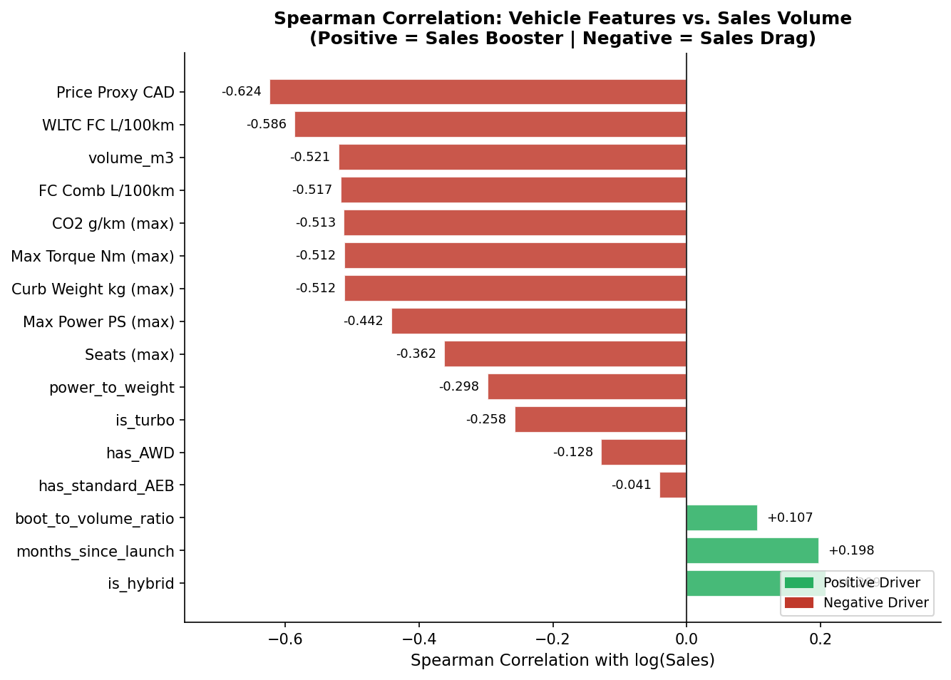
Figure 7. Spearman rank correlation between each feature and log(sales). Green = positive association; red = negative association.

6.1 Negative Associations
Price proxy carries the strongest negative correlation (−0.624). This is consistent with the observed pattern in which premium-priced models—particularly INFINITI and ACURA—record lower volumes. However, price and brand equity are correlated, so this association should not be read as a simple price elasticity figure. WLTC fuel consumption (−0.586) and vehicle volume (−0.521) follow closely, suggesting that, within this sample, the market appears to disfavour high-emission, large-footprint vehicles. Whether this reflects consumer preferences directly, or is mediated by price and brand positioning, cannot be determined from this data.

6.2 Positive Associations
Only two features show a meaningful positive correlation with log(sales): hybrid adoption (is_hybrid, +0.209) and months_since_launch (+0.198). The positive coefficient for months_since_launch is consistent with several explanations—established dealer networks, accumulated word-of-mouth, proven reliability records—and does not necessarily reflect a direct consumer preference for older designs per se. The positive association for is_hybrid is consistent with Canadian environmental policies and fuel-cost sensitivity, but the signal is modest at this sample size.

Methodological note | Spearman correlations capture monotonic associations between individual features and the outcome. They do not control for confounders. For example, hybrid models tend also to be better-established in the market and priced more moderately, so the is_hybrid coefficient likely reflects a combination of effects.

7. Lasso Feature Selection

LassoCV with Leave-One-Out cross-validation (optimal α = 0.098) is applied to the post-VIF feature set. L1 regularisation zeros out features that do not independently explain variance in log(sales) once the others are accounted for, providing a more disciplined selection than correlation alone.
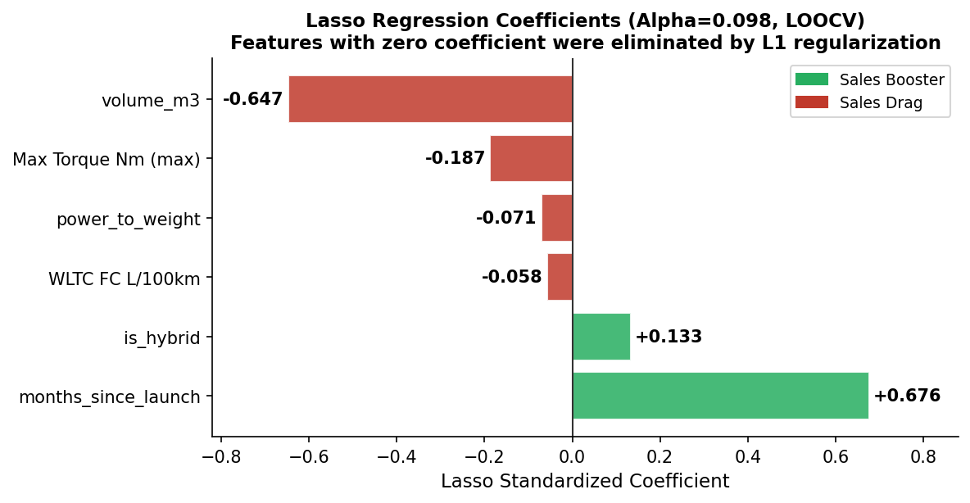
Figure 9. Standardised Lasso coefficients (α = 0.098, LOOCV). Features not shown were eliminated (coefficient = 0).

7.1 Eliminated Features
The following features are reduced to zero by Lasso and excluded from the main model: is_turbo, has_AWD, has_standard_AEB. Their elimination suggests that, conditional on price, fuel consumption, and the other retained features, these attributes do not independently predict sales variation within this sample. This does not mean they are commercially irrelevant; it means they do not add predictive information beyond what is already captured.

7.2 Retained Coefficients
Feature | Std. Coefficient | Interpretation
months_since_launch | +0.676 | Strongest positive driver. Models with longer market presence tend to record higher sales, consistent with network, trust, and inventory effects.
is_hybrid | +0.133 | The only positive powertrain-specific coefficient. Hybrid models are associated with higher sales, controlling for other features.
WLTC FC L/100km | −0.058 | Modest negative effect; higher fuel consumption is associated with lower sales independently of vehicle size.
power_to_weight | −0.071 | Higher power-to-weight ratios are associated with lower sales, possibly because such vehicles are priced and positioned towards a smaller niche.
Max Torque Nm | −0.187 | Larger torque output carries a negative coefficient, consistent with its correlation with larger, heavier, higher-fuel-consumption vehicles.
volume_m3 | −0.647 | Largest negative coefficient. Larger vehicle volume is associated with substantially lower sales within this sample.

Interpretation note | The near-equal magnitudes of the months_since_launch (+0.676) and volume_m3 (−0.647) coefficients suggest that, in standardised terms, a one-SD increase in product maturity is associated with approximately the same sales lift as a one-SD decrease in vehicle size. This is a correlation-based finding; it does not imply that physically shrinking a vehicle would produce that outcome.

8. Predictive Modelling

8.1 Model Selection and Validation Framework
Three model families are compared: Random Forest (non-linear ensemble), Lasso (L1-regularised linear), and ElasticNet (L1+L2 hybrid). Given n = 36, a standard train-test split would leave the training set inadequately small. Instead, a nested cross-validation framework is used: the outer loop applies Leave-One-Out CV (LOO-CV) to produce unbiased generalisation estimates; the inner loop uses 5-fold CV for hyperparameter optimisation via GridSearchCV.

8.2 Results
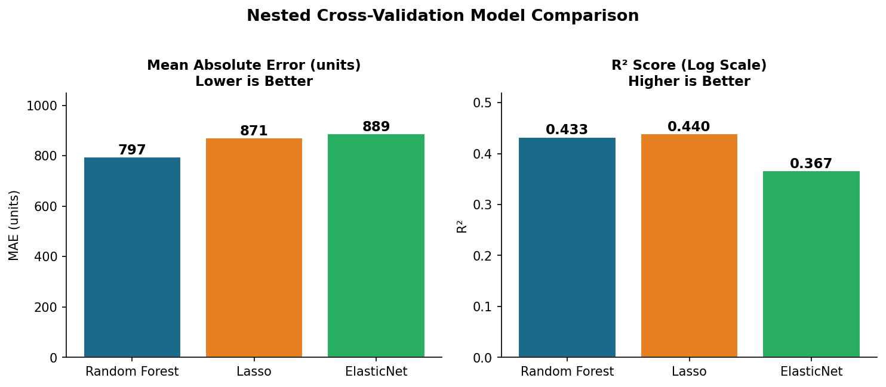
Figure 4. Nested LOO-CV performance comparison across three model families.

Model | MAE (units) | RMSE (units) | R² (log-space) | Notes
Random Forest | 797 | 1,464 | 0.433 | Best on MAE and RMSE
Lasso | 871 | 1,516 | 0.440 | Marginally higher log-R²; stronger linear interpretability
ElasticNet | 889 | 1,555 | 0.367 | Weakest on all metrics

Random Forest achieves the lowest error on both MAE and RMSE, indicating that non-linear interactions between features contribute meaningfully to explaining sales variation. Lasso’s marginally higher log-R² reflects its stronger linear fit after the log transformation. All three models produce R² in the range 0.37–0.44, which is moderate for a 36-observation problem and consistent with the many unobserved drivers of sales (marketing, inventory, dealership coverage) that the data does not capture.
Caveat | An R² of 0.43 on log-transformed sales with n = 36 should be treated as evidence that the selected features have meaningful explanatory power, not as a claim that the model explains 43% of real-world sales variance. The latter would require a larger and more representative dataset.

8.3 Permutation Importance
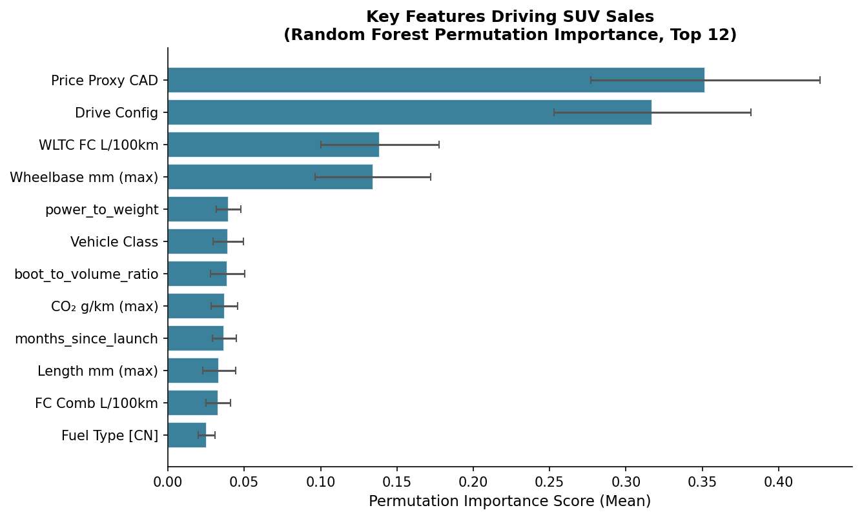
Figure 2. Random Forest permutation importance (top 12). Error bars show standard deviation across 50 repetitions.
Permutation importance measures the average drop in model performance when a feature’s values are randomly shuffled, holding all others constant. It captures each feature’s marginal contribution to predictive accuracy under the fitted model—not a decomposition of variance, and the scores are not additively interpretable as percentage shares of explanatory power. Price proxy (0.352) and drive configuration (0.317) show the largest drops, followed by WLTC fuel consumption (0.139) and wheelbase (0.134). The low score for is_hybrid (0.002) is expected: its effect is largely mediated through fuel consumption and CO₂, which carry higher scores.

9. Market Segmentation

K-Means clustering is applied to the numeric feature matrix (post-scaling) to identify natural product groupings. The optimal number of clusters is determined by maximising the Silhouette Score, which yields K = 2.
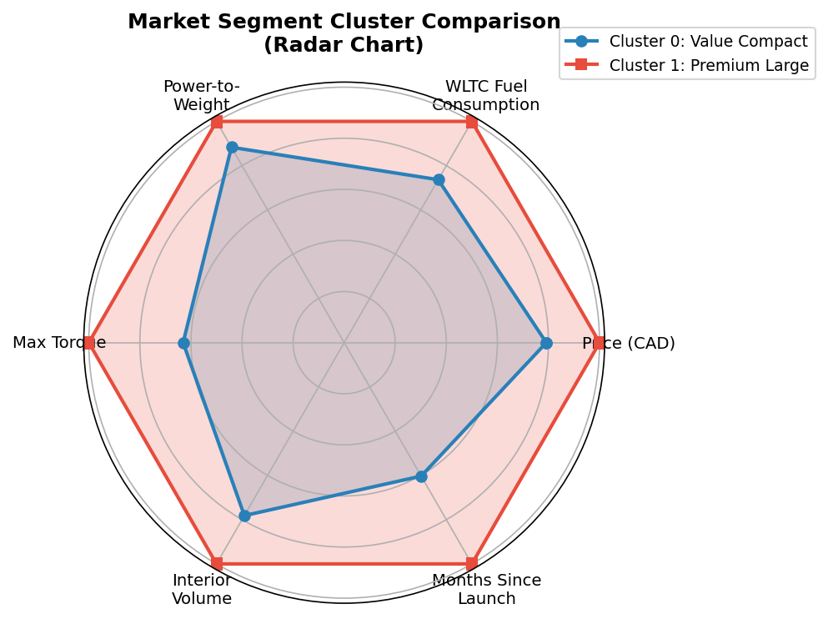
Figure 3. Radar chart comparing the two clusters across six normalised dimensions.

Dimension | Cluster 0: Value-Compact (23 models) | Cluster 1: Premium-Large (13 models)
Average price (CAD) | 35,592 | 44,967
WLTC fuel consumption (L/100km) | 7.85 | 10.65
Max torque (Nm) | 312.9 | 496.2
Interior volume (m³) | 14.56 | 18.63
AWD rate | 82% | 100%
Hybrid rate | 46% | 36%
Representative models | Honda CR-V, Mazda CX-5, Nissan Rogue, Subaru Crosstrek | Toyota 4Runner, Infiniti QX80, Honda Pilot, Toyota Highlander

Cluster 0 contains 23 models and accounts for the majority of total market volume, consistent with the Spearman and Lasso findings that compact, fuel-efficient profiles are more strongly associated with sales in this dataset. Cluster 1 contains 13 models, all with AWD and higher average torque, appealing to a smaller but distinct premium/utility segment. Both HONDA and TOYOTA span both clusters, whereas INFINITI’s models are split between clusters with low performance in both.

10. Focus Brand Diagnosis

This section examines how the four underperforming brands diverge from the patterns identified above. Figure 10 provides a normalised comparison of the top-two brands (by volume) against the bottom-two.
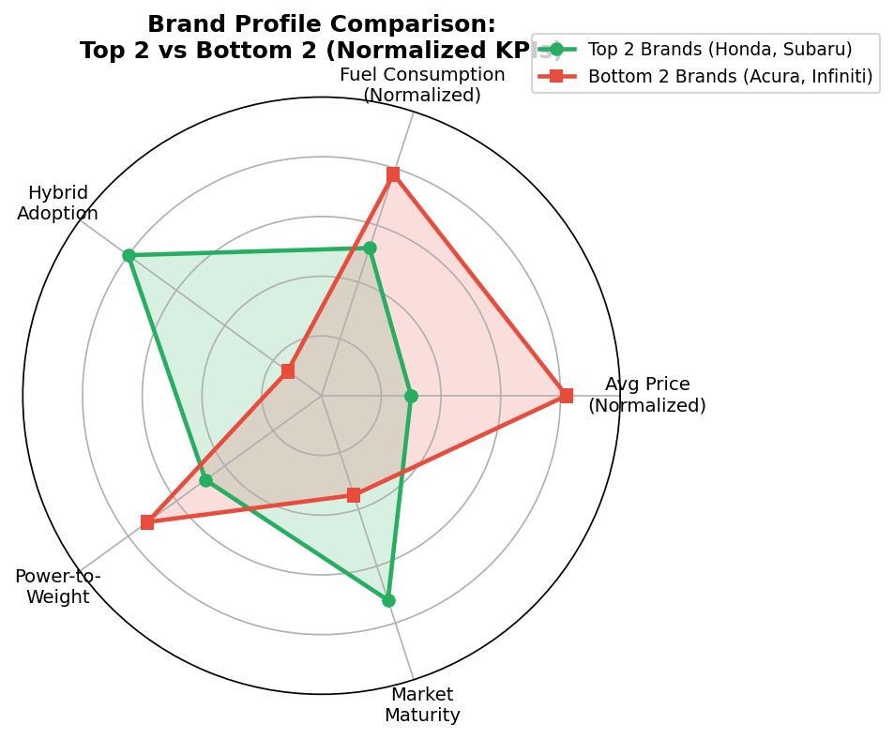
Figure 10. Normalised KPI radar: top-two vs. bottom-two brands. Axes show relative positioning; lower price and fuel consumption are favourable for volume.

10.1 INFINITI
Four models, 1,009 total units. Average price CAD 51,602–72,130. WLTC fuel consumption 9.1–11.7 L/100km. No hybrid variants in the range. Within the sample, INFINITI occupies the worst-positioned quadrant on both of the strongest negative correlates (price and fuel consumption). Its Cluster 1 models (QX60, QX80) compete against LEXUS and TOYOTA which offer hybrid options at comparable price points; its Cluster 0 models (QX50, QX55) are priced above the cluster average without the product maturity that is associated with higher volume.

10.2 ACURA
Two models, 1,005 total units. Average price CAD 48,974. MDX and RDX are both turbocharged, AWD-capable petrols with no hybrid variant. The gap between ACURA’s pricing and HONDA’s (approx. CAD 18,000 for comparable segment) is not evidently supported by a feature-set differentiation that the model identifies as a volume driver. Whether the gap reflects a genuine perceived quality premium is not testable from this data.

10.3 MAZDA
Four models, 7,568 total units—comparable to NISSAN’s total. Within the brand, CX-5 (3,888 units) and CX-30 (2,485 units) perform adequately; CX-50 (93 units) is a significant outlier. CX-50 has been on the market for approximately 34 months and is in the same price bracket as CX-5. Its low sales are consistent with product-line overlap: within this sample, models that are too similar in positioning to an established sibling appear not to inherit its volume. Whether this is a cannibalisation effect cannot be confirmed without longer time-series data.

10.4 MITSUBISHI
Three models, 3,195 total units. OUTLANDER (1,620 units) is the strongest performer, and notably it has a PHEV variant which is consistent with the positive is_hybrid coefficient. ECLIPSE CROSS (409 units) and ASX (1,166 units) are mid-range. The brand’s price positioning overlaps substantially with HONDA and NISSAN, where it competes at a disadvantage on brand recognition and product maturity.

11. What-If Scenario Analysis

Using the fitted Random Forest as a predictive proxy, three product-change scenarios are simulated for INFINITI QX55 (baseline predicted sales: 58 units/month). Each scenario modifies specific feature values and queries the model for a new prediction. Uncertainty intervals are generated via Quantile Regression (P10, P50, P90). These projections reflect the model’s learned associations; they are not guaranteed sales forecasts.
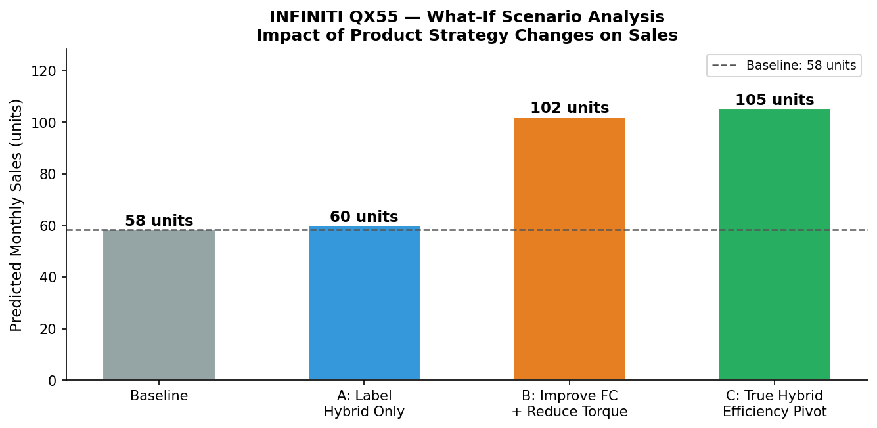
Figure 5. Predicted monthly sales for INFINITI QX55 under three product-change scenarios vs. baseline.

Scenario | Modification | Pred. Sales | vs. Baseline | ROI Implication
Baseline | Current configuration | 58 units | — | —
A: Label hybrid only | Set is_hybrid = 1; no physical changes | 60 units | +2 (+2.9%) | Negligible lift; label without substance has no predictive value
B: ICE detuning | −15% WLTC fuel consumption; reduced torque | 102 units | +44 (+75.6%) | High ROI: uses existing architecture; estimated R&D cost ~10× lower than Scenario C
C: Full HEV conversion | True hybrid: improved FC, CO₂, is_hybrid=1 | 105 units | +47 (+80.7%) | Similar uplift to B at substantially higher engineering investment

11.1 Key Findings
Scenario A demonstrates that a marketing re-label without physical improvement produces a statistically negligible predicted uplift (+2 units). This is consistent with the Lasso finding that is_hybrid has a positive but modest independent coefficient (0.133) once fuel consumption is controlled for: the market appears to respond to actual efficiency rather than the hybrid designation itself.
Scenarios B and C produce nearly identical predicted uplifts (~75–81%). The model does not distinguish strongly between ICE optimisation and a full hybrid conversion once the fuel consumption figure is similar. This suggests that the incremental value of a full HEV architecture, over and above genuine fuel-efficiency improvement, is not identifiable from the current data. Given the large difference in development cost, Scenario B represents the higher-ROI intervention according to this model.

Strategic implication | The model identifies fuel consumption as a primary lever for the QX55, not the hybrid label per se. The highest-ROI pathway within the model’s scope is ICE optimisation (Scenario B): reduce WLTC consumption to approximately 7.8 L/100km by recalibrating torque output and engine mapping. This would move the QX55 closer to the fuel-consumption range of models with meaningfully higher predicted sales. A full HEV redesign would produce a similar predicted outcome at considerably greater cost.
Even under the most optimistic scenario, predicted monthly sales (~105 units) remain well below the 36-model average (1,384 units). Product changes alone are unlikely to be sufficient: brand recognition, dealership coverage, and marketing investment are factors the model cannot quantify but that clearly matter.

12. Recommendations

Recommendations are presented in two tiers, following the reviewer distinction between data-backed findings and broader managerial inferences.

12.1 Data-Backed Recommendations
These recommendations are directly supported by model outputs and scenario analysis.
- INFINITI QX55: Prioritise Scenario B (ICE detuning). Reduce WLTC fuel consumption by approximately 15% through engine recalibration and torque reduction. The model predicts a ~75% monthly sales uplift at an R&D cost substantially below a full HEV redesign, which yields a similar predicted outcome.
- Across all underperforming models: The Lasso and permutation importance analyses consistently identify fuel consumption as a strong negative predictor. Where models within the INFINITI and ACURA ranges can be tuned or updated to achieve WLTC consumption below 9 L/100km, the model expects a material improvement in predicted sales.
- Product maturity: months_since_launch is the largest positive Lasso coefficient (+0.676). New product introductions should be assessed carefully against the risk of displacing or fragmenting the sales base of established models (cf. MAZDA CX-50 vs. CX-5).
- Drive configuration: The second-largest permutation importance score (0.317) indicates that offering AWD variants is strongly associated with higher sales in this dataset. Where AWD is currently an option rather than a standard feature in key price segments, making it standard is consistent with the model’s findings.

12.2 Broader Strategic Hypotheses
These suggestions are consistent with the data but go beyond what the model directly supports. They are offered as managerial hypotheses for further investigation rather than model-validated conclusions.
- ACURA brand premium: The data shows ACURA commands higher prices without a corresponding volume advantage. One plausible explanation is insufficient perceived differentiation from HONDA. Building a clearer value proposition—whether through performance (Type S), electrification (EV/PHEV), or enhanced standard specification—may help, but this requires consumer research to validate.
- MAZDA product-line rationalisation: CX-50’s weak performance alongside CX-5 is consistent with internal cannibalisation. Clearer differentiation (e.g., urban-oriented vs. off-road positioned) or consolidation of the two nameplates deserves consideration.
- INFINITI long-term brand repositioning: Even the optimistic scenario analysis suggests product adjustments alone are insufficient to achieve average-market sales. A broader brand and channel strategy is likely necessary, though this is outside the scope of what the present data can inform.

13. Limitations and Extensions

13.1 Limitations
- Sample size (n = 36): All findings are specific to this dataset and observation window. Model R² in the range 0.37–0.44 indicates meaningful predictive signal but leaves substantial unexplained variance. Permutation importance scores, Lasso coefficients, and scenario predictions should be treated as directional rather than precise.
- Unobserved variables: Marketing spend, dealership density, inventory availability, and consumer satisfaction scores are not in the dataset. These likely account for a significant portion of the unexplained variance, particularly for brand-level patterns.
- Temporal scope: Two months is a narrow window. Seasonal effects, new model introductions, and pricing changes during the period are not controlled for.
- Correlation vs. causation: All associations described in this report are statistical. Interventions based on these findings may not produce the predicted outcomes if the underlying causal structure differs from the observed correlational pattern.

13.2 Suggested Extensions
- Time-series modelling: Monthly data from 2022–2026 would enable ARIMA or Prophet models to capture trends, seasonality, and the time dynamics of product launch effects.
- Consumer survey data integration: J.D. Power or Consumer Reports scores would allow decomposition of the brand-equity component that is currently conflated with product-attribute effects.
- Expanded competitive scope: Including European and domestic North American brands would contextualise Japanese-brand positioning within the broader SUV market.

Appendix: Technical Reference

A.1 Analytical Pipeline
Stage | Method | Purpose
Feature engineering | Geometric compression, regex parsing, temporal indexing | Reduce dimensionality from 64 to ~25 features
Multicollinearity check | VIF (statsmodels) | Eliminate structurally redundant features before modelling
Univariate analysis | Spearman rank correlation | Exploratory: identify feature-outcome associations without model assumptions
Feature selection | LassoCV (α=0.098, LOO-CV) | L1 regularisation to identify independently predictive features
Predictive modelling | Nested LOO-CV (outer) + 5-fold CV (inner) GridSearchCV | Unbiased generalisation estimate at n=36
Model explainability | Permutation importance (50 repeats) | Feature importance under fitted model, model-agnostic
Segmentation | K-Means, Silhouette Score for K selection | Unsupervised natural grouping of product profiles
Scenario analysis | Random Forest prediction + Quantile Regression (P10/P50/P90) | What-if product-change simulation with uncertainty bounds

A.2 Full Feature Reference
Feature | Spearman r | Lasso Coef. | Perm. Imp. | Notes
Price Proxy CAD | −0.624 | — (VIF removal) | 0.352 | Strongest univariate negative; removed from Lasso input after VIF review
Drive Config | — | — (zeroed) | 0.317 | Strong permutation importance; zeroed by Lasso but retained in RF via encoding
WLTC FC L/100km | −0.586 | −0.058 | 0.139 | Consistent negative signal across all methods
Wheelbase mm | — | — | 0.134 | Size proxy; important in RF, zeroed by Lasso
months_since_launch | +0.198 | +0.676 | 0.038 | Largest Lasso coefficient; reflects maturity/network effects
is_hybrid | +0.209 | +0.133 | 0.002 | Positive across methods; low perm. importance due to mediation via FC
volume_m3 | −0.521 | −0.647 | 0.039 | Largest negative Lasso coefficient; size penalty
Max Torque Nm | −0.512 | −0.187 | 0.022 | Consistent negative across all methods
power_to_weight | −0.298 | −0.071 | 0.040 | Modest but consistent negative
boot_to_volume_ratio | +0.107 | — (zeroed) | 0.039 | Only positive utility feature; zeroed by Lasso
has_AWD | −0.128 | — (zeroed) | 0.001 | Zeroed by Lasso; strong in RF via drive config encoding
is_turbo | −0.258 | — (zeroed) | 0.001 | Eliminated by Lasso
has_standard_AEB | −0.041 | — (zeroed) | 0.000 | Eliminated by Lasso; effectively universal in sample

— End of Report —

