

Lab Report

Title | Marks
Course Code: CSE-342
Course Title: Computer Graphics
Lab no:



Submitted By | Submitted To
Name: Junaeid Hasan Bijoy  ID: 21225103299  Intake: 49  Section: 05  Department of CSE  Bangladesh University of Business & Technology | Name: Md. Khairul Islam  Designation: Lecturer  Department of CSE  Bangladesh University of Business & Technology

Submission Date Teacher’s Signature

1.​ Title: Line Drawing Algorithm

2.​ Objective:
The objective of this report is to understand and implement the line drawing
algorithm(DDA), analyze the efficiency, and evaluate the effectiveness in computer
graphics for generating straight lines between two points.

3.​ Environment:
●​ Operating System: Windows
●​ Programming Language: Python
●​ Editor: Jupyter Notebook
●​ Graphics Library: matplotlib
●​ Hardware: Standard computer system with basic graphics capabilities

4.​ Introduction:
In computer graphics, a line is a fundamental element used to create shapes, curves,
and complex images. Since computer screens are made up of discrete pixels, drawing a
straight line requires approximating the ideal line by selecting the nearest pixels. The
Digital Differential Analyzer (DDA) algorithm is one of the simplest methods used for this
purpose. It incrementally plots points between two endpoints of a line by calculating
intermediate positions.
This lab report focuses on implementing and analyzing the DDA algorithm to understand
its working principle and performance.

5.​ Algorithm:
Digital Differential Analyzer (DDA) Algorithm
Steps:
1.​ Input Coordinates:
Accept the starting point (x0,y0​) and the ending point (x1,y1​) of the line.
2.​ Calculate Differences:
Compute the absolute differences:
dx=∣x1−x0∣
dy=∣y1−y0∣
3.​ Determine Steps:
Set the number of steps as the maximum of dx and dy:
max_steps=max⁡(dx,dy)
4.​ Compute Increments:
Calculate the incremental changes in x and y for each step:
xincrement=(dx/max_steps)
yincrement=(dy/max_steps)
5.​ Initialize Starting Point:
Set x=x0​and y=y0
6.​ Iterate Over Steps:
For each step:
1.​ Append the rounded x and y values to the list of coordinates.
2.​ Update x and y by adding xincrement​and yincrement​, respectively.
7.​ Plot the Line:
Use the list of computed points to plot the line on a graph.
8.​ Display Results:
Show the generated line on a grid with appropriate markers.

6. Code:

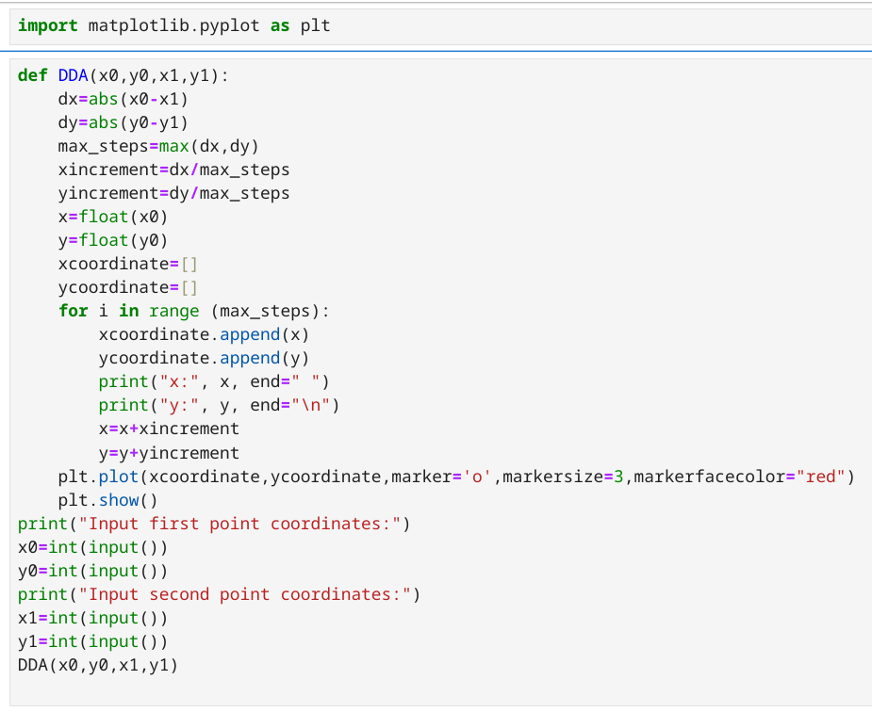

7.Snapshot(Input & Output):

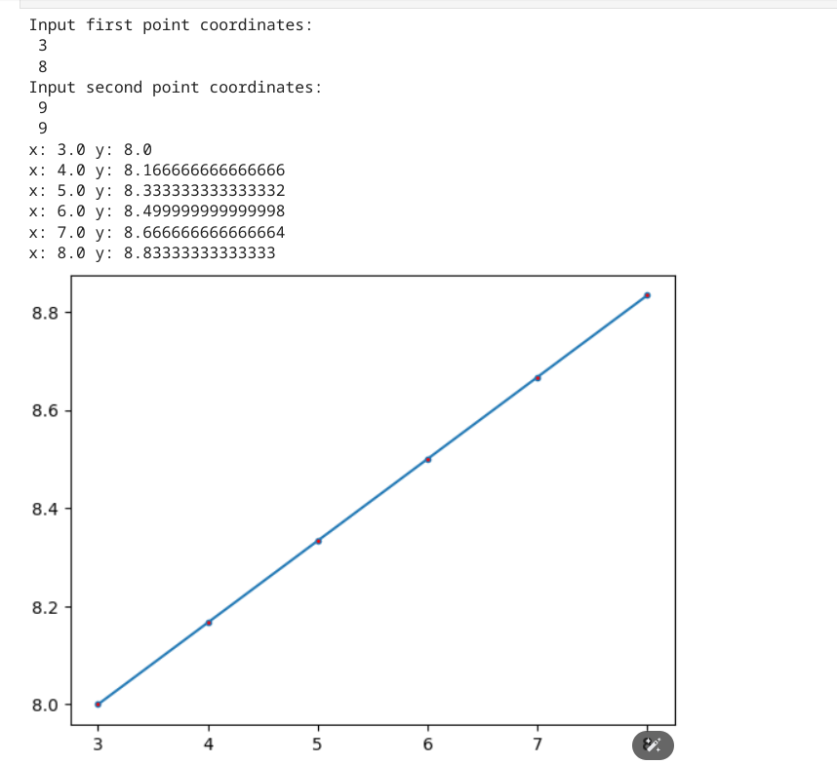
8.​ Discussion & conclusion:
From the implementation and analysis of the DDA algorithm, we observed the following:
1.​ The algorithm uses floating-point arithmetic, which can be computationally expensive
compared to integer-based methods.
2.​ It produces smooth lines but requires rounding operations, which may introduce minor
inaccuracies.
3.​ Despite its limitations, the DDA algorithm is simple to implement and serves as a
foundation for understanding line-drawing techniques in computer graphics.
In conclusion, the DDA algorithm is a straightforward method suitable for educational purposes
and applications where simplicity is preferred over computational efficiency.

