

Lab Report

Title | Marks
Course Code: CSE-342
Course Title: Computer Graphics
Lab no:



Submitted By | Submitted To
Name: Junaeid Hasan Bijoy  ID: 21225103299  Intake: 49  Section: 05  Department of CSE  Bangladesh University of Business & Technology | Name: Md. Khairul Islam  Designation: Lecturer  Department of CSE  Bangladesh University of Business & Technology

Submission Date Teacher’s Signature

1.​ Title: Bresenham's Line Drawing Algorithm

2.​ Objective:
The objective of this report is to implement and understand Bresenham’s Line Drawing Algorithm for rendering lines on a pixel-based display.

3.​ Environment:
●​ Operating System: Windows
●​ Programming Language: Python
●​ Editor: Jupyter Notebook
●​ Graphics Library: matplotlib
●​ Hardware: Standard computer system with basic graphics capabilities

4.​ Introduction:
In computer graphics, Bresenham’s Line Algorithm is an efficient way to draw a straight line on a raster display using only integer calculations. Developed by Jack Bresenham in 1962, this algorithm determines the pixels that should be illuminated to best approximate a straight line between two given points. Unlike traditional methods that rely on floating-point arithmetic, Bresenham’s algorithm uses only integer additions and subtractions, making it computationally efficient for graphics applications.

5.​ Algorithm:
Digital Differential Analyzer (DDA) Algorithm
Steps:
Start with the initial pixel at – (x0, y0).
- Compute the differences:
  - dx = x1 - x0
  - dy = y1 - y0
- Initialize decision parameter:
  - p = 2dy - dx
- Iterate through x from x0 to x1:
  - Plot the pixel at (x, y)
  - If p < 0:
    - p = p + 2dy
  - Else:
    - y = y + 1
    - p = p + 2dy - 2dx
- Repeat until the endpoint (x1, y1) is reached.

6. Code:

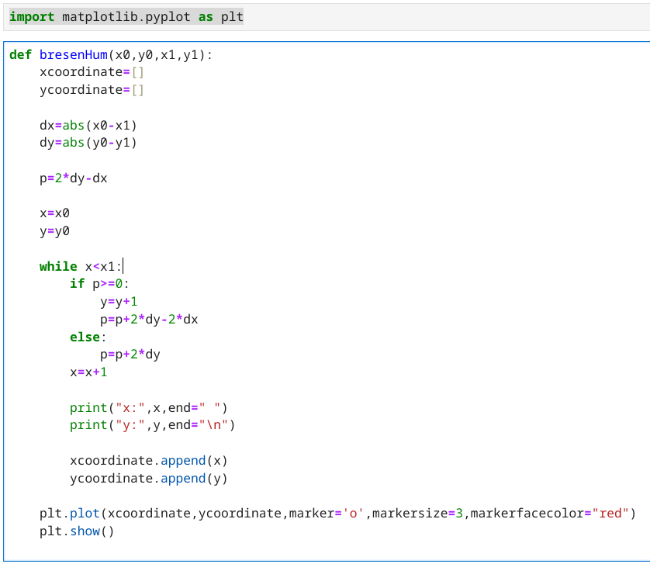

7.Snapshot(Input & Output):
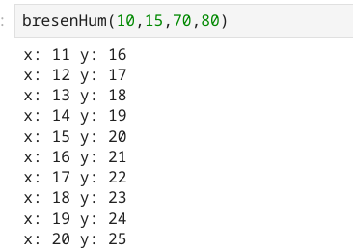

…..
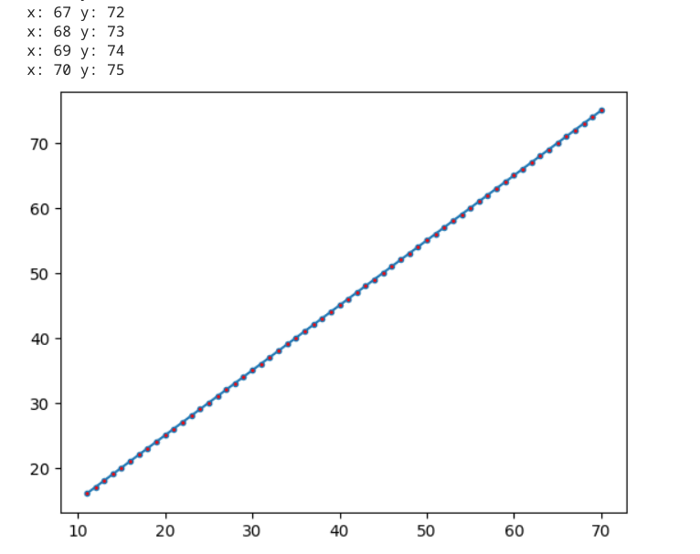

8.​ Discussion & conclusion:
Bresenham’s Line Algorithm is widely used in graphical applications due to its simplicity and speed. Unlike other line-drawing methods that rely on floating-point arithmetic, this algorithm efficiently uses integer calculations, making it ideal for real-time rendering. One of its main advantages is its ability to minimize computational overhead while maintaining accuracy. However, the algorithm is limited to lines with a slope between 0 and 1 in its basic form, requiring adaptations for other cases. Additionally, anti-aliasing techniques may be needed to smooth jagged edges in high-resolution displays.

